Task 7
This task implements ETL procedures for loading data from the source layer into the BL_3NF layer. Each table is loaded through a separate stored procedure located in the BL_CL schema. The procedures support repeatable execution, centralized logging, exception handling, and incremental loading logic.
  - Load ce_dates()
This procedure loads unique dates from the source layer into the CE_DATES table. Duplicate records are prevented using a WHERE NOT EXISTS condition, making the procedure repeatable. Successful and failed executions are recorded in the centralized logging table.
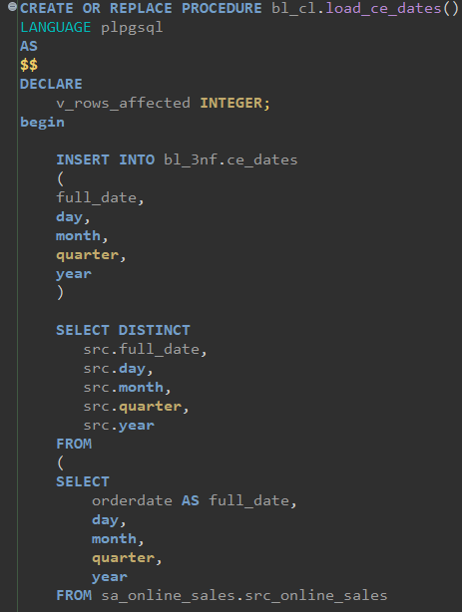
  - ce_geographies
This procedure loads unique geography records from both source systems into CE_GEOGRAPHIES. Customer and store locations are combined into a single entity. Existing records are skipped using WHERE NOT EXISTS.
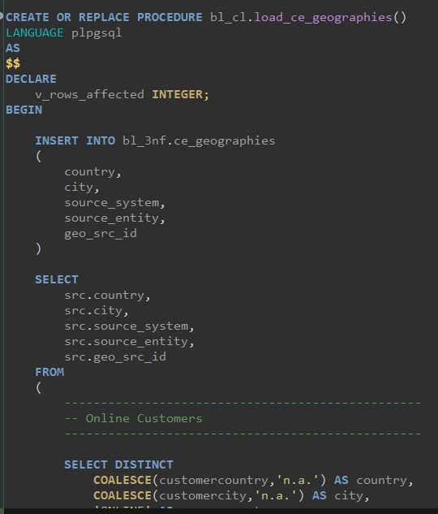
2.3 ce_customers
This procedure loads customer information from both source systems into CE_CUSTOMERS. Customer identifiers together with the source system guarantee uniqueness. Existing customers are not inserted again during subsequent executions. (inserting a screenshot of the ending of the script to not overflood the document with screens and also not screen only beginnings.)
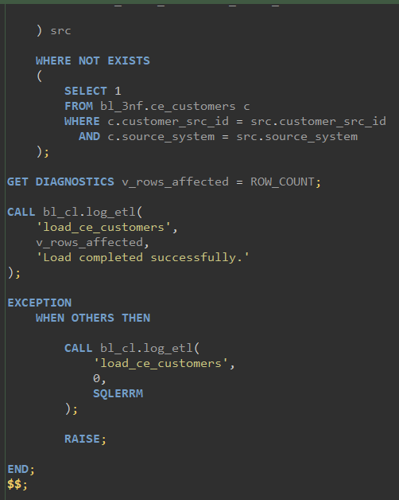
2.4 ce_stores
This procedure loads store information into CE_STORES. The corresponding geography identifier is resolved from CE_GEOGRAPHIES before inserting the data. Duplicate stores are avoided through incremental loading logic.
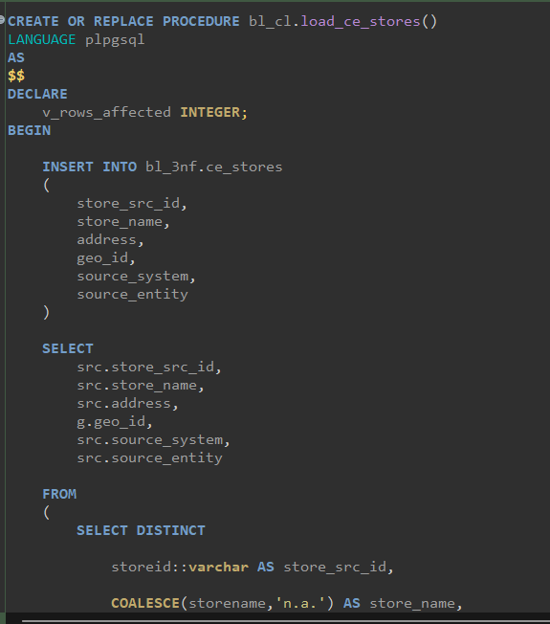
2.5 ce_employees
This procedure loads employee information into CE_EMPLOYEES. Employee names are split into first and last names, and each employee is linked to the appropriate store. Existing employees are ignored during repeated executions.
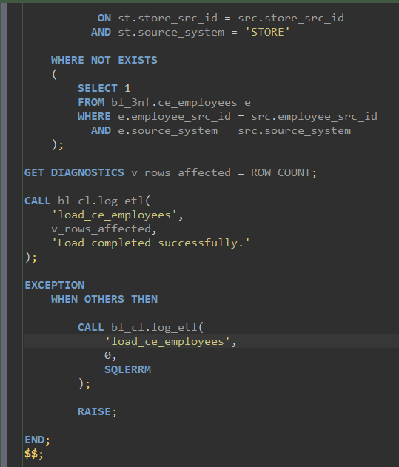

2.6 ce_products_scd
This procedure implements Slowly Changing Dimension Type 2 (SCD2) logic. New products are inserted, modified products are expired by updating the previous version, and a new active version is created. Historical product information is therefore preserved.
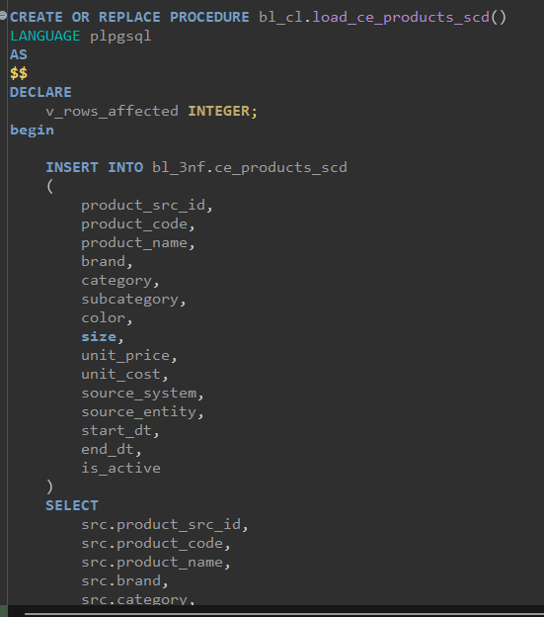
Data loaded into BL_3NF
The screenshot below shows that the ETL procedures successfully populated the BL_3NF layer from the staging tables.
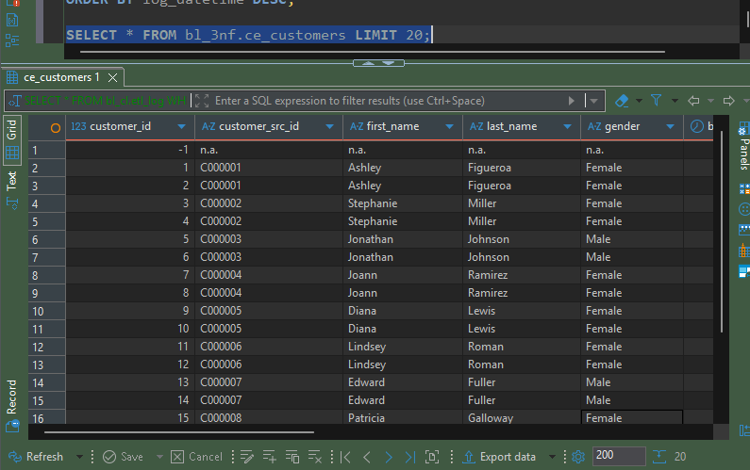
3.1 Testing. Customers table
The procedure was executed after the initial data load. Since all customer records were already present in the target table, the WHERE NOT EXISTS condition prevented duplicate inserts. As a result, the logging table shows 0 affected rows, confirming that the procedure is repeatable and can be executed multiple times without creating duplicate data.
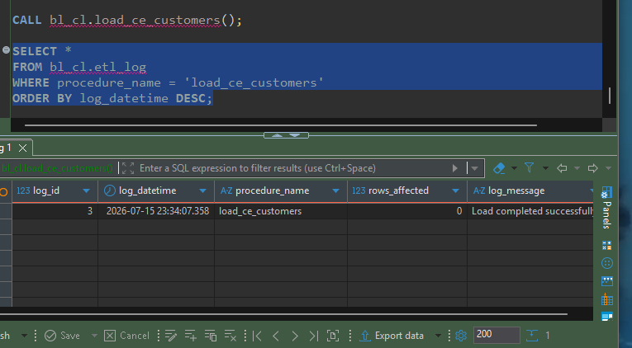
3.2 products_scd
The load_ce_products_scd procedure was executed after the initial product load. No new product versions were detected, therefore the procedure completed successfully without inserting additional records. The logging table confirms successful execution with 0 affected rows.
