Task 9
- Intro
Task 9 focused on improving the ETL process developed in the previous assignment rather than creating it from scratch. The main goal was to make the loading process more suitable for real-life data warehouse scenarios by introducing incremental loading, partitioned fact tables and a rolling window approach.
Instead of redesigning the existing solution, I decided to build upon the architecture from Task 8. My goal was to preserve the existing ETL flow while improving maintainability and performance. Wherever possible I preferred extending existing procedures rather than rewriting them, since this better reflects how ETL systems are usually enhanced in production environments.
- Architechture
The first design decision I had to make was whether to modify the existing procedures or introduce new ones. Since the incremental loading requirement applies only to the 3NF fact layer, I chose to create a dedicated load_ce_sales() procedure. This allowed me to keep the responsibilities separated: one procedure is responsible for loading the 3NF fact table, while another loads the dimensional model. I believe this makes the ETL process easier to understand and maintain.
  - Incremental loading
One of the biggest improvements in this task was implementing incremental loading for the 3NF fact table. Rather than truncating and reloading the table, I chose to insert only new business records identified by the business key (source_system, sales_src_id). This approach avoids unnecessary work during repeated executions and makes the ETL process rerunnable.
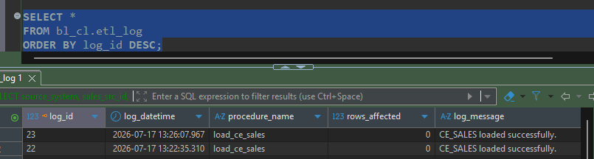
  - Partitioning
I created monthly partitions representing the rolling three-month window because this matched the assignment requirements while also reflecting a realistic reporting scenario.
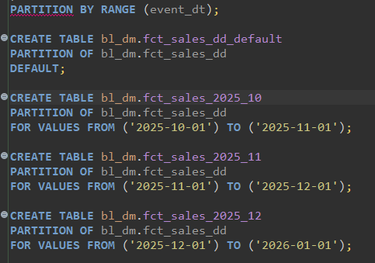
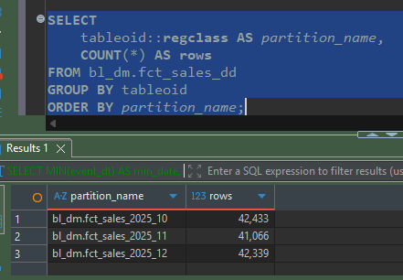
  - Rolling window
Initially I considered hardcoding the three-month period, but later I decided against it. Instead, I calculated the window dynamically from the latest available date in the warehouse. I believe this makes the solution more flexible because future data can be loaded without modifying the procedure.
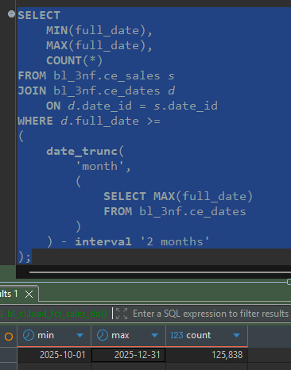
  - Partition management
At first I planned to place the partition management logic directly inside the fact loading procedure. After reviewing the overall architecture, I decided to separate this functionality into its own procedure (manage_fct_sales_partitions). Although both approaches satisfy the assignment requirements, I believe separating responsibilities produces cleaner ETL code and makes future maintenance easier.
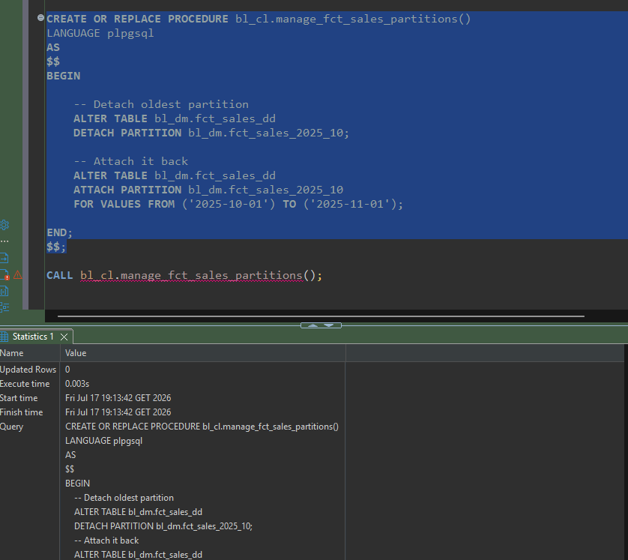
  - Loading DM fact table
After implementing the optimized set-based loading procedure, I executed the ETL process to populate the dimensional fact table. Unlike the initial cursor-based implementation, the final version loads the required records using a single INSERT ... SELECT statement, which significantly improves performance while preserving the incremental loading logic. The resulting fact table contains only records from the rolling three-month period.
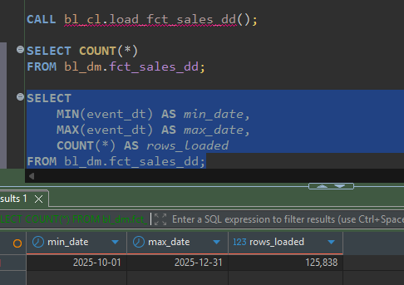

3.6 Validation
After implementing the changes, I verified that repeated executions did not create duplicate records. I also validated the business key uniqueness and confirmed that the ETL process remained rerunnable after introducing incremental loading and partition management.
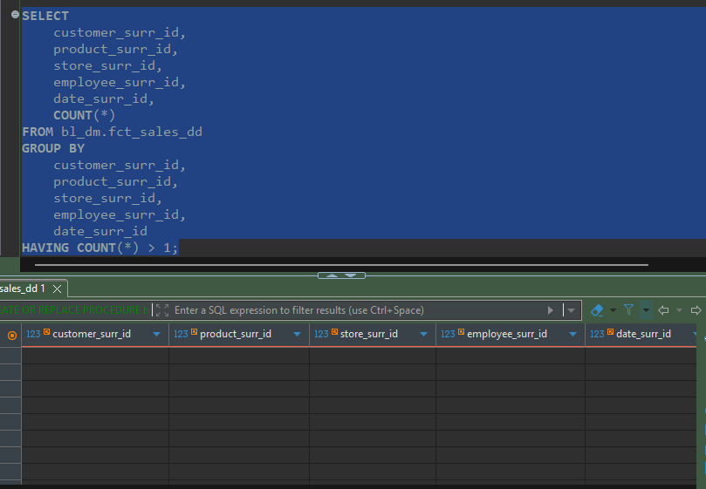
Since the incremental loading relies on (source_system, sales_src_id) as the business key, I verified that this combination remained unique across the 3NF fact table. The query returned no duplicate records, confirming that the incremental logic functions correctly.
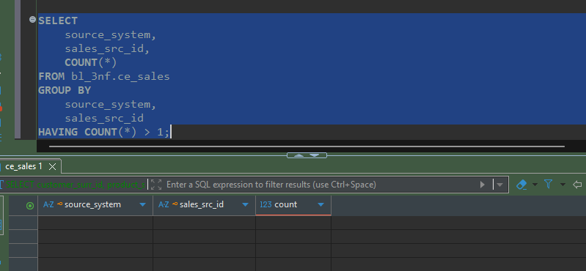

- Conclusion
Task 9 focused on improving the ETL solution developed in the previous assignment. While the original implementation fulfilled the functional requirements, this task provided an opportunity to improve maintainability and performance. By introducing incremental loading, partitioned fact tables, a rolling-window strategy and a set-based loading approach, the final solution became more suitable for larger analytical datasets while remaining rerunnable and preserving data integrity.

