Nike

1.1 Business Background
Nike is a global sportswear retailer selling footwear, apparel and accessories through two independent operational systems:
• Online Store (e-commerce)
• Physical Point of Sale (POS) stores.
The business generates a large volume of transactional data including customers, products, stores, employees, dates, payments and sales. To support business analysis, these operational datasets are integrated into a centralized Data Warehouse. The warehouse enables consistent reporting, historical analysis and decision-making across all sales channels.

1.2 Problems Because of Poor Data Management
Without a centralized Data Warehouse, online and in-store data remain isolated, making reporting inconsistent and time-consuming. Product and customer information may differ between systems, creating duplicate or inconsistent records. Managers cannot easily analyze total sales, customer purchasing behavior, regional performance, employee productivity or product profitability. Manual reporting also increases the risk of errors and delays.

1.3 Benefits From Implementing a Data Warehouse
A Data Warehouse integrates data from both source systems into a single repository for analysis. It enables:
• Analysis of online vs. store sales.
• Product performance by category and subcategory.
• Customer purchasing behavior by country and city.
• Revenue, cost and discount analysis.
• Employee and store performance.
• Historical trend analysis by Year, Quarter, Month and Day.
• Faster and more reliable business reporting.

1.4 Datasets Description
Source System 1 – Nike Online Sales
Contains denormalized online order information including:
• Customer (ID, name, gender, birth date, email, country, city)
• Product (ID, code, name, brand, category, subcategory, color, size)
• Date (OrderDate, Year, Quarter, Month, Day)
• Sales measures (Quantity, Unit Price, Unit Cost, Sales Amount, Cost Amount, Discount Amount)
• Payment Method, Shipping Type, Coupon Code and Sales Channel.
Source System 2 – Nike Store Sales (POS)
Contains denormalized in-store sales including:
• Customer information
• Store (ID, name, address, country, city)
• Employee (ID, name, position)
• Product information
• Date hierarchy
• Sales measures
• Register Number, Shift, Payment Method and Sales Channel.
Hierarchy Descriptions
Date Hierarchy:
Year
└── Quarter
└── Month
└── Day
Product Hierarchy:
Category
└── Subcategory
└── Product
Geography Hierarchy:
Country
└── City
└── Store / Customer

1.5 Grain / Dimension / Fact
Grain:
One record represents one completed sales transaction (one purchased product in one transaction).
Fact:
FactSales
Measures:
• Quantity
• Unit Price
• Unit Cost
• Sales Amount
• Cost Amount
• Discount Amount
Dimensions:
• DimCustomer
• DimProduct
• DimStore
• DimEmployee
• DimDate
• DimGeography

2. Business layer 3nf
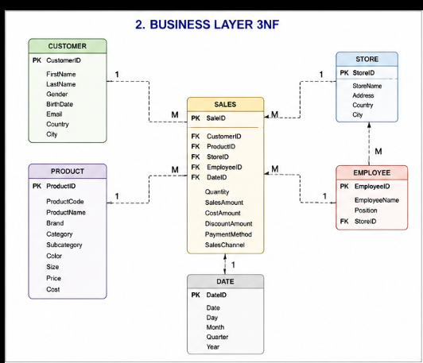

3. business layer dimensional model

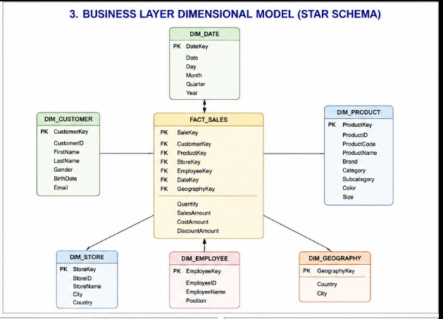

4. logical scheme

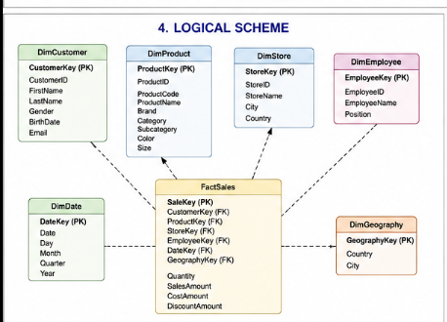

5. data flow

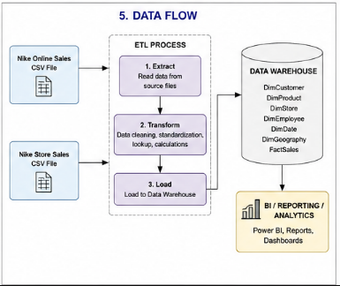

6. fact table partitioning strategy
The FactSales table will be partitioned by Year and Month using the transaction date. Since the datasets contain two years of sales data (2024–2025), partitioning by time improves query performance, reduces scan time for analytical queries, simplifies maintenance, and allows efficient loading of new data. Historical partitions can also be archived independently without affecting recent sales data.

