Auction house
Business Description

Benefits of Implementing the Database / Project Vision
The goal of the auction house database is to support the management of auction activities, including participants, items, auction events, bidding processes, and financial transactions. The database enables the auction house to store and manage structured information about sellers, buyers, auction lots, bids, and auction outcomes.
The database solves several operational challenges. First, it centralizes information about items submitted for auction, ensuring that item descriptions, ownership, and categories are stored consistently. Second, it allows the auction house to track bidding activity for each lot and determine the winning bidder after an auction closes.
Data integrity and consistency are ensured through the use of primary keys, foreign keys, and constraints that enforce relationships between entities. These constraints prevent invalid references and ensure that every bid, payment, or auction result is associated with the correct participants and auction events.
The model also preserves the history of auction activities. Instead of overwriting data, each bid is stored as a separate record in the Bids table, which allows the system to reconstruct the complete bidding history for any auction lot.
The database structure is scalable. New participants, items, auction events, or bids can be added without requiring changes to the database structure. The design also allows participants to act as both buyers and sellers without modifying the schema.
Model Description
Definitions & Acronyms
Several important terms are used throughout the database model:
Participant – A person registered in the system who may act as a buyer, seller, or bidder.
Item – A physical object submitted by a participant for auction.
Lot – A unit offered for sale during an auction event. A lot may contain one or more items.
Auction Event – A scheduled auction session that takes place at a specific location and is managed by an employee.
Bid – An offer made by a participant to purchase a lot at a specific price.
Auction Result – The final outcome of an auction for a particular lot, including the winning participant and final price.
Payment – A financial transaction made by the auction winner after the auction ends.

Technical Terms
- PK (Primary Key) – Unique identifier for each record
- FK (Foreign Key) – Reference to another table
- TEXT/VARCHAR – String data types
- TIMESTAMPTZ – Timestamp with timezone
- CHECK – Restricts allowed values
- DEFAULT – Assigns default value
- UNIQUE – Prevents duplicate values

These definitions ensure that the meaning of each entity and relationship is clearly understood within the database design.

Logical Scheme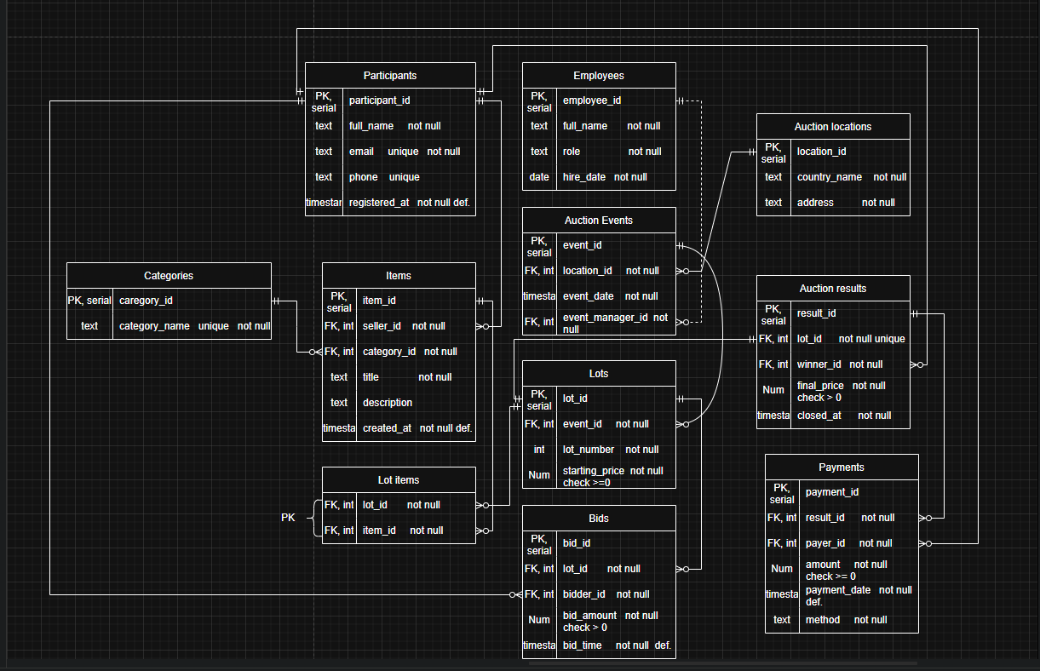
The most difficult modeling decision was determining how to represent the relationship between items and lots. In real auction systems, a lot may contain multiple items, and occasionally items may appear in different auction contexts. This created a many-to-many relationship between items and lots.
Relational databases cannot represent many-to-many relationships directly, so a junction table (Lot_Items) was introduced. This table contains the foreign keys lot_id and item_id, forming a composite primary key. This design ensures flexibility in grouping items into lots while preventing duplication.
Another design consideration was allowing participants to act both as buyers and sellers. Instead of creating separate tables, a single Participants table was used and referenced in different roles such as seller_id, bidder_id, winner_id.
The database design prevents several types of anomalies.
Insertion anomalies are avoided by separating entities into their own tables. For example, category information is stored in the Categories table instead of repeating it for every item.
Update anomalies are prevented because data is stored in a single location. If a category name changes, it only needs to be updated in the Categories table rather than in multiple item records.
Deletion anomalies are avoided because historical data such as bids and auction results are stored independently. Deleting an item record does not remove historical bidding information because the relationships are maintained through foreign keys.
Foreign key constraints ensure that records cannot reference non-existent entities. For example, a bid cannot exist without a valid participant and lot.
The model is designed to be scalable. New attributes can be added to existing tables without affecting the relationships between entities. For example, additional participant information such as address or identification numbers could be added to the Participants table without modifying other tables.
Similarly, new participants, items, bids, or auction events can be added without altering the database structure because the relationships are defined using primary and foreign keys.
The use of separate tables for events, lots, items, bids, and payments ensures that the system can support a growing amount of auction activity while maintaining consistent data organization.
The part of the model most likely to change is the auction event and bidding structure. If the auction house introduces new bidding mechanisms such as online bidding, automatic bidding increments, or reserve prices, additional attributes or tables may be required.
For example, a new table could be added to manage reserve prices or bid increments, or the Bids table could be extended to include additional attributes related to bid type or bidding channel.
However, because the current model separates auction events, lots, bids, and results into distinct entities, such extensions could be implemented without requiring a complete redesign of the database structure.

2.3 OBJECTS

Table: Participants
Real-world concept
The Participants table represents all individuals who interact with the auction house system. A participant may act as a seller who submits items, a bidder who places bids, or a buyer who wins auctions.

Why stored separately
Participant information must be stored separately because the same person can participate in multiple roles throughout the system. If participant data were stored inside other tables such as bids or items, it would cause duplication and inconsistencies.
Normalization level
The table satisfies Third Normal Form (3NF).
- 1NF: All attributes contain atomic values.
- 2NF: All attributes depend on the primary key participant_id.
- 3NF: There are no transitive dependencies because participant attributes depend only on the primary key.
Dependencies
All attributes (full_name, email, phone, registered_at) depend only on the primary key participant_id.
Primary Key and Foreign Keys
The primary key participant_id uniquely identifies each participant.
This key is referenced as a foreign key in several tables:
- items.seller_id
- bids.bidder_id
- auction_results.winner_id
- payments.payer_id
A composite key is not necessary because a single identifier uniquely represents each participant.

Table: Employees
Real-world concept
The Employees table represents staff members responsible for managing auction events.
Why stored separately
Employees are stored separately because they represent internal staff rather than auction participants. This separation helps distinguish operational management from auction participation.
Normalization level
The table satisfies 3NF.
- All attributes depend on the primary key employee_id.
- There are no transitive dependencies.
Dependencies
Attributes full_name, role, and hire_date depend only on employee_id.
Primary Key and Foreign Keys
employee_id is the primary key.
It is referenced in:
- auction_events.event_manager_id

Table: Auction_Locations
Real-world concept
The Auction_Locations table represents physical locations where auction events take place.
Why stored separately
Storing locations separately avoids repeating location details for every auction event and allows multiple events to take place at the same location.
Normalization level
The table satisfies 3NF.
All attributes depend on the primary key location_id.
Dependencies
country_name and address depend only on location_id.
Primary Key and Foreign Keys
location_id is the primary key.
It is referenced by:
- auction_events.location_id

Table: Categories
Real-world concept
The Categories table represents classifications of auction items, such as antiques, jewelry, or artwork.
Why stored separately
Separating categories prevents repetition of category names for every item and ensures consistent categorization across the system.
Normalization level
The table is in 3NF.
All attributes depend only on the primary key category_id.
Dependencies
category_name depends only on the primary key.
Primary Key and Foreign Keys
category_id is the primary key.
It is referenced in:
- items.category_id

Table: Items
Real-world concept
The Items table represents objects submitted by participants to be sold at auction.
Why stored separately
Items contain descriptive information about objects and exist independently of auction events. Storing them separately allows items to be grouped into lots and linked to sellers without duplication.
Normalization level
The table satisfies 3NF.
- All attributes depend on item_id.
- Category information is stored in a separate table to remove transitive dependency.
Dependencies
Attributes title, description, and created_at depend only on item_id.
Primary Key and Foreign Keys
item_id is the primary key.
Foreign keys:
- seller_id → participants
- category_id → categories
A composite key is unnecessary because each item has a unique identifier.

Table: Auction_Events
Real-world concept
The Auction_Events table represents scheduled auction sessions where lots are sold.
Why stored separately
Auction events must be stored independently because multiple lots are sold within the same event and events occur at different locations and times.
Normalization level
The table satisfies 3NF because all attributes depend on event_id.
Dependencies
location_id, event_date, and event_manager_id depend on the primary key.
Primary Key and Foreign Keys
Primary key: event_id
Foreign keys:
- location_id → auction_locations
- event_manager_id → employees

Table: Lots
Real-world concept
The Lots table represents units of sale during an auction event. A lot may contain one or more items.
Why stored separately
Lots must be stored separately because auctions operate by selling lots rather than individual items. This structure allows items to be grouped logically.
Normalization level
The table satisfies 3NF because attributes depend only on the primary key lot_id.
Dependencies
event_id, lot_number, and starting_price depend only on lot_id.
Primary Key and Foreign Keys
Primary key: lot_id
Foreign key:
- event_id → auction_events
A composite key could theoretically include (event_id, lot_number), but lot_id is used for simplicity and efficiency.

Table: Lot_Items
Real-world concept
The Lot_Items table represents the relationship between lots and items.
Why stored separately
Lots and items have a many-to-many relationship, meaning one lot can contain multiple items and items can potentially appear in different lots. A junction table is required to represent this relationship.
Normalization level
The table satisfies 3NF.
Dependencies
There are no additional attributes beyond the composite key.
Primary Key and Foreign Keys
Composite primary key:
(Lot_id, item_id)
Foreign keys:
- lot_id → lots
- item_id → items

Table: Bids
Real-world concept
The Bids table records every bid placed by participants during an auction.
Why stored separately
Bids must be stored independently to preserve the full bidding history and ensure that bids are not overwritten.

Normalization Justification
All tables satisfy Third Normal Form (3NF):
- 1NF: All attributes are atomic
- 2NF: All non-key attributes fully depend on the primary key
- 3NF: No transitive dependencies exist
Example:
- Category data stored separately → removes redundancy
- Country separated from location → removes transitive dependency
- Winner removed → eliminates derived data redundancy
Dependencies
bid_amount and bid_time depend only on bid_id.
Primary Key and Foreign Keys
Primary key: bid_id
Foreign keys:
- lot_id → lots
- bidder_id → participants

Table: Auction_Results
Real-world concept
The Auction_Results table represents the final outcome of an auction for a specific lot.
Why stored separately
Auction results are stored separately from lots because the result only exists after the auction ends and represents the final state of the auction.
Normalization level
The table satisfies 3NF.
Dependencies
winner_id, final_price, and closed_at depend only on result_id.
Primary Key and Foreign Keys
Primary key: result_id
Foreign keys:
- lot_id → lots
- winner_id → participants

Table: Payments
Real-world concept
The Payments table represents financial transactions made by auction winners after the auction concludes.
Why stored separately
Payments must be stored separately because financial transactions may occur after the auction result and may involve different payment methods or multiple payments.
Normalization level
The table satisfies 3NF.
Dependencies
amount, payment_date, and method depend only on payment_id.
Primary Key and Foreign Keys
Primary key: payment_id
Foreign keys:
- result_id → auction_results
- payer_id → participants

Example data
Participants – Table definitions and example data

Field | Description | Type | Constraints
Participant_id | Unique ID | SERIAL | PK
Full_name | Full name | TEXT | NOT NULL
Email | Email | TEXT | Not null, unique
Phone | Phone number | Text | Unique
Registered_at | Registration date | Timestampz | Not null, default now()

participant_id | full_name | email | phone | registered_at
1 | Vako Tamazashvili | vako.tamazashvili@email.com | 555-1234 | 2026-01-10 09:30
2 | Ilia Topuria | ilia.topuria@email.com | 555-9789 | 2026-01-10 09:56
3 | Merab Dvalishvili | merabdvalishvili@email.com | 555-9731 | 2026-01-10 11:30

Employees – Table Definitions and example data
Field | Description | Type | Constraints
Employee_id | Unique ID | Serial | Pk
Full_name | Name | Text | Not null
Role | Role | Text | Not null, check(role IN(‘Auction Manager’, ‘Event Coordinator’, ‘Auction Assistant’))
Hire_date | Hire date | Date | Not null

employee_id | full_name | role | hire_date
1 | Liana Jojua | Auction Manager | 2023-01-17
2 | Hulk Hogan | Event Cooridnator | 2022-04-15
3 | John Cena | Auction Assistant | 2024-05-16

Auction_locations – Table definitions and example data
Field | Description | Type | Constraints
Location_id | ID | Serial | PK
Country_id | Country reference | INT | FK
Address | Address | Text | Not null

location_id | Country_id | address
1 | 1 | S.Rustaveli Avenue #74
2 | 2 | 1600 Pennsylvania Avenue, Washington, D.C
3 | 3 | 123 Somename Str.

Countries – Table definitions and examples
Field | Description | Type | Constraints
Country_id | Unique ID | Serial | PK
Country_name | Country | Text | Not null, unique

Country_id | Country_name
1 | Georgia
2 | USA
3 | Norway

Categories – Table definitions and examples
Field | Description | Type | Constraints
Category_id | ID | Serial | PK
Category_name | Category | Text | Not null, unique

Category_id | Category_name
1 | Antiques
2 | Jewelry
3 | Artwork

Items – Table definitions and examples
Field | Description | Type | Constraints
Item_id | ID | Serial | PK
Seller_id | Seller | Int | FK, not null
Category_id | Category | Int | FK, not null
Title | Title | Text | Not null
Description | Description | Text
Created_at | Created date | Timestampz | Not null, default NOW()

Item_id | Seller_id | Category_id | Title | Description | Created_at
1 | 1 | 1 | Vintage clock | Clock made in 1907 | 2026-01-12
2 | 2 | 2 | Oil painting | Painting from Bob Ross collection | 2026-01-13
3 | 3 | 3 | Gold necklace | Gold necklace found on island | 2026-01-14

Auction events – Table definitions and examples
Field | Description | Type | Constraints
Event_id | ID | Serial | PK
Location_id | Location | INT | FK, not null
Event_date | Date | Timestampz | Not null
Event_manager_id | Manager | Int | FK, not null

Event_id | Location_id | Event_date | Event_manager_id
1 | 1 | 2026-02-01 16:00 | 1
2 | 2 | 2026-02-05 17:45 | 2
3 | 3 | 2026-03-17 18:30 | 3

Lots – Table definitions and examples
Field | Description | Type | Constraints
Lot_id | ID | Serial | PK
Event_id | Event | Int | FK, not null
Lot_number | Number | Int | Not null
Starting_price | Price | Numeric | Not null, Check (starting price>=0)

Lot_id | Event_id | Lot_number | Starting_price
1 | 1 | 101 | 500
2 | 2 | 102 | 650
3 | 3 | 103 | 970

Lot items – Table definition and examples
Field | Description | Type | Constraints
Lot_id | Lot | Int | PK, FK
Item_id | Item | Int | PK, FK

Lot_id | Item_id
1 | 1
2 | 2
3 | 3

Bids – Table definitions and examples
Field | Description | Type | Constraints
Bid_id | ID | Serial | PK
Lot_id | Lot | Int | FK, Not null
Bidder_id | Participant | Int | FK, not null
Bid_amount | Amount | Numeric | Not null, Check (bid_amount > 0)
Bid_time | Time | Timestampz | Not null, Default NOW()

Bid_id | Lot_id | Bidder_id | Bid_amount | Bid_time
1 | 1 | 2 | 600 | 2026-01-02 15:14
2 | 1 | 3 | 650 | 2026-01-02 15:15
3 | 2 | 1 | 1000 | 2026-01-02 16:13

Auction Results – Table definitions and examples
Field | Description | Type | Constraints
Result_id | ID | Serial | PK
Lot_id | Lot | Int | FK, Unique, Not null
Final_price | Final price | Numeric | Not null, CHECK (final_price > 0)
Closed_at | Close time | Timestampz | Not null

Result_id | Lot_id | Final_price | Closed_at
1 | 1 | 690 | 2026-01-02 15:25
2 | 2 | 880 | 2026-01-02 16:37
3 | 3 | 1050 | 2026-01-02 17:01

Payments – Table definitions and examples
Field | Description | Type | Constraints
Payment_id | Id | Serial | PK
Result_id | Result | Int | FK, not null
Payer_id | Participant | Int | FK, not null
Amount | Amount | Numeric | Not null, CHECK(amount >=0)
Payment_date | Date | Timestampz | Not null, default NOW()
Method | Payment method | Text | Not null, Check (method IN (‘cash’, ‘card’, ‘bank_transfer’, ‘insurance’))

