Insurance Fraud Claims Detection using Explainable Analytics

Chapter 3 Methodology

3.1 Research Philosophy
This study will adopt a positivist research philosophy, which focuses on the collection and analysis of objective data to generate measurable and evidence-based findings. Positivism is considered appropriate for this research because the project aims to investigate insurance fraud detection through quantitative data analysis and machine learning techniques. The study will rely on structured insurance claim records rather than subjective opinions or personal experiences, making a data-driven approach suitable for achieving the research objectives.
The positivist philosophy supports the use of statistical methods, predictive modelling, and performance evaluation metrics to examine patterns associated with fraudulent insurance claims. The selected machine learning algorithms will be evaluated using quantitative measures such as accuracy, precision, recall, F1-score, and ROC-AUC to determine their effectiveness in identifying fraudulent activities. Furthermore, explainable analytics techniques will be applied to provide transparent insights into model predictions based on measurable feature contributions.
By adopting a positivist perspective, the research will ensure that findings are derived from observable evidence within the dataset and can be objectively assessed and replicated. This approach aligns with the technical nature of the project and supports the development of a reliable and interpretable insurance fraud detection system.
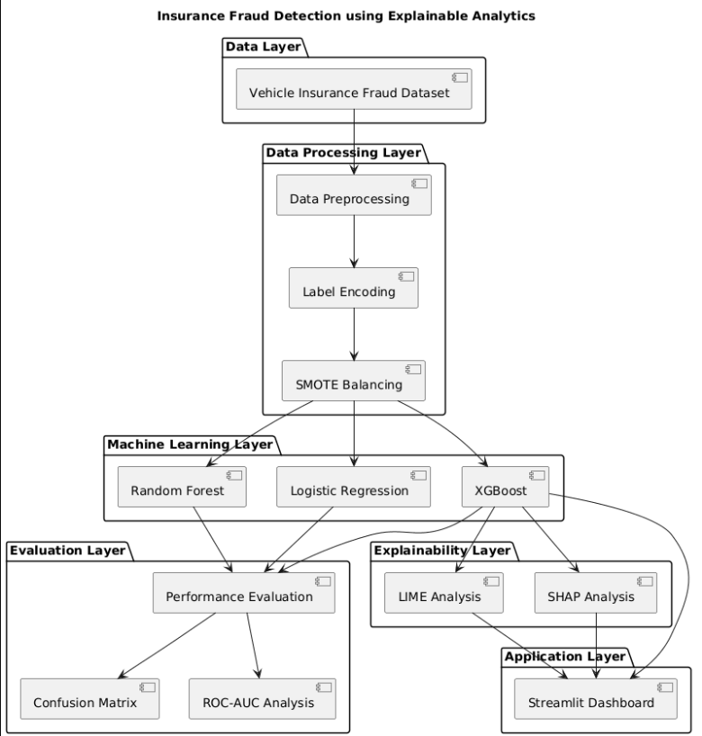
Figure 3.1 presents the proposed system architecture for the insurance fraud detection framework.

3.2 Research Approach
This research will adopt a quantitative research approach to investigate the application of machine learning and explainable analytics for insurance fraud detection. A quantitative approach is appropriate because the study focuses on analysing numerical and categorical insurance claim data to identify patterns associated with fraudulent activities. The research will rely on measurable data, statistical analysis, and predictive modelling techniques to generate objective findings.
The study will utilise a publicly available vehicle insurance fraud dataset containing historical insurance claim records. Data preprocessing techniques will be applied to prepare the dataset for analysis, followed by the development of multiple machine learning models. Logistic Regression, Random Forest, and XGBoost algorithms will be implemented and compared to determine their effectiveness in detecting fraudulent claims. Model performance will be assessed using quantitative evaluation metrics, including accuracy, precision, recall, F1-score, and ROC-AUC.
In addition, explainable analytics methods such as SHAP and LIME will be incorporated to improve model transparency and interpretability. The quantitative approach will enable the research to evaluate model performance objectively and provide evidence-based conclusions regarding the suitability of machine learning techniques for insurance fraud detection.

3.3 Research Strategy
This study will follow a system development and experimental research strategy to design, implement, and evaluate an insurance fraud detection system using machine learning and explainable analytics. The strategy is appropriate because the project aims not only to analyse insurance claim data but also to develop a functional fraud detection solution that can support decision-making within the insurance sector.
The research process will begin with the collection and examination of a vehicle insurance fraud dataset. The dataset will undergo preprocessing procedures, including data cleaning, encoding of categorical variables, and preparation of features for machine learning analysis. Since fraud datasets often contain imbalanced class distributions, suitable techniques will be applied to address this issue and improve model performance.
Following data preparation, multiple machine learning algorithms, including Logistic Regression, Random Forest, and XGBoost, will be developed and trained using the processed dataset. The performance of each model will be evaluated and compared using established classification metrics. The most effective model will then be selected for further analysis.
To improve transparency and interpretability, explainable analytics techniques such as SHAP and LIME will be incorporated into the framework. Finally, the selected model and explainability components will be integrated into a Streamlit-based dashboard that will allow users to explore fraud predictions and model explanations through an interactive interface. This strategy will ensure that both predictive accuracy and model interpretability are addressed within the proposed solution.

3.4 Dataset Collection and Description
This research will utilise the Vehicle Insurance Fraud Detection Dataset obtained from Kaggle, a widely used platform for machine learning and data analytics research. The dataset was selected because it contains real-world insurance claim attributes that are suitable for developing and evaluating fraud detection models. Insurance fraud is a significant challenge for insurance companies, and the availability of historical claim information provides an opportunity to identify patterns associated with fraudulent behaviour through data-driven techniques.
https://www.kaggle.com/datasets/shivamb/vehicle-claim-fraud-detection?utm
The dataset contains 15,420 insurance claim records and 33 attributes representing various characteristics of policyholders, vehicles, accidents, and insurance claims. Examples of attributes include age, gender, vehicle category, policy type, deductible amount, accident area, driver rating, and claim-related information. The target variable, FraudFound, indicates whether a claim is classified as fraudulent or genuine. This labelled structure makes the dataset suitable for supervised machine learning classification tasks.
The dataset includes both numerical and categorical variables, enabling the investigation of different factors that may influence fraud detection. Its relatively large size provides sufficient data for model training, testing, and validation while supporting reliable performance evaluation. Furthermore, the dataset reflects realistic insurance claim scenarios, making it appropriate for assessing the effectiveness of machine learning algorithms in identifying suspicious claims.
By using this dataset, the research will be able to explore fraud detection patterns, compare multiple classification models, and evaluate the contribution of explainable analytics techniques in improving transparency and trust in fraud prediction systems.

3.5 Data Preparation and Preprocessing
Data preparation and preprocessing will be conducted to ensure that the dataset is suitable for machine learning analysis and model development. Raw datasets often contain inconsistencies, redundant information, and categorical attributes that require transformation before they can be used effectively by machine learning algorithms. Therefore, a structured preprocessing process will be implemented to improve data quality and enhance model performance.
Initially, the dataset will be examined to identify missing values, duplicate records, and potential data quality issues. Records containing inconsistencies will be reviewed and handled appropriately to maintain the reliability of the analysis. Descriptive statistics and exploratory analysis techniques will also be applied to gain a better understanding of the dataset structure and feature distributions.
Since the dataset contains numerous categorical variables, encoding techniques will be employed to convert categorical data into numerical representations suitable for machine learning algorithms. Label Encoding will be applied to transform categories such as vehicle type, policy type, marital status, accident area, and other categorical attributes into machine-readable formats. Numerical features will be reviewed to ensure consistency and suitability for model training.
Following data transformation, the target variable will be separated from the predictor variables, and the dataset will be divided into training and testing subsets. The training data will be used to develop machine learning models, while the testing data will be reserved for unbiased performance evaluation. This preprocessing stage will establish a clean and structured dataset that supports accurate fraud prediction and reliable model assessment throughout the study.

3.6 Class Imbalance Handling
One of the major challenges in insurance fraud detection is the presence of class imbalance within the dataset. In most real-world insurance datasets, genuine claims significantly outnumber fraudulent claims. As a result, machine learning models may become biased towards the majority class and fail to identify fraudulent cases effectively. This can lead to misleading performance results, particularly when accuracy is considered as the sole evaluation metric.
To address this issue, the Synthetic Minority Oversampling Technique (SMOTE) will be applied during the data preparation stage. SMOTE is a widely used resampling method that generates synthetic samples of the minority class rather than simply duplicating existing records. By creating additional synthetic fraud instances, the technique helps balance the class distribution within the training dataset.
The application of SMOTE is expected to improve the model's ability to recognise fraudulent claims and reduce the risk of bias towards genuine claims. This approach will also contribute to improved recall and F1-score, which are important evaluation metrics in fraud detection studies. By balancing the dataset prior to model training, the research aims to develop more reliable and effective machine learning models capable of detecting insurance fraud with greater accuracy and consistency.

3.7 Machine Learning Model Development
The primary objective of this research is to develop an effective machine learning-based system capable of detecting fraudulent insurance claims. To achieve this objective, multiple classification algorithms will be implemented and evaluated to determine their suitability for fraud detection. The use of multiple models will enable a comparative analysis of predictive performance and provide insights into the strengths and limitations of different machine learning approaches.
Three supervised machine learning algorithms will be selected for this study: Logistic Regression, Random Forest, and XGBoost. Logistic Regression will be used as a baseline classification model due to its simplicity, efficiency, and interpretability. As a widely adopted statistical learning technique, it provides a useful benchmark against which more advanced models can be compared.
Random Forest will be implemented as an ensemble learning method that combines multiple decision trees to improve prediction accuracy and reduce overfitting. The algorithm is capable of handling complex relationships within data and has been successfully applied in numerous fraud detection applications. Its ability to evaluate feature importance also contributes to understanding the factors influencing fraud predictions.
XGBoost (Extreme Gradient Boosting) will be employed as the advanced machine learning model within this research. XGBoost is known for its high predictive performance, computational efficiency, and ability to handle structured tabular datasets. The algorithm utilises gradient boosting techniques to iteratively improve model performance by correcting prediction errors from previous iterations. Due to its effectiveness in classification tasks, XGBoost is expected to provide strong fraud detection capabilities.
The dataset will be divided into training and testing subsets before model development. Each algorithm will be trained using the processed training data and evaluated on unseen testing data. Performance metrics including accuracy, precision, recall, F1-score, and ROC-AUC will be used to compare the models. The best-performing model will subsequently be selected for explainability analysis and integration into the proposed fraud detection dashboard.

3.8 Model Evaluation Strategy
The effectiveness of the developed machine learning models will be assessed using a comprehensive evaluation strategy. Since insurance fraud detection is a binary classification problem, multiple performance metrics will be employed to provide a balanced assessment of each model's predictive capability. Relying solely on accuracy may be misleading because fraud datasets often contain imbalanced class distributions, where genuine claims significantly outnumber fraudulent claims.
Accuracy will be used to measure the overall proportion of correctly classified instances. However, additional metrics such as precision, recall, and F1-score will also be considered. Precision measures the proportion of claims predicted as fraudulent that are actually fraudulent, while recall evaluates the model's ability to identify fraudulent claims correctly. Recall is particularly important in fraud detection because failing to detect fraudulent claims may result in financial losses for insurance companies. The F1-score will provide a balanced measure by combining precision and recall into a single metric.
Furthermore, the Receiver Operating Characteristic Area Under the Curve (ROC-AUC) will be used to assess the model's ability to distinguish between fraudulent and non-fraudulent claims across different classification thresholds. A higher ROC-AUC score indicates better classification performance.
In addition to numerical metrics, Confusion Matrices will be generated to visualise the classification results and identify the number of true positives, true negatives, false positives, and false negatives produced by each model. The evaluation results will be compared systematically to determine the most effective machine learning model for insurance fraud detection. The selected model will then be used for explainability analysis and dashboard integration.

3.9 Explainable Analytics Framework
One of the key challenges associated with machine learning-based fraud detection systems is the lack of transparency in model decision-making. While advanced algorithms can achieve high predictive performance, they often operate as "black box" models, making it difficult for users to understand the reasons behind specific predictions. In the insurance industry, transparency is particularly important because fraud-related decisions can have significant financial and operational implications. Therefore, this research will incorporate explainable analytics techniques to improve model interpretability and support informed decision-making.
The study will utilise SHAP (SHapley Additive exPlanations) as the primary explainability technique. SHAP is a game theory-based method that explains how individual features contribute to a model's predictions. It provides both global and local explanations, enabling the identification of the most influential variables affecting fraud detection across the entire dataset as well as for individual insurance claims. SHAP visualisations will be used to analyse feature importance and understand the overall behaviour of the selected machine learning model.
In addition, LIME (Local Interpretable Model-Agnostic Explanations) will be employed to generate local explanations for individual predictions. LIME works by approximating the behaviour of a complex model around a specific instance and identifying the features that contribute most significantly to the prediction outcome. This allows users to understand why a particular claim has been classified as fraudulent or genuine.
By combining SHAP and LIME, the research aims to provide both global and local interpretability. The integration of these explainability techniques will enhance transparency, increase user trust, and support the practical adoption of machine learning models in insurance fraud detection systems.

3.10 Streamlit Dashboard Development
To enhance the usability and accessibility of the proposed fraud detection system, a web-based dashboard will be developed using Streamlit. Streamlit is an open-source Python framework that enables the rapid development of interactive data science and machine learning applications. It has been selected for this research due to its simplicity, flexibility, and ability to integrate machine learning models into user-friendly interfaces without requiring extensive web development expertise.
The dashboard will serve as the front-end component of the proposed system and will provide an interactive environment for exploring insurance fraud predictions and model explanations. Users will be able to input relevant insurance claim information and receive a prediction indicating whether a claim is likely to be fraudulent or genuine. This functionality will demonstrate the practical application of the developed machine learning model.
In addition to fraud prediction, the dashboard will include sections dedicated to dataset exploration and model performance evaluation. Visualisations such as confusion matrices, model comparison charts, and performance metrics will be incorporated to present evaluation results in a clear and understandable format. Furthermore, explainability outputs generated using SHAP and LIME will be integrated into the dashboard to provide transparent insights into model decision-making.
The Streamlit dashboard will act as a proof-of-concept application that demonstrates how machine learning and explainable analytics can be combined within a practical fraud detection framework. By providing an interactive and user-friendly interface, the dashboard will support better understanding, interpretation, and communication of fraud prediction results.

3.11 Ethical Considerations
Ethical considerations are important in ensuring that the research is conducted responsibly and in accordance with academic and professional standards. This study will utilise a publicly available insurance fraud dataset obtained from Kaggle, meaning that no direct interaction with human participants will be required. Consequently, the research will not involve surveys, interviews, observations, or the collection of personal information from individuals.
The dataset will be used solely for academic research purposes and will be handled in accordance with the terms and conditions of the data provider. Any personally identifiable information contained within the dataset will not be disclosed or used for purposes beyond the scope of this study. Furthermore, the research will focus on developing and evaluating machine learning models without causing harm to individuals, organisations, or society.
The proposed fraud detection system will be designed as a decision-support tool rather than a fully automated decision-making system. Explainable analytics techniques will be incorporated to improve transparency and reduce the risks associated with black-box machine learning models. These measures will help ensure that the research is conducted ethically, responsibly, and in compliance with relevant academic guidelines.

