PHP ASSIGNMENT

**TOPIC – SQL TASK 1**

**CREATE database:**

**CREATE** **DATABASE** sqltask1;

**CREATE TABLE:**

**CREATE** TABLE employee(EM\_ID **INT** **PRIMARY** **KEY** **AUTO\_INCREMENT**,

FIRST\_NAME **VARCHAR**(50) **NOT** **NULL**,

LAST\_NAME **VARCHAR**(50) **NOT** **NULL**,

SALARY **INT**(10) **NOT** **NULL**,

JOINING\_DATE **DATE**,

DEPARTMEN **VARCHAR**(40)

);

**INSERT TABLE DATA:**

**INSERT** **INTO** employee(EM\_ID,FIRST\_NAME,LAST\_NAME,SALARY,JOINING\_DATE,DEPARTMEN)

**VALUES**

(1,"JOHAN","ABRAHAM",1000000,"2013-01-01","BANKING"),

(2,"MICHAEL","CLERK",800000,"2013-01-01","INSURANCE"),

(3,"ROY","THOMAS",700000,"2013-02-01","BANKING"),

(4,"TOM","JOSE",600000,"2013-02-01","INSURANCE"),

(5,"JERRY","PINTO",650000,"2013-01-01","INSURANCE"),

(6,"PHILIP","MATHEW",750000,"2013-01-01","SARVISH"),

(7,"TESTNAME1","123",650000,"2013-01-01","SARVISH"),

(8,"TESTNME2","LNAME%",600000,"2013-02-01","INSURANCE");

TABLE: - EMPLOYEE

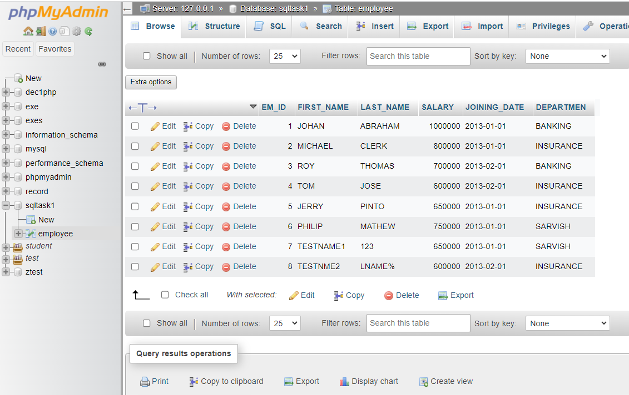

**CREATE TABLE:**

**CREATE** **TABLE** Incentives(Incentive\_Id **INT** **PRIMARY** **KEY** **AUTO\_INCREMENT**,

employee\_ref\_Id **INT**(10) **NOT** **NULL** ,

Incentive\_date **DATE** **NOT** **NULL** ,

incentive\_amt **int**(10) **NOT** **NULL**

);

**INSERT TABLE DATA:**

**INSERT** **INTO** incentives(Incentive\_Id,employee\_ref\_Id,Incentive\_date,Incentive\_amt)

**VALUES**

(1,1,"2013-02-01",5000),

(2,2,"2013-02-01",3000),

(3,3,"2013-02-01",4000),

(4,1,"2013-01-01",4500),

(5,2,"2013-01-01",3500);

TABLE: - INCENTIVES

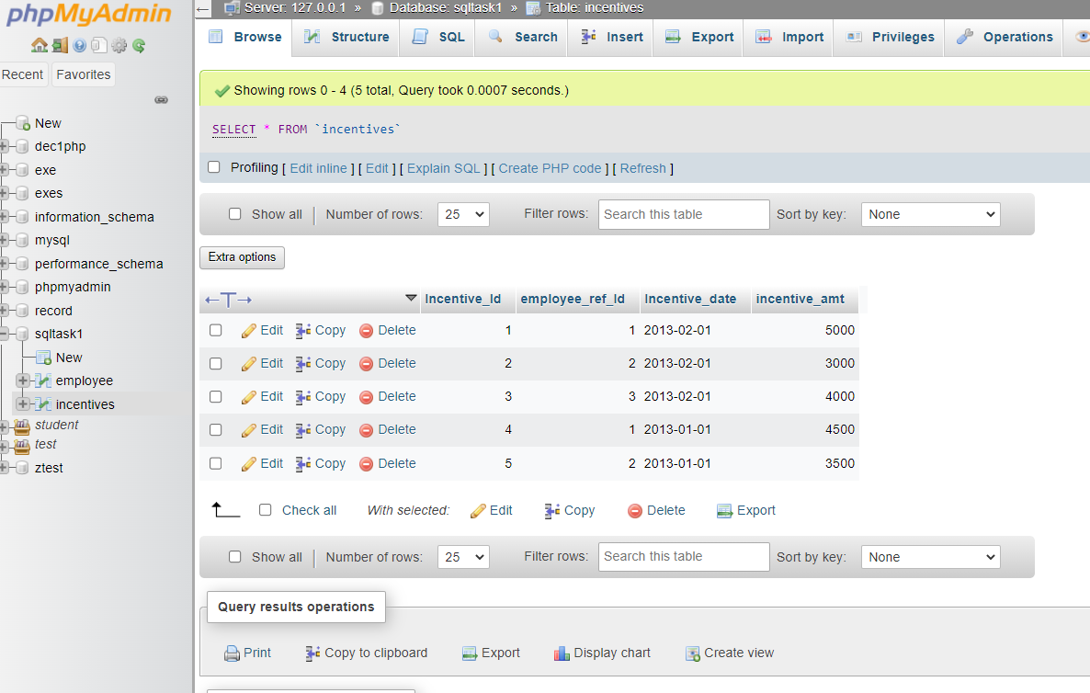

---------------------------------------QUESTION---------------------------------------

1. Get First\_Name from employee table using alias name “Employee Name”.

Ans: -> **SELECT** FIRST\_NAME EMPLOYEE\_NAME **FROM** employee;

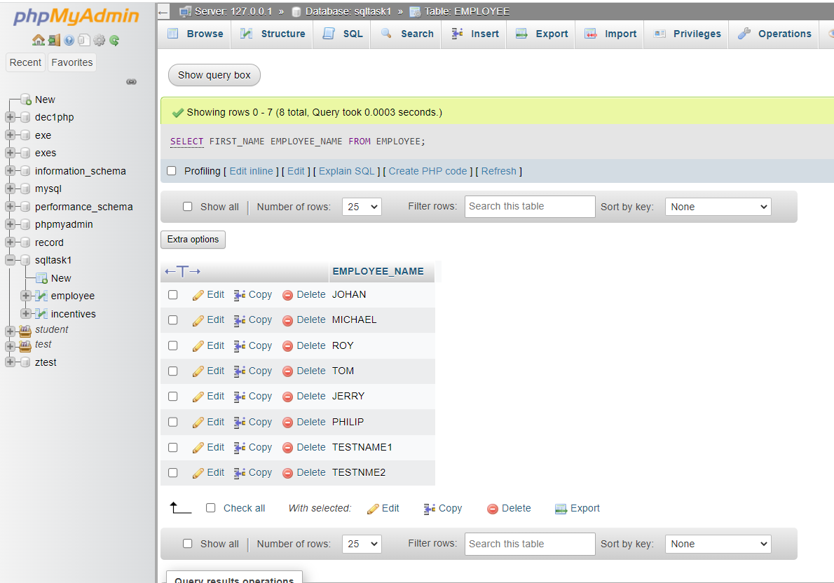

1. Get FIRST\_NAME, Joining year, Joining Month and Joining Date from employee table.

Ans: - **SELECT** e.FIRST\_NAME, **DATE\_FORMAT**(e.JOINING\_DATE, "%Y") JOINYEAR ,

**DATE\_FORMAT**(e.JOINING\_DATE, "%m") JOINMONTH,

**DATE\_FORMAT**(e.JOINING\_DATE, "%d") JOINDATE **FROM** employee e;

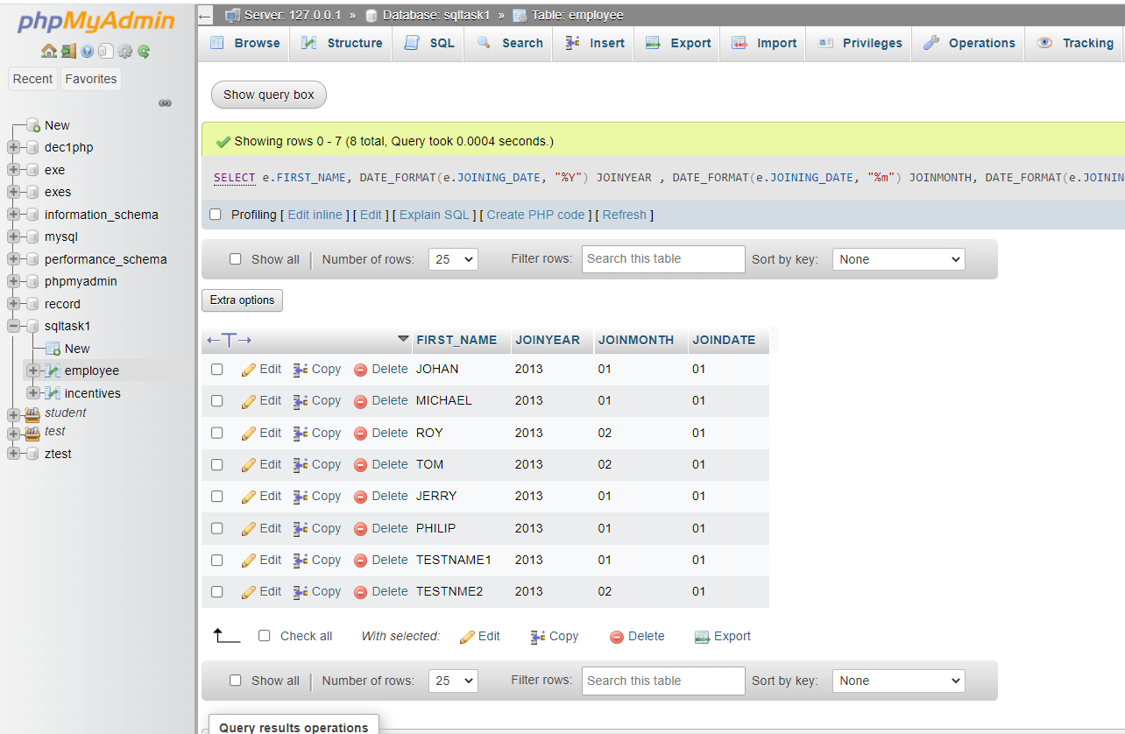

1. Get all employee details from the employee table order by First Name Ascending And Salary descending?

Ans: -> **SELECT** \* **FROM** employee e **ORDER** **BY** e.FIRST\_NAME **ASC**,e.SALARY **DESC** ;

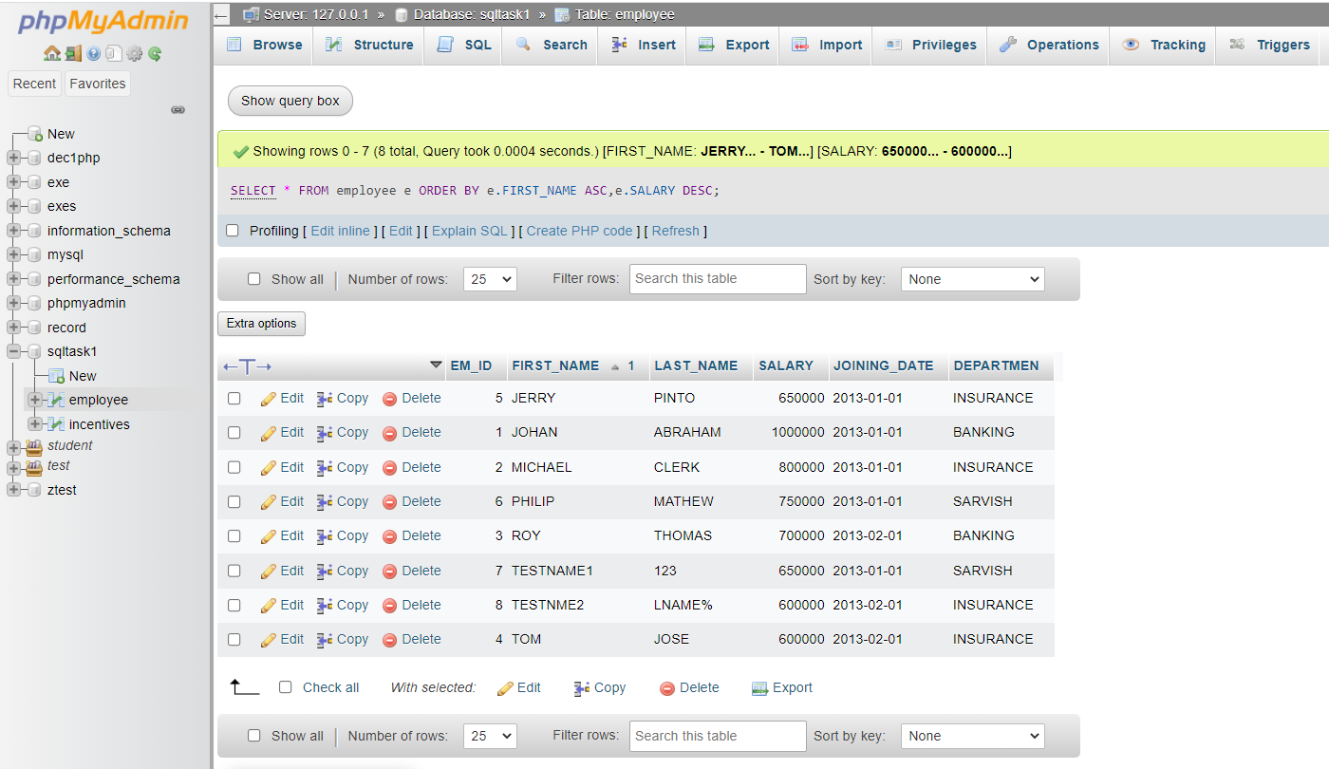

1. Get employee details from employee table whose first name contains „o‟.

Ans: -> **SELECT** \* **FROM** employee e **WHERE** (e.FIRST\_NAME **LIKE** '%o%');

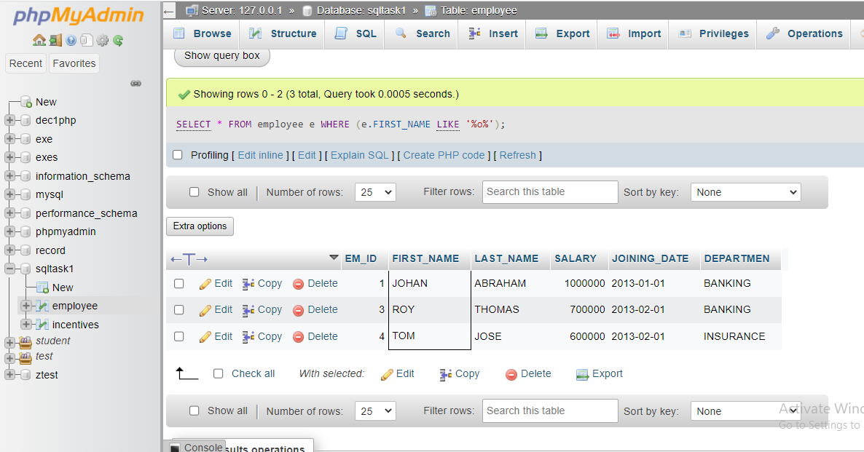

e) Get employee details from employee table whose joining month is “January”.

Ans: - -> **SELECT** \* **FROM** employee e **WHERE** **DATE\_FORMAT**(e.JOINING\_DATE, "%M") =

"january";

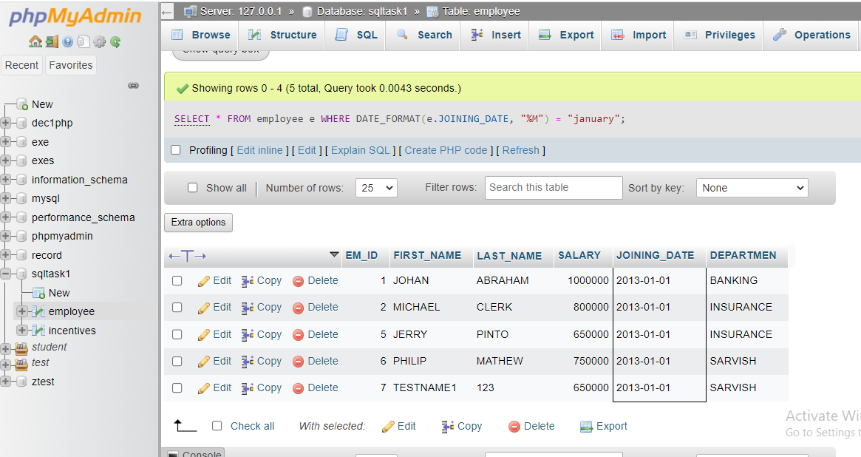

1. Get department, total salary with respect to a department from employee table Order By total salary descending.

Ans: -> **SELECT** e.DEPARTMEN,**SUM**(e.SALARY) TOTAL\_SALARY **FROM** employee e **GROUP** **BY** e.DEPARTMEN **ORDER** **BY** TOTAL\_SALARY **DESC**;

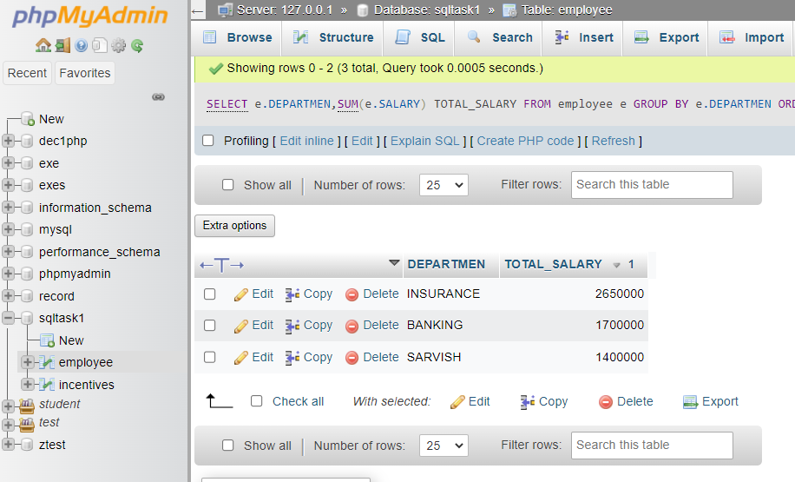

1. Get department wise maximum salary from employee table order by salary ascending?

Ans: - -> **SELECT** e.DEPARTMEN,**MAX**(e.SALARY) MAXSALARY **FROM** employee e **GROUP** **BY**

e.DEPARTMEN **ORDER** **BY** e.SALARY **ASC**;

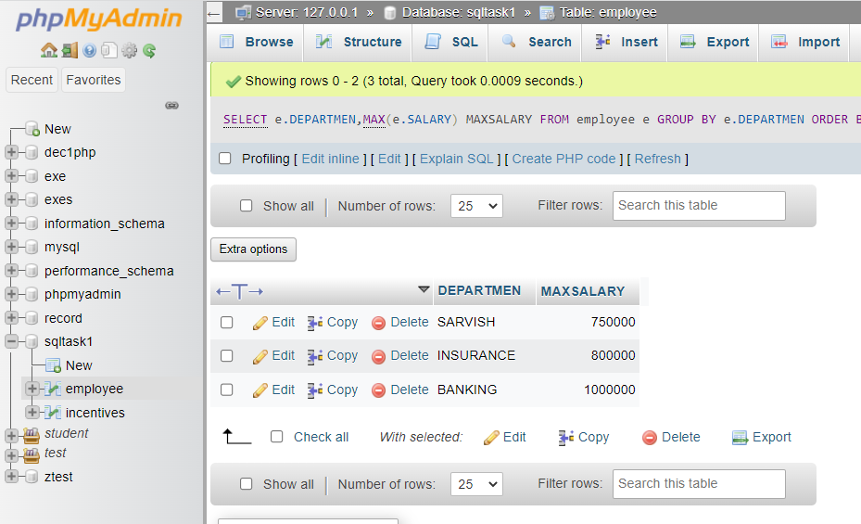

1. Select first\_name, incentive amount from employee and incentives table for those Employees who have incentives and incentive amount greater than 3000

Ans: - -> **SELECT** e.FIRST\_NAME,i.incentive\_amt **FROM** employee e **INNER** **JOIN** INCENTIVES i

**ON** e.EM\_ID=i.employee\_ref\_Id **AND** i.incentive\_amt >3000;

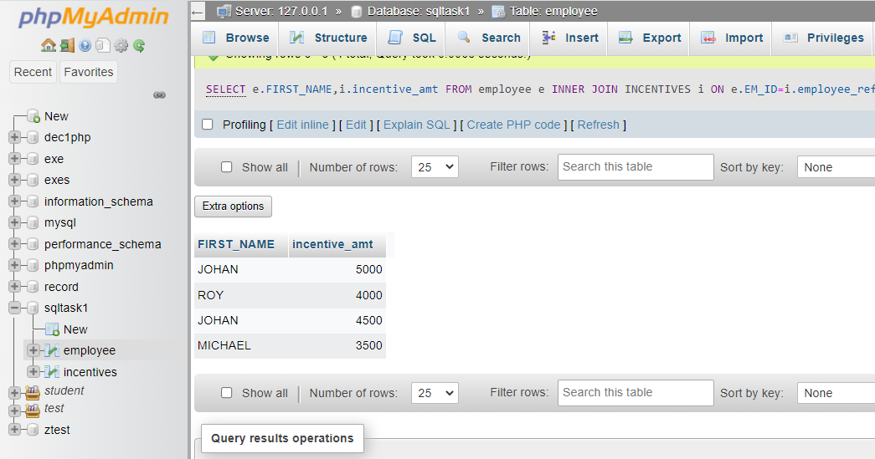

i) Select 2nd Highest salary from employee table.

Ans: -> **SELECT** e.FIRST\_NAME,i.incentive\_amt **FROM** employee e **INNER** **JOIN** INCENTIVES i

**ON** e.EM\_ID=i.employee\_ref\_Id **AND** i.incentive\_amt >3000;

Ans: ->**select** \* **from** employee **group** **by** salary **order** **by** salary **desc** **LIMIT** 1,1 ;

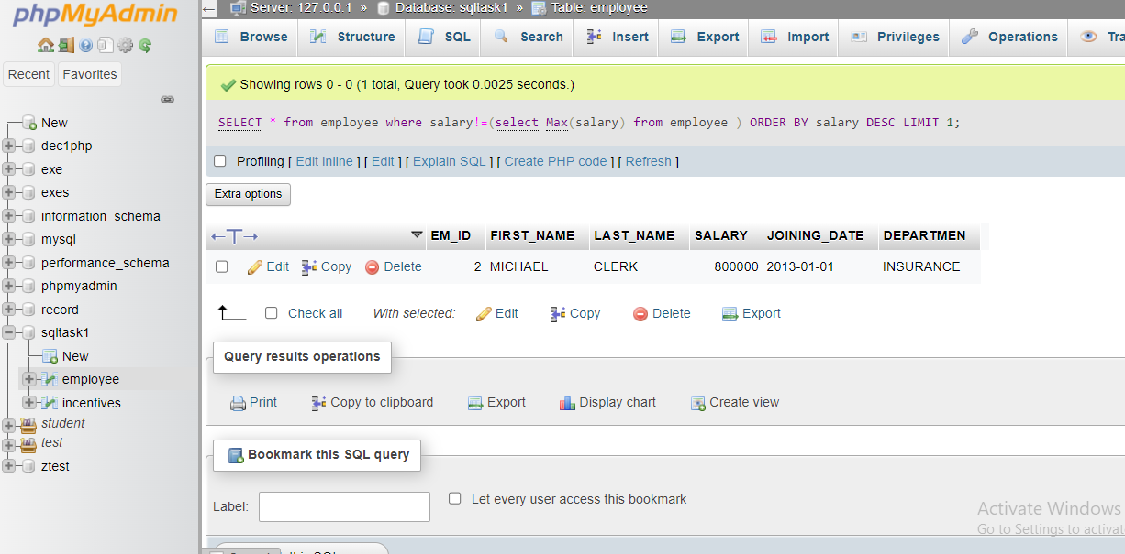

1. Select first\_name, incentive amount from employee and incentives table for all Employees who got incentives using left join

Ans:[SELECT](http://localhost/phpmyadmin/url.php?url=https://dev.mysql.com/doc/refman/8.0/en/select.html" \t "mysql_doc) e.FIRST\_NAME,NVL(i.incentive\_amt,0) AS incentives\_amt FROM employee e [LEFT](http://localhost/phpmyadmin/url.php?url=https://dev.mysql.com/doc/refman/8.0/en/string-functions.html%23function_left)

JOIN incentives i ON e.EM\_ID=i.employee\_ref\_Id;

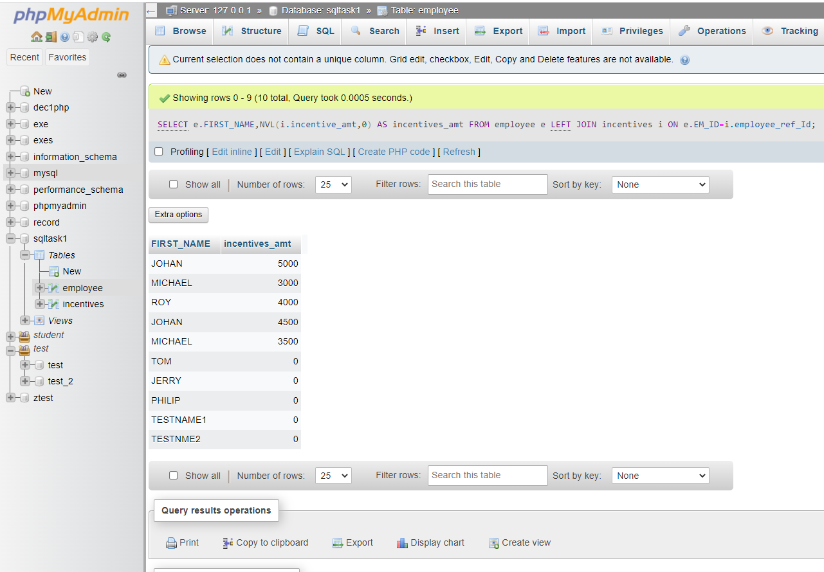

1. Create View OF Employee table in which store first name, last name and salary only.

Ans: -  **CREATE** **VIEW** employee\_view **AS** **SELECT** e.FIRST\_NAME,e.LAST\_NAME,e.SALARY **FROM**

employee e;

**SELECT** \* **FROM** employee\_view;

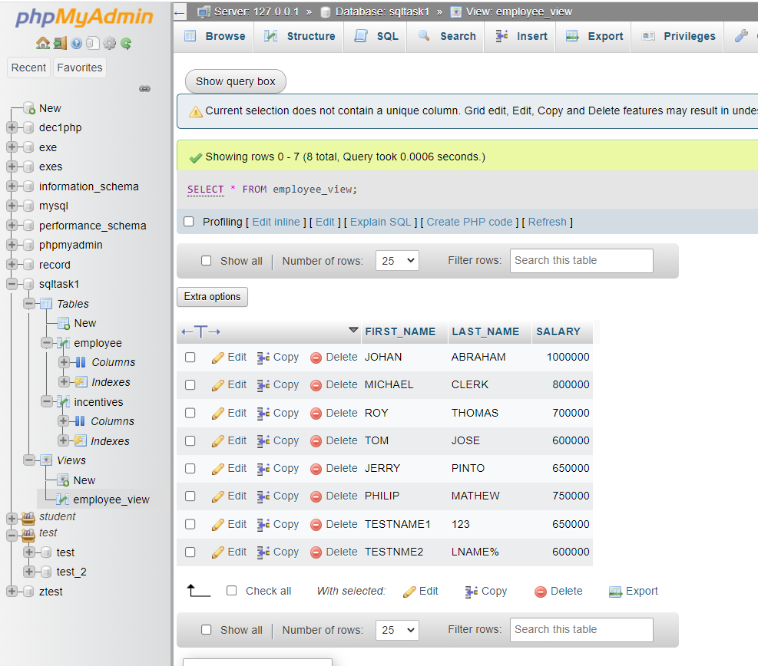

1. Create Procedure to find out department wise highest salary.

Ans: - **CREATE** **PROCEDURE** emp\_maxsalary(**INOUT** SALARY **INT**(10))

**SELECT** e.DEPARTMEN, **MAX**(e.SALARY) **FROM** employee e

**GROUP** **BY** e.DEPARTMEN;

**CALL** emp\_maxsalary(1);

`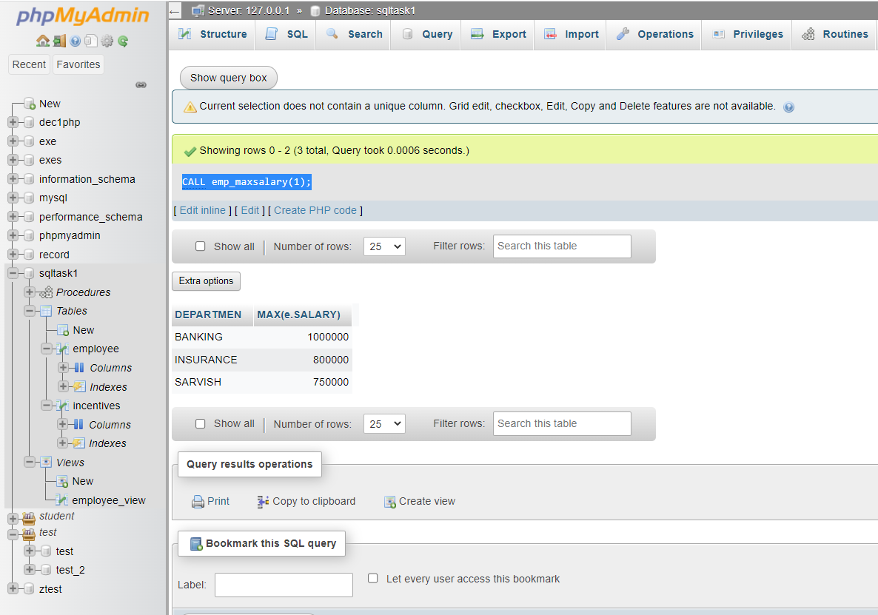

m) Create after Insert trigger on Employee table which insert records in view table.

Ans: - **CREATE** **TRIGGER** insert\_into\_view **AFTER** **INSERT** **ON** employee

**FOR** **EACH** **ROW**

**INSERT** **INTO** employee\_view (FIRST\_NAME,LAST\_NAME,SALARY,)

**VALUES**

(**NEW**.FIRST\_NAME, **NEW**.LAST\_NAME,**NEW**.SALARY);

**INSERT** **INTO** employee(EM\_ID,FIRST\_NAME,LAST\_NAME,SALARY,JOINING\_DATE,DEPARTMEN)

**VALUES**

(9,"yashpal","vala",750000,"2022-01-01","BANKING");

