When Prediction Misleads: Confounding and the Limits of Machine Learning in Observational Data

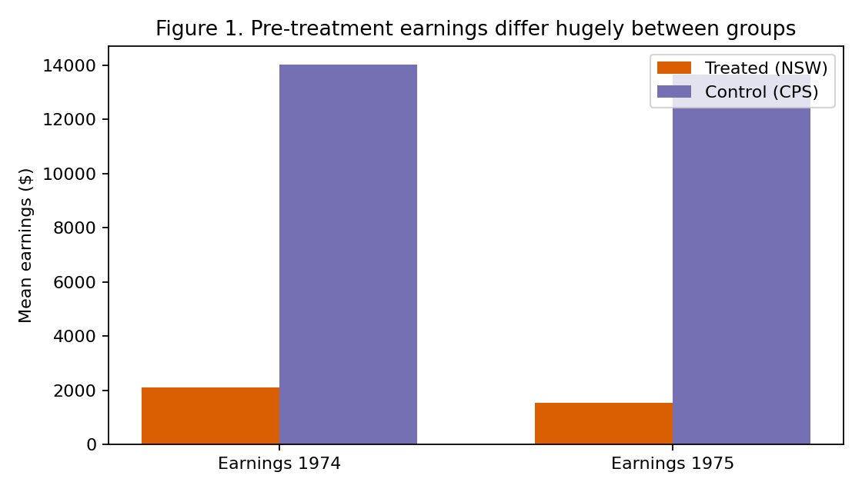
Figure 1. Pre-treatment earnings differ hugely between the treated and comparison groups.
import warnings
import numpy as np
import pandas as pd
import matplotlib.pyplot as plt
from sklearn.ensemble import GradientBoostingRegressor, GradientBoostingClassifier
from sklearn.linear_model import LogisticRegression
from sklearn.model_selection import KFold, train_test_split
from sklearn.metrics import mean_squared_error, r2_score
from causaldata import nsw_mixtape, cps_mixtape

warnings.filterwarnings("ignore")
COV = ["age", "educ", "black", "hisp", "marr", "nodegree", "re74", "re75"]
exp = nsw_mixtape.load_pandas().data.copy() # randomized experiment = truth
cps = cps_mixtape.load_pandas().data.copy() # non-randomized controls
obs = pd.concat([exp[exp.treat == 1], cps], ignore_index=True)

TRUTH = exp.loc[exp.treat == 1, "re78"].mean() - exp.loc[exp.treat == 0, "re78"].mean()
X = obs[COV].values
T = obs["treat"].values.astype(int)
Y = obs["re78"].values
print(f"observational rows: {len(obs):,} | experimental rows: {len(exp):,}")

XT = np.column_stack([X, T])
Xtr, Xte, Ytr, Yte = train_test_split(XT, Y, test_size=0.3, random_state=0)
pred = GradientBoostingRegressor(random_state=0).fit(Xtr, Ytr)
rmse = np.sqrt(mean_squared_error(Yte, pred.predict(Xte)))
r2 = r2_score(Yte, pred.predict(Xte))

# S-learner: predict everyone twice (treated / untreated) and average the gap
full = GradientBoostingRegressor(random_state=0).fit(XT, Y)
naive = (full.predict(np.column_stack([X, np.ones_like(T)])) -
full.predict(np.column_stack([X, np.zeros_like(T)]))).mean()
def manual_dml(X, T, Y, K=5, seed=0):
"""DML: model out Y and T from X, then regress the residuals."""
n = len(Y)
y_res = np.zeros(n)
t_res = np.zeros(n)
kf = KFold(n_splits=K, shuffle=True, random_state=seed)
for tr, te in kf.split(X): # cross-fitting
m_y = GradientBoostingRegressor(random_state=seed).fit(X[tr], Y[tr])
m_t = GradientBoostingClassifier(random_state=seed).fit(X[tr], T[tr])
y_res[te] = Y[te] - m_y.predict(X[te]) # outcome residual
t_res[te] = T[te] - m_t.predict_proba(X[te])[:, 1] # treatment residual
theta = (t_res @ y_res) / (t_res @ t_res) # the causal effect
eps = y_res - theta * t_res
se = np.sqrt((eps**2 @ t_res**2) / (t_res @ t_res)**2)
return theta, theta - 1.96*se, theta + 1.96*se
prop = LogisticRegression(max_iter=2000).fit(X, T).predict_proba(X)[:, 1]
mask = (prop >= prop[T == 1].min()) & (prop <= prop[T == 1].max())
Xt, Tt, Yt = X[mask], T[mask], Y[mask]

ate, lo, hi = manual_dml(Xt, Tt, Yt) # correct: trimmed
ate_raw, _, _ = manual_dml(X, T, Y) # comparison: untrimmed
covers = "Yes" if lo <= TRUTH <= hi else "No"

print("=" * 62)
print(f"(1) PREDICTIVE PRECISION: RMSE {rmse:,.0f} R^2 {r2:.3f}")
print("=" * 62)
print("(2) CAUSAL PRECISION (distance from experimental truth)")
print(f" Experimental truth : {TRUTH:+,.0f}")
print(f" {'Method':<28}{'Estimate':>10}{'Error':>9}{'Covers?':>9}")
print(f" {'Naive predictive':<28}{naive:>+10,.0f}{abs(naive-TRUTH):>9,.0f}{'n/a':>9}")
print(f" {'Double ML (no trimming)':<28}{ate_raw:>+10,.0f}{abs(ate_raw-TRUTH):>9,.0f}{'--':>9}")
print(f" {'Double ML (common support)':<28}{ate:>+10,.0f}{abs(ate-TRUTH):>9,.0f}{covers:>9}")
print(f" Double ML 95% CI : [{lo:,.0f}, {hi:,.0f}]")
print("=" * 62)
print(f"Rows: {len(T):,} total, {mask.sum():,} kept after trimming.")

# Figure 1: the groups differ before treatment (this is the confounding)
plt.figure(figsize=(7, 4))
mt = obs[obs.treat == 1][["re74", "re75"]].mean()
mc = obs[obs.treat == 0][["re74", "re75"]].mean()
xp = np.arange(2); w = 0.35
plt.bar(xp - w/2, mt, w, label="Treated (NSW)", color="#d95f02")
plt.bar(xp + w/2, mc, w, label="Control (CPS)", color="#7570b3")
plt.xticks(xp, ["Earnings 1974", "Earnings 1975"])
plt.ylabel("Mean earnings ($)")
plt.title("Figure 1. Pre-treatment earnings differ between groups")
plt.legend(); plt.tight_layout()
plt.savefig("fig1_imbalance.png", dpi=160); plt.show()

# Figure 2: propensity overlap
plt.figure(figsize=(7, 4))
plt.hist(prop[T == 0], bins=50, alpha=0.6, label="Control (CPS)", color="#7570b3", log=True)
plt.hist(prop[T == 1], bins=50, alpha=0.7, label="Treated (NSW)", color="#d95f02", log=True)
plt.xlabel("Estimated propensity score"); plt.ylabel("Count (log scale)")
plt.title("Figure 2. Most controls are not comparable")
plt.legend(); plt.tight_layout()
plt.savefig("fig2_overlap.png", dpi=160); plt.show()

# Figure 3: estimates vs the truth
plt.figure(figsize=(7.5, 4.5))
methods = ["Naive predictive", "Double ML\n(no trimming)", "Double ML\n(common support)"]
vals = [naive, ate_raw, ate]
colors = ["#c0392b", "#e67e22", "#27ae60"]
bars = plt.bar(methods, vals, color=colors, alpha=0.85)
plt.errorbar([2], [ate], yerr=[[ate - lo], [hi - ate]], fmt="none", ecolor="black", capsize=6)
plt.axhline(TRUTH, ls="--", color="black", lw=1.5, label=f"Experimental truth (+{TRUTH:,.0f})")
plt.axhline(0, color="grey", lw=0.8)
plt.ylabel("Estimated effect on 1978 earnings ($)")
plt.title("Figure 3. The naive model is confidently wrong")
plt.legend()
for b, v in zip(bars, vals):
plt.text(b.get_x() + b.get_width()/2, v + (200 if v > 0 else -500),
f"{v:+,.0f}", ha="center", fontsize=9)
plt.tight_layout()
plt.savefig("fig3_estimates.png", dpi=160); plt.show()

print("Saved: fig1_imbalance.png, fig2_overlap.png, fig3_estimates.png")
5. Results
The predictive model performs respectably as a predictor: on the held-out test set it achieves an RMSE of about $6,983 and an R-squared of 0.474, explaining nearly half of the variance in earnings. Its causal answer, however, is wrong. The S-learner estimate of the programme's effect is −$2,293, missing the true value by $4,087 and carrying the wrong sign: it claims the programme reduced earnings when in fact it raised them. Applying double machine learning to the full, untrimmed data does not fix this; the estimate of −$5,791 is even further from the truth, because most CPS controls are simply not comparable to the treated group. Figure 2 makes this visible: the vast majority of controls have near-zero propensity scores, far from the treated distribution.
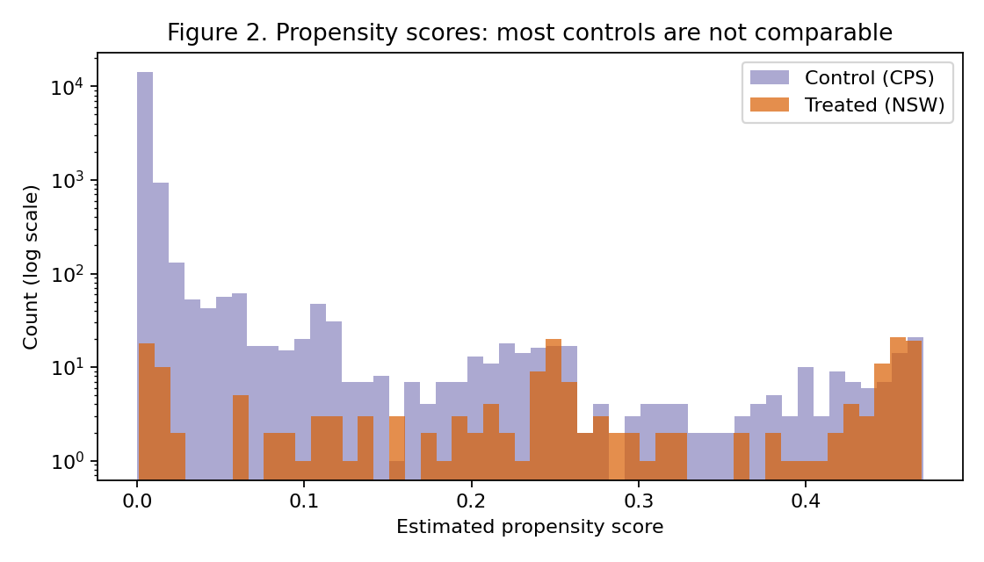
Figure 2. Propensity-score distributions: most CPS controls are not comparable to the treated group.
After trimming to the common-support region (5,860 of 16,177 rows retained), double machine learning recovers an estimate of +$1,970, only $176 from the experimental truth, with a 95% confidence interval of [−$592, +$4,533] that covers the true effect. Figure 3 summarises the comparison.
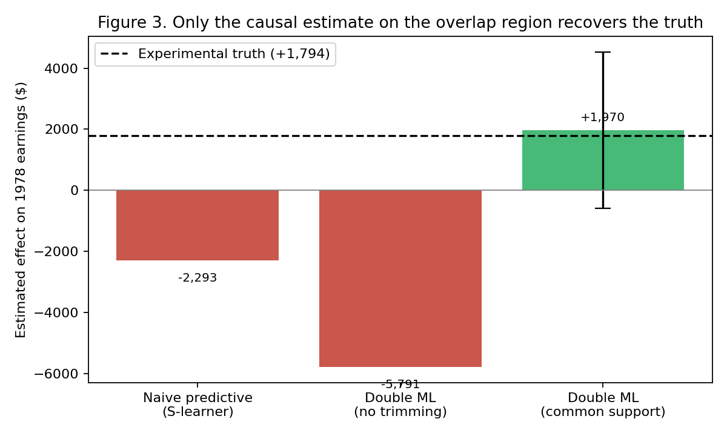
Figure 3. Estimates compared with the experimental truth (+$1,794, dashed line).

