Step 1 : start Selenium standalone server (role=hub) with testhub.json

**Command**: java -jar selenium-server-standalone-3.141.59.jar -role hub -hubConfig e:\testhub.json

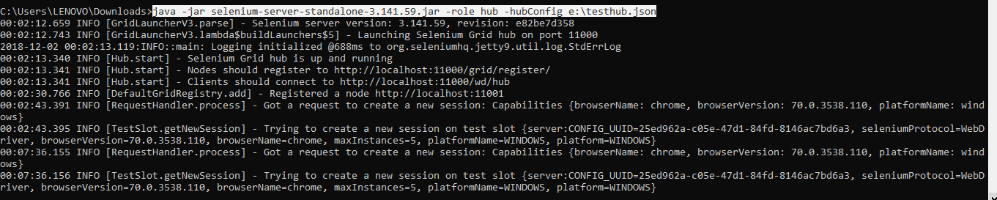

testhub.json

{

"host": "localhost",

"port": 11000,

"newSessionWaitTimeout": -1,

"servlets" : [],

"prioritizer": null,

"nodePolling": 5000,

"cleanUpCycle": 5000,

"browserTimeout": 0,

"jettyMaxThreads":-1

}

Step 2: Start selenium standalone server(role=node) with test.json and chromedriver as specified below:

**Command:** java -Dwebdriver.chrome.driver=E:/Automation/gitHub/bdd-java/resources/chromedriver_2.44.exe -jar selenium-server-standalone-3.141.59.jar -role node -nodeConfig E:\test.json

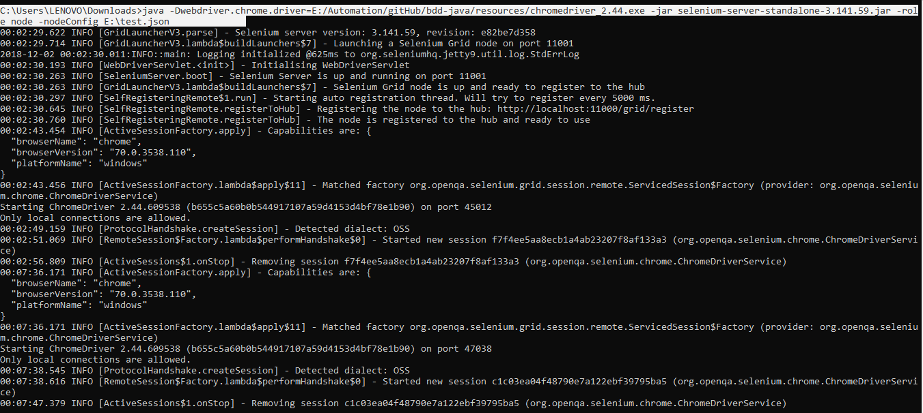

Test.json

{

"capabilities": [

{

"browserName": "firefox",

"maxInstances": 5,

"seleniumProtocol": "WebDriver",

"platform": "WINDOWS"

},

{

"browserName": "chrome",

"browserVersion": "70.0.3538.110"

"maxInstances": 5,

"seleniumProtocol": "WebDriver",

"platform": "WINDOWS"

},

{

"browserName": "internet explorer",

"maxInstances": 5,

"seleniumProtocol": "WebDriver",

"platform": "WINDOWS"

},

{

"browserName": "MicrosoftEdge",

"maxInstances": 5,

"seleniumProtocol": "WebDriver",

"platform": "WINDOWS"

},

{

"browserName": "phantomjs",

"maxInstances": 5,

"seleniumProtocol": "WebDriver",

"platform": "WINDOWS"

},

{

"browserName": "opera",

"maxInstances": 5,

"seleniumProtocol": "WebDriver",

"platform": "WINDOWS"

}

],

"maxSession": 25,

"host": "localhost",

"port": 11001,

"register": true,

"registerCycle": 5000,

"hub": "http://localhost:11000"

}

Step 3 : for firefox start new node

Command: java -Dwebdriver.gecko.driver=E:/Automation/gitHub/bdd-java/resources/geckodriver.exe -jar selenium-server-standalone-3.141.59.jar -role node -nodeConfig E:\Automation\gitHub\bdd-java\resources\testffnode.json

Step 4 : refer \src\main\java\browserHelper\remoteBrowser.java for java code to invoke browser..