# Название кнопок управления геймпада Xbox One

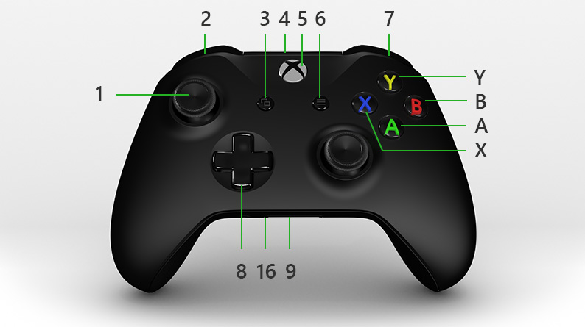

|  |  |  |
| --- | --- | --- |
| 1 Left stick |  | 9 Expansion port |
| 2 Left bumper |  | 10 Right stick |
| 3 View button |  | 16 3.5mm port |
| 4 USB charge port |  | X X button |
| 5 Xbox button |  | Y Y button |
| 6 Menu button |  | A A button |
| 7 Right bumper |  | B B button |
| 8 Directional pad (D-pad) |  |  |

Get to know your Xbox One Wireless Controller

<https://support.xbox.com/en-US/help/hardware-network/controller/xbox-one-wireless-controller>

# Система команд геймпада XBOX One

|  |  |  |
| --- | --- | --- |
| HorizontalVectorX | Left stick вправо | 0/1 |
| HorizontalVectorY | Left stick вниз | 0/1 |
| VericalThrust | Right stick вниз | 0/1 |
| PowerTarget | Power Limit Control | float |
| AngularVelocityZ | Right stick вправо | 0/1 |
| ManipulatorState | Left bumper нажат | 0/1 |
| Right bumper нажат | 0/-1 |
| ManipulatorRotate | Left trigger нажат | 0/1 |
| Right trigger нажат | 0/-1 |
| CameraRotate | **A** нажата | 0/-1 |
| **Y** нажата | 0/1 |
| ResetInitialization | Menu нажата | 0/1 |
| LightsState | **X** нажата | 0/1 |
| StabilizationState | Stab Checkbox | 1..15 |
| RollInc | D-pad вверх | 0/1 |
| D-pad вниз | 0/-1 |
| PitchInc | D-pad вправо | 0/1 |
| D-pad влево | 0/-1 |
| ResetPosition | **B** нажата | 0/1 |

|  |  |
| --- | --- |
| Left bumper | Bumper, left, xbox icon - Download on Iconfinder |
| Right bumper | Bumper, right, xbox icon - Download on Iconfinder |
| Left trigger | Left, trigger, xbox icon - Download on Iconfinder |
| Right trigger | Right, trigger, xbox icon - Download on Iconfinder |

# Структура пакетов

|  |  |  |  |  |
| --- | --- | --- | --- | --- |
| **Телеметрия** | | | | |
| **#** | **Название** | **Тип данных** | **Размер** | **Примечание** |
| 1 | Roll | float | 4 |  |
| 2 | Pitch | float | 4 |  |
| 3 | Yaw | float | 4 |  |
| 4 | Heading | float | 4 |  |
| 5 | Depth | float | 4 |  |
| 6 | RollSetPoint | float | 4 |  |
| 7 | PitchSetPoint | float | 4 |  |
|  |  | ВСЕГО | **28** |  |

|  |  |  |  |  |
| --- | --- | --- | --- | --- |
| **Управление** | | | | |
| **#** | **Название** | **Тип данных** | **Размер** | **Примечание** |
| 1 | HorizontalVectorX | float | 4 |  |
| 2 | HorizontalVectorY | float | 4 |  |
| 3 | VericalThrust | float | 4 |  |
| 4 | PowerTarget | float | 4 |  |
| 5 | AngularVelocityZ | float | 4 |  |
| 6 | ManipulatorState | float | 4 |  |
| 7 | ManipulatorRotate | float | 4 |  |
| 8 | CameraRotate | float | 4 |  |
| 9 | ResetInitialization | int8_t | 1 |  |
| 10 | LightsState | int8_t | 1 |  |
| 11 | StabilizationState | int8_t | 1 |  |
| 12 | RollInc | float | 4 |  |
| 13 | PitchInc | float | 4 |  |
| 14 | ResetPosition | int8_t | 1 |  |
| 15 | RollKp | float | 4 |  |
| 16 | RollKi | float | 4 |  |
| 17 | RollKd | float | 4 |  |
| 18 | PitchKp | float | 4 |  |
| 19 | PitchKi | float | 4 |  |
| 20 | PitchKd | float | 4 |  |
| 21 | YawKp | float | 4 |  |
| 22 | YawKi | float | 4 |  |
| 23 | YawKd | float | 4 |  |
| 24 | DepthKp | float | 4 |  |
| 25 | DepthKi | float | 4 |  |
| 26 | DepthKd | float | 4 |  |
| 27 | UpdatePID | int8_t | 1 |  |
|  |  | ВСЕГО | **93** |  |