# **Supplementary online material**

|  |  |
| --- | --- |
| **Table S1. The composition of 11 world regions** | |
| **World region** | **Countries** |
| Northern Africa and Western Asia | Algeria, **Armenia**, **Azerbaijan**, Bahrain, Cyprus, Egypt, **Georgia**, Iraq, Israel, Jordan, Kuwait, Lebanon, Libyan Arab. Jamahiriya, Morocco, Oman, Qatar, Saudi Arabia, Syrian Arab Republic, Tunisia, Turkey, United Arab Emirates, Yemen |
| Sub-Saharan Africa | Angola, Benin, Botswana, Burkina Faso, Burundi, Cameroon, Cape Verde, Central African Republic, Chad, Comoros, Dem Republic of Congo, Republic of Congo, Côte d'Ivoire, Djibouti, Equatorial Guinea, Gabon, Gambia, Ghana, Guinea, Guinea-Bissau, Kenya, Lesotho, Liberia, Madagascar, Malawi, Mali, Mauritania, Mauritius, Mozambique, Namibia, Niger, Nigeria, Rwanda, Réunion, Senegal, Sierra Leone, Somalia, South Africa, Sudan, Swaziland, United Rep of Tanzania, Togo, Uganda, Zambia, Zimbabwe, Eritrea, Ethiopia, |
| Central Asia and Russian Federation | **Kazakhstan**, **Kyrgyzstan**, **Russian Federation**, **Tajikistan**, **Turkmenistan**, **Uzbekistan** |
| Eastern Asia | China, Japan, Korea, Dem People's Rep, Korea, Republic of, Mongolia |
| Southern Asia | Afghanistan, Bangladesh, Bhutan, India, Iran, Islamic Rep of, Nepal, Pakistan, Sri Lanka, |
| South-Eastern Asia | Brunei Darussalam, Cambodia, Indonesia, Laos, Malaysia, Myanmar, Philippines, Thailand, Timor-Leste, Viet Nam |
| Northern America | Canada, United States of America |
| Latin America | Argentina, Bahamas, Belize, Bolivia, Brazil, Chile, Colombia, Costa Rica, Cuba, Dominican Republic, Ecuador, El Salvador, French Guiana, Guadeloupe, Guatemala, Guyana, Haiti, Honduras, Jamaica, Martinique, Mexico, Nicaragua, Panama, Paraguay, Peru, Puerto Rico, Suriname, Trinidad and Tobago, Uruguay, Bolivarian Republic of Venezuela |
| Western Europe | Austria, Belgium-Luxembourg, Denmark, Finland, France, Germany, Greece, Iceland, Ireland, Italy, Malta, Netherlands, Norway, Portugal, Spain, Sweden, Switzerland, United Kingdom |
| Eastern and South-Eastern Europe | Albania, **Belarus**, Bosnia and Herzegovina, Bulgaria, Croatia, Czech Republic, **Estonia**, Hungary, **Latvia**, **Lithuania,** Poland, **Republic of Moldova**, Romania, Serbia and Montenegro, , Slovakia, Slovenia, The Former Yugoslav Republic of Macedonia, **Ukraine** |
| Oceania and Australia | Australia, Fiji Islands, French Polynesia, New Caledonia, New Zealand, Papua New Guinea, Samoa, Solomon Islands, Vanuatu |

**Source:** Based onKrausmann et al., 2008, Haberl et al., 2007, and UNSD, 2006 (highlighted countries are USSR (Union of Soviet Socialist Republics) member countries which were grouped under the Central Asia and Russian Federation region in 1990; blue are countries with no data in 1990)

|  |  |  |  |
| --- | --- | --- | --- |
| **Table S2. Region-specific wood density in Ovendry biomass per cubic metre green volume [t dm / m³]** | | | |
| Forest type | Region | C | NC |
| tropical | Africa | 0.43 | 0.58 |
|  | America | 0.43 | 0.60 |
|  | Asia | 0.43 | 0.57 |
|  | Oceania | 0.43 | 0.57 |
| temperate | Africa | 0.41 | 0.58 |
|  | America | 0.41 | 0.58 |
|  | Asia | 0.41 | 0.58 |
|  | Europe | 0.41 | 0.58 |
|  | Oceania | 0.41 | 0.58 |
| boreal | America | 0.44 | 0.45 |
|  | Asia | 0.44 | 0.45 |
|  | Europe | 0.44 | 0.45 |

Source: Penman et al., 2003, Brown and Lugo, 1984, Brown, 1997

**Industrial residues**

**Roundwood**

**Figure S1. The global wood biomass flows model emphasizing wood biomass uses made from roundwood (green dotted lines) and industrial residues (red dotted lines). The box color indicates the following: light blue is data derived from LPJ dynamic global vegetation model (Haberl et al. 2007); dark blue are data taken from ForesSTAT (FAO, 2014); orange are calculated data using region-specific factor, recovery rate (RR) or shoot-root ratio (SRR) (see text); green are estimated woodfuels data based on extensive literature survey; and yellow are data taken from UN database (i.e. wood for CHP) and wood pellets reports. The asterisk (*) indicates the data were converted to roundwood equivalent volume using conversion factors (see Table S3) in order to estimate volume of raw materials required. Abbreviations: NPP means Net primary production and CHP means combined heat and power**



|  |  |  |  |  |  |  |  |  |  |
| --- | --- | --- | --- | --- | --- | --- | --- | --- | --- |
| **Table S3. Region-specific parameters for the conversion of wood products quantities to roundwood equivalent volume (MP-; CP – chemical pulp; SCP-semi-chemical pulp; DP – dissolving pulp)** | | | | | | | | | |
| **World regions** | **Sawnwood**  **C**  **(m3)** | **Sawnwood NC**  **(m3)** | **Plywood**  **(m3)** | **Veneer (m3)** | **Fiberboard (m3)** | **Particle board (m3)** | **Paper and paperboard (t)** | **Wood pulp (t)** | **Type of woodpulp** |
| Northern Africa and Western Asia | 2.30 | 2.00 | 2.40 | 2.00 | 1.80 | 1.45 | 3.60 | 3.00  4.00  3.30  4.40 |  |
| Sub-Saharan Africa | 2.30 | 2.00 | 2.40 | 2.00 | 1.80 | 1.45 | 3.60 |  |
| Central Asia and Russian Federation | 1.80 | 1.60 | 2.30 | 2.00 | 1.80 | 1.45 | 3.60 | mechanical pulp |
| Eastern Asia | 1.80 | 1.70 | 2.30 | 1.90 | 1.80 | 1.45 | 3.60 | chemical pulp |
| Southern Asia | 2.00 | 1.80 | 2.30 | 1.90 | 1.80 | 1.45 | 3.60 | semi-chemical pulp |
| South-Eastern Asia | 2.00 | 1.80 | 2.30 | 1.90 | 1.80 | 1.45 | 3.60 | dissolving pulp |
| Latin America and the Caribbean | 2.30 | 2.00 | 2.50 | 1.80 | 1.80 | 1.45 | 3.60 |  |
| Oceania and Australia | 2.00 | 1.80 | 2.30 | 1.90 | 1.80 | 1.45 | 3.60 |  |
| Northern America | 1.90 | 1.70 | 2.30 | 1.80 | 1.80 | 1.40 | 3.60 | 2.45  3.35  2.70  3.70 | mechanical pulp  chemical pulp  semi-chemical pulp  dissolving pulp |
| Western Europe | 1.80 | 1.70 | 2.30 | 1.80 | 1.80 | 1.40 | 3.60 | 2.50  4.50  2.90  4.90 | mechanical pulp  chemical pulp |
| Eastern and South-Eastern Europe | 1.80 | 1.70 | 2.30 | 1.80 | 1.80 | 1.40 | 3.60 | semi-chemical pulp  dissolving pulp |

Sources: Olufemi et al., 2012; Mantau, 2012; Owusu et al., 2011; UNECE/FAO, 2010; Meyfroidt and Lambin, 2009; Meil et al, 2007; Enters, 2001; Zerbe et al., 2000; Koopmans and Koppejan, 1997; Alviar, 1993; Dykstra, 1992, see text.

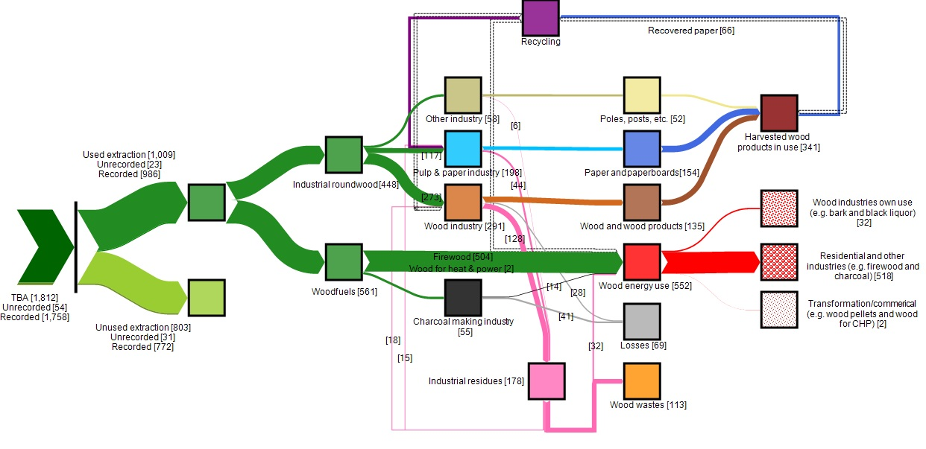

Figure S2. Global wood carbon flows from Total biomass appropriation (TBA), along the different stages of economic processing to final consumption in Megaton Carbon per year [Mt C/yr] in 1990 (the width of the line is proportional to the flow). Dotted lines indicate unquantified flows of wood biomass (i.e. post-consumer wood). Unrecorded under used extraction (UE) means unrecorded industrial wood removals and recorded means recorded wood removals (i.e. industrial wood and woodfuels). NPPact amounts to 42, 965 MtC/yr.

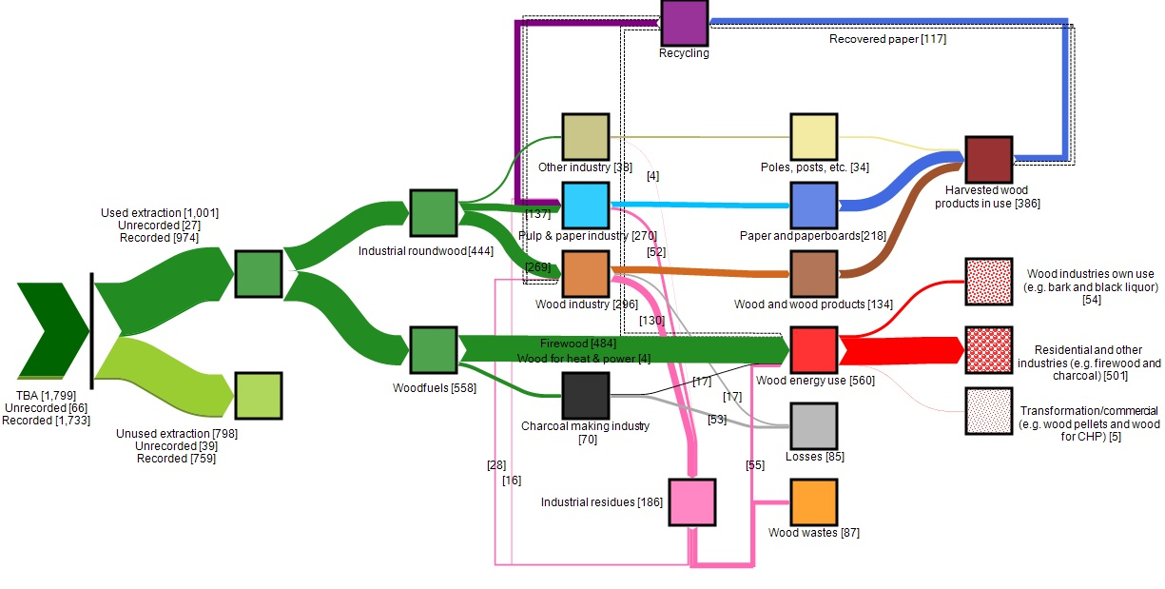

Figure S3. Global wood carbon flows from Total biomass appropriation (TBA), along the different stages of economic processing to final consumption in Megaton Carbon per year [Mt C/yr] in 2000 (the width of the line is proportional to the flow). Dotted lines indicate unquantified flows of wood biomass (i.e. post-consumer wood). Unrecorded under used extraction (UE) means unrecorded industrial wood removals and recorded means recorded wood removals (i.e. industrial wood and woodfuels). NPPact amounts to 43,628 MtC/yr.

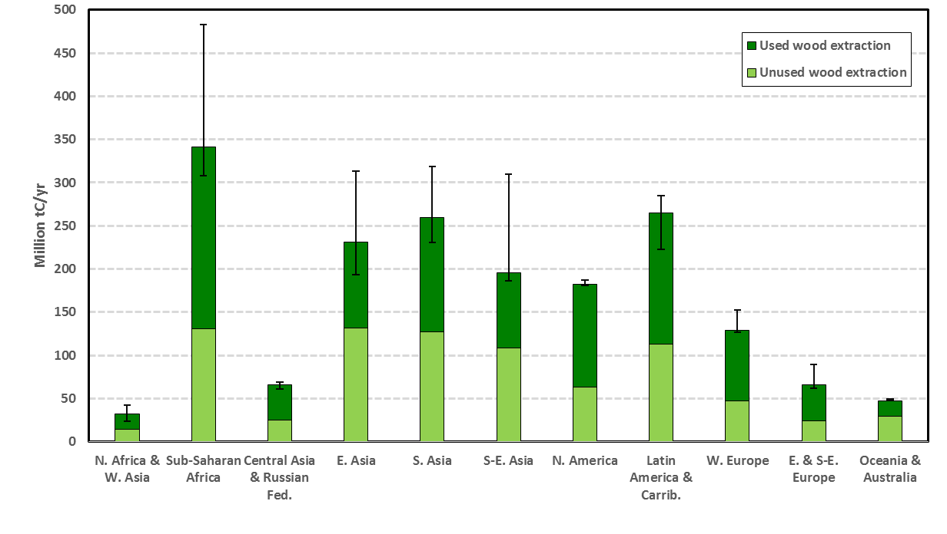**Figure S4. Total biomass appropriation (used and unused wood extraction) including uncertainties in 11 world regions in the year 2010.**

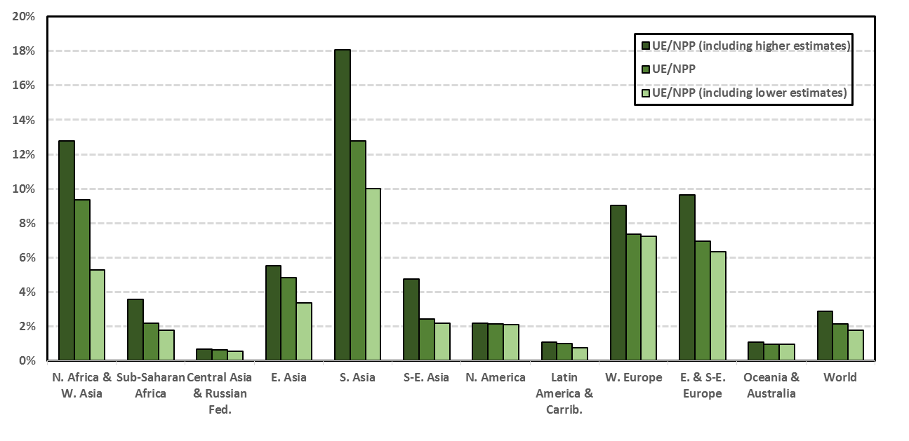

**Figure S5. Used extraction in relation to current NPP with and without woodfuel removals uncertainties (low and high estimates, see text) in 2010**

|  |  |  |  |  |  |  |  |  |  |  |  |  |  |  |
| --- | --- | --- | --- | --- | --- | --- | --- | --- | --- | --- | --- | --- | --- | --- |
| **Table S4. Net primary production (NPP), total biomass appropriation (TBA), Used extraction (UE), apparent consumption and net trade in 1990 (kgC/cap/yr)** | | | | | | | | | | | | | |  |
|  | | N.Africa/ W. Asia | | Sub-Saharan Africa | C. Asia/ Russian Fed. | Eastern Asia | Southern Asia | S.-E. Asia | Northern America | Latin America | Western Europe | E. & S.E. Europe | Oceania & Australia | World |
| Population (1000 capita) | | 249,107 | | 510,028 | 288,666 | 1,379,414 | 1,191,648 | 443,735 | 282,171 | 441,116 | 377,214 | 84,175 | 26,536 | 5,273,810 |
| Land area (1000 km2) | | | 10,348 | 22,542 | 21,923 | 11,560 | 6,408 | 4,356 | 18,253 | 20,144 | 3,633 | 763 | 8,483 | 128,414 |
| Population density (cap/km2) | 24 | | | 23 | 13 | 119 | 186 | 102 | 15 | 22 | 104 | 110 | 3 | 41 |
| GDP per capita (US$/cap) | 2,440 | | | 594 | 3,307 | 2,717 | 441 | 761 | 23,289 | 2,576 | 19,121 | 25 | 13,848 | 4,127 |
|  |  | | |  |  |  |  |  |  |  |  |  |  |  |
| Net Primary Production (forest) | | **604.50** | | **19,610.93** | **26,639.63** | **1,454.45** | **835.51** | **9,806.26** | **18,777.29** | **38,478.19** | **2,804.77** | **2,421.70** | **72,090.67** | **9,600.61** |
| Total biomass appropriated | | **109.02** | | **483.00** | **564.60** | **190.27** | **209.95** | **533.73** | **923.07** | **423.18** | **340.41** | **240.95** | **1160.40** | **343.70** |
|  | |  | |  |  |  |  |  |  |  |  |  |  |  |
| ***Used extraction*** | | **61.60** | | **295.34** | **352.88** | **86.56** | **105.32** | **246.26** | **605.29** | **250.73** | **216.14** | **152.98** | **438.03** | **191.41** |
| Industrial roundwood | | 12.99 | | 32.08 | 242.68 | 24.87 | 10.80 | 65.64 | 456.34 | 72.91 | 149.71 | 102.74 | 291.78 | 75.80 |
| Bark (industrial roundwood) | | 1.78 | | 3.22 | 36.05 | 2.46 | 1.43 | 8.41 | 50.59 | 8.36 | 19.92 | 15.01 | 36.19 | 9.30 |
| Woodfuel+bark | | 46.84 | | 260.04 | 74.15 | 59.23 | 93.10 | 172.21 | 98.36 | 169.46 | 46.50 | 35.23 | 110.07 | 106.32 |
|  | |  | |  |  |  |  |  |  |  |  |  |  |  |
| ***Apparent consumption*** | | **69.56** | | **291.14** | **336.13** | **103.62** | **106.03** | **224.53** | **545.72** | **244.94** | **250.54** | **152.56** | **351.44** | **191.60** |
| *Harvested wood products* | |  | |  |  |  |  |  |  |  |  |  |  |  |
| Semi-finished wood products | | 11.16 | | 4.33 | 81.14 | 15.07 | 4.90 | 12.18 | 125.20 | 17.26 | 74.03 | 36.87 | 72.85 | 25.85 |
| Wood pulp | | 2.05 | | 2.34 | 21.80 | 9.67 | 1.06 | 2.51 | 113.57 | 8.49 | 70.89 | 16.20 | 47.01 | 16.85 |
| Poles, piles, etc. | | 2.45 | | 13.65 | 62.70 | 7.47 | 1.60 | 8.15 | 13.36 | 5.46 | 5.76 | 17.76 | 10.43 | 9.79 |
| *Wood energy* | |  | |  |  |  |  |  |  |  |  |  |  |  |
| Firewood/fuelwood | | 33.89 | | 209.83 | 74.15 | 56.40 | 89.95 | 165.74 | 95.22 | 138.74 | 43.77 | 31.15 | 73.91 | 95.67 |
| Wood charcoal | | 3.39 | | 12.32 | 0.00 | 0.77 | 0.77 | 1.51 | 0.88 | 7.37 | 0.54 | 0.85 | 0.52 | 2.57 |
| Black liquor | | 0.33 | | 1.04 | 6.79 | 2.29 | 0.27 | 0.60 | 60.95 | 4.10 | 15.16 | 3.89 | 11.81 | 6.01 |
| Wood pellets | | 0.00 | | 0.00 | 0.00 | 0.00 | 0.00 | 0.00 | 0.30 | 0.00 | 0.26 | 0.00 | 0.00 | 0.03 |
| Wood for heat & power | | 0.00 | | 0.00 | 0.00 | 0.43 | 0.02 | 0.00 | 0.15 | 0.35 | 0.25 | 0.25 | 35.21 | 0.35 |
| *Losses and waste* | |  | |  |  |  |  |  |  |  |  |  |  |  |
| Losses | | 10.48 | | 40.01 | 10.49 | 3.58 | 3.00 | 10.27 | 24.42 | 40.83 | 9.55 | 10.81 | 21.69 | 13.10 |
| Unutilized industrial residues | | 5.81 | | 7.62 | 79.06 | 7.94 | 4.46 | 23.57 | 111.68 | 22.35 | 30.35 | 34.77 | 77.99 | 21.37 |
|  | |  | |  |  |  |  |  |  |  |  |  |  |  |
| ***Net trade (total)*** | | **7.96** | | **-4.19** | **-16.75** | **17.06** | **0.71** | **-21.73** | **-59.57** | **-5.79** | **34.41** | **-0.42** | **-86.59** | **0.20** |
| Roundwood | | 1.67 | | -2.52 | -9.93 | 8.40 | 0.37 | -12.76 | -17.30 | -1.71 | 8.35 | -3.74 | -30.31 | -0.19 |
| Wood pulp | | 0.91 | | -0.67 | -1.27 | 3.11 | 0.28 | 0.95 | -26.04 | -2.09 | 12.28 | 4.00 | -8.43 | 0.20 |
| Wood products | | 5.32 | | -0.77 | -4.96 | 3.00 | 0.07 | -9.31 | -9.67 | -0.45 | 12.86 | -0.35 | 7.72 | 0.32 |
| Wood pellets | | 0.00 | | 0.00 | 0.00 | 0.00 | 0.00 | 0.00 | 0.01 | 0.00 | 0.00 | 0.00 | 0.00 | 0.00 |
| Wood charcoal | | 0.05 | | -0.01 | 0.00 | 0.03 | 0.00 | -0.07 | 0.04 | -0.04 | 0.27 | -0.05 | 0.28 | 0.02 |
| Wood residues | | 0.00 | | 0.00 | -0.22 | 0.00 | 0.00 | 0.00 | -0.02 | 0.01 | 0.24 | -0.10 | 0.00 | 0.00 |
| Wood chips and particles | | 0.00 | | -0.23 | -0.37 | 2.53 | 0.00 | -0.55 | -6.59 | -1.51 | 0.40 | -0.19 | -55.85 | -0.16 |

|  |  |  |  |  |  |  |  |  |  |  |  |  |  |  |
| --- | --- | --- | --- | --- | --- | --- | --- | --- | --- | --- | --- | --- | --- | --- |
| **Table S5. Net primary production (NPP), total biomass appropriation (TBA), Used extraction (UE), apparent consumption and net trade in 2000 (kgC/cap/yr)** | | | | | | | | | | | | | |  |
|  | N.Africa/ W. Asia | | | Sub-Saharan Africa | C. Asia/ Russian Fed. | Eastern Asia | Southern Asia | S.-E. Asia | Northern America | Latin America | Western Europe | E. & S.E. Europe | Oceania & Australia | World |
| Population (1000 capita) | 321,593 | | | 666,549 | 201,810 | 1,506,560 | 1,447,850 | 524,411 | 315,297 | 521,846 | 390,585 | 191,521 | 30,833 | 6,118,855 |
| Land area (1000 km2) | | 10,540 | | 23,643 | 20,308 | 11,560 | 6,402 | 4,342 | 18,256 | 20,116 | 3,633 | 2,126 | 8,484 | 129,409 |
| Population density (cap/km2) | | | 31 | 28 | 10 | 130 | 226 | 121 | 17 | 26 | 108 | 90 | 4 | 47 |
| GDP per capita (US$/cap) | | | 3,389 | 535 | 1,471 | 4,309 | 499 | 1,151 | 34,980 | 4,334 | 21,209 | 2,543 | 15,567 | 5,247 |
|  | | |  |  |  |  |  |  |  |  |  |  |  |  |
| Net Primary Production (forest) | **533.30** | | | **14,900.59** | **25,675.89** | **1,444.46** | **676.92** | **7,800.99** | **11,129.61** | **26,578.18** | **2,985.21** | **3,180.46** | **62,640.62** | **7,128.40** |
| Total biomass appropriated | **95.64** | | | **451.55** | **319.74** | **148.68** | **164.95** | **425.97** | **810.34** | **445.43** | **336.34** | **278.70** | **1,421.84** | **294.01** |
|  |  | | |  |  |  |  |  |  |  |  |  |  |  |
| ***Used extraction*** | **53.02** | | | **276.23** | **199.84** | **66.72** | **84.66** | **192.32** | **531.37** | **257.90** | **213.55** | **176.95** | **535.39** | **163.66** |
| Industrial roundwood | 13.32 | | | 29.76 | 117.29 | 21.05 | 5.09 | 59.88 | 437.95 | 87.60 | 151.00 | 124.06 | 359.23 | 64.70 |
| Bark (industrial roundwood) | 1.67 | | | 3.00 | 18.64 | 2.13 | 0.69 | 7.67 | 48.06 | 9.98 | 20.43 | 16.87 | 45.29 | 7.76 |
| Woodfuel+bark | 38.03 | | | 243.47 | 63.91 | 43.54 | 78.89 | 124.77 | 45.36 | 160.32 | 42.13 | 36.03 | 130.88 | 91.20 |
|  |  | | |  |  |  |  |  |  |  |  |  |  |  |
| ***Apparent consumption*** | **64.12** | | | **270.03** | **143.48** | **85.85** | **85.48** | **179.23** | **490.64** | **245.90** | **261.77** | **142.01** | **353.60** | **163.43** |
| *Harvested wood products* |  | | |  |  |  |  |  |  |  |  |  |  |  |
| Semi-finished wood products | 13.60 | | | 3.27 | 18.69 | 12.85 | 2.17 | 11.08 | 144.71 | 21.47 | 81.03 | 30.14 | 76.84 | 22.11 |
| Wood pulp | 2.89 | | | 1.62 | 11.29 | 11.81 | 1.06 | 7.96 | 104.06 | 8.81 | 79.12 | 14.08 | 41.85 | 16.36 |
| Poles, piles, etc. | 0.61 | | | 10.88 | 16.55 | 6.60 | 0.56 | 6.20 | 10.12 | 4.93 | 2.86 | 8.83 | 29.42 | 5.60 |
| *Wood energy* |  | | |  |  |  |  |  |  |  |  |  |  |  |
| Firewood/fuelwood | 25.36 | | | 191.05 | 55.43 | 41.17 | 76.02 | 116.35 | 39.99 | 127.72 | 40.50 | 32.01 | 104.30 | 79.13 |
| Wood charcoal | 3.43 | | | 12.77 | 0.14 | 0.70 | 0.70 | 1.81 | 1.39 | 7.80 | 0.55 | 0.09 | 0.67 | 2.85 |
| Bark | 0.00 | | | 0.29 | 6.62 | 0.37 | 0.00 | 0.00 | 23.84 | 0.00 | 11.74 | 7.37 | 18.24 | 2.64 |
| Black liquor | 0.40 | | | 1.07 | 6.08 | 2.36 | 0.29 | 3.41 | 58.29 | 6.33 | 17.35 | 3.95 | 10.89 | 6.11 |
| Wood pellets | 0.00 | | | 0.00 | 0.00 | 0.00 | 0.00 | 0.00 | 0.34 | 0.00 | 1.07 | 0.00 | 0.00 | 0.09 |
| Wood for heat & power | 0.16 | | | 0.00 | 6.47 | 0.44 | 0.02 | 0.25 | 1.37 | 0.35 | 1.57 | 1.32 | 23.79 | 0.72 |
| *Losses and waste* |  | | |  |  |  |  |  |  |  |  |  |  |  |
| Losses | 10.50 | | | 43.35 | 3.67 | 3.35 | 2.62 | 11.00 | 28.59 | 38.92 | 9.92 | 16.68 | 15.16 | 13.80 |
| Unutilized industrial residues | 7.18 | | | 5.72 | 18.55 | 6.20 | 2.03 | 21.18 | 77.95 | 29.55 | 16.07 | 27.54 | 32.42 | 14.02 |
|  |  | | |  |  |  |  |  |  |  |  |  |  |  |
| ***Net trade (total)*** | **11.10** | | | **-6.20** | **-56.35** | **19.13** | **0.82** | **-13.09** | **-40.73** | **-12.01** | **48.22** | **-34.94** | **-181.79** | **-0.23** |
| Roundwood | 2.16 | | | -2.76 | -40.06 | 6.50 | 0.52 | -4.82 | -4.73 | -1.45 | 25.05 | -21.05 | -77.99 | -0.02 |
| Wood pulp | 1.77 | | | -1.15 | -6.77 | 5.28 | 0.21 | -0.12 | -29.32 | -6.88 | 14.36 | 2.41 | -9.02 | -0.07 |
| Wood products | 7.03 | | | -0.70 | -8.80 | 4.26 | 0.08 | -6.97 | -1.37 | -1.73 | 6.59 | -13.49 | -8.40 | 0.21 |
| Wood pellets | 0.00 | | | 0.00 | 0.00 | 0.00 | 0.00 | 0.00 | -0.26 | 0.00 | 0.22 | 0.00 | 0.00 | 0.00 |
| Wood charcoal | 0.10 | | | -0.12 | -0.00 | 0.06 | 0.00 | -0.18 | 0.01 | -0.08 | 0.41 | -0.23 | -0.01 | 0.01 |
| Wood residues | 0.01 | | | 0.00 | -0.05 | 0.02 | -0.00 | -0.00 | 0.10 | -0.08 | 0.44 | -1.35 | -0.03 | -0.01 |
| Wood chips and particles | 0.03 | | | -1.48 | -0.66 | 3.01 | -0.00 | -1.00 | -5.17 | -1.78 | 1.15 | -1.23 | -86.34 | -0.35 |

|  |  |
| --- | --- |
| **Table S6. The composition of 4 country groups in 2010** | |
| **Country groups** | **Countries** |
| Industrialized countries (LC) | Australia, Canada, Finland, Iceland, New Zealand, Norway, South Africa, Sweden, United States of America,  Austria, Belgium-Luxembourg, Denmark, France, Germany, Greece, Ireland, Israel, Italy, Japan, Malta, Netherlands, Portugal, Spain, Switzerland, United Kingdom |
| Transition market (TM) | Belarus, Estonia, Kazakhstan, Kyrgyzstan, Latvia, Lithuania, Russian Federation, Turkmenistan,  Albania, Armenia, Azerbaijan, Bosnia and Herzegovina, Bulgaria, Croatia, Czech Republic, Georgia, Hungary, Moldova, Republic of, Poland, Romania, Serbia and Montenegro, Slovakia, Slovenia, Tajikistan, The former Yugoslav Republic of Macedonia, Ukraine, Uzbekistan |
| Developing countries (DC) | Algeria, Argentina, Bahamas, Belize, Bolivia, Botswana, Brazil, Cameroon, Chile, Colombia, Congo, Fiji, French Guiana, Gabon, Guyana, Iran, Islamic Republic of, Libyan Arab Jamahiriya, Mongolia, Namibia, New Caledonia, Nicaragua, Oman, Panama, Papua New Guinea, Paraguay, Peru, Saint Pierre and Miquelon, Saudi Arabia, Suriname, Uruguay, Venezuela, Bolivarian Republic of, Zimbabwe,  Bahrain, Barbados, British Virgin Islands, Brunei Darussalam, China, Cook Islands, Costa Rica, Cuba, Cyprus, Dominica, Dominican Republic, Ecuador, Egypt, El Salvador, French Polynesia, Ghana, Guadeloupe, Guatemala, Honduras, India, Indonesia, Iraq, Jamaica, Jordan, Kenya, Korea, Democratic People's Republic of, Korea, Republic of, Kuwait, Lebanon, Malaysia, Martinique, Mauritius, Mexico, Micronesia, Federated States of, Morocco, Nigeria, Pakistan, Philippines, Qatar, Réunion, Saint Kitts and Nevis, Saint Lucia, Saint Vincent and Grenadines, Seychelles, Singapore, Sri Lanka, Swaziland, Syrian Arab Republic, Thailand, Timor-Leste, Tonga, Trinidad and Tobago, Tunisia, Turkey, United Arab Emirates, Viet Nam, |
| Least developed countries (LD) | Afghanistan, Angola, Bhutan, Central African Republic, Chad, Congo, Democratic Republic of, Djibouti  Equatorial Guinea, Guinea, Lao People's Democratic Republic, Liberia, Madagascar, Mali, Mauritania, Mozambique  Niger, Solomon Islands, Somalia, Sudan (former), Tanzania, United Republic of, Vanuatu, Yemen, Zambia,  Bangladesh, Benin, Burkina Faso, Burundi, Cambodia, Cape Verde, Comoros, Côte d'Ivoire, Eritrea, Ethiopia, Gambia  Guinea-Bissau, Haiti, Kiribati, Lesotho, Malawi, Maldives, Myanmar, Nepal, Rwanda, Samoa, Sao Tome and Principe, Senegal, Sierra Leone, Togo, Uganda |

|  |  |  |  |  |  |  |  |
| --- | --- | --- | --- | --- | --- | --- | --- |
| **Table S7. Estimated maximum and minimum woodfuel removals by country in 2010 (tC/yr)** | | | | | | | |
| **Country** | **Woodfuel MAX** | **Woodfuel MIN** | **Woodfuel FAO** | **Country** | **Woodfuel MAX** | **Woodfuel MIN** | **Woodfuel FAO** |
| Albania | 378,607 | 25,915 | 169,554 | Central African Rep | 636,400 | 622,081 | 636,400 |
| Algeria | 2,202,245 | 2,124,374 | 2,124,374 | Chad | 2,366,869 | 1,356,404 | 2,248,935 |
| Angola | 6,793,516 | 1,112,300 | 1,276,887 | Chile | 6,844,738 | 3,693,387 | 4,401,510 |
| Argentina | 1,420,402 | 1,396,286 | 1,396,286 | China | 67,889,543 | 14,987,251 | 52,299,769 |
| Armenia | 2,021,317 | 12,742 | 565,320 | Colombia | 2,932,489 | 2,518,563 | 2,659,180 |
| Australia | 3,127,616 | 1,564,559 | 1,564,559 | Comoros | 91,721 | 53,283 | 84,578 |
| Austria | 2,006,930 | 1,218,483 | 1,497,253 | Congo | 732,748 | 356,209 | 425,126 |
| Azerbaijan | 119,138 | 1,019 | 1,019 | Congo, Dem. Rep. | 31,844,274 | 17,692,780 | 24,372,393 |
| Bahamas | 11,034 | 10,890 | 10,890 | Costa Rica | 1,114,288 | 131,251 | 1,113,958 |
| Bahrain | 2,266 | 2,180 | 2,180 | Côte d'Ivoire | 10,516,299 | 2,705,388 | 2,844,779 |
| Bangladesh | 8,770,723 | 8,761,446 | 8,761,446 | Croatia | 488,373 | 244,028 | 279,005 |
| Barbados | 1,645 | 1,645 | 1,645 | Cuba | 445,383 | 376,487 | 442,700 |
| Belarus | 1,264,714 | 580,173 | 580,173 | Cyprus | 4,814 | 819 | 968 |
| Belgium-Luxembourg | 257,084 | 257,084 | 257,084 | Czech Republic | 1,357,941 | 314,107 | 468,049 |
| Belize | 75,752 | 41,601 | 41,601 | Denmark | 645,220 | 240,647 | 282,252 |
| Benin | 2,984,253 | 1,159,460 | 1,996,256 | Djibouti | 119,411 | 113,180 | 113,180 |
| Bhutan | 1,313,607 | 1,265,742 | 1,265,742 | Dominica | 2,480 | 2,480 | 2,480 |
| Bolivia | 795,064 | 10,658 | 775,066 | Dominican Republic | 309,543 | 205,300 | 301,000 |
| Bosnia & Herzegovina | 256,910 | 66,637 | 256,910 | Ecuador | 1,803,745 | 1,326,031 | 1,532,832 |
| Brazil | 46,956,146 | 26,788,908 | 45,914,980 | Egypt | 5,667,843 | 32,661 | 5,570,930 |
| British Virgin Islands | 483 | 454 | 454 | El Salvador | 1,394,599 | 770,020 | 1,391,627 |
| Brunei Darussalam | 3,815 | 3,809 | 3,809 | Equatorial Guinea | 142,235 | 139,022 | 142,235 |
| Bulgaria | 1,021,001 | 454,150 | 759,128 | Eritrea | 715,541 | 398,943 | 402,205 |
| Burkina Faso | 4,449,814 | 1,983,358 | 4,067,422 | Estonia | 621,936 | 299,298 | 389,126 |
| Burundi | 3,132,994 | 2,368,873 | 2,945,179 | Ethiopia | 33,043,419 | 23,726,769 | 31,694,127 |
| Cambodia | 5,321,721 | 2,713,667 | 2,713,667 | Fiji | 50,768 | 11,628 | 11,628 |
| Cameroon | 6,096,630 | 3,151,945 | 3,151,945 | Finland | 3,131,510 | 1,303,015 | 1,323,693 |
| Canada | 2,858,573 | 520,620 | 654,365 | France | 12,949,556 | 7,514,601 | 7,931,766 |
| Cape Verde | 65,673 | 61,423 | 61,423 | French Guiana | 48,356 | 42,083 | 42,083 |

Source: UN, 2014; FAO, 2011; EPE, 2010; IBGE, 2010; FAO, 1999a, 1999b; RWEDP/FAO, 1997, 1996

|  |  |  |  |  |  |  |  |
| --- | --- | --- | --- | --- | --- | --- | --- |
| **Table S7. Continuation…** | | | | | | | |
| **Country** | **Woodfuel MAX** | **Woodfuel MIN** | **Woodfuel FAO** | **Country** | **Woodfuel MAX** | **Woodfuel MIN** | **Woodfuel FAO** |
| French Polynesia | 1,453 | 1,418 | 1,418 | Lao PDR | 1,911,759 | 1,864,606 | 1,910,139 |
| Gabon | 1,553,240 | 241,468 | 340,473 | Latvia | 754,011 | 105,561 | 105,561 |
| Gambia | 244,379 | 201,231 | 220,843 | Lebanon | 27,315 | 5,086 | 6,159 |
| Georgia | 496,015 | 170,651 | 220,963 | Lesotho | 668,972 | 634,835 | 661,443 |
| Germany | 3,775,546 | 2,450,603 | 2,609,265 | Liberia | 2,491,400 | 1,806,199 | 2,228,778 |
| Ghana | 13,278,870 | 6,429,222 | 12,018,978 | Libyan Arab J. | 315,539 | 210,226 | 303,090 |
| Greece | 770,161 | 321,062 | 349,448 | Lithuania | 601,791 | 293,677 | 433,998 |
| Guadeloupe | 7,130 | 5,068 | 5,068 | Madagascar | 6,243,915 | 3,465,262 | 4,168,420 |
| Guatemala | 6,696,906 | 125,895 | 5,016,114 | Malawi | 4,812,620 | 1,600,081 | 1,719,427 |
| Guinea | 3,857,621 | 3,069,052 | 3,804,670 | Malaysia | 970,247 | 855,636 | 901,496 |
| Guinea-Bissau | 865,081 | 827,170 | 827,170 | Maldives | 5,265 | 5,062 | 5,062 |
| Guyana | 279,849 | 5,876 | 279,849 | Mali | 1,742,935 | 1,552,793 | 1,683,631 |
| Haiti | 668,238 | 631,940 | 659,878 | Martinique | 3,300 | 3,300 | 3,300 |
| Honduras | 2,591,785 | 2,309,572 | 2,589,709 | Mauritania | 624,205 | 501,256 | 580,179 |
| Hungary | 981,958 | 766,011 | 927,484 | Mauritius | 5,437 | 1,617 | 1,912 |
| India | 133,706,560 | 70,782,698 | 98,641,794 | Mexico | 11,881,140 | 175,673 | 11,823,703 |
| Indonesia | 63,761,512 | 15,360,884 | 19,235,368 | Micronesia, | 871 | 835 | 835 |
| Iran, Islamic Rep. | 1,622,440 | 5,831 | 17,510 | Moldova, Rep. | 98,175 | 73,628 | 98,175 |
| Iraq | 37,589 | 37,589 | 37,589 | Mongolia | 220,101 | 118,013 | 184,541 |
| Ireland | 238,013 | 6,962 | 50,532 | Morocco | 3,199,787 | 95,176 | 2,068,433 |
| Israel | 1,102 | 524 | 538 | Mozambique | 10,941,874 | 5,321,655 | 5,321,655 |
| Italy | 4,787,589 | 1,807,089 | 1,841,151 | Myanmar | 14,767,214 | 10,704,411 | 12,306,071 |
| Jamaica | 179,802 | 179,797 | 179,797 | Namibia | 260,269 | 255,180 | 255,180 |
| Japan | 1,308,988 | 23,760 | 27,193 | Nepal | 4,394,333 | 3,271,381 | 3,271,381 |
| Jordan | 104,801 | 1,400 | 96,288 | Netherlands | 368,267 | 90,729 | 90,729 |
| Kazakhstan | 263,307 | 49,909 | 66,675 | New Caledonia | 3,846 | 3,741 | 3,741 |
| Kenya | 12,540,874 | 7,228,506 | 8,205,925 | New Zealand | 172,146 | 172,146 | 172,146 |
| Kiribati | 1,018 | 960 | 960 | Nicaragua | 1,979,630 | 8,745 | 1,952,913 |
| Korea, DPR of | 1,561,147 | 1,249,381 | 1,532,183 | Niger | 3,768,962 | 1,288,652 | 3,121,808 |
| Korea, Republic of | 694,777 | 693,199 | 693,199 | Nigeria | 68,595,907 | 19,540,896 | 20,631,010 |
| Kuwait | 6,202 | 5,889 | 5,889 | Norway | 1,469,904 | 388,629 | 570,087 |
| Kyrgyzstan | 17,545 | 4,018 | 10,083 | Oman | 13,629 | 12,270 | 12,270 |

Source: UN, 2014; FAO, 2011; EPE, 2010; IBGE, 2010; FAO, 1999a, 1999b; RWEDP/FAO, 1997, 1996

|  |  |  |  |  |  |  |  |
| --- | --- | --- | --- | --- | --- | --- | --- |
| **Table S7. Continuation…** | | | | | | | |
| **Country** | **Woodfuel MAX** | **Woodfuel MIN** | **Woodfuel FAO** | **Country** | **Woodfuel MAX** | **Woodfuel MIN** | **Woodfuel FAO** |
| Pakistan | 23,238,530 | 8,617,309 | 9,514,711 | Sudan (former) | 9,890,866 | 5,982,050 | 5,982,050 |
| Panama | 590,171 | 357,485 | 372,032 | Suriname | 26,966 | 430 | 15,537 |
| Papua New Guinea | 1,739,437 | 1,739,437 | 1,739,437 | Swaziland | 352,282 | 227,917 | 335,807 |
| Paraguay | 3,560,596 | 2,090,629 | 2,090,629 | Sweden | 2,451,391 | 1,258,422 | 1,614,969 |
| Peru | 3,712,268 | 2,031,431 | 2,431,384 | Switzerland | 1,162,633 | 434,310 | 436,556 |
| Philippines | 13,801,973 | 95,351 | 3,972,930 | Syrian Arab Rep | 6,587 | 5,904 | 5,904 |
| Poland | 5,553,203 | 1,082,872 | 1,218,618 | Tajikistan | 25,351 | 1,676 | 25,351 |
| Portugal | 976,708 | 179,322 | 179,322 | Tanzania | 21,749,418 | 6,750,694 | 7,261,669 |
| Qatar | 1,741 | 1,702 | 1,702 | Thailand | 23,548,593 | 6,203,968 | 6,203,968 |
| Réunion | 9,864 | 541 | 9,864 | The former YRM | 301,183 | 142,209 | 175,007 |
| Romania | 5,398,003 | 1,073,001 | 1,073,001 | Timor-Leste | 355,175 | 34,082 | 38,633 |
| Russian Federation | 11,109,338 | 3,430,474 | 7,947,141 | Togo | 3,209,926 | 814,645 | 1,407,707 |
| Rwanda | 2,109,930 | 1,351,122 | 1,590,994 | Tonga | 12,026 | 664 | 672 |
| Saint Lucia | 3,365 | 3,334 | 3,334 | Trinidad &Tobago | 11,236 | 10,542 | 10,848 |
| Saint Pierre | 198 | 198 | 198 | Tunisia | 1,617,103 | 676,863 | 676,863 |
| Saint Vincent | 2,457 | 2,457 | 2,457 | Turkey | 4,474,471 | 1,340,769 | 1,444,618 |
| Samoa | 22,011 | 21,649 | 22,011 | Turkmenistan | 3,244 | 2,758 | 3,244 |
| Sao Tome, Principe | 35,345 | 34,355 | 34,355 | Uganda | 13,174,610 | 11,374,122 | 12,606,953 |
| Saudi Arabia | 86,570 | 79,249 | 79,249 | Ukraine | 2,131,737 | 1,003,363 | 2,131,737 |
| Senegal | 2,193,125 | 1,427,000 | 1,726,355 | United Arab Emirates | 7,321 | 7,132 | 7,132 |
| Serbia and Montenegro | 3,033,697 | 295,286 | 1,664,491 | United Kingdom | 715,141 | 265,724 | 265,724 |
| Seychelles | 1,006 | 811 | 1,006 | USA | 12,750,455 | 10,494,895 | 11,866,522 |
| Sierra Leone | 1,809,938 | 1,432,835 | 1,776,031 | Uruguay | 1,023,489 | 503,510 | 749,332 |
| Singapore | 10,364 | 10,364 | 10,364 | Uzbekistan | 7,137 | 5,791 | 7,137 |
| Slovakia | 3,667,843 | 74,687 | 136,519 | Vanuatu | 28,421 | 27,871 | 28,421 |
| Slovenia | 744,034 | 176,208 | 300,235 | Venezuela | 1,379,082 | 1,336,851 | 1,336,851 |
| Solomon Is. | 42,488 | 39,983 | 40,341 | Viet Nam | 21,660,066 | 6,681,589 | 6,835,829 |
| Somalia | 4,796,636 | 2,142,585 | 4,301,060 | Yemen | 155,446 | 113,503 | 139,341 |
| South Africa | 18,041,457 | 3,632,460 | 3,716,090 | Zambia | 8,113,709 | 2,705,216 | 2,900,533 |
| Spain | 3,832,267 | 1,141,309 | 1,141,309 | Zimbabwe | 5,665,237 | 2,562,168 | 2,770,677 |
| Sri Lanka | 3,508,625 | 1,598,705 | 1,674,651 |  |  |  |  |

Source: UN, 2014; FAO, 2011; EPE, 2010; IBGE, 2010; FAO, 1999a, 1999b; RWEDP/FAO, 1997, 1996

|  |  |  |  |  |  |
| --- | --- | --- | --- | --- | --- |
| **Table S8. Comparison of woodfuel removals, fuelwood, charcoal, industrial residues, and woodfuel for CHP. Mass units in dry matter (DM)** | | | | | |
| Item | Sims et al., 2006  [EJ/yr] | Sims et al., 2007  [EJ/yr] | This estimate [EJ/yr] | This estimate  [EJ/yr] | This estimate  [EJ/yr] |
| Reference year | 2004 | 2004 | Average 2000 and 2010 | 2010 | 2000 |
| Total woodfuel supply (forests and non-forests) | **34.97\*\*** | **36.20** | **36.87ѱ** | **36.25ѱ** | **37.49 ѱ** |
|  |  |  |  |  |  |
| **Traditional woodfuel supply** | **31.99** | **31.30** | **33.52** | **32.25** | **34.80** |
| Fuelwood (forest + non-forests) | 30.70 | 30.00 | 31.90 ѱ | 30.41 ѱ | 33.39 ѱ |
| *Fuelwood (forests)* | *15.60* |  | *19.18* | *18.84†* | *19.52†* |
| *Fuelwood (non-forests)* | *15.10\** |  | *12.72* | *11.57* | *13.87* |
| Wood charcoal (including losses) | 1.29 | 1.30 | 1.62 | 1.84 | 1.41 |
|  |  |  |  |  |  |
| **Modern woodfuel supply** | **2.98** | **3.20** | **3.35** | **4.00** | **2.69** |
| Woodfuel (roundwood) for CHP | 0.00 | 1.00‡ | 0.58 | 1.01+ | 0.14+ |
| Industrial residues for energy use | 2.98 | 2.20 | 2.77 | 2.99 | 2.55 |
| *Black liquor* | *2.98* | *2.10* | *1.56* | *1.61* | *1.51* |
| *Other industrial residues (bark and wood pellet)* | *0.00* | *0.10ᵠ* | *1.21*ᵟ | *1.38*ᵟ | *1.04*ᵟ |

* Unspecified source of fuelwood, † data from FAO statistics (assumed from forests), ѱ maximum estimates from various sources, ‡ forest residues,

ᵞ for wood industry heat and power plants, ᵠ for modern gas production, ᵟ for woodpellets production and bark for CHP, + UN statistics

|  |  |  |  |  |  |  |  |  |  |  |  |  |
| --- | --- | --- | --- | --- | --- | --- | --- | --- | --- | --- | --- | --- |
| **Table S9. The country level regression Pearson’s correlation coefficient (r)** | | | | | | | | | | | | |
| Item [tC/yr] | Population density | | | Forest area [ha] | | | Forest productivity, NPPact [tC/yr] | | | GDP [US$/yr] | | |
| 1990 | 2000 | 2010 | 1990 | 2000 | 2010 | 1990 | 2000 | 2010 | 1990 | 2000 | 2010 |
| *Production* |  |  |  |  |  |  |  |  |  |  |  |  |
| Used extraction (UE) | -0.03 | -0.03 | -0.03 | **0.71** | **0.65** | **0.62** | 0.46 | **0.64** | **0.65** | **0.58** | **0.60** | **0.64** |
| Total biomass appropriation (TBA) | -0.03 | -0.02 | -0.02 | **0.65** | **0.62** | **0.56** | 0.41 | **0.62** | **0.59** | **0.52** | **0.53** | **0.59** |
| *Consumption* |  |  |  |  |  |  |  |  |  |  |  |  |
| Harvested wood products | -0.02 | -0.02 | -0.02 | **0.68** | 0.47 | 0.49 | **0.57** | 0.38 | 0.44 | **0.85** | **0.94** | **0.85** |
| Traditional woodfuels | -0.01 | 0.00 | -0.00 | 0.39 | 0.40 | 0.36 | 0.17 | 0.44 | 0.42 | 0.22 | 0.16 | 0.31 |
| Modern woodfuels | -0.03 | -0.04 | -0.01 | 0.43 | 0.48 | 0.42 | 0.15 | 0.37 | 0.32 | **0.89** | **0.86** | **0.52** |

In bold is highly correlated (0.5 to 1.0)

References

Alviar G. O., Sawmilling industry in Nigeria, In*: Field documents No. 17*, 1993, Food and Agricultural Organization (FAO); Rome, Italy.

Dykstra D. P., Wood residues from timber harvesting and primary processing: a global assessment for tropical forests, In: *unpublished mimeograph*, 1992, Food and Agriculture Organization of the United Nations; Rome, Italy (93pp).

Enters T., Asia-Pacific Forestry Commission: Trash or treasure? Logging and mill residues in Asia and the Pacific, 2001, Food and Agriculture Organization of the United Nations Regional Office for Asia and the Pacific; Bangkok, Thailand.

EPE, Empresa de Pesquisa Energetica. Relatório Final do Balanço Energético Nacional, In: *Final Report of the National Energy balance*, 2010, https://ben.epe.gov.br/ BENSeriesCompletas.aspx.

FAO, Global forest resources assessment 2010. In: *Main Report*, 2011, Food and Agriculture Organization of the United Nations; Rome, Italy.

FAO, The role of wood energy in Africa. In: *Wood Energy Today for Tomorrow (WETT)*, 1999a, Food and Agriculture Organization of the United Nations; Rome, Italy.

FAO, The role of wood energy in the Near East. In: *Wood Energy Today for Tomorrow (WETT)*, 1999b, Food and Agriculture Organization of the United Nations; Rome, Italy.

Haberl H., Erb K.-H., Krausmann F., Gaube V., Bondeau A., Plutzar C., Gingrich S., Lucht W., Fischer-Kowalski M., Quantifying and mapping the human appropriation of net primary production in earth's terrestrial ecosystems, *Proceedings of the National Academy of Science* **104**, 2007, 12942–12947.

IBGE, Instituto Brasileiro de Geografia e Estatistica. Sinopse preliminar do censo demografico, 2010, Rio de Janeiro, Brazil v. 7, p. 1-1 – 5-5, 2000. ISSN 0104-057X. <http://www.ibge.gov.br/home/presidencia/noticias/imprensa/ppts/0000000237.pdf>

Koopmans A. and Koppejan J., Agricultural and forest residues –generation, utilization and availability. In: *Paper presented at the Regional consultation on Modern Applications of Biomass Energy*, 6-10 January 1997; Kuala Lumpur, Malaysia.

Krausmann F., Erb K.-H., Gingrich S., Lauk C., Haberl H., Global patterns of socioeconomic biomass flows in the year 2000: a comprehensive assessment of supply, consumption and constraints, *Ecological Economics* **65** (3), 2008, 471–487.

Meyfroidt P. and Lambin E.F., Forest transition in Vietnam and displacement of deforestation abroad, *PNAS* **106** (38), 2009, 16139-16144.

Meil J., Wilson J., O’Connor J., Dangerfield, An assessment of wood product processing technology advancements between the CORRIM I and II studies, *Forest Products Journal* **57**, 2007, 83-89.

Olufemi B., Akindeni J.O., Olaniran S.O., Lumber recovery efficiency among selected sawmills in Akure, Nigeria, *DRVNA INDUSTRIJA* 63 (1), 2012, 15-18.

Owusu F.W., Appiah J.K., Damnyag L., Blay D., Comparative analysis of recovery efficiencies of some milling techniques in Ghana, *Ghana J. Forestry* **27**, 2011, 87-100.

RWEDP/FAO, Regional study on wood energy today and tomorrow in Asia, In: *Working Paper No: APFSOS/WP/34*. *Regional Wood Energy Development Program* in Asia, 1997, FAO of the United Nations; Bangkok. November.

RWEDP/FAO, Wood Energy Data, In: *Wood Energy News, Volume 11 No. 2. Regional Wood Energy Development Program* in Asia (GCP/RAS/154/NET) (June 1996), 1996.

Sims, R.E.H., Schock, R.N., Adegbululgbe, A., Fenhann, J., Konstantinaviciute, I., Moomaw, W., Nimir, H.B., Schlamadinger, B., Torres-Martínez, J., Turner, C., Uchiyama, Y., Vuori, S.J.V., Wamukonya, N., Zhang, X., Energy supply. In Metz B., Davidson O.R., Bosch P.R, Dave R., Meyer L.A. (Eds), *Climate Change 2007: Mitigation. Contribution of Working Group III to the Fourth Assessment Report of the Intergovernmental Panel on Climate Change*, 2007, Cambridge University Press, Cambridge, United Kingdom and New York, NY, USA.

Sims R.H., Hastings A., Schlamadinger B., Taylors G., Smith P., Energy crops: current status and future prospects, *Global Change Biology* **12**, 2006, 2054-2076

UN, UNdata, Fuelwood statistics, 2014, United Nations Statistics Division, (Accessed on November 2014 at http://data.un.org/Data.aspx?q=fuelwood&d=EDATA&f= cmID%3aFW).

UNECE/FAO, Forest products conversion factors for the UNECE region, In: *Geneva timber and forest discussion paper 49*, 2010, United Nations; Geneva.

UNSD, Composition of macro geographical (continental) regions, geographical sub-regions, and selected economic and other groupings, 2006 (http://unstats.un.org/unsd/methods/m49/m49regin.htm. United Nations Statistical Division).

Zerbe J.I., Erickson J.R., Ross R.J. and Wang X., Increasing utilization efficiency and the reduction of losses and waste throughout the production chain., In: *ITTO Pre-Project PPD 24/99 (I),* 2000, International Tropical Timber Organization.