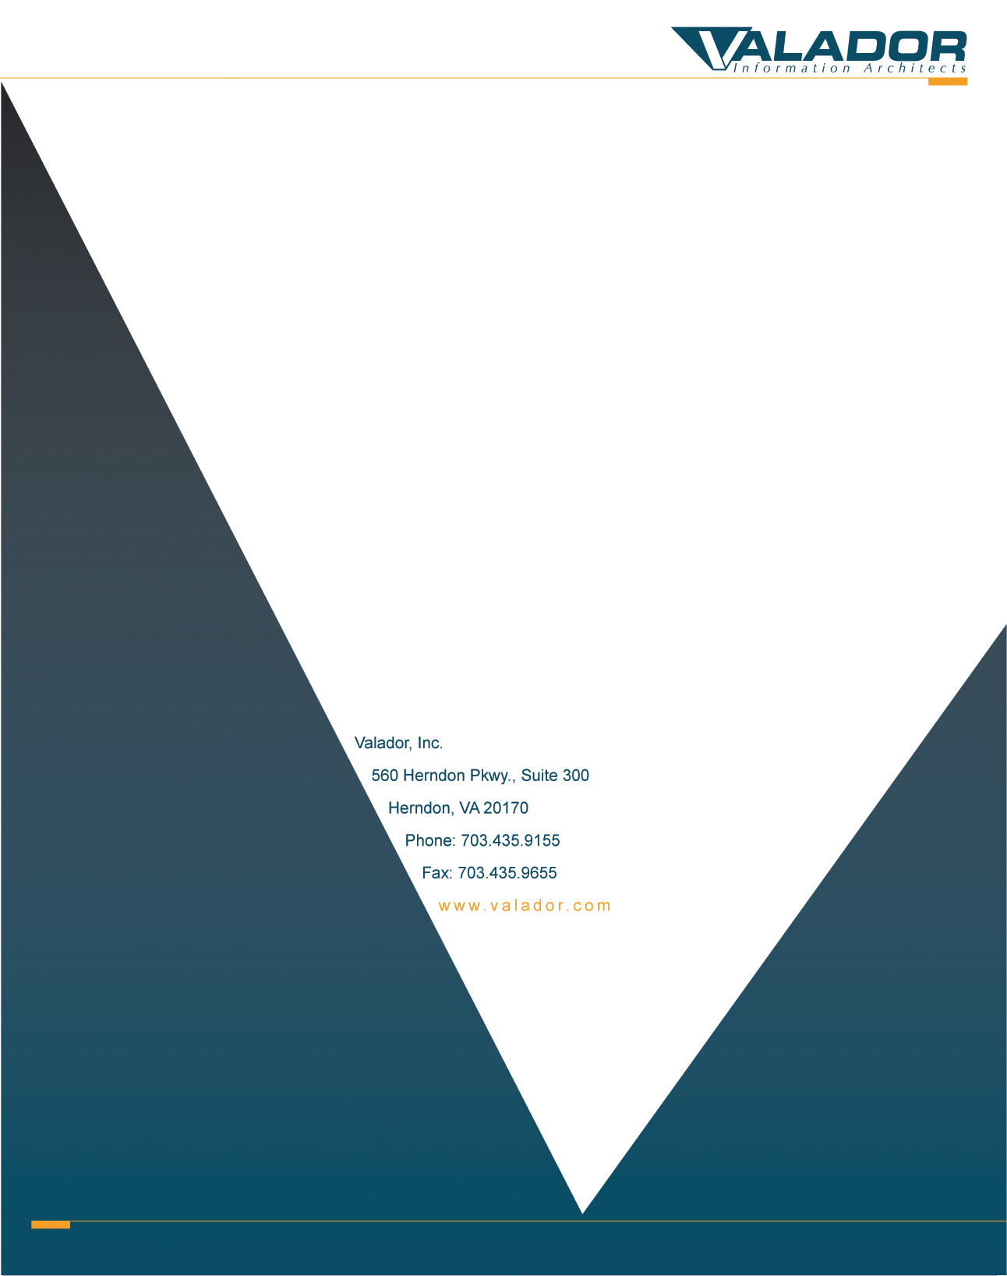
Project Management Plan
for the
reactionRx Application Project
(Pool2)

Prepared for:
U.S. General Services Administration (GSA)
by:
Kevin Sadeghian
Valador, Inc.
703-435-9155
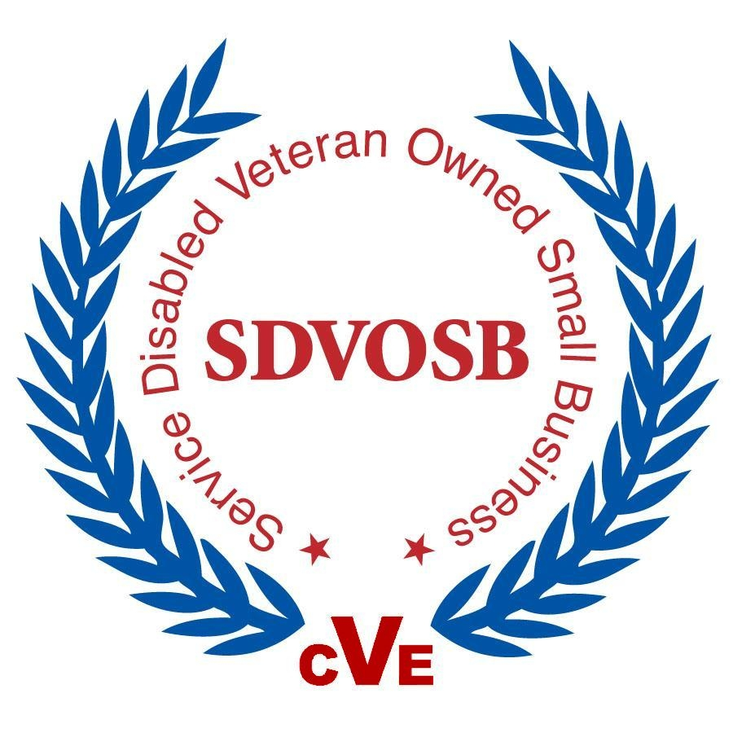

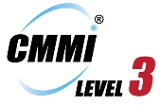

Approval
PROJECT TITLE:
PROJECT NUMBER:
CONTRACT/D.O. NUMBER:
PERIOD OF PERFORMANCE:
PROJECT MANAGER:
PROJECT APPROVAL:  Kevin Sadeghian Date  Technical Architect | QA APPROVAL:  Benjamin Franzini Date  Project QA Manager
CUSTOMER APPROVAL:  GSA POC Date  Technical Customer | PROGRAM APPROVAL:  Kevin T. Mabie Date  President & CEO

CMMI COMPLIANCE APPROVAL:

Benjamin Franzini Date
CMMI Auditor
Distribution
Valador |  | Customer

RECORD OF CHANGES
- A - ADDED M - MODIFIED D - DELETED
REVISION  IDENTIFIER | DATE | FIGURE, TABLE, OR PARAGRAPH  NUMBER | A  M  D | TITLE OR BRIEF DESCRIPTION
v1.0 | 6/19/2015 |  | A | Initial Release
v1.1 | 6/25/2015 |  |  | Modifications based on the sprint review
v1.2 | 6/29/2015 |  |  | Modifications based on focus group
v1.3 | 7/7/2015 |  |  | Addition of the Actual costs table, showing the total cost of the project.
TABLE OF CONTENTS
Page
1.0 PROJECT OVERVIEW 5
1.1 SCOPE/BACKGROUND 5
1.2 CUSTOMER 5
2.0 TECHNICAL APPROACH 5
3.0 BUDGET & SCHEDULE 9
3.1 SCHEDULE/ MILESTONES 9
3.2 BUDGET 10
4.0 RISK MANAGEMENT 10
4.1 RISK MANAGEMENT OVERVIEW 10
4.2 RISK IDENTIFICATION 11
4.3 RISK RESPONSIBILITY 11
4.4 RISK ASSESSMENT 11
4.5 RISK RESPONSE AND CONTINGENCY PLANNING 12
4.6 RISK REGISTER 13
5.0 DATA MANAGEMENT 14
5.1 DATA CONTENT AND FORMAT 14
5.2 IDENTIFIED ITEMS 14
5.2.1 PROJECT PLAN 14
6.0 RESOURCES 15
6.1 STAFF 15
7.0 KNOWLEDGE & SKILLS 15
7.1 STAFFING PLANS 15
7.2 TRAINING PLANS 15
8.0 STAKEHOLDER INVOLVEMENT 16
8.1 LIST OF STAKEHOLDERS 16
8.2 COMMUNICATION PLAN 16
9.0 PROJECT PROCESS TAILORING PLAN 16
10.0 MEASUREMENT AND ANALYSIS PLAN 17

PROJECT OVERVIEW

SCOPE/BACKGROUND
The reactionRx Application was developed as part of a Response effort to a Request for Quotation (RFQ) from GSA, under Federal Acquisition Regulation (FAR) 8.405-3 ordering procedures, to establish multiple award Blanket Purchase Agreements (BPAs). The purpose of the Application is to provide users and stakeholders with the ability to quickly and easily view reaction(s) associated with one or more drugs, as well as drugs that can attribute to any identified reaction a user might have; the reactionRx Application allows users to search for this data on a PC or a mobile device, significantly increasing usability and availability of the system.
GSA will evaluate the submitted prototypes in consideration for multiple awards under the identified BPAs; in developing the reactionRx Application, Valador will utilize its extensive experience in Agile development to produce a product that is created iteratively, efficiently, and benefits from the frequent involvement of actual users and stakeholders; this translates to a product that is developed on time and within the very short RFQ timeframe, with minimized development costs given the efficiencies that accompany an Agile project done correctly.

CUSTOMER
The customers for this project are:
GSA - agilebpa@gsa.gov
GSA Technical Lead: TBD
GSA Contracting officer: TBD

TECHNICAL APPROACH
Valador follows an Agile Scrum Methodology for Development of products; the reactionRx Application will start with an official Project Kickoff, where key personnel from Development, management, as well as other stakeholders are involved; Scope is further defined and the team is officially defined and key pieces of information about the processes to be followed during the development timeframe are shared and understood by all participants. A Product Owner is identified, who will be responsible for the on-time and on-budget delivery of the products. Other resources that were identified include:
Kevin Sadeghian – Technical Architect
Philip Stroh – Software Engineer
David White – System Architect
Sean Yao – Software Developer
Ben Franzini – Technical Writer
Since Valador’s Agile Scrum methodology takes an iterative approach to Development, a decision will be made with regards to the number of “Sprints” or “Cycles” in which the product(s) can be best developed in; the ideal number of Sprints when developing the reactionRx Application is 2 to 3 sprints; functionalities are built into the Application incrementally, with a demonstrable ‘prototype/product’ at the end of each sprint.
The environments are used in the development effort: Development Environment, Test Environment, and Production Environment; the team will use each environment to manage the progress of the effort, in final preparation of the prototype which will reside in the Production Environment before delivery to the customer.

The architecture diagram that was developed for the Development effort was put together iteratively; as more research was conducted, the details and the configuration of the system components were modified to accommodate the new information. The latest version of the System Architecture Diagram for Development (pool 2) is shown below:

For this submission Valador chose jsp for front end development linked to the service by way of a RESTful clinet. This allowed us to develop a robust service capable of interfacing with any number of popular or established front end development technologies.

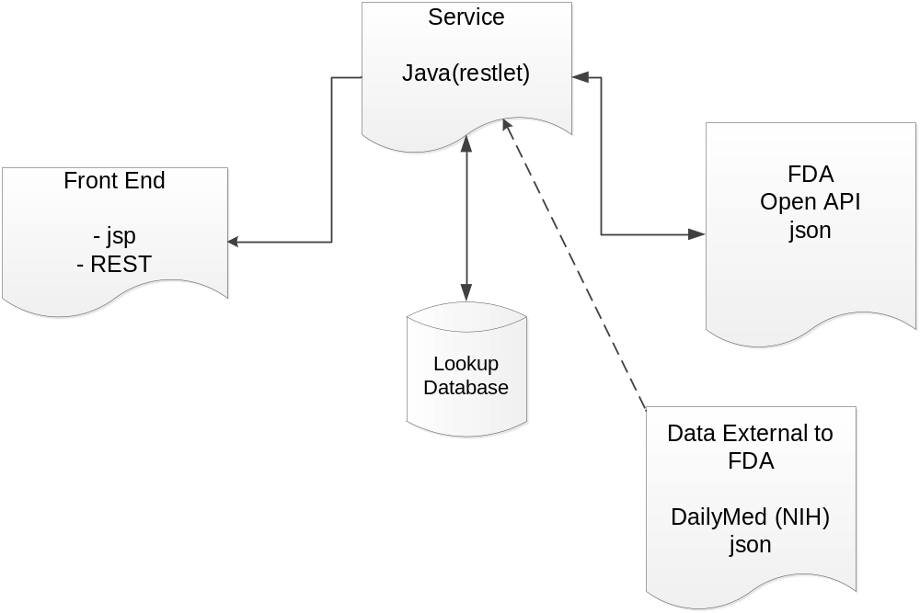

Valador created a central RESTful service responsible for coordinating all internal and external data from services, SQL databases, etc. The service manages all connections and logic required to meet the functional needs of the front end. A small lookup database was created in MySQL to facilitate autocomplete functionality. We took this approach as the raw data the from Opendata need additional processing for use in the lookup functions. The central service approach allowed us a great deal of flexibility as it allowed us to:
• Aggregate data sources (MySQL, OpenFDA, DailyMed)
• Provide API access for use with a variety of front end development platforms. (PHP, iOS, etc.)
• Provide centralized management and administration of the system.

Valador’s approach includes the development of a prototype application, which will consist of development, using the openFDA dataset and Application Programming Interface (API); Valador’s approach to the Development effort will highlight our Agile delivery capabilities. At the end of each full sprint, Valador will review the developed functionalities of the prototypes and involve ‘focus groups’ (ie. People/Users) in order to receive feedback and ideas for improvements; this feedback is then implemented into the workload in the following sprint, and worked on accordingly.
Valador uses an iterative, incremental framework for project management and agile software Development, as illustrated in the graphic below. This translates to frequent involvement of customers and other stakeholders, developing products in sprints iteratively, continuously adding to the progress of previous products.
During each “sprint”, typically a two to four week period, although cut short for this effort due to the time restrictions imposed by the RFQ, the team creates a potentially shippable product increment (for example, working and tested software). The set of features that go into a sprint come from the product “backlog,” which is a prioritized set of high level requirements of work to be done, organized by the assigned Product Owner. Which backlog items go into the sprint is determined during the sprint planning meeting. During this meeting, the Product Owner informs the team of the items in the product backlog that he or she wants completed. The team then determines how much of this they can commit to complete during the next sprint. During a sprint, no one is allowed to change the sprint backlog, which means that the requirements are frozen for that sprint. After a sprint is completed, the team demonstrates the use of the software.
Scrum enables the creation of self-organizing teams by encouraging co-location of all team members, and verbal communication across all team members and disciplines that are involved in the project.
A key principle of Scrum is its recognition that during a project the customers can change their minds about what they want and need (often called requirements churn), and that unpredicted challenges cannot be easily addressed in a traditional predictive or planned manner. As such, Scrum adopts an empirical approach—accepting that the problem cannot be fully understood or defined at the beginning of the project, and focusing instead on maximizing the team’s ability to deliver quickly and respond to emerging requirements and changes.
Valador’s scrum methodology used for Development (pool2) is shown below:

Valador’s Scrum methodology used for Development (Pool2) is shown below. Sprint durations were adjusted given the limited timeframe required for the response.

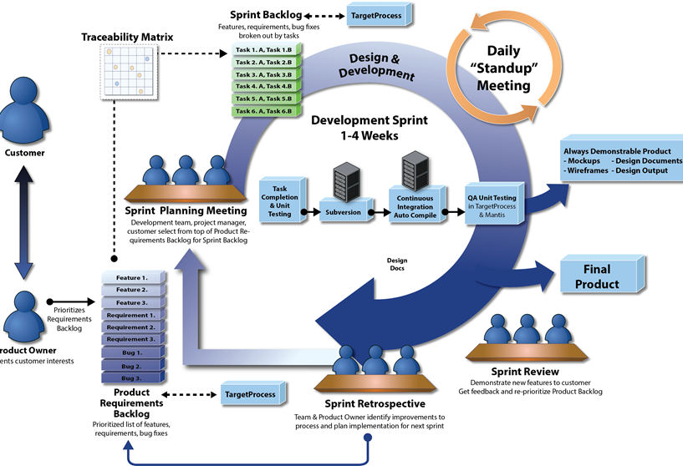

BUDGET & SCHEDULE

SCHEDULE/ MILESTONES
The period of Performance for this effort was originally 6/17/2015 to 6/26/2015; the deadline was extended to 7/1/2015 at 8pm, and again to 7/7.

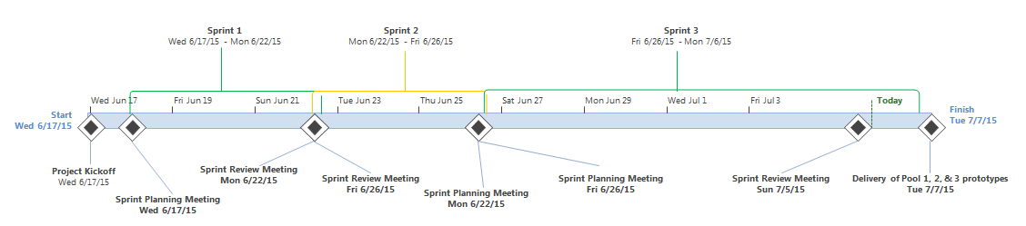
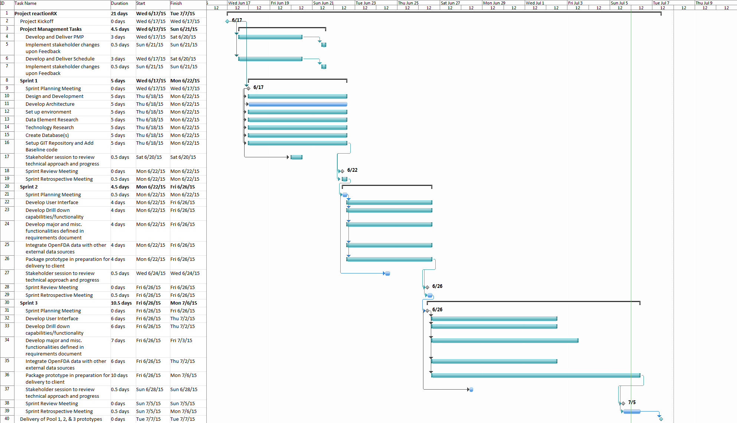

BUDGET
The budget (hours) estimated for the development of pool 1, 2, and 3 prototypes is shown below. The actual hours spent may vary depending on complexity of the solution that’s implemented.
Labor Category from Attachment B. | Proposed BPA Price Labor Rate | Hours (Level of effort) | Total Price based on labor rate times hours (Level of effort
Technical Architect | $112.58 | 10 | $1,125.81
Frontend Web Developer | $87.73 | 50 | $4,386.60
Backend Web Developer | $87.73 | 50 | $4,386.60
DevOps Engineer | $101.59 | 40 | $4,063.68
 | Total Estimated Budget |  | $13,962.69

The actual hours spent, and the total cost of the Development effort by Valador is shown below. This information was captured based on totaling the hours spent by each team members during the response timeframe.
Labor Category from Attachment B. | Proposed BPA Price Labor Rate | Hours (Level of effort) | Total Price based on labor rate times hours (Level of effort
Technical Architect | $112.58 | 10 | $1,125.81
Frontend Web Developer | $87.73 | 46 | $4,035.67
Backend Web Developer | $87.73 | 46 | $4,035.67
DevOps Engineer | $101.59 | 36 | $3,657.31
 | Total Actuals |  | $12,854.47

RISK MANAGEMENT

RISK MANAGEMENT OVERVIEW
Valador’s Risk Management process is based on the Continuous Risk Management cycle which is based on identification, analysis, planning, tracking, and control risks while maintaining constant communication between all stakeholders. Additionally, a comprehensive understanding of project risks will allow Risk Informed Decision-Making (RIDM) for specific circumstances within projects such as key development decisions, make or buy decisions, budget allocation decisions, resource decisions as well as those that involve requirements or re-baselining of requirements.

RISK IDENTIFICATION
Risk identification occurs during Project Initiation and is a continuous process throughout the project lifecycle. As risks are identified, they are added to the Project Risk Register.

RISK RESPONSIBILITY
Risk Activity | Responsibility
Risk Identification | Project Stakeholders
Risk Registry | Project Manager
Risk Assessment | Project Stakeholders
Risk Response Options Identification | Project Stakeholders
Risk Response Approval | Project Sponsor and PM
Risk Contingency Planning | Project Sponsor & PM
Risk Response Management | Project Manager
Risk Reports (On Status Report) | Project Manager

RISK ASSESSMENT
The risks identified will be analyzed with respect to impact and severity in the risk register. The risk register categories are as follows:
Category | Description
Risk ID | Keep Unique id consistent between the risk register, status report & PMP (id ex: RSK###)
Description | A description of the identified risk and stakeholders
Probability | Assign the risk a high, medium, or low likelihood of occurrence  - High: An event is expected to occur in most circumstances  - Medium: An event will probably occur in many circumstances  - Low: An event may occur at some time
Impact | Assign the risk a high, medium, or low impact  - High: Serious impact on product, schedule, or cost  - Medium: Significant impact on product, schedule, or cost  - Low: Less significant impact on product, schedule, or cost
Risk Mitigation | Define the threshold at which the mitigation plan will be initiated. Document risk mitigation plans (along with alternatives) and handling options for each identified risk
Owner | The person(s) responsible for ensuring that the risk is being monitored and mitigated. This person(s) will typically take the next action on resolving the risk.
Status | Identifies whether the risk is open or closed

Special cases may require advanced quantitative assessment techniques.

RISK RESPONSE AND CONTINGENCY PLANNING
In the case major risks are identified, risk response options and contingency planning can help identify potential responses should a risk occur. The risk response identification and contingency plans are communicated to the project stakeholders in the project Status Reports and may require follow-on discussions or meetings between Project stakeholders.

RISK REGISTER
The baseline risk register is shown below. Updates to the Risk Register are made to the Valador Project Risk Register Template and maintained by the Project Manager.
Unique id: | Description | Consequence | Probability | Impact | Risk Mitigation Plan | Risk Owner | Status
RSK001 | Schedule of the task.  The development timeframe of the project is short, thus requiring careful planning and efficiencies throughout. Stakeholders include GSA, as well as all users of the reactionRx system being developed. | If careful attention isn't paid to the remaining timeframe to submit Product to GSA, the team runs the risk of either delivering a product too late (ie. Past the delivery deadline), or delivering an incomplete product that lacks proper testing and features. | Medium | High | The Valador Team will use our Agile methodology to diligently develop features of the reactionRx system iteratively and thus reducing the risks involved with development in a short time frame; the team will be meeting frequently and communicating often; Stakeholders are included in major planning, reviews, and decision points, in order to provide buy-in and consensus, ensuring a smooth development process, with as few surprises as possible. | Kevin Sadeghian – Technical Architect | Open
RSK002 | External Database to get information from.  The team needs to find a data base that can feed the reactionRx system with additional data, and effectively integrate with the OpenFDA data obtained originally for the project. | If a proper dataset, in the correct format, isn't found, it could lead to dealys, as additional steps may be needed to convert the dataset output into usable tables. | Low | Medium | The Valador team will be conducting research early on, in order to find the information needed as soon as possible. Multiple researchers will be involved in order to mitigate the amount of time required to find the ideal dataset. | Kevin Sadeghian - Technical Architect | Open

DATA MANAGEMENT

DATA CONTENT AND FORMAT
This project recognizes two types of data content:
- Documentation Items
- Software Deliverable Items

All identified items are to be named using the following naming convention:
- ProjectName_ItemName_Version_Date.doc
Documentation Items include all written documents describing the project. They are to be based on standardized Valador templates for the individual document. They are to be named using the following convention:

- ProjectName_Project_Plan_v1.0_Date.doc

IDENTIFIED ITEMS
The following data items have been identified for this project. Additional data items will be added on project wiki page as needed.

PROJECT PLAN
The project plan is used to guide project execution and control. Its primary detailed uses are to document planning assumptions and decisions, facilitate communication among stakeholders, and document approved cost and schedule baselines.

Source: Customer requirements (enhancements) provided via email, meetings or discussions between Customer representative and the Project Manager (aka Product Owner).
Development: This document is written by the Project Manager.
Configuration Control: Located in the document directory on OPS drive.
Distribution: As-needed

RESOURCES

STAFF
Role | Fulfilled By (Name)
Technical Architect | Kevin Sadeghian
Software Engineer | Philip Stroh
System Architect | David White
Software Developer | Sean Yao
Technical Writer | Ben Franzini
*While this section provides the initial staffing, the team member list will be maintained by the Project Manager.

KNOWLEDGE & SKILLS
Valador will develop the prototypes using internal resources, including a System Architect, Project Manager, Software Engineer, Software Developer, and Technical Writer. The project team does not anticipate needing any support from outside resources or vendors.

STAFFING PLANS
All of the roles on this project will be fulfilled by existing Valador employees in the beginning of the project. If it needs more staff to join the project, Valador will hire the new staff as needed. Outside resources are not used for this project.

TRAINING PLANS
All of the roles on this project will be required to take the client required training and Valador required training.
Type | Description | Frequency
Company Training | Organizational training governed by the Organizational Training Policy, Strategic Training Plan and Tactical Training Plan, see https://vmis.valador.com/wiki/index.php/Software_Department_Process_Library | Every Year
Employee Training | Employee selected training to improve skills | Every Year

STAKEHOLDER INVOLVEMENT

LIST OF STAKEHOLDERS
Stakeholder Position | Contact Info | Project Activities
Valador President & CEO | Kevin Mabie  kevin.mabie@valador.com | Approve project plan, Authorize budget  Review and respond to status updated from the development team; Authorize staffing plans and new requirements
Valador Technical Architect | Kevin Sadeghian  Kevin.Sadeghian@valador.com | Plan and monitor development, testing and deployment activities; Provide project status reports; Assign resources as needed, resolve impediments during development
GSA | agilebpa@gsa.gov | Customer.

COMMUNICATION PLAN
Valador will maintain an open dialog with the customer through formal questions, to ensure that the agency’s needs are met. Valador commits on-time delivery of task deliverables that meet our high standards of quality and our customer’s needs.
To ensure that our products meet not only the defined deliverables of the contract, but also address the needs of the customer’s environment, Valador staff will maintain close communications with the Customer’s representatives throughout the project.

PROJECT PROCESS TAILORING PLAN
The project will follow the standard process guidelines/recommendations from Valador’s Process Library. There is no tailoring choice on this project.

Processes to follow | Non-Standard Projects | Standard Projects | Used (Yes/No)
Planning Processes
Proposal Development Process | Not required | Required
Release Planning Process | Not required | Required
Resource Management Process | Recommended but not required | Required
Sprint Planning Process | Recommended but not required | Required for software projects
Tailoring Process | Required | Required
Development Processes
Project Initiation Process | Required | Required
Requirements Gathering Process | Required | Required
Product Backlog Management Process | Recommended but not required | Required for software projects
Development Process | Recommended but not required | Required for software projects
Daily Standup Process | Recommended but not required | Required for software projects
Deployment and Release Process | Recommended but not required | Required for software projects
Configuration Management Process | Required | Required
Quality Assurance Processes
Document Quality Assurance Process | Recommended but not required | Required
Quality Assurance Process | Recommended but not required | Required
Project Monitoring Process | Required | Required
Software Quality Assurance Process | Recommended but not required | Required for software projects
Sprint Review Process | Recommended but not required | Required for software projects
Risk Management Process | Required | Required
Table 9-1: Tailoring Plan

MEASUREMENT AND ANALYSIS PLAN
Measurement and Analysis activities will be performed throughout the lifecycle of the project according to the project measures detailed in the standard Valador Measurement and Analysis Process. These measures are available for processes within each of Valador’s planning, development, quality assurance, and process improvement process groups.

This data will be monitored periodically and insights from these measurement and analysis activities will be communicated through the Project Status reports when they are available.

