
限定用途教學教材，不得公開販售或流通

7
I. 文意字彙與詞類變化：30%
英文1 學習卷
Lesson 5 The Life of a Plastic Bag

eagerly 1. The children waited e y for the magician to start the show.
obvious 2. The teacher’s disappointment was o s when the students failed to turn in their assignments.
substance 3. The scientist analyzed the s e and discovered that it was a rare element.
surroundings 4. The townspeople complained about the pollution caused by the factories in their
s gs.
environmental 5. Many e l issues, such as climate change, have become major concerns worldwide.
consumes 6. If Leo c mes more than one cup of coffee during the day, he usually has trouble falling asleep at night.
properly 7. It is important to follow the instructions for how to p rly assemble the furniture.
harmful 8. PM 2.5 has proved to be (harm) to the human heart and lungs, so it is
necessary to wear a mask when you go outside.
production 9. The new drug is now being tested and will go into (product) next year.
envied/envy 10. Most of the other boys in the school (envy) Dan’s good looks and amazing soccer skills.

II. 文法選擇：10%
( A ) 11. Jessie borrowed books about Albert Einstein’s Theory of Relativity from the library in order to do research for her speech.
(A) a few (B) least (C) few (D) little
( A ) 12. Since we were running out of soy sauce, my father asked me to buy some in a store .
(A) nearby (B) near (C) nowhere (D) nearly
( D ) 13. Going to night markets makes Winnie because she is scared of getting lost in the crowd.
(A) nervously (B) nerves (C) nerve (D) nervous
( B ) 14. Before the match started, Rodney waved to the three friends who watched from up .
(A) behind (B) above (C) beyond (D) below
( A ) 15. The war has lasted for five years. All the people truly hope .
(A) that it will end soon (B) the war to end soon
(C) to have been ended the war (D) when it will end
III. 綜合測驗：10%
A plastic bag was made in a factory and sent to a store. It was taken 16. the store 16. the beach by some kids who were going on a picnic. However, when the kids left for the day, the plastic bag was left alone on the beach and then swept out to sea by the wind. It floated in the ocean for a few days with other plastic things until it was eaten by a huge fish. The fish eventually died, and the plastic bag was washed back onto the shore.
There, a group of schoolchildren showed up carrying bags and tongs. Their teacher had them 17.
up the bag along with other litter, and so that plastic bag was put into a big bag of trash. The teacher explained to the schoolchildren that a lot of plastic 18. are dumped into the river and into the ocean and then are eaten by sea creatures. When humans eat these creatures, 19. from the plastic enters their bodies. They may then get sick as a result.
Plastic goods offer 20. and can make our lives better, but we often misuse them and make our lives worse. Hopefully, we can all learn to respect the earth and the things we make and use them well.
( B ) 16. (A) such; as (B) from; to (C) so; that (D) either; or
( B ) 17. (A) to pick (B) pick (C) picked (D) picks
( A ) 18. (A) products (B) crowds (C) consumers (D) locations
( D ) 19. (A) exposure (B) envy (C) distance (D) poison
( C ) 20. (A) harm (B) environment (C) convenience (D) recycling
IV. 文意選填：10%
(A) environment (B) proper (C) crowded (D) recycled (E) drifted
(F) research (G) end up (H) teamed up (I) reduce (J) surrounded
The Ocean Cleanup wants to clean up plastic in the oceans. This project was started by a teenager called Boyan Slat, who had found himself 21. by plastic while scuba diving. It shocked him that we could not keep our 22. clean. When he finished his dive, he started to 23. the problem.
After years of hard work, the Ocean Cleanup discovered some effective and 24. methods for removing plastic from the ocean. The organization is focused on large areas where plastic items have 25.
together, known as garbage patches. It also has a plan to clean the one thousand rivers that are most 26.
with plastic trash. Taking the plastic out of these rivers means it will not 27. in oceans.
The plastic collected is 28. and made into useful items. The Ocean Cleanup’s goal is to 29.
the quantity of plastics in the world’s oceans by ninety percent by 2040. Of course, the Ocean Cleanup cannot clean the oceans on its own. Therefore, it has 30. with other groups and with governments to achieve its goal. We, too, should do our part to protect the oceans.
21. J 22. A 23. F 24. B 25. E
26. C 27. G 28. D 29. I 30. H

V. 篇章結構：8%
(A) Others prefer bags with handles, as they are easier to carry and can be reused for other purposes.
(B) However, whether you pick plastic or paper, remember that you always have the choice of bringing your own bag on the basis of your values and needs.
(C) Different things affect which bag people choose and how they feel about it.
(D) A plastic bag costs about TWD 0.35 to make, while a paper bag costs four to five times more.
(E) By contrast, paper bags can also break down into smaller pieces, but they are not harmful to living things.
Have you ever been to a supermarket where the cashier takes out a paper bag instead of the usual plastic bag? Some might just take the bag without thinking. Some may support the choice. 31. The results of choosing one over the other are also different.
Both types of bag can be broken down into smaller pieces. However, plastic bags can take up to one thousand years to break down and are usually not recyclable. This can lead to serious problems. For example, if a plastic bag is washed into the ocean, the broken-down pieces may get consumed by fish and other marine life, often leading to their deaths. 32.
Aside from ecological considerations, cost also matters. While both are low-cost options, plastic bags are still the more economical* choice for distribution. 33. Therefore, plastic bags are used in large numbers and more often than paper bags. Additionally, plastic bags can typically hold more weight due to the stretchable* nature of plastic, while paper bags can easily tear when their contents get heavy.
There are pros and cons* when it comes to what type of bag you use to pack up your groceries. 34.
註：economical 經濟實惠的 stretchable 可延展的 pros and cons 事物的利與弊
31. C 32. E 33. D 34. B

VI. 翻譯：20%（35至37每格1分，38至39每題5分）
35. Betty要搬新家了，但她的朋友們都忙著工作，所以她必須自己打包東西。
Betty was about to move to a new home, but her friends were all busy working, so she had to
pack her things up by herself.
36. 那個男人凝視著那幅畫一陣子，因為他被畫上的圖案所吸引。
That man stared at the painting for a while because he was attracted
by the patterns on it.
37. 所有受邀賓客都準時到達了，所以典禮按照計畫開始。
All the invited guests came along on time, so the ceremony started according
to the scheduled timetable.
38. 在夏季，Judy讓她的孩子們在外面玩耍直到晚上九點。
In (the) summer, Judy lets her children play outside until 9 p.m.
39. Cathy很失望這場比賽因為不佳的天氣而被取消了。
Cathy was disappointed that the match was canceled because of bad weather.

VII. 混合題：12%
After Leila learned about the life cycle of a plastic bag, her teacher had the class film a documentary* in order to discourage* people from using plastic bags. She and her teammates chose plastic straws as the main topic of their documentary. They searched online for the helpful information shown below:
註：documentary 紀錄片 discourage 阻止
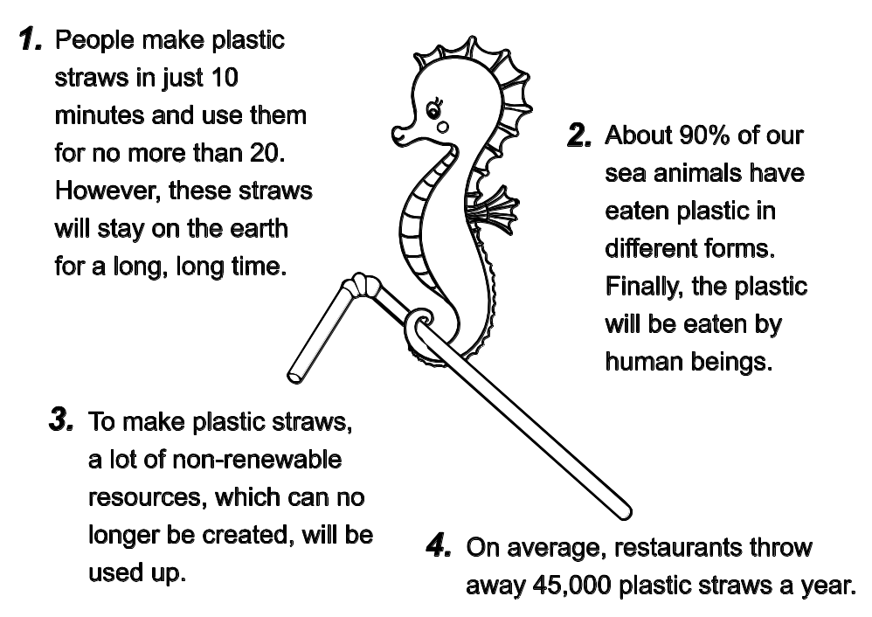

( C ) 40. What does the number “20” in the above poster mean? (4%)
(A) Twenty years. (B) Twenty plastic straws.
(C) Twenty minutes. (D) Twenty percent.
41. What is the documentary likely to encourage viewers to reflect on? Choose TWO answers. (4%)
(C) (F)
(A) The economic advantages of plastic straw production.
(B) The environmental and health benefits of using plastic straws.
(C) Their personal consumption habits regarding plastic straws.
(D) The need for stricter laws governing the restaurant industry.
(E) Ways to recycle plastic straws more efficiently.
(F) The impact of plastics on marine life and human health.
42. 下列簡短敘述摘記上方文章重點。請從文章中找出最適當的單詞（word）填入下列句子空格中，使句子語意完整、語法正確，並符合全文文意。(4%)
Leila and her classmates focused their documentary on the ecological harm caused by plastic straws, which not only remain in the environment but also consume non-renewable resources during production and are discarded by restaurants in large numbers.

