
限定用途教學教材，不得公開販售或流通

7
I. 文意字彙與詞類變化：30%
英文1 學習卷
Lesson 5 The Life of a Plastic Bag

eagerly 1. The children waited e y for the magician to start the show.
obvious 2. The teacher’s disappointment was o s when the students failed to turn in their assignments.
substance 3. The scientist analyzed the s e and discovered that it was a rare element.
surroundings 4. The townspeople complained about the pollution caused by the factories in their
s gs.
environmental 5. Many e l issues, such as climate change, have become major concerns worldwide.
consumes 6. If Leo c mes more than one cup of coffee during the day, he usually has trouble falling asleep at night.
properly 7. It is important to follow the instructions for how to p rly assemble the furniture.
harmful 8. PM 2.5 has proved to be (harm) to the human heart and lungs, so it is
necessary to wear a mask when you go outside.
production 9. The new drug is now being tested and will go into (product) next year.
envied/envy 10. Most of the other boys in the school (envy) Dan’s good looks and amazing soccer skills.

II. 文法選擇：10%
( A ) 11. Jessie borrowed books about Albert Einstein’s Theory of Relativity from the library in order to do research for her speech.
(A) a few (B) least (C) few (D) little
( A ) 12. Since we were running out of soy sauce, my father asked me to buy some in a store .
(A) nearby (B) near (C) nowhere (D) nearly
( D ) 13. Going to night markets makes Winnie because she is scared of getting lost in the crowd.
(A) nervously (B) nerves (C) nerve (D) nervous
( B ) 14. Before the match started, Rodney waved to the three friends who watched from up .
(A) behind (B) above (C) beyond (D) below
( A ) 15. The war has lasted for five years. All the people truly hope .
(A) that it will end soon (B) the war to end soon
(C) to have been ended the war (D) when it will end
III. 綜合測驗：10%
A plastic bag was made in a factory and sent to a store. It was taken 16. the store 16. the beach by some kids who were going on a picnic. However, when the kids left for the day, the plastic bag was left alone on the beach and then swept out to sea by the wind. It floated in the ocean for a few days with other plastic things until it was eaten by a huge fish. The fish eventually died, and the plastic bag was washed back onto the shore.
There, a group of schoolchildren showed up carrying bags and tongs. Their teacher had them 17.
up the bag along with other litter, and so that plastic bag was put into a big bag of trash. The teacher explained to the schoolchildren that a lot of plastic 18. are dumped into the river and into the ocean and then are eaten by sea creatures. When humans eat these creatures, 19. from the plastic enters their bodies. They may then get sick as a result.
Plastic goods offer 20. and can make our lives better, but we often misuse them and make our lives worse. Hopefully, we can all learn to respect the earth and the things we make and use them well.
( B ) 16. (A) such; as (B) from; to (C) so; that (D) either; or
( B ) 17. (A) to pick (B) pick (C) picked (D) picks
( A ) 18. (A) products (B) crowds (C) consumers (D) locations
( D ) 19. (A) exposure (B) envy (C) distance (D) poison
( C ) 20. (A) harm (B) environment (C) convenience (D) recycling
IV. 文意選填：10%
(A) environment (B) proper (C) crowded (D) recycled (E) drifted
(F) research (G) end up (H) teamed up (I) reduce (J) surrounded
The Ocean Cleanup wants to clean up plastic in the oceans. This project was started by a teenager called Boyan Slat, who had found himself 21. by plastic while scuba diving. It shocked him that we could not keep our 22. clean. When he finished his dive, he started to 23. the problem.
After years of hard work, the Ocean Cleanup discovered some effective and 24. methods for removing plastic from the ocean. The organization is focused on large areas where plastic items have 25.
together, known as garbage patches. It also has a plan to clean the one thousand rivers that are most 26.
with plastic trash. Taking the plastic out of these rivers means it will not 27. in oceans.
The plastic collected is 28. and made into useful items. The Ocean Cleanup’s goal is to 29.
the quantity of plastics in the world’s oceans by ninety percent by 2040. Of course, the Ocean Cleanup cannot clean the oceans on its own. Therefore, it has 30. with other groups and with governments to achieve its goal. We, too, should do our part to protect the oceans.
21. J 22. A 23. F 24. B 25. E
26. C 27. G 28. D 29. I 30. H

V. 篇章結構：8%
(A) Others prefer bags with handles, as they are easier to carry and can be reused for other purposes.
(B) However, whether you pick plastic or paper, remember that you always have the choice of bringing your own bag on the basis of your values and needs.
(C) Different things affect which bag people choose and how they feel about it.
(D) A plastic bag costs about TWD 0.35 to make, while a paper bag costs four to five times more.
(E) By contrast, paper bags can also break down into smaller pieces, but they are not harmful to living things.
Have you ever been to a supermarket where the cashier takes out a paper bag instead of the usual plastic bag? Some might just take the bag without thinking. Some may support the choice. 31. The results of choosing one over the other are also different.
Both types of bag can be broken down into smaller pieces. However, plastic bags can take up to one thousand years to break down and are usually not recyclable. This can lead to serious problems. For example, if a plastic bag is washed into the ocean, the broken-down pieces may get consumed by fish and other marine life, often leading to their deaths. 32.
Aside from ecological considerations, cost also matters. While both are low-cost options, plastic bags are still the more economical* choice for distribution. 33. Therefore, plastic bags are used in large numbers and more often than paper bags. Additionally, plastic bags can typically hold more weight due to the stretchable* nature of plastic, while paper bags can easily tear when their contents get heavy.
There are pros and cons* when it comes to what type of bag you use to pack up your groceries. 34.
註：economical 經濟實惠的 stretchable 可延展的 pros and cons 事物的利與弊
31. C 32. E 33. D 34. B

VI. 翻譯：20%（35至37每格1分，38至39每題5分）
35. Betty要搬新家了，但她的朋友們都忙著工作，所以她必須自己打包東西。
Betty was about to move to a new home, but her friends were all busy working, so she had to
pack her things up by herself.
36. 那個男人凝視著那幅畫一陣子，因為他被畫上的圖案所吸引。
That man stared at the painting for a while because he was attracted
by the patterns on it.
37. 所有受邀賓客都準時到達了，所以典禮按照計畫開始。
All the invited guests came along on time, so the ceremony started according
to the scheduled timetable.
38. 在夏季，Judy讓她的孩子們在外面玩耍直到晚上九點。
In (the) summer, Judy lets her children play outside until 9 p.m.
39. Cathy很失望這場比賽因為不佳的天氣而被取消了。
Cathy was disappointed that the match was canceled because of bad weather.

VII. 混合題：12%
After Leila learned about the life cycle of a plastic bag, her teacher had the class film a documentary* in order to discourage* people from using plastic bags. She and her teammates chose plastic straws as the main topic of their documentary. They searched online for the helpful information shown below:
註：documentary 紀錄片 discourage 阻止
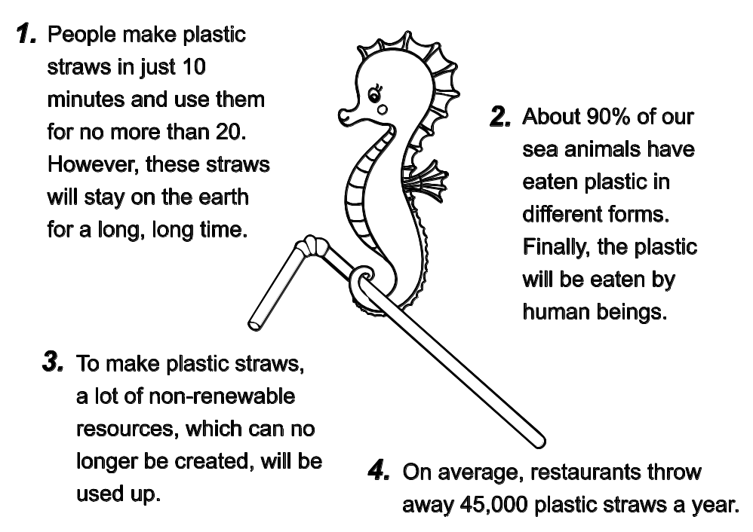

( C ) 40. What does the number “20” in the above poster mean? (4%)
(A) Twenty years. (B) Twenty plastic straws.
(C) Twenty minutes. (D) Twenty percent.
41. What is the documentary likely to encourage viewers to reflect on? Choose TWO answers. (4%)
(C) (F)
(A) The economic advantages of plastic straw production.
(B) The environmental and health benefits of using plastic straws.
(C) Their personal consumption habits regarding plastic straws.
(D) The need for stricter laws governing the restaurant industry.
(E) Ways to recycle plastic straws more efficiently.
(F) The impact of plastics on marine life and human health.
42. 下列簡短敘述摘記上方文章重點。請從文章中找出最適當的單詞（word）填入下列句子空格中，使句子語意完整、語法正確，並符合全文文意。(4%)
Leila and her classmates focused their documentary on the ecological harm caused by plastic straws, which not only remain in the environment but also consume non-renewable resources during production and are discarded by restaurants in large numbers.

英文1學習卷詳解——第7回
Lesson 5 The Life of a Plastic Bag
61001S1-A
請尊重著作權，勿擅自翻印
限定用途教學教材，不得公開販售或流通
I. 文意字彙與詞類變化
1. eagerly 2. obvious 3. substance 4. surroundings 5. environmental
6. consumes 7. properly 8. harmful 9. production 10. envied/envy
1. 孩子們熱切地等待魔術師開始表演。
2. 當學生們沒能繳交作業時，老師的失望是很明顯的。
3. 那位科學家分析了這個物質，發現它是一個稀有元素。
4. 鎮民們抱怨他們周遭環境中由工廠所造成的汙染。
5. 許多環境議題（例如氣候變遷）已成為全球關注的重大焦點。
6. 如果Leo在白天攝取超過一杯咖啡，他晚上通常會有入睡困難。
7. 遵循說明書以了解如何正確地組裝家具是非常重要的。
8. PM 2.5已證實對人類心臟與肺部有害，所以出門時有必要戴上口罩。
9. 這款新藥目前正在測試中，明年將投入量產。
10. 學校裡大部分的男生都羨慕Dan的長相與出神入化的足球技巧。

II. 文法選擇
11. (A) 12. (A) 13. (D) 14. (B) 15. (A)
11. 空格後方的books為「可數複數名詞」，故選(A) a few，表「一些」（肯定語意），符合Jessie為了做研究而借書的語境。(B) least表「最小、最少」（little的最高級），通常前需加the，且接不可數名詞；(C) few表「很少、幾乎沒有」，接可數複數名詞（否定語意）；(D) little表「很少、幾乎沒有」，接不可數名詞（否定語意）。
12. nearby為形容詞或副詞，後者可直接放在名詞（a store）後面修飾，表示「在附近的商店」。(B) near通常作為介系詞，後方須接名詞（如near the store）；(D) nearly「幾乎」（副詞，語意不合）。
13. make + O + adj. 讓……變得……（受詞後接形容詞作補語），故選(D) nervous。
14. 關鍵字在於空格前的up。up above 在上方（指從高處看）。(A) behind 在後面；(C) beyond 在更遠處；(D) below 在下方
15. hope後接that引導的名詞子句作受詞S + hope + that S + V。注意：S + hope to VR表「希望『自己』做某事」；若要表達「希望『其他事物／人』做某事」，則不可寫作S + hope + O + to VR，必須使用S + hope + that S + V句型或S + hope + for + O + to VR。

III. 綜合測驗
16. (B) 17. (B) 18. (A) 19. (D) 20. (C)
一個塑膠袋從工廠生產出來後，再運送到了一間商店。它被一些要去野餐的孩子^{16.}從商店帶到了海灘。然而，當孩子們結束了一天要離開時，那個塑膠袋被獨自留在了沙灘上，然後讓風吹入了海中。它和其他塑膠製品一起在海裡漂浮了幾天，直到被一條大魚吃掉。那條魚最終死掉了，而塑膠袋又沖回到了岸上。
在那兒，一群學童提著袋子和鉗子走了過來。他們的老師請他們把袋子和其他垃圾一起^{17.}撿起來，而那個塑膠袋也就放入一個大袋垃圾中了。老師向學童們解釋，許多塑膠^{18.}製品遭人傾倒於河流再進到海洋，並讓海洋生物吃掉了。當人類食用這些生物時，塑膠中的^{19.}毒物會進入他們的體內。然後，他們可能會因此生病。
塑膠製品提供了^{20.}便利性並能讓我們的生活更美好，但我們經常濫用它們，讓我們的生活變得更糟。希望我們都能學會尊重地球和我們所創造的物品，並善用它們。
16. 語意為塑膠袋被「從」商店帶「到」海邊，from A to B表「從A到B」。(A) 如此……以致於；(C) 如此……以致於；(D) 不是……就是……
17. have在此為使役動詞，have + O + VR表「命令或安排某人做……」。主動語態下，受詞（them，指學生們）執行動作（撿起垃圾），故使用原形動詞pick。
18. 根據上下文，這裡指被傾倒進河流與海洋的塑膠「製品」，故選(A) products 製品／產品。(B) 群眾；(C) 消費者；(D) 位置
19. (A) 暴露；(B) 羨慕；(C) 距離；(D) 毒素
20. 此處在討論塑膠製品的正反面影響。前半句提到正面價值：提供「便利」並讓生活更好；後半句以but轉折討論負面誤用，故選(C) convenience 便利。(A) 傷害；(B) 環境；(D) 回收

IV. 文意選填
21. (J) 22. (A) 23. (F) 24. (B) 25. (E) 26. (C) 27. (G) 28. (D) 29. (I) 30. (H)
「海洋清理」組織致力於清除海洋中的塑膠。這個計畫是由一位名叫Boyan Slat的青少年所發起的，他在一次水肺潛水時，發現自己被塑膠給^{21.}包圍了。這讓他感到震驚，沒想到我們竟然無法保持^{22.}環境的整潔。在他結束潛水後，他便開始對這個問題進行^{23.}研究。
經過多年的努力，「海洋清理」發現了一些從海洋中移除塑膠有效且^{24.}適當的方法。該組織專注於塑膠物品 ^{25.}漂流聚集的大型區域，即所謂的「垃圾帶」。此外，他們也有一個計畫要清理一千條塑膠垃圾最為^{26.}充斥的河流。將塑膠從這些河流中取出，意味著它們將不會^{27.}最終流入大海。
收集到的塑膠會被^{28.}回收並製成實用的物品。「海洋清理」的目標是在2040年前，將全球海洋中的塑膠量 ^{29.}減少百分之九十。當然，「海洋清理」無法單憑一己之力清理海洋。因此，它已經與其他團體及政府^{30.}合作，以達成其目標。我們也應該盡自己的一份心力來保護海洋。
21. 此處需填入過去分詞作為受詞補語，find oneself + p.p.表示「發現自己處於被……的狀態」，且後方有介系詞by引導被動語態，指創辦人發現自己「被塑膠包圍」。故選(J) surrounded。
22. 此處需填入名詞作為keep的受詞，句意為對於人類無法保持我們所處的「環境」整潔感到震驚。故選(A) environment。
23. 此處需填入原形動詞，接在start to之後，表示在他潛水結束後，開始對這個垃圾問題進行「研究」。故選(F) research。
24. 此處需填入形容詞修飾名詞methods（方法），指該組織經過多年努力，找到了移除海洋塑膠的「適當」方法。故選(B) proper。
25. 此處需填入過去分詞與have構成現在完成式，用以描述塑膠物品在海上「漂流」並聚集在一起。故選(E) drifted。
26. 此處需填入形容詞與be動詞構成固定片語，be crowded with意為「擠滿了……」，形容河流中充斥著塑膠垃圾。故選(C) crowded。
27. 此處需填入原形動詞，接在will not之後，end up in...為固定片語，意為「最後落得……／最終流向……」。故選(G) end up。
28. 此處需填入過去分詞作為被動語態，指被收集起來的塑膠會「被回收」並製成實用的物品。故選(D) recycled。
29. 此處需填入原形動詞，接在goal is to之後，表示該組織的目標是「減少」全球海洋中百分之九十的塑膠量。故選(I) reduce。
30. 此處需填入過去分詞與has構成現在完成式，且後方有介系詞with，team up with意為「與……團隊合作」。故選(H) teamed up。

V. 篇章結構
31. (C) 32. (E) 33. (D) 34. (B)
你是否曾去過超市，結帳員拿出的是紙袋而不是常見的塑膠袋？有些人可能不假思索地就拿走袋子；有些人可能支持此選擇。^{31.}不同的因素會影響人們選擇哪種袋子，以及他們對此的感受。選擇其中一種而非另一種的結果也是不同的。
這兩種類型的袋子都可以被分解成較小的碎片。然而，塑膠袋可能需要長達一千年的時間才能分解，而且通常是無法回收的。這可能導致嚴重的問題。例如，如果塑膠袋被沖入大海，分解後的碎片可能會被魚類和其他海洋生物吞食，通常會導致牠們死亡。^{32.}相比之下，紙袋也可以分解成較小的碎片，但它們對生物並無害處。
除了生態方面的考量，成本也很重要。雖然兩者都是低成本的選擇，但在分銷（配送）方面，塑膠袋仍然是更經濟實惠的選擇。^{33.}一個塑膠袋的製作成本約為0.35新臺幣，而紙袋的成本則高出四到五倍。因此，塑膠袋的使用數量龐大，且比紙袋更頻繁。此外，由於塑膠具備可延展的特性，塑膠袋通常能承載更多重量，而紙袋在內容物變重時則容易撕裂。
對於使用哪種袋子來包裝你的雜貨，各有利弊。^{34.}然而，無論你選擇塑膠還是紙，請記住，根據你的價值觀與需求，你永遠可以選擇帶上自己的袋子。
31. 此處需填入與「人們對袋子選擇」相關的承接句。前兩句分別提到「有人不經思考」與「有人支持」，故選(C) 以總結不同因素會影響人的選擇與感受。
32. 此處需填入與「塑膠袋對海洋生物有害」相對比的句子。前文描述塑膠碎片會造成魚類死亡，後文以「By contrast」（相比之下）引出紙袋雖會分解但無害。故選(E)。
33. 此處需填入關於「成本」的具體數據。前句提到塑膠袋是「更經濟實惠的選擇」（more economical choice），後句則用數據證明塑膠袋與紙袋的價格差。故選(D)。
34. 此處作為全文總結。前句提到兩者各有「利弊」（pros and cons），最終呼籲讀者無論選擇哪種，最好的做法是「帶自己的袋子」。故選(B)。

VI. 翻譯
35. pack；up
36. for；a；while；by
37. came；along；according；to
38. In (the) summer, Judy lets her children play outside until 9 p.m.
39. Cathy was disappointed that the match was canceled because of bad weather.
35. pack…up 收拾；打包
36. for a while 一陣子；be attracted by 被……吸引
37. come along 到達、出現；according to 根據……；按照……
38. 使役動詞句型S + make/have/let + O + VR，make表「強迫」；have表「命令」或「委託」；let表「允許」，故此翻譯題只適合使用let。
39. be disappointed that S + V 對……感到失望；被動語態句型be + p.p.；because of + 名詞（片語），表「因為……」。

VII. 混合題
40. (C) 41. (C) (F) 42. non-renewable
在Leila了解了塑膠袋的生命週期後，她的老師讓全班拍攝一部紀錄片，以阻止人們使用塑膠袋。她和她的隊友選擇了「塑膠吸管」作為紀錄片的主題。他們在網路上搜尋到了如下所示的實用資訊：
1. 人們只需10分鐘就能製造出塑膠吸管，且使用時間通常不超過20分鐘。然而，這些吸管會留在地球上很長、很長一段時間。
2. 大約90%的海洋動物曾攝取過不同形式的塑膠。最後，這些塑膠將會被人類吃進肚子裡。
3. 製造塑膠吸管會耗盡大量不可再生資源（意即無法再被創造出來的資源）。
4. 平均而言，一家餐廳一年會丟棄45,000支塑膠吸管。
綜合解析：本題組設計發想自環境宣傳海報，藉由圖文閱讀，配合教科書選文所揭示之環境教育議題，培養學生重點擷取、推論整合、評估詮釋等能力。
40. 此題考點為素養閱讀中的「擷取訊息」，要回答此題，需搜尋上下文，得知「20」是比照10 minutes的省略，原為20 minutes。
41. (C)正確，圖表第1點提到人們製造吸管只要10分鐘，使用不超過20分鐘。這是在提醒觀眾去思考自己的個人消費習慣（personal consumption habits）；(F)正確，圖表第2點明確指出90%的海洋生物誤食塑膠，且最終會回到人類身上。這直接對應到塑膠對海洋生物及人類健康的影響（impact on marine life and human health）；(A)錯誤，圖表強調的是環境代價，而非經濟優勢；(B)錯誤，使用塑膠吸管對環境和健康並無好處；(D)錯誤，雖然這是一個議題，但圖表數據並未提及法律規範；(E)錯誤，圖表強調的是「減少使用」和「資源耗盡」，而非回收方式。
42. 由空格後方名詞可知，適合填入「形容詞」，再找到相對應的第三點敘述可知，為了製造吸管（to make plastic straws），必須使用非常多不可再生資源（…non-renewable resources…will be used up）。

