PSNA COLLEGE OF ENGINEERING AND TECHNOLOGY

Department of Computer Science and Engineering

PROJECT REPORT

ON

“QUEULESS – QUEUE MANAGEMENT SYSTEM”

Submitted by

Valarmathi M

Under the Guidance of

_____________

July 2025

# Table of Contents

1. Introduction

2. Objective

3. Technology Stack

4. Features

5. System Modules

6. User Flow Diagram

7. Implementation Summary

8. Future Enhancements

9. Conclusion

# 1. Introduction

QueuLess is a smart, minimal, and effective queue management system developed using PHP, MySQL, HTML, CSS, and JavaScript. It eliminates physical queues by letting users generate tokens online, track live status, and receive alerts when their turn arrives. It is tailored for service desks, hospitals, banks, and reception areas to ensure smooth user flow and efficient service management.

# 2. Objective

The main objective of QueuLess is to reduce wait times, improve user experience, and enable staff to manage queues effectively. It provides a digital alternative to manual token systems with real-time tracking, alerts, and analytics.

# 3. Technology Stack

• Frontend: HTML, CSS, JavaScript

• Backend: PHP

• Database: MySQL

• Server: XAMPP (Apache)

# 4. Features

• Token Booking and Cancellation

• Live Queue Dashboard and Position Tracking

• Audio Alerts and Popup Notifications

• Feedback Collection Module

• Staff Login and Token Management

• Analytics Dashboard with Reports

• Dark Mode and Multilingual Interface

• Emergency Token Handling and Priority Queueing

# 5. System Modules

1. User Module – Token request, dashboard view, feedback submission

2. Staff Module – Serve token, manage queue, view feedback

3. Analytics Module – Token stats, reports, visual charts

4. Feedback Module – Submit and analyze user feedback

# 6. User Flow Diagram

The below diagram illustrates the overall user and staff interaction flow in the system:

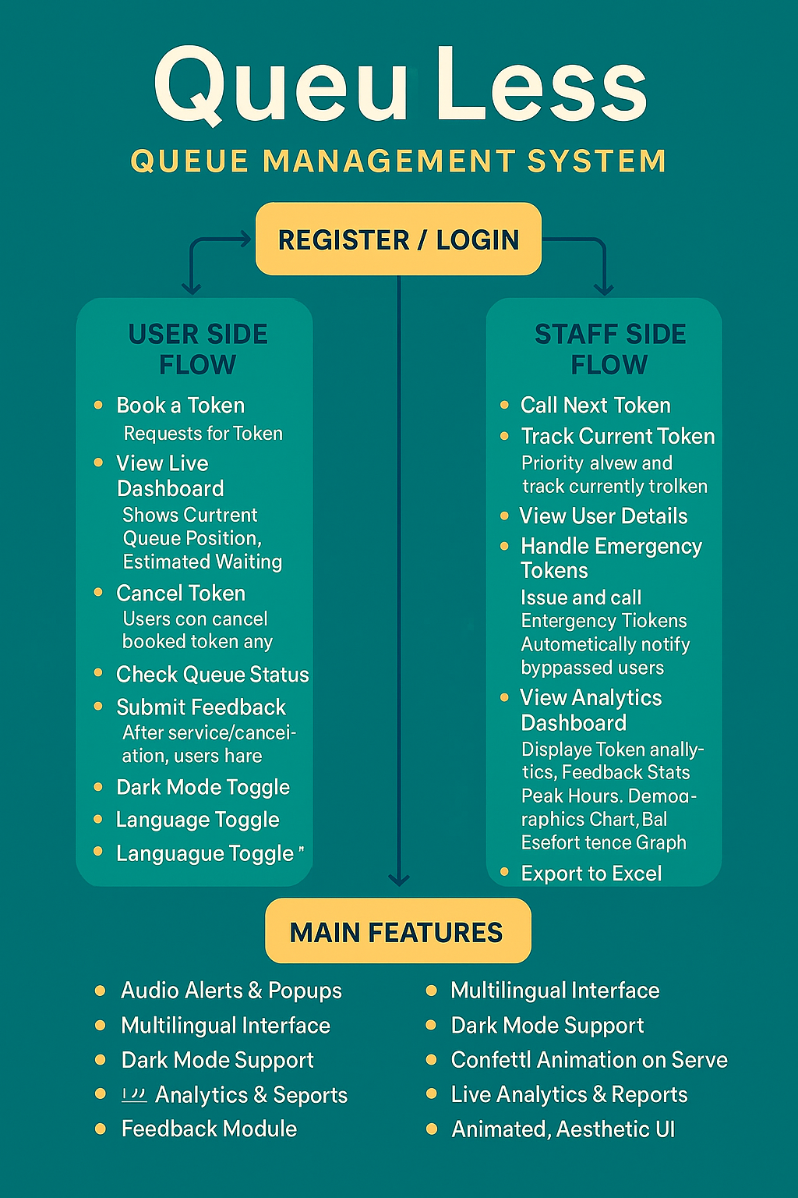

# 7. Implementation Summary

The project is implemented with a simple login system for staff, token issuance for users, and queue visualization. Token data is stored in a MySQL database. Staff can serve tokens one by one, triggering sound alerts and changing the token status. Emergency tokens are prioritized and bypassed users are notified. All tokens are analyzed in real-time in the analytics module. The interface includes aesthetic styling, animations, dark mode support, and language toggle features.

# 8. Future Enhancements

• SMS/Email notifications

• Admin panel for full control

• API integration for mobile apps

• Token printout system

# 9. Conclusion

QueuLess provides a compact and effective solution to the common problem of long waiting lines. It enhances user satisfaction by simplifying the queuing process and equipping staff with powerful tools to handle crowd flow. The project serves as a practical and educational demonstration of full-stack development using PHP and MySQL.