A Mini Project Report
On
DRIVER DROWSINESS DETECTION SYSTEM
Submitted in partial fulfillment of the requirements for the End Semester Exam of
MINIPROJECT(CS3291)
In
Third Year Semester-II
By
BALASANI RAJESH(O190957)
VALAVALA RAJESWARI (O191021)
SHAIK NASEEMA(O190126)
MALAKA PRIYAMADHURI(O190787)
MELAM NARENDHRA BABU(O191106)
Under the Guidance of
Mr.M.KRISHNA
Assistant Professor Dept of CSE (I/C)
Department of Computer Science and Engineering

RAJIV GANDHI UNIVERSITY OF KNOWLEDGE TECHNOLOGIES – A.P.
ONGOLE CAMPUS
Kurnool Road, ONGOLE, Prakasam Dt.,Andhra Pradesh-523225


BONAFIDE CERTIFICATE

This is to certify that the project entitled “DRIVER DROWSINESS DETECTION SYSTEM” being submitted by, BALASANI RAJESH(O190957), VALAVALA RAJESWARI(O191021), SHAIKNASEEMA(O190126), MALAKAPRIYAMADHURI(O190787), MELAM NARENDRA BABU(O191106) partial fulfillment of the Requirements for the award of the degree of the Bachelor of Technologies in Computer Science and Engineering to Rajiv Gandhi University of Knowledge Technologies-AP. ONGOLE Campus, is a record of bonafide work carried out under my supervision during the academic year 2023-24.extremely thankful and pay my gratitude to Mr.M.KRISHNA, (I/C) Assistant Professor, CSE, for his valuable guidance and support on the completion of this project.The report hasn’t been submitted previously in part or in full to this or any other university or institution for the award of any degree.

Mr.M.KRISHNA, Mr.N.MALLIKARJUNA,
Department of CSE, HOD CSE(I/C)
RGUKT,ONGOLE. Department of CSE,
RGUKT,ONGOLE

CERTIFICATE

This is to certify that the project entitled “DRIVER DROWSINESS DETECTION SYSTEM” being submitted by BALASANI RAJESH(O190957),VALAVALA RAJESWARI (O191021), SHAIK NASEEMA (O190126), MALAKA PRIYAMADHURI (O190787) and MELAM NARENDRA BABU(O191106) in partial fulfillment of the requirements for the End Semester Lab Exams and for award of the degree of the Bachelor of Technology in Computer Science and Engineering to Rajiv Gandhi University of Knowledge Technologies -A.P. ONGOLE Campus, is a bonafide work carried out by them under my guidance and supervision from March 2024 to June 2024.
The results presented in this project have been verified and found to be satisfactory. The results embodied in this project report have not been submitted to any other University for the award of any other degree or diploma.

Faculty-In-Charge Head Of The Department

Internal Examiner External Examiner

ACKNOWLEDGEMENT

We extend our sincere thanks to our Academic Dean Mr. MEESALA RUPAS KUMAR, for his encouragement and constant help.
It is our privilege to express a profound sense of respect, gratitude and indebtedness to our guide Mr. M.KRISHNA Assistant Professor(c), Department of Computer Science and Engineering,Rajiv Gandhi University Of Knowledge Technologies-A.P.,ONGOLE Campus,for her indefatigable inspiration, guidance, cogent discussion, constructive criticisms and encouragement throughout the dissertation work.
We express our sincere gratitude to Mr. NANDI.MALLIKARJUNA HOD CSE(i/c)-CSE for his suggestions,motivations and co-operation for the successful completion of the work.
We extend our sincere thanks to Prof.Dr.BHASKAR PATEL Director, RGUKT-AP, ONGOLE CAMPUS for his encouragement.

BALASANI RAJESH(O190957)
VALAVALA RAJESWARI(O191021)
SHAIK NASEEMA(O190126)
MALAKA PRIYAMADHURI(O190787)
MELAM NARENDRA BABU(O191106)

APPROVAL SHEET

This project entitled “DRIVER DROWSINESS DETECTION SYSTEM” submitted by Balasani Rajesh(O190957) ,Valavala Rajeswari(O191021),Shaik Naseema(O190126) ,Malaka Priyamadhuri(O190787) ,Melam Narendra babu(O191106) is approved by Mr.M.Krishna, Assistant Professor for the Degree of Bachelor of Technology in COMPUTER SCIENCE AND ENGINEERING.

Examiner:
_________________
_________________
_________________

Supervisor:
_________________
_________________
_________________
Date:________________
Place:________________

DECLARATION

We hereby declare that the project work entitles “DRIVER DROWSINESS DETECTION SYSTEM” submitted to the Rajiv Gandhi University Of Knowledge Technologies-A.P. ONGOLE Campus in partial fulfillment of the requirements for the End Semester Lab Exams of Third Year Semester-I in Computer Science and Engineering is a record of an original work done by us under the guidance of Mr.M.KRISHNA ASSISTENT PROFESSOR CSE(i/c), Dept. of Computer Science and Engineering and this project work have not been submitted to any university for the award of any other degree or diploma.

BALASANI RAJESH(O190957 ) _____________________
VALAVALA RAJESWARI (O191021) _____________________
SHAIK NASEEMA(O190126) _____________________
MALAKA PRIYAMADHURI(O190787) _____________________
MELAM NARENDRA BABU(O191106) _____________________
Date:
Place:

ABSTRACT

Driver Drowsiness Detection is a significant cause of road accidents in world wide,to prevent these accidents we will build a system using python,Open CV, Keras which will helps to alert the user when he/she feels sleepy and This project include eye monitoring,facial recognition. We seen huge number of people driving on the highway day and night and also people travelling long distances so they suffer from lack of sleep and drowsy driving can be dangerous as driving under the influence of alcohol,These reasons will lead to the causes of the accident So,Our Project Drowsiness Detection will prevent accidents that are caused by Drowsiness.

CONTENT
S.NO TITLE PAGE NO
1. INTRODUCTION 1
1.1 MOTIVATION
1.2 PROBLEM DEFINITION
1.3 OBJECTIVES OF THE PROJECT
2. LITERATURE REVIEW 4
3. ANALYSIS 5
3.1 EXISTING SYSTEM
3.2 PROPOSED SYSTEM
3.3 SOFTWARE REQUIREMENT SPECIFICATION
4. DESIGN 8
4.1 UML DIAGRAMS
5. IMPLEMENTATION 21
5.1 MODULES
5.2 MODULES DESCRIPTION
5.3 INTRODUCTION OF TECHNOLOGIES USED
5.4 SAMPLE CODE
6. TESTING 30
6.1 UNIT TESTING
6.2 INTEGRATION TESTING
6.3 BLACKBOX TESTING
6.4 WHITE BOX TESTING
7. RESULT 34
8. CONCLUSION 38
9. FUTURE ENHANCEMENT 39
10. BIBLIOGRAPHY 41

1.INTRODUCTION

Driver Drowsiness is a critical issue that poses a significant risk to road safety. Fatigue and drowsiness can impair a driver attention,reaction time,and decision-making abilities,leading to an increased likelihood of accidents. According to studies,drowsy driving can be as dangerous as driving under the influence of alcohol. To address this problem,driver drowsiness detection system have been developed using computer vision and machine learning techniques. These system aim to monitor the drivers behavior and alert them when signs of drowsiness are detected,allowing them to take necessary measures to prevent accidents .The driver drowsiness detection system discussed in this project utilizes computer vision algorithms to analyze the drivers eye behavior and determine if they are becoming drowsy. By monitoring the eye aspect ratio(EAR),Which measures the openness of the eyes, the system can identify patterns associated with drowsiness or eye closure.
The core idea behind this system is to detect changes in the driver eye behavior indicative of drowsiness. When the eye aspect ratio falls below a certain threshold for a specific number of consecutive frames,it triggers an alarm of warning to alert the driver .This can be in the form of a sound, visual message,or a combination of both. The system uses the dlib library for face detection and facial landmark prediction .It tracks the position of the eyes in real-time and calculates the eyes aspect ratio based on the distances between specific landmarks on the face. By continously monitoring the eye aspect ratio, the system can detect when the driver eye are closing or becoming drowsy. In this project,we will implement the driver drowsiness detection system using python and the OpenCV, dlib and pygame libraries. we will explain the code implementation ,describe the underlying concepts,and provide improvements and application to the system to further enhance driver safety on the roads.

1.1 MOTIVATION
The motivation behind driver drowsiness detection is to enhance road safety and prevent accidents caused by drowsy driving. By implementing real-time drowsiness detection system ,we aim to:
1.Enhance road safety by alerting driver when they exhibit sings of drowsiness
2.prevent accidents by intervening before drowsiness leads to impaired driving.
3.Mitigate human error by compensating for cognitive and physical limitations caused by fatigue.
4.Increase awareness about the dangers of drowsy driving and promote responsible driving
behavior.
5.Ensure compliance with regulations and guidelines related to driver safety and fatigue
management.
6.Take advantage of technological advancement in computer vision and machine learning
develop accurate and reliable drowsiness detection methods.
Overall,the motivation into leverage technology to detect and address driver drowsiness, reducing the risk and consequences associated with drowsy driving.

1.2 PROBLEM DEFINITION
The problem is to detect and address driver drowsiness to prevent accidents caused by fatigue while driving. The goal is to develop a system that can monitor driver in real-time,detect signs of drowsiness,and provide timely alerts or warnings to ensure driver safety and prevents accidents on the road. The challenge is to accurate identify drowsiness indicators,design an effective detection algorithm, and create a non-intrusive and reliable system can operate in various driving conditions.
1.3. OBJECTIVE OF THE PROJECT
The objectives of the project is to develop a driver drowsiness detection system that utilizes computer vision techniques to monitor and detect signs of drowsiness in real-time. The primary goal is to enhance road safety by alerting drivers when they exhibit drowsiness symptoms, allowing them to take necessary measures to prevent accidents. the projects aims to implementation an efficient and accurate algorithm that analyzes facial features,particularly eye behavior,to determine drowsiness levels. the system should provide timely alerts or warnings to the driver, encouraging them to rest or take appropriate actions to combat fatigue. Overall the objectives is to develop a practical and effective solution for mitigating the risk of drowsy driving

2. LITERATURE SURVEY

[1] Python-Based Algorithms for Driver Drowsiness Detection:A Review by Sharma, A…,& Singh,G.(2021): This survey explores various python-based algorithms and techniques used in driver drowsiness detection system. it disscuss different approaches, such as image processing machine learning and deep learning,implemented using python libraries like OpenCV, Scikit-learn, andTensorFlow.
[2] A Survey of python-Based Drowsiness detection system for drivers by Guptha,R& Shaerma,P.(2020): This survey specifically investigates vision-based driver drowsiness detection systems developed using python. it provides an overview of different Python libraries,such as dlib, face_recognization and keras, and their application in tasks like facial landmark analysis.
[3] Python-Based Sensor integration Techniques for Driver Drowsiness Detection:A Review by Varma,A,,&Maheshwari,p.(2020): This survey focuses on python-based sensor integration techniques fro driver drowsiness detection. It explores the integration of various sensors,such as cameras, accelerometers, and heart rate monitors,using Python libraries like OpenCV, NumPy, and pandas. The survey also discuss the challenges ad performances evaluation methods.
[4] A Review of Python-Based Deep Learning Models for Driver Drowsiness Detection Patel,R..,etal.(2020): This survey provides an overview of Python-based deep learning models used in driver drowsiness detection. It discuss the implementation of convolutional neural networks(CNNs),recurrent neural networks (RNNs),and hybrid models using Python frameworks like TensorsFLow and Keras.The survey also compares different architecture and datasets..

3. ANALYSIS

3.1 EXISTED SYSTEM
In early we seen so many applications one of the existed system we refers EYE TRACKING SYSTEM’ it is a eye tracking based drowsiness detection system focus on monitoring the drivers eye movements and eyelid behaviour . By analyzing parameters such as eye closure duration,eye blink rate, or eye aspect ratio,these systems can determine the drivers drowsiness.

3.2 PROPOSED SYSTEM
Based on the EYE TRACKING SYSTEM we creating the ’DRIVER DROWSINESS DETECTION’ in which it is detecting drowsiness by computer vision techniques in additionally we added the ALERT GENERATION in this to alert the driver,the system uses pygame to play an alarm sound continously when drowsiness is detected.

3.3. SOFTWARE REQUIREMENT SPECIFICATION

Software Requirements:
The software requirements fo this project include the following
1.PYTHON:The code provided is written in python,so you will need to have python installed on your system. It is recommended to uses python 3.6version.
2.LIBRARIES AND DEPENDENCIES: The project relies on several python libraries and dependencies including:
-scipy: User for distance calculations in the eye_aspect_ratio function.
-dlib: Required for face detection and shape prediction.
-OpenCV2: Used for image processing and video capturing.
-imutils: Provides covenience function for resizing and manipulating images.
-pygame: Used for playing the alarm sound.
3.PRE-TRAINED SHAPE PREDICTOR MODEL: The code uses a pre-defined shape predictor
model file (‘shape_predictor_68_face_landmark.dat’) for facial landmark detection. You need to download this model file and specify is correct path in the code.
4.AUDIO FILE: The code includes an alarm sound file(‘alarm.wav’)that is played when drowsiness is detected.
5.WEBCAM OR VIDEO SOURCE: The code is set to capture video frames (device) index0 if you are using a different video sources, such as an external webcam or a video file you can modify the code uses the appropriate video source.

Hardware Requirements:

Personal Computers, Laptops, Tablets,Smart Phones , e.t.c.,
Processor: Dual-core or higher
RAM: 2GB or more
Storage: 100GB HDD/SDD or Higher
Network Interface: Ethernet or Wi-Fi for internet connectivity

3.3.1 PURPOSE
The Purpose of this project is to develop a driver drowsiness detection system using computer vision techniques to enhance road safety by alerting drivers when they show of drowsiness.

3.3.2 SCOPE
The Scope of the driver drowsiness detection project includes real-time monitoring of the drivers eye behaviour,calculation of the eye aspect ratio,generating alerts for drowsiness detection,video processing and display,utilization of relevant libraries and models,single-user application,platform compatability,and documentation and reporting. The project aims to provide a practical and platform independent solution for detecting driver drowsiness using computer vision techniques.

3.3.3 OVERALL DESCRIPTION
The Driver drowsiness detection project aims to develop a system that utilizes computer vision techniques to detect signs of drowsiness in drivers. The project focuses on monitoring the drivers eye behavior and providing timely alerts to prevent accidents caused by drowsy driving.The system employs a webcamor video source to capture real-time video frames of the driver face.It utilizes the dlib library for face detection and shape prediction to locate and track the driver face in the video feed. By identifying specific facial landmarks,particularly the eye regions, the system's calculates the eye aspect ratio,which is a reliable indicator of drowsiness. The eye aspect ratio is determine by measuring the distances between certain points on the eye countours. When the eye aspect ratio falls below a predefined threshold,it signifies that the drivers eye are exhibiting characteristics associated with drowsiness At this point,this system triggers on alert to notify the driver and prompt them to take appropriate action.
The primary objectives of the project to enhance road safety by detect driver drowsiness alerting drivers to prevent accidents caused by inattentiveness or falling asleep at the wheel. The system provides approach to address the critical issue of drowsiness driving and contribute to mitigating road accidents associated with driver fatigue.

4.DESIGN
4.1 UML DIAGRAMS
A UML Diagram is based on UML(Unified Modeling Language)with the purpose of visually representing a system along with its main actors, roles, actions, artifacts or classes, in order to better understand, alter, maintain ,or document information about the system. The UML diagrams are divided into Structural and Behavioural UML Diagrams.

4.1.1 STRUCTURAL UML DIAGRAMS:
Structural diagrams depict a static view of a structure of a system.It is widely used in the Documentation of software architecture. The Structural UML Diagrams involves 6 diagrams
They are:
- Class Diagram
- Object Diagram
- Component Diagram
- Composite Diagram
- Package Diagram
- Deployment Diagram
- Profile Diagram

4.1.2 BEHAVIOURAL UML DIAGRAMS:
Behavioural diagrams potray a dynamic view of a system or the behaviour of a system which describes the functioning the system. It involves diagrams They are:

- Use Case Diagram
- State Machine Diagram
- Timing Diagram
- Communication Diagram
- Sequential Diagram
- Interaction diagram
- Activity Diagram

CLASS DIAGRAM

The class diagram is the main building block of object-oriented modeling. It is used for general conceptual modeling of the structure of the application, and for detailed modeling translating the models into programming code. Class diagrams can also be used for data modelling.

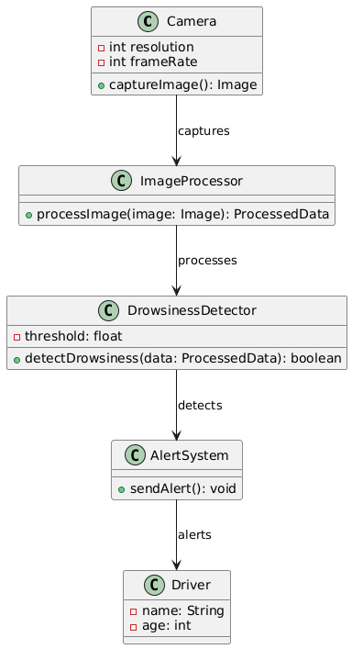

OBJECT DIAGRAM
It describes the static structure of a system at a particular point in time. It can be used to test the accuracy of class diagrams. It represents distinct instances of classes and the relationship between them at a time.

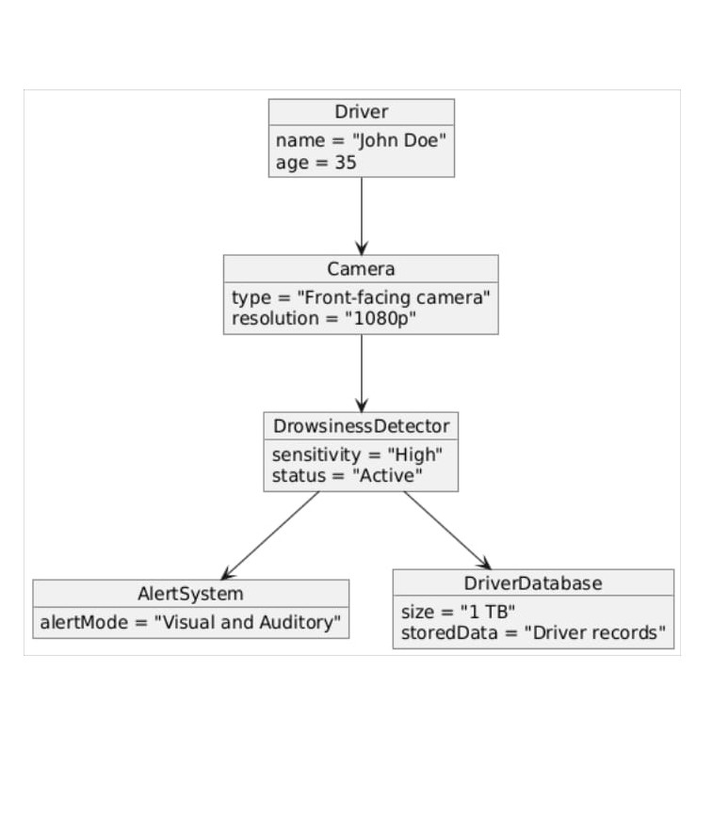

PACKAGE DIAGRAM

Package diagrams are used, in part, to depict import and access dependencies between packages,
classes, components, and other named elements within your system. Each dependence is rendered as a connecting line with an arrow representing the type of relationship between the two or more elements.

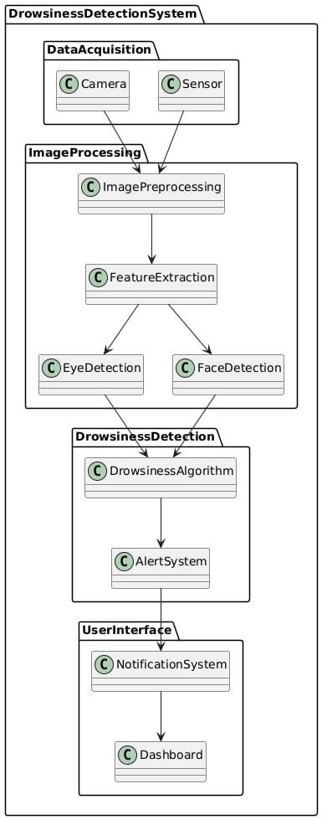

DEPLOYMENT DIAGRAM

A deployment diagram is a UML diagram type that shows the execution architecture of a system, including nodes such as hardware or software execution environments, and the middleware connecting them. Deployment diagrams are typically used to visualize the physical hardware and software of a system.

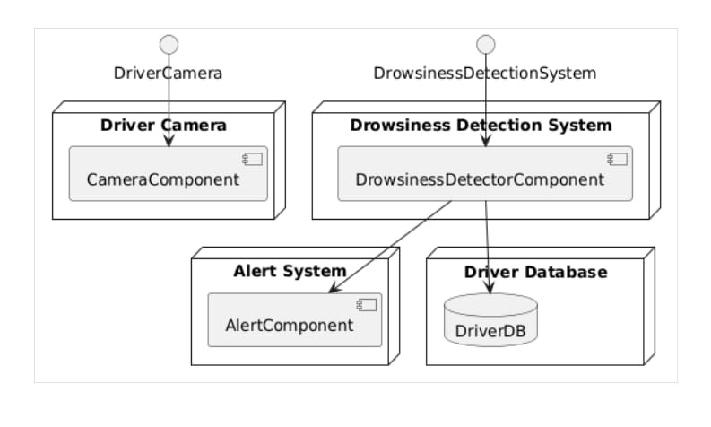

SEQUENTIAL DIAGRAM

A sequence diagram consists of a group of objects that are represented by lifelines and the messages that they exchange over time during the interaction. A sequence diagram shows the sequence of messages passed between objects. Sequence diagrams can also show the control structures between objects.

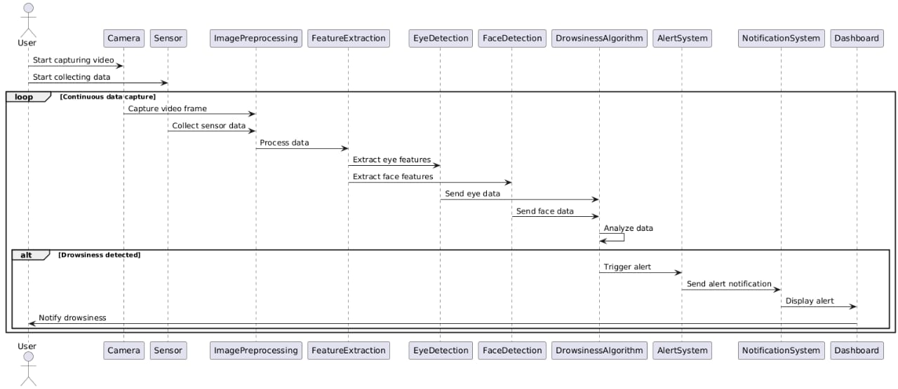

COMMUNICATION DIAGRAM

A Communication diagram models the interactions between objects or parts in terms of sequenced messages. Communication diagrams represent a combination of information taken from Class, Sequence, and Use Case Diagrams describing both the static structure and dynamic behavior of a system.

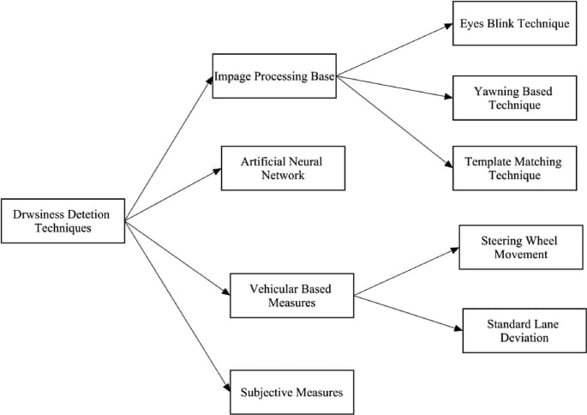

ACTIVITY DIAGRAM

An activity diagram visually presents a series of actions or flow of control in a system similar to a flowchart or a data flow diagram. Activity diagrams are often used in business process modeling. They can also describe the steps in a use case diagram. Activities modeled can be sequential and concurrent.

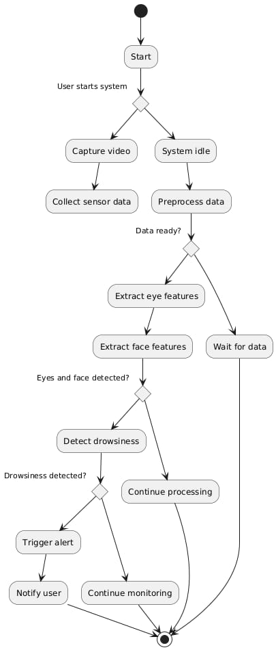

INTERACTION OVERVIEW DIAGRAM

An interaction diagram is a type of UML diagram that's used to capture the interactive behavior of a system. Interaction diagrams focus on describing the flow of messages within a system, providing context for one or more lifelines within a system.

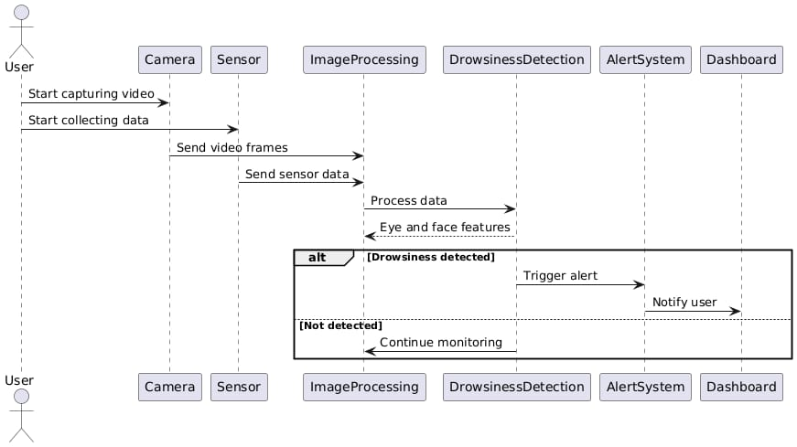

STATE MACHINE DIAGRAM

A state diagram, also known as a state machine diagram or statechart diagram, is an illustration ofthe states an object can attain as well as the transitions between those states in the Unified Modeling Language (UML).

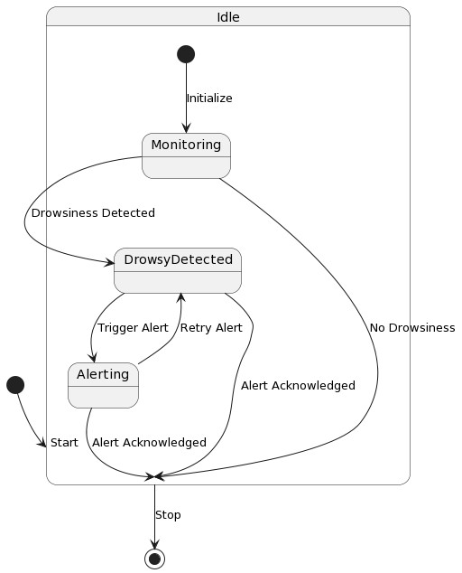

TIMING DIAGRAM

A timing diagram includes timing data for at least one horizontal lifeline, with vertical messages exchanged between states. Timing diagrams represent timing data for individual classifiers and interactions of classifiers. You can use this diagram to provide a snapshot of timing data for a particular part of a system.

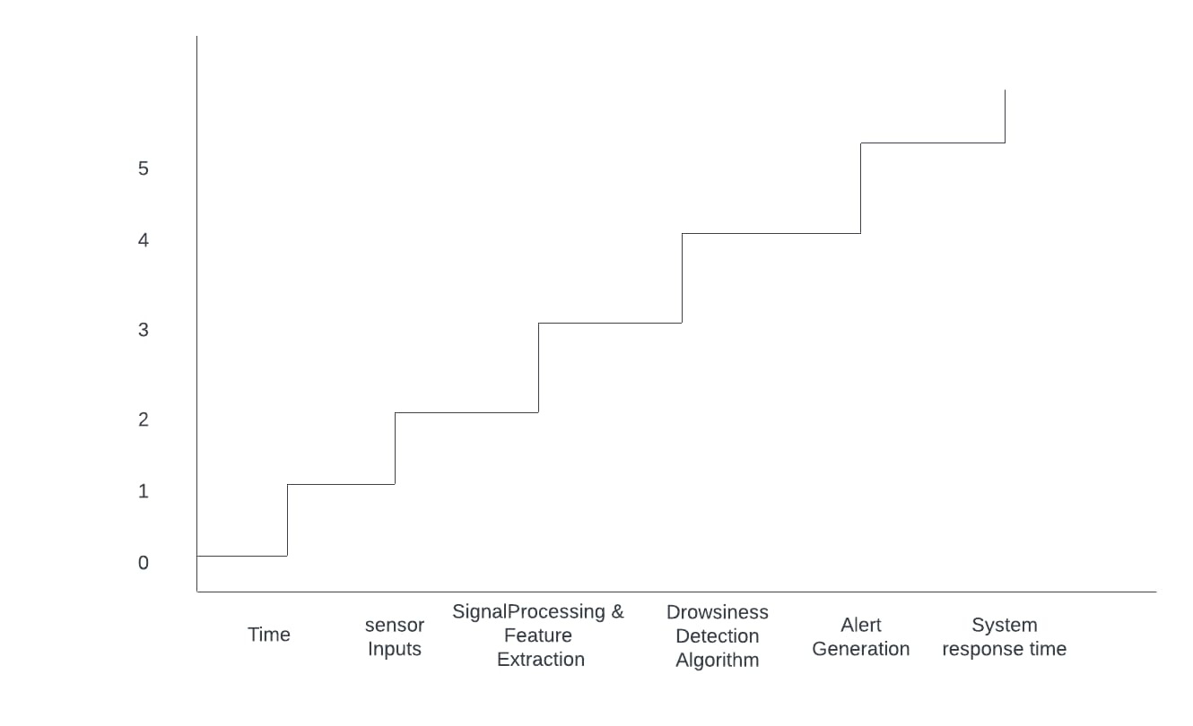

USE CASE DIAGRAM
Use-case diagrams describe the high-level functions and scope of a system. These diagrams also identify the interactions between the system and its actors. The use cases and actors in use case diagrams describe what the system does and how the actors use it, but not how the system operates internal.

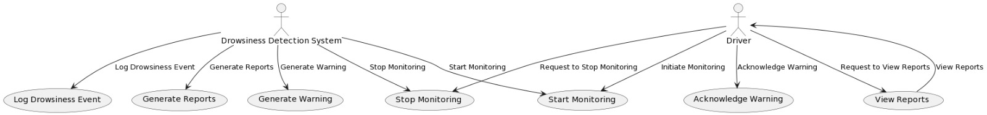

COMPONENT DIAGRAM

Component diagrams are used in modeling the physical aspects of object-oriented systems that are
used for visualizing, specifying, and documenting component-based systems and also for constructing
executable systems through forward and reverse engineering.Component diagrams are essentially
class diagrams that focus on a system's components that often used to model the static view of diagram.

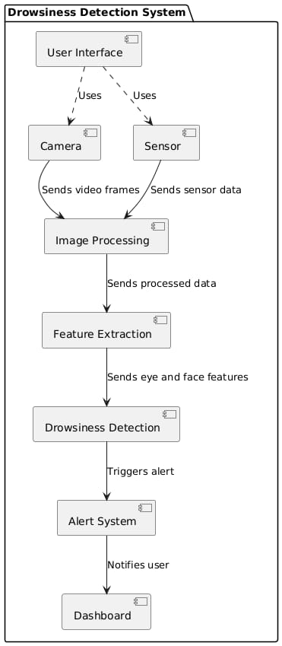

5.IMPLEMENTATION

5.1. MODULES:
- Data Retrieval Module
- Preprocessing Module
- Feature Selection Module
- Model Training Module
- Prediction Module
- Evaluation Module
- Deployment Module
- Logging and Feedback Module
5.2. MODULE DESCRIPTION:
1.Data Retrieval Module:
- Sensors: Collects data from various sensors such as cameras (for eye and facial monitoring), steering angle sensors, and possibly heart rate monitors.
- Data Acquisition: Interfaces with the sensors to gather data in real-time or from a dataset.
2.Preprocessing Module:
- Data Cleaning: Handles noise reduction and removal of irrelevant data.
- Normalization: Scales the data to a uniform range to improve the performance of the machine learning models.
- Feature Extraction: Extracts relevant features such as eye closure duration, head position, yawning frequency, and others.
3.Feature Selection Module:
- Dimensionality Reduction: Uses techniques like Principal Component Analysis (PCA) to reduce the number of features while retaining essential information.
- Selection Algorithms: Selects the most relevant features for model training using methods like recursive feature elimination.

4.Model Training Module:
- Algorithm Selection: Chooses appropriate machine learning algorithms (e.g., Support Vector Machines, Random Forests, Convolutional Neural Networks).
- Training: Trains the chosen model(s) on the preprocessed and selected features from the dataset.
- Validation: Validates the model using techniques like cross-validation to ensure it generalizes well to new data.
5.Prediction Module:
- Real-time Monitoring: Applies the trained model to real-time data to predict driver drowsiness.
- Alert System: Triggers alerts (e.g., sounds, vibrations) if drowsiness is detected

6.Evaluation Module:
- Performance Metrics: Evaluates the model’s performance using metrics such as accuracy, precision, recall, and F1-score.
- Confusion Matrix: Analyzes the true positives, false positives, true negatives, and false negatives to understand the model’s performance in detail.

7.Deployment Module:
- Integration: Integrates the system into the vehicle’s onboard system or a mobile application.
- User Interface: Provides a user-friendly interface to display alerts and status to the driver.
- Maintenance: Includes mechanisms for regular updates and improvements to the model based on new data.

7.Logging and Feedback Module:
- Feedback Loop: Allows users to provide feedback on the system’s performance, which can be used to retrain and enhance the model.
- Data Logging: Logs data for continuous learning and improvement of the model.

5.3 INTRODUCTION OF TECHNOLOGIES USED:
Introduction to Python programming Language:
Python(language):The code provided is written in python,ensure that you have Python installed on your system. It is recommended to use Python 3.6 for compatibility with the mentioned libraries.
2.MACHINE LEARNING LIBRARIES AND DEPENDENCIES:
The project relies on several Python libraries and dependencies,including:
scipy:
Usage: Used for scientific and technical computing. In this project, it is specifically used for calculating distances in the eye_aspect_ratio function.
Dlib:
Usage: A toolkit that provides machine learning algorithms and tools for creating complex applications. In this project, it is used for face detection and shape prediction.
OpenCV (cv2):
Usage: An open-source computer vision library that provides tools for image and video processing. It is used for capturing video from the webcam and processing images.
Imutils:
Usage: A set of convenience functions to make basic image processing functions such as translation, rotation, resizing, skeletonization, and displaying Matplotlib images easier with OpenCV.
pygame:
Usage: A set of Python modules designed for writing video games. In this project, it is used for playing the alarm sound when drowsiness is detected.

Implementing the driver drowsiness detection project involves the following
STEPS:
1.Set Up the Development Environment:Intsall python and the necessary (scipy,dlib OpenCV,imutils,pygame)
using pip.Download the pre-trained shape predictor model(shape_predictor_68_face_landmarks.dat’)and store
it in the appropriate directory.
2.Import Required Libraries:Import the required libraries in your python script,including scipy,dlib,cv2,imulits,
and pygame.
3.Define the Eye Aspect Ratio Function:Implement the ‘eye_aspect_ratio’function,which calculates the eye
aspect ratio based on the distance between specific points on the eye countors.
4.Initialize Variables and Thresholds:Set up variables for frame check,count, and threshold values. These
variables determine when to trigger the drowsiness alarm based on the eye aspect ratio.
5. Set Up Video:Capture :Initialize the video captuure obejct(using the webcam or other video source) and
start reading video frames in a while loop.
6.Process Video Frames:Within the while loop,read each video frame,resize,it and convert it to grayscale.
Apply the face detection algorithm to detect faces in the frame. Iterate over each detected face and perform
facial landmark detection using the shape predictor model.
7.Calculte Eye Aspect Ratio: Exact the eye regions using the facial landmark and calculate the eye aspect ratio
for each eye. Take the average of the left and right eye aspect ratios.
8.Drowsiness Detection and Alarm:If the calculated eye aspect ratio falls below the defined threshold,increment
the count variables.if the count exceeds the frame check value,play the alarm sound using pygame and display
a warning messageon the video frame.
9.Rest Count and Alarm: If the eye aspect ratio is above the threshold,reset the count variables and stop the
alarm sound.
10.Display video frame:Draw countours sround the eye on the video frame fro visualizartion.Display the frame
with the added countors and warning message using cv2.imshow. Its important to note that the provided code
is a basic implementation outline, and you may need to customize and optimize it according to your specific
requirement and environment.

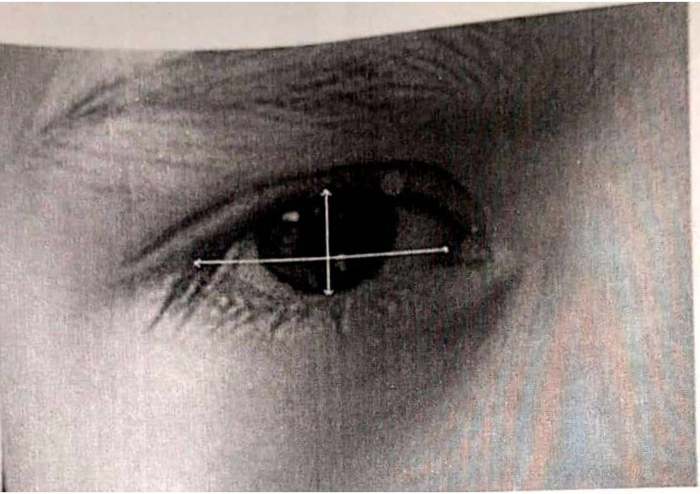
Eyes with horizontal and vertical distances marked for eye Aspect Ratio calculation Now we check if the
ratio value is less than 0.25(0.25 was chosen as a base case after some tests).If it is less an alarm is sounded
and user is warned.

5.4 SAMPLE CODE
from scipy.spatial import distances
import dlib
import cv2
from imutils import face_utils
import imutils
import pygame
def eye_aspect_ratio(eye):
a=distance.euclidean(eye[1],eye[5])
b=distance.euclidean(eye[2],eye[4])
c=distance.euclidean(eye[0],eye[3])
ear=(a+b)/(2.0*c)
return ear
pygame.mixer=0.25
pygame.mixer.music.load(‘/home/student/Desktop/ddd/alarm.Wav)
thresh=0.25
frame_check=50
count=0
detect=dlib.get_frontal_face_detector()
predict=dlib.shape_predictor(“/home/student/Desktop/ddd/shape_predictor_68_face_landmarks.dat”)
(Istart,Iend)=face_utils.FACIAL_LANDMARKS_68_IDXS[“left_eye”]
(rstart,rEnd)=face_utils.FACIAL_LANDMARKS_68_IDXS[“right_eye”]
cap=cv2.VideoCapture(0)
while True:
ret,frame=cap.read()
frame=imutiles.resize(frame,width=900)
gray=cv2.cvtColor(frame,cv2.COLOR_BGR2GRAY)
subjects=detect(gray,0)

for subject in subjects:
shape=predict(gray,subject)
shape=face_utils.shape_to_np(shape)
leftEye=shape[Start:Iend]
rightEye=shape[rStart:rEnd]
leftEyeHull=cv2.convexHull(leftEye)
rightEyeHull=cv2.convexHull(rightEye)
leftEyeAspectRatio=eye_aspect_ratio(leftEye)
rightEyeAspectRatio=eye_aspect_ratio(rightEye)
EyesAspectRatio=(leftEyeAspectRatio+rightEyeAspectRatio)/2
cv2.drawCountours(frame,[leftEyeHll],-1,(0,255,0),1)
cv2.drawCountours(frame,[rightEyeHull],-1,(0,255,0),1)
if EyeAspectRatio<thresh:
count+=1
if count>=frame_check:
pygame.mixer.music.play(-1)
cv2.putText(frame,” Driver is Drowsy”,(150,100),cv2.FONT_HERSHEY_SIMPLEX, 1.5,
(0,0,255),2)
else:
pygame.mixer.music.stop()
count=0
cv2.imshow(“Frame”,frame)
key=cv2.WaitKey(1)
if Key==ord(“q”0
break
cv2.destroyA||WIndows()
cap.release()

detect=dlib.get_frontal_face_detector()
predict=dlib.shape_predictor(“/home/student/Desktop/ddd/
shape_predictor_68_face_landmarks.dat”)
(Istart,Iend)=face_utils.FACIAL_LANDMARKS_68_IDXS[“left_eye”]
(rstart,rEnd)=face_utils.FACIAL_LANDMARKS_68_IDXS[“right_eye”]
cap=cv2.VideoCapture(0)
while True:
ret,frame=cap.read()
frame=imutiles.resize(frame,width=900)
gray=cv2.cvtColor(frame,cv2.COLOR_BGR2GRAY)
23subjects=detect(gray,0)
for subject in subjects:
shape=predict(gray,subject)
shape=face_utils.shape_to_np(shape)
leftEye=shape[Start:Iend]
rightEye=shape[rStart:rEnd]
leftEyeHull=cv2.convexHull(leftEye)
rightEyeHull=cv2.convexHull(rightEye)
leftEyeAspectRatio=eye_aspect_ratio(leftEye)
rightEyeAspectRatio=eye_aspect_ratio(rightEye)
EyesAspectRatio=(leftEyeAspectRatio+rightEyeAspectRatio)/2
cv2.drawCountours(frame,[leftEyeHll],-1,(0,255,0),1)
cv2.drawCountours(frame,[rightEyeHull],-1,(0,255,0),1)
if EyeAspectRatio<thresh:
count+=1
if count>=frame_check:
pygame.mixer.music.play(-1)
cv2.putText(frame,” Driver is Drowsy”,(150,100),cv2.FONT_HERSHEY_SIMPLEX, 1.5,

(0,0,255),2)
else:
pygame.mixer.music.stop()
count=0
cv2.imshow(“Frame”,frame)
rightEyeAspectRatio=eye_aspect_ratio(rightEye)
EyesAspectRatio=(leftEyeAspectRatio+rightEyeAspectRatio)/2
cv2.drawCountours(frame,[leftEyeHll],-1,(0,255,0),1)
cv2.drawCountours(frame,[rightEyeHull],-1,(0,255,0),1)
if EyeAspectRatio<thresh:
count+=1
if count>=frame_check:
pygame.mixer.music.play(-1)
cv2.putText(frame,” Driver is Drowsy”,(150,100),cv2.FONT_HERSHEY_SIMPLEX, 1.5,
(0,0,255),2)
else:
pygame.mixer.music.stop()
count=0
cv2.imshow(“Frame”,frame)
key=cv2.WaitKey(1)
if Key==ord(“q”0
break
cv2.destroyA||WIndows()
cap.release()

6.TESTING
6.1 Unit testing:
Unit testing, a testing techniques using which individual modules are tested to determine If there are issues by the developer himself.it is concerned with functional correctness of there standalone modules. The main aims to isolate each unit of the system to identify, analyze and fix the defects.
Unit Testing Techniques:
Black Box Testing:Using which the user interface,input and output are tested.
White Box Testing:Used to test each one of those function behavior is tested.
User Interface Testing: User interface testing, a testing technique used to identify the presence of defects is a product/software under test by Graphical User Interface [GUI]
6.2 Integration Testing:
Integration Testing done upon completion of unit testing,The units or modules are to be integrated which gives raise too integration testing. The purpose of integration testing is to verify the functional ,performance, and reliability between the modules that are integrated.
6.3 BlackBox Testing:
Over View: Black-box testing focuses on testing the functionality of the system without any knowledge of the internal code structure, implementation details, or internal paths. Testers evaluate the system by providing inputs and examining the outputs. This type of testing is often referred to as behavioral or functional testing.

Application in Driver Drowsiness Detection System
1.Functional Testing:
  - Verify that the system accurately detects drowsiness and triggers alerts when the driver’s eyes are closed for a specified period.
  - Test the system’s response to various facial expressions and head movements to ensure it distinguishes between drowsy and non-drowsy states.

- Usability Testing:
  - Ensure the user interface displays alerts and notifications clearly and understandably.
  - Assess the system’s ease of use and how well it integrates with the vehicle’s existing dashboard and controls.
- Performance Testing:
  - Measure the system’s response time from detecting drowsiness to triggering an alert.
  - Evaluate the system’s performance under different lighting conditions, camera angles, and driver positions.
- Error Handling:
  - Test how the system handles situations where the camera is obstructed or when there are multiple faces in the frame.
  - Verify that the system recovers gracefully from sensor failures or interruptions in video feed.
Example test cases for blackbox testing:
- Test Case 1: Verify that the system triggers an alarm when the driver’s eyes are closed for more than 2 seconds.
- Test Case 2: Ensure that the system does not trigger a false alarm when the driver blinks or looks away momentarily.
- Test Case 3: Test the system’s ability to detect drowsiness in different lighting conditions (daylight, night, artificial light).
6.4 WhiteBox Testing:
Overview:White-box testing involves testing the internal structures, code, and logic of the system. Testers have full visibility into the codebase and can design tests that examine specific code paths, conditions, loops, and data structures. This type of testing is also known as structural, glass-box, or clear-box testing.

Application in Driver Drowsiness Detection System
- Unit Testing:
  - Test individual functions such as eye_aspect_ratio to ensure they return the correct calculations.
  - Verify the accuracy of face and eye detection algorithms by examining the output of dlib and OpenCV functions.
- Code Coverage:
  - Ensure that all branches and conditions in the code are tested to achieve high code coverage.
  - Use tools like coverage.py to measure which parts of the code are executed during testing.
- Path Testing:
  - Examine all possible execution paths within the system to identify and test edge cases and potential logical errors.
  - Verify the system’s behavior under various sequences of events, such as continuous eye closure, rapid blinking, and head movement.
- Integration Testing:
  - Test the interactions between different modules, such as video capture, face detection, and alarm triggering.
  - Ensure that data flows correctly between components and that integrated modules work together as expected.
Example test cases for blackbox testing:
- Test Case 1: Verify that the eye_aspect_ratio function correctly calculates the aspect ratio for various eye positions.
- Test Case 2: Ensure that all branches in the drowsiness detection algorithm are tested, including normal eye movement, eye closure, and rapid blinking.
- Test Case 3: Test the interaction between the video capture module and the facial landmark detection to ensure data is processed accurately and efficiently.

Test ID | Test Case Title | Test Condition | System Behaviour | Expected Result
T01 | TC01 | Straight Face,  Good Light, with  Glasses | Drowsy | Drowsy
T02 | TC02 | Tilted Face, Good  Light, No glasses | Drowsy | Drowsy
T03 | TC03 | Glasses | Drowsy | Drowsy

7.RESULT

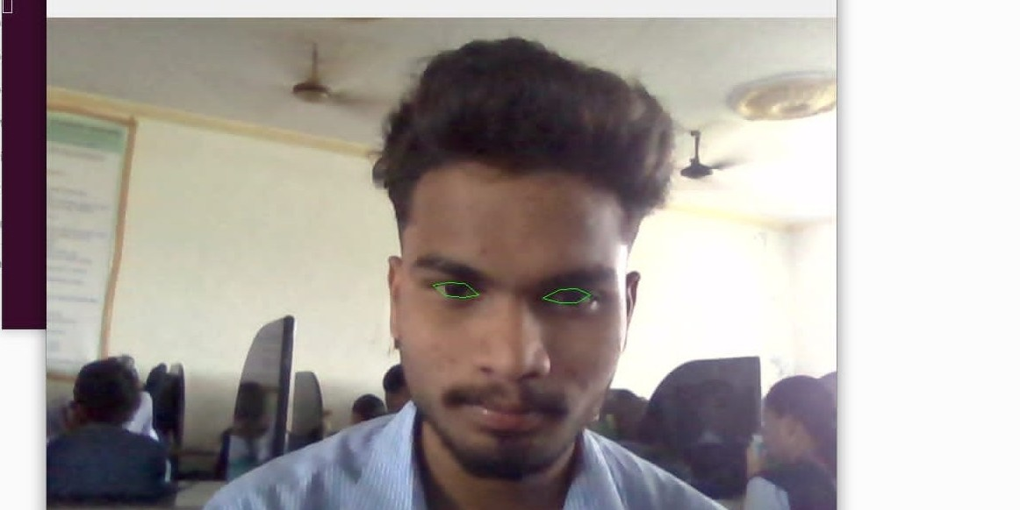

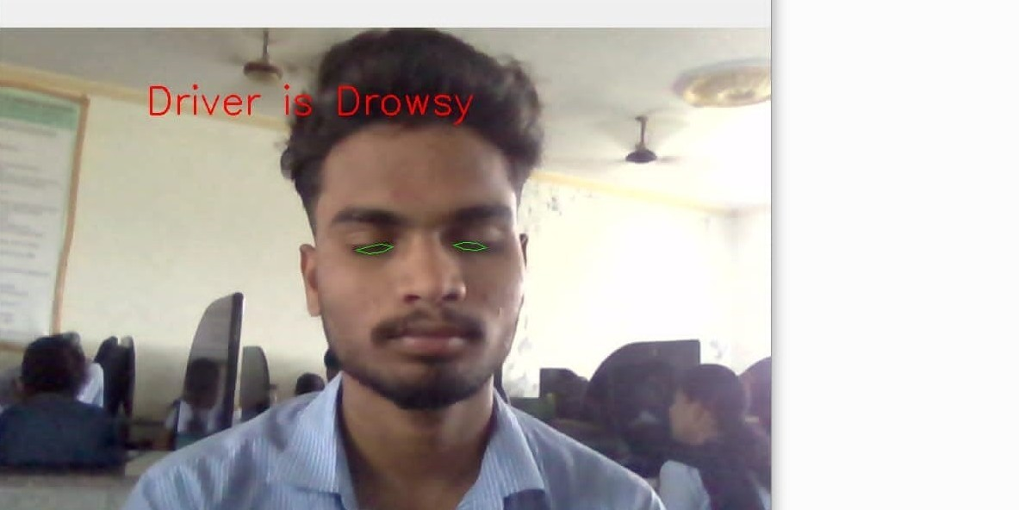

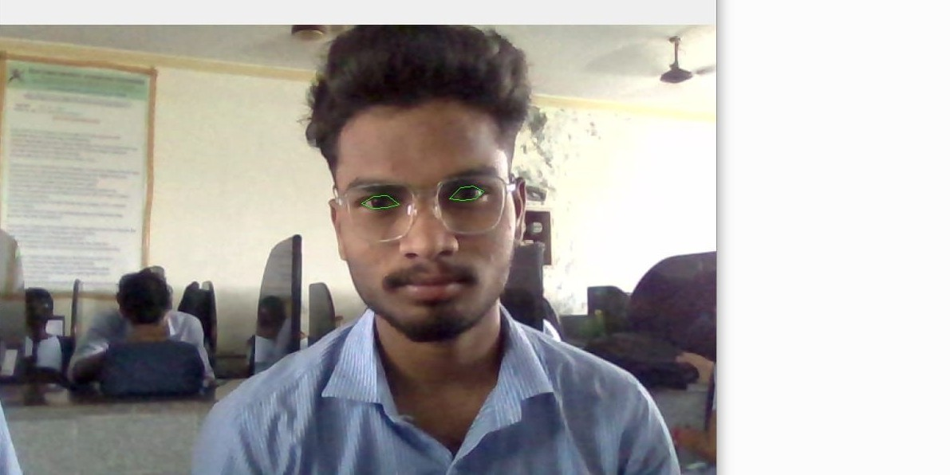

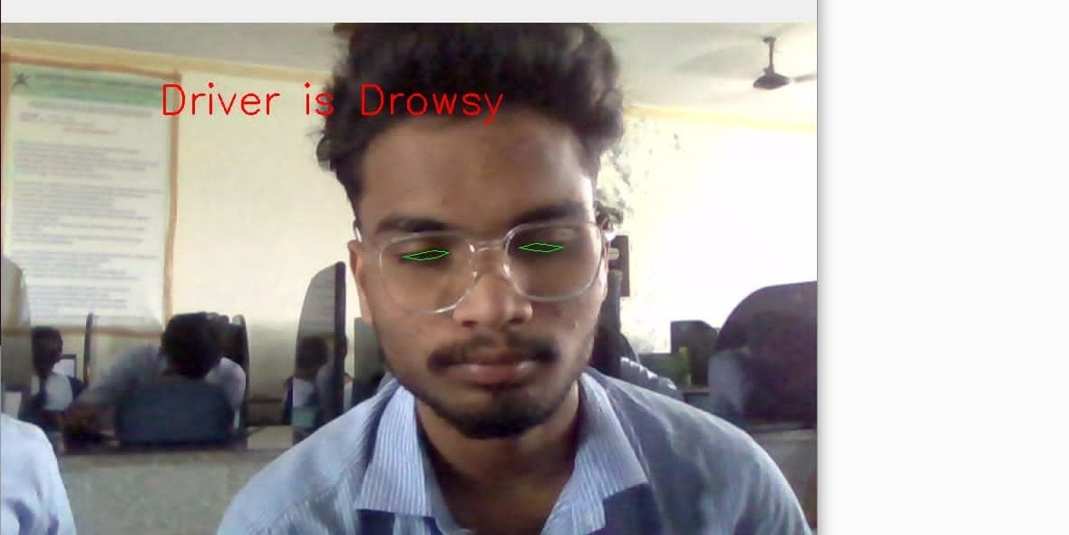

8.CONCLUSION

It completely meets the objectives and requirements of the system's.The framework has acieved an unfaltering state where all the bugs have been disposed of the framework cognized clients who are familiar with the framework and comprehend its focal points and the fact that it takes care of the issues of stressing out for individuals having fatigue- related issues to inform them about the drowsiness level while driving. A low cost,real time driver drowsiness monitoring system has been proposed based on visual behaviour and machine learning aaproach.Here,visual behaviour features like eyeaspect ratio,mouth opening ratio and nose length ratio are computed from the streaming video,captured by webcam.An self-developed image-processing algorithm (python based algorith) using machinelearning technique has been developed to detect driver drowsinesss in real time.

9.FUTURE ENHANCEMENT

Future Enhancements
For future enhancements, several avenues can be explored to further improve the drowsiness detection.
1. Advanced Sensor Integration
Multi-Sensor Fusion:
- Integrate additional sensors such as heart rate monitors, steering wheel sensors, and EEG sensors to provide more comprehensive data for drowsiness detection.
- Combine data from multiple sensors using sensor fusion techniques to improve detection accuracy.
Infrared and Night Vision Cameras:
- Use infrared or night vision cameras to improve detection accuracy in low-light or nighttime conditions.
- Ensure the system works effectively in all lighting conditions, enhancing its usability for night drivers.
2. Machine Learning and AI Enhancements
Deep Learning Models:
- Implement more advanced deep learning models, such as convolutional neural networks (CNNs) and recurrent neural networks (RNNs), to improve the accuracy of drowsiness detection
- Train models on larger and more diverse datasets to enhance their ability to generalize to different drivers and conditions.
Real-time Adaptive Learning:
- Develop adaptive learning algorithms that can adjust to individual driver behaviors and patterns over time, improving personalized detection accuracy.
- Implement online learning techniques to continuously update the model based on new data.

3. Improved User Interface and Alerts
Customizable Alerts:
- Allow users to customize the type and frequency of alerts based on their preferences, such as audio, visual, or haptic feedback.
- Implement a graded alert system that provides escalating alerts based on the severity of drowsiness detected.
User-Friendly Interface:
- Design a more intuitive and user-friendly interface for both the driver and fleet management systems.

4. Integration with Vehicle Systems
Autonomous Driving Assistance:
  - Integrate the drowsiness detection system with autonomous driving features to take control of the vehicle in case of severe drowsiness detected.
  - Implement automatic braking or lane-keeping assistance to prevent accidents when drowsiness is detected.
Fleet Management Integration:
  - Integrate with fleet management systems to provide real-time monitoring and reporting of driver alertness for commercial fleets.
  - Enable remote monitoring and intervention by fleet managers in case of drowsiness detection.
5. Behavioral and Environmental Context Awareness
Contextual Awareness:
  - Incorporate environmental factors such as road conditions, traffic density, and weather conditions to provide context-aware drowsiness detection.

10.BIBLIOGRAPHY
For successfully completing our project. We have taken help from the following website’s links:

Websites:

These are the websites that we are referred while doing this project.

- Opencv Website: OpenCV
- Dlib Website: Dlib
- TensorFlow Hub: TensorFlow Hub
- SciPy Website: SciPy
- Python Software Foundation Website: Python.org
- IEEE Research Papers:to foster technological innovation and excellence for the benefit of humanity.
- GitHub: Explore repositories related to driver drowsiness detection system on GitHub
- Stack Overflow Website: Stack Overflow

