Contents
1. Introduction 1
2. Objectives 1
3. Tools and Technologies 2
4. Interface Design and Wireframe 2
5. Application Interface 3
6. Source Code 4
6.1 Class and component declarations 4
6.2 Change Text button 4
6.3 Background colour buttons 4
7. How the Application Works 5
8. complete the Actual Result column after testing the program 5
Challenges and Solutions 5
Conclusion 6

Introduction
This project is a basic interactive Graphical User Interface (GUI) developed in Java using the Swing library. It demonstrates how to create a window, display text and an image, and respond to button clicks. It is a beginner-level exercise in building desktop interfaces.

2. Objectives
- Create a desktop window using Java Swing.
- Display a heading and the developer’s name.
- Display an image or icon inside the application window.
- Allow the user to change the displayed text.
- Allow the user to change the panel background using colour buttons.
- Practise using Swing components and event listeners.

Tools and Technologies
- Programming language: Java
- GUI library: Java Swing (javax.swing)
- Layout and graphics classes: java.awt
- Development environment: IntelliJ IDEA
- Wireframe tool: Balsamiq (if this is the tool you used)

4. Interface Design and Wireframe
The wireframe is used to plan the interface before or during implementation. It shows the approximate arrangement of the image placeholder, heading, author name, and buttons. It is a design guide rather than the working application.

5. 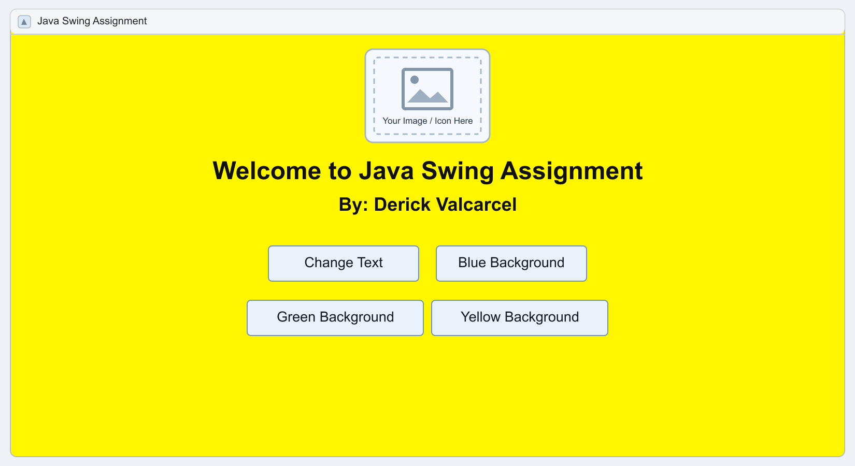

Application Interface
The running application displays a heading and the developer’s name, an image or icon, and buttons for changing the text and panel background colour.

6. 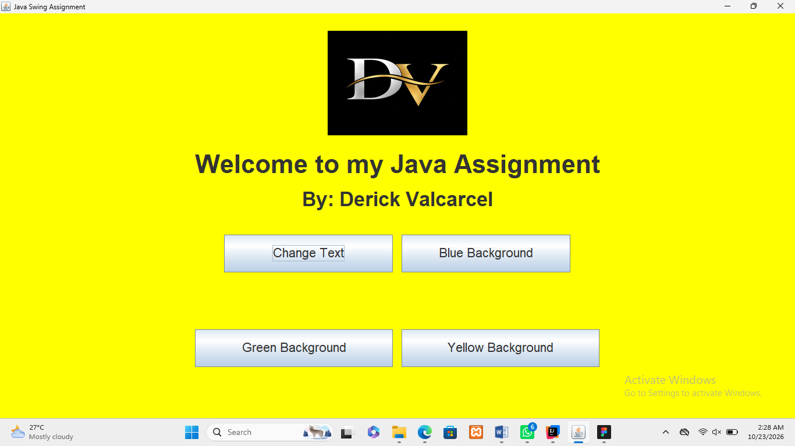

Source Code
The Java source code creates the window and adds Swing components. Action listeners specify what happens when the user clicks a button.

6.1 Class and component declarations
The program uses a JFrame for the window, a JPanel to hold components, a JLabel for text or image content, and JButton objects for user interaction.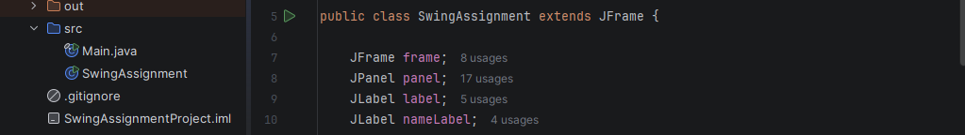

Change Text button
The Change Text button opens an input dialog. If the user enters non-empty text, the label is updated.
6.3 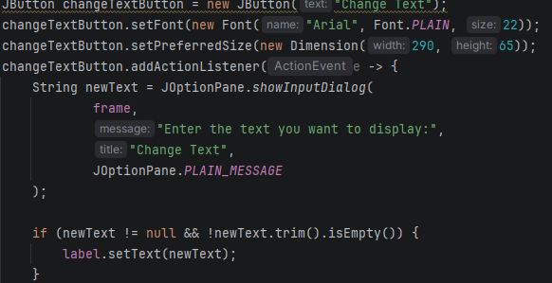

Background colour buttons
The Blue Background, Green Background, and Yellow Background buttons change the panel background when clicked. This demonstrates event handling in Swing.
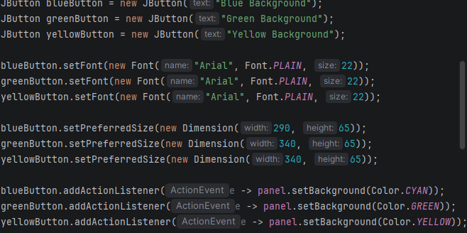

How the Application Works
- When the program starts, it creates and displays the application window.
- The heading and developer name are displayed in a label.
- The image or icon is loaded and displayed at the chosen size.
- Clicking Change Text opens a dialog for entering new text.
- Clicking a background colour button changes the panel colour.
- The user can close the application using the window close button.
- 8. Testing

- complete the Actual Result column after testing the program.
Test | Expected result | Actual result
Run program | Application window opens. | Write result here
Click Change Text | Input dialog opens and label can update. | Write result here
Click Blue Background | Panel changes to cyan/blue. | Write result here
Click Green Background | Panel changes to green. | Write result here
Click Yellow Background | Panel changes to yellow. | Write result here
Load image | Image appears at a suitable size. | Write result here

Challenges and Solutions
A possible challenge is displaying an image that is too large for the application window. Scaling the image before displaying it can solve this. If an image does not appear, check that it is in the expected folder and that the filename and path in the code are correct.
Another challenge is arranging components in the desired order. Using a suitable layout manager and separate panels for button rows can help keep the interface organised.

Conclusion
This project demonstrates the fundamentals of creating an interactive desktop GUI with Java Swing. It uses labels, buttons, an image, layout managers, input dialogs, and action listeners. The project provides practical experience in arranging interface components and responding to user actions. Add the screenshots requested in this document to show the wireframe, running application, and important sections of the source code.

