**Smart Reminder**

Database before

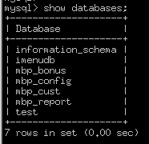

Database After

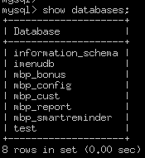

Menu before

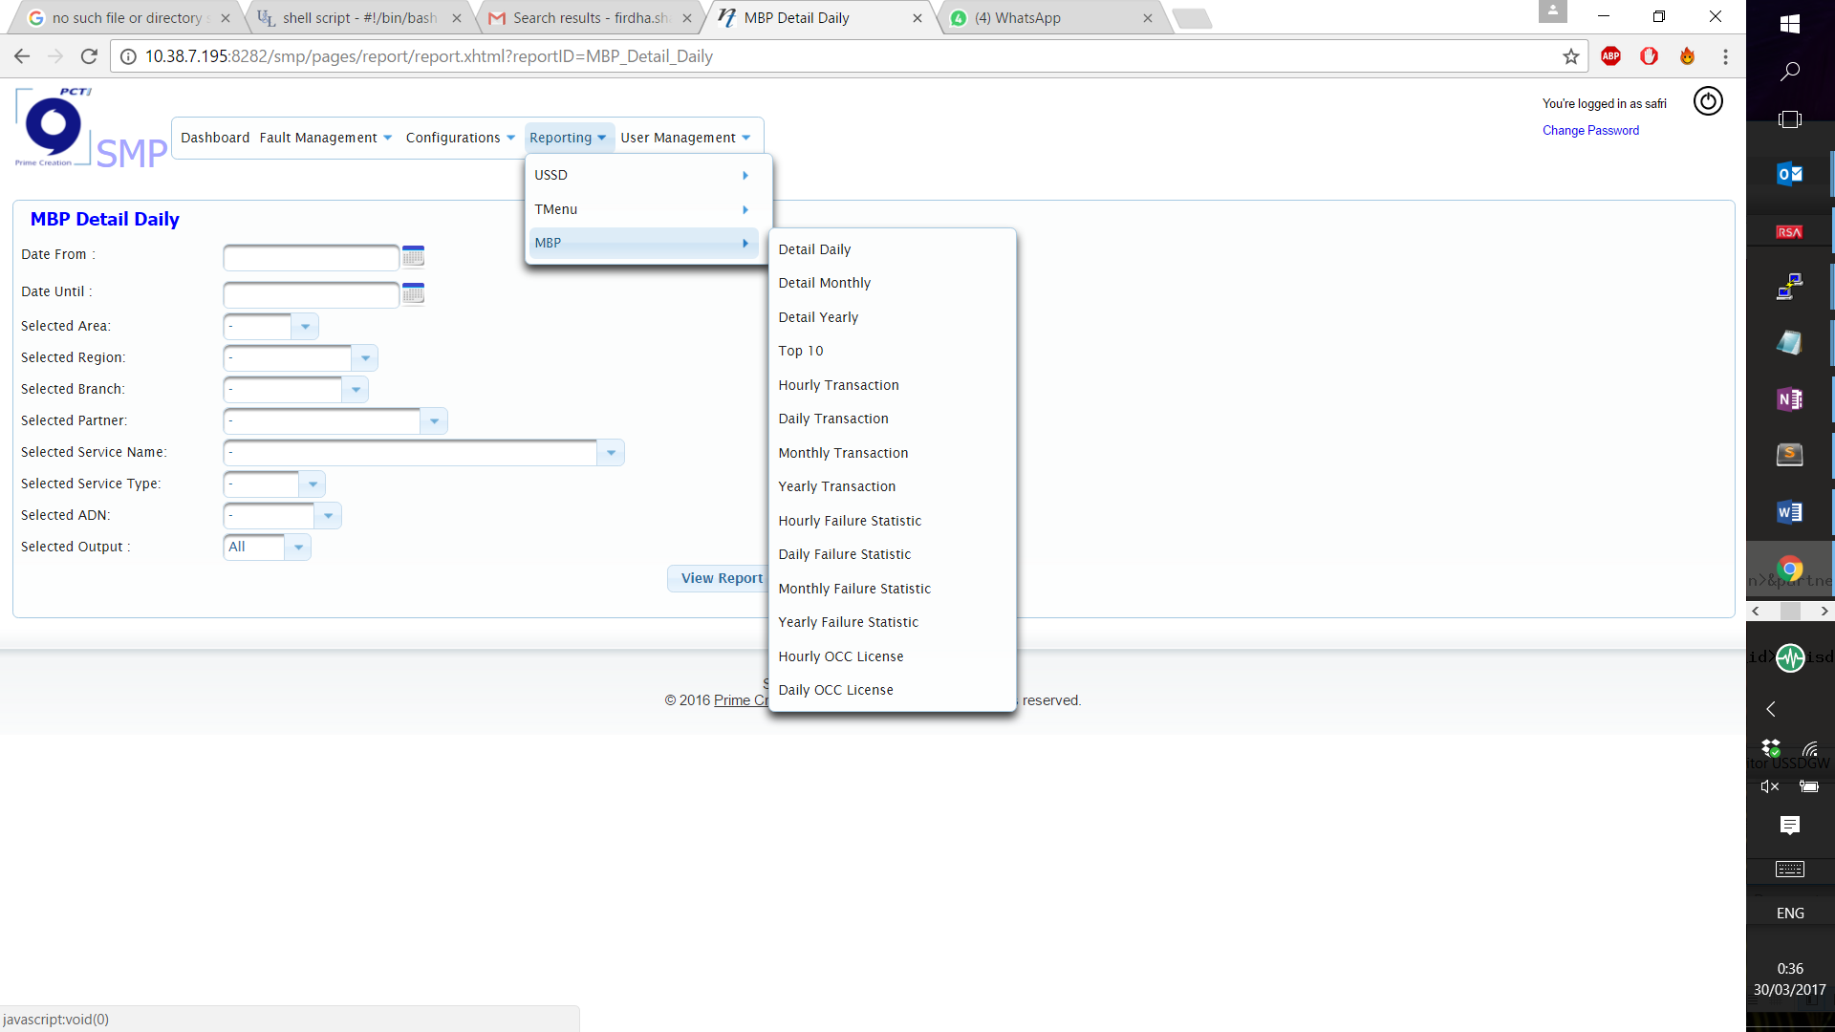

Menu after

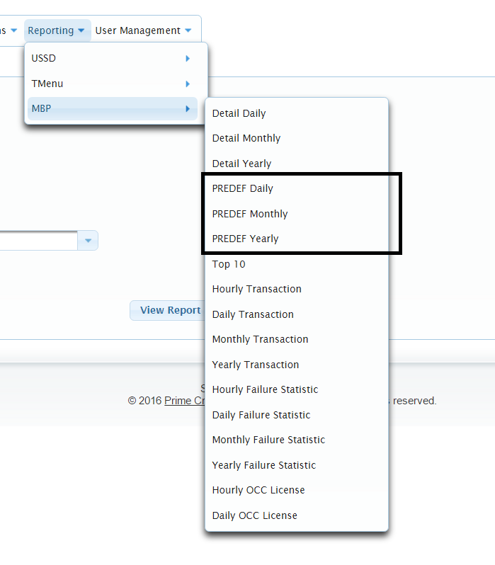

Report detail before

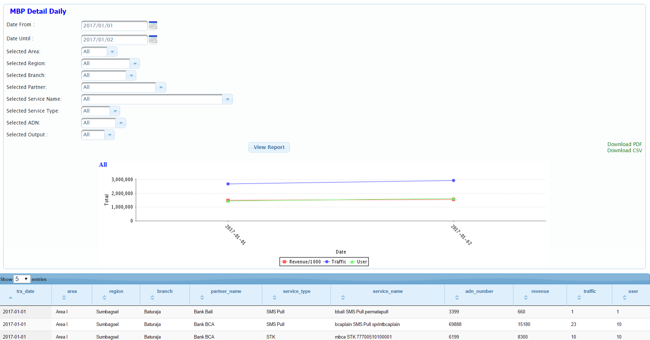

**MBP Dashboard**

Dashboard Before:

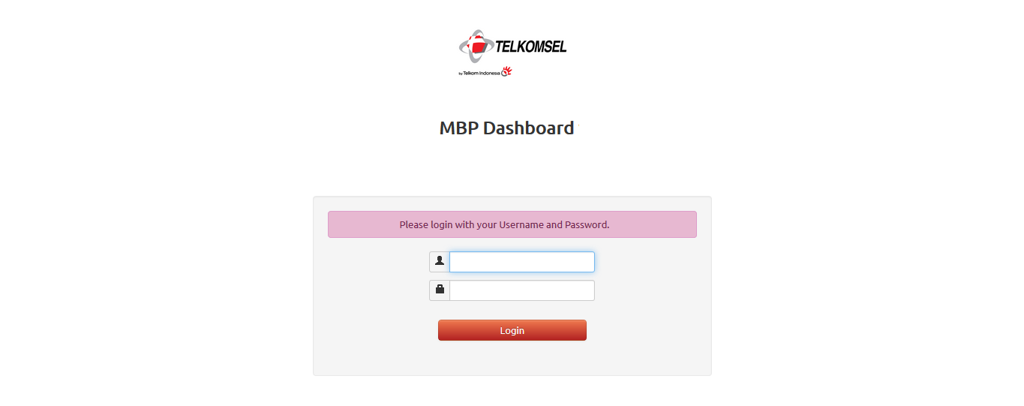

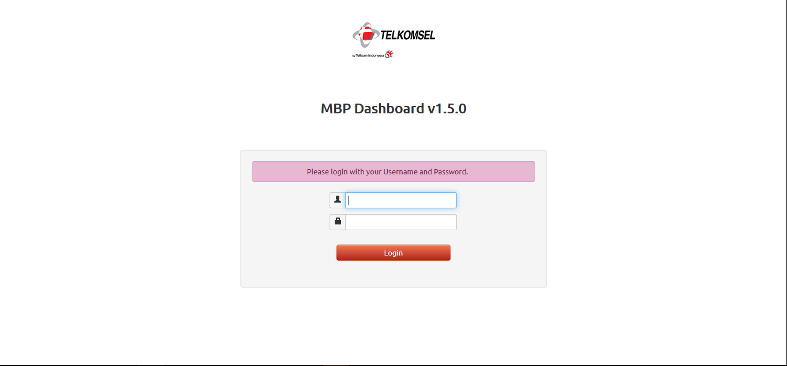Dashboard After:

**DSP**

1. DSP Process

**Before**there is no dsp process on tmenu MBP

**After**   
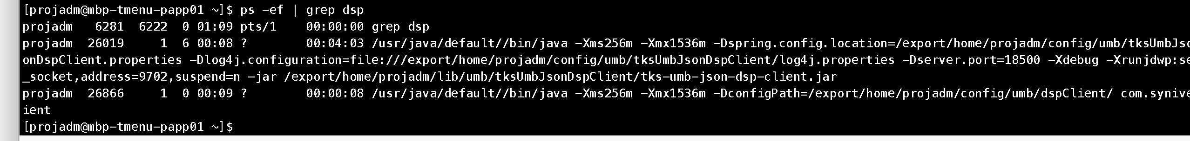

2. DSP connection  
  
**Before**there is no dsp connection on tmenu MBP

**After   
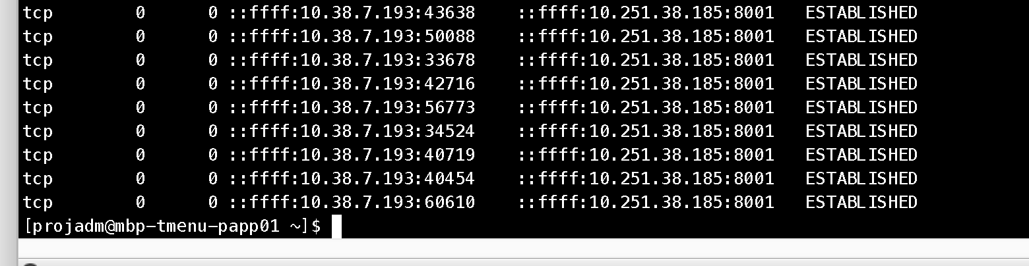**

Dsp client of Tmenu MBP is connected with DSP server

**3. LOG file**  
**Before**there is no dsp log on tmenu MBP

**After**   
