LinkFixer Web Application
User Manual
Contents

1. Introduction
1.1. What is it?
1.2. Who can use it?
2. General information
2.1. System overview
2.2. Contact
3. Setting up the LinkFixer Web Application
3.1. Install Xwiki
3.2. Install LinkChecker
3.3. Install Curl
3.4. Import LinkFixer.WebHome.xar in the XWiki
3.5. User Access
4. Using the system
4.1. How are the different links fixed
4.2. Parameter Value Include warnings
4.3. Output file
4.4. Recursion depth
4.5. Number of threads
4.6. Number of noFollow links
4.7. Linkchecker result file
4.8. Domain to fix
4.9. Submit and abort
4.10. LinkFix

Introduction
This user guide documents the use of the LinkFixer Web Application.

What is it?
The LinkFixer Web Application implements automated fixing of broken links for XWiki CMS, fixing content and storing the necessary site documents.

Who can use it?
The LinkFixer Web Application is made as such that it can be used by anybody with average computer skills. No special system administration and programming skills are required.
General information

System overview
1.Web interface for user friendly input setting configuration.
2. Launch LinkCheker to view the broken links
3. Launch LinkFixer to automatically fix 10 different types of broken links found by LinkCheker
4. User guide that explains the usage/setup of the project

The LinkFixer Web Application allows input of data through manual input into the entry grids.

Contact
Requests for access to, inquiries on the use of the software, and comments on the design and functionalities of the application should be written in https://github.com/EdmundsOzolins/LinkFixer/issues .
Setting up the LinkFixer Web Application

This chapter describes the different steps you should take to get the application up and running.

Install Xwiki
All installations are available on the following URL: https://www.xwiki.org/xwiki/bin/view/Documentation/AdminGuide/Installation/.

Install LinkChecker
All installations are available on the following URL:
https://github.com/wummel/linkchecker/blob/master/doc/install.txt.

sudo apt install python2
curl https://bootstrap.pypa.io/get-pip.py --output get-pip.py
sudo python2 get-pip.py
sudo pip2 install LinkChecker

Install Curl
All installations are available on the following URL: https://www.luminanetworks.com/docs-lsc-610/Topics/SDN_Controller_Software_Installation_Guide/Appendix/Installing_cURL_for_Ubuntu_1.html
https://curl.haxx.se/download.html.

Import LinkFixer.WebHome.xar in the XWiki
Download LinkFixer.WebHome.xar file from the following URL: https://github.com/EdmundsOzolins/LinkFixer/blob/master/LinkFixer.WebHome.xar.
Import LinkFixer.WebHome.xar in the Xwiki. All import instructions are available on the following URL: https://www.xwiki.org/xwiki/bin/view/Documentation/AdminGuide/ImportExport.

User Access
Ensure that the user has edit rights.
Use [your_site]/xwiki/bin/view/LinkFixer/GUI for fixing broken links

Using the system

How are the different links fixed.
The table below explains how are the different links fixed:
Name | Description | Xwiki syntax | Fix
Implicit URL | Converts to url automatically | url | Delete
Explicit URL | As implicit, but with extra [[]] | [[url]] | Delete
URL with label | Link which is hidden by custom label | [[label>>url]] | Change to label name
Link to email address | Like URL with label, but with mailto: | [[email>>mailto:email]] | Change to email
Link to image | A link to some image | [[image:url]] | Delete
Link on an image | Clicking this image results in following a link | [[image:url1>>url2]] | Delete
Attachment | Attaches some file | [[attach:file]] | Replace with name of file
Link that opens in a new window | Clicking on the link will open it in a new page | [[url||target=”_blank”]] | Delete
An url link | url | [[url:url]] | Delete
An ftp link | A link to a file | {{some file=”location”}} | Replace with name

The picture below shows how LinFixer Web Application looks like:
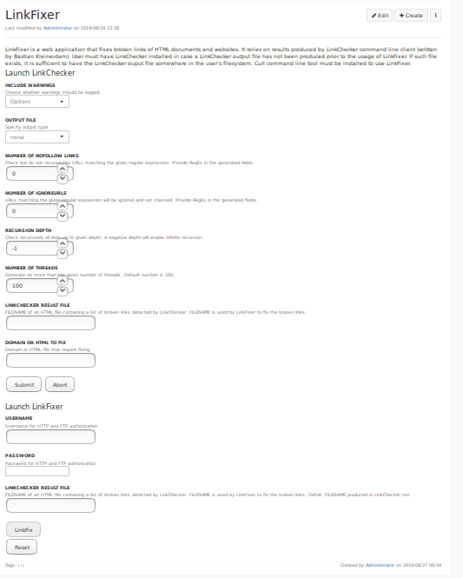

Include warnings
Yes - include warnings.
No - only errors.

Output file
Valid file output types are text, html, sql, csv, gml, dot, xml, sitemap, none or blacklist. Default is no file output. Note that you can suppress all console output with the option none.
text - Standard text logger, logging URLs in keyword: argument fashion.
html - Log URLs in keyword: argument fashion, formatted as HTML. Additionally has links to the referenced pages. Invalid URLs have HTML and CSS syntax check links appended.
csv - Log check result in CSV format with one URL per line.
gml - Log parent-child relations between linked URLs as a GML sitemap graph.
dot - Log parent-child relations between linked URLs as a DOT sitemap graph.
gxml - Log check result as a GraphXML sitemap graph.
xml - Log check result as machine-readable XML.
sitemap - Log check result as an XML sitemap whose protocol is documented at http://www.sitemaps.org/protocol.html.
sql - Log check result as SQL script with INSERT commands. An example script to create the initial SQL table is included as create.sql.
blacklist - Suitable for cron jobs. Logs the check result into a file ~/.linkchecker/blacklist which only contains entries with invalid URLs and the number of times they have failed.
none - Logs nothing. Suitable for debugging or checking the exit code.

Number of nofollow links
Check but do not recurse into URLs matching the given regular expression.

Number of ignoreurls
URLs matching the given regular expression will be ignored and not checked.
This option can be given multiple times.

Recursion depth
Check recursively all links up to given depth. A negative depth will enable infinite recursion. The maximum recursion level must not be exceeded.

Number of threads
Generate no more than the given number of threads. Default number of threads is 100. To disable threading specify a non-positive number.

Linkchecker result file
Create a new file and copy file path into the “Linkchecker result file”. The file type should be the same as “Output file”.

Domain or html to fix
Link of domain or html to fix.

Submit , reset and abort
Click on “Submit” button and wait for results to appear.
“Abort” button – abort the process.
“Reset” button – reset form fields.

Username, password
User must have edit rights.

LinkFix
Click on “LinkFix” button to fix broken links.

