# Session Form

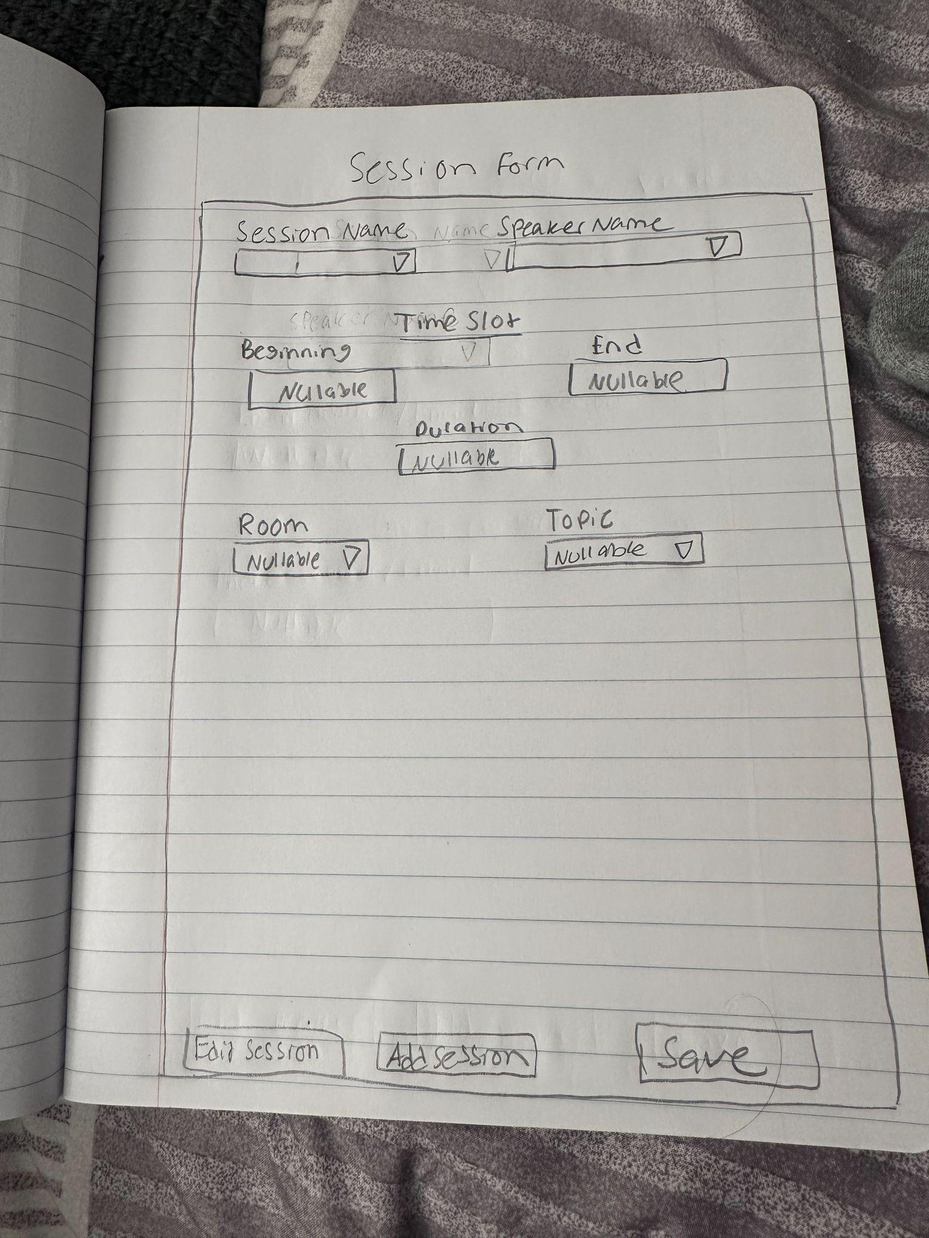

**Session Name** (Dropdown) this will be user defined name for the specific session

**Speaker Name** (Dropdown) selects from list of speakers that are registered

**Timeslot**(Dropdown) should auto populate if the field already exists

**Beginning** (Datetime Picker) choose start time

**End** (Datetime Picker) choose end time

**Duration** (Calculated Field) calculated using beginning and end time

**Room** (Dropdown) selects from available rooms

**Topic** (Dropdown) select from a list of predefined topics

**Edit Session** (Button) this will enable that ability to modify a session that is already existing, this will require a session selection

**Add Session** (Button) clears the form completely and will reset all the fields to empty values

**Save** (Button) this will validate information and commit the data to the database

### **Backend**

* **Database Tables**: Session Form
  + Sessions: session name, speaker, time, duration, topic, room, etc.
  + Speakers: speaker ID, name, bio, etc.
  + Topics: topic ID, name, category.
  + Rooms: room ID, name, capacity.

### **Frontend**

* Form layout with labeled fields and dropdowns.
* Date/time pickers for Beginning and End.
* Dynamic dropdowns populated from backend.
* Button handlers for Save, Edit, Add.
* Validation logic, this will help with making sure required fields are complete.

—----------------------------------------------------------------------------------------------------------------------

# Room form

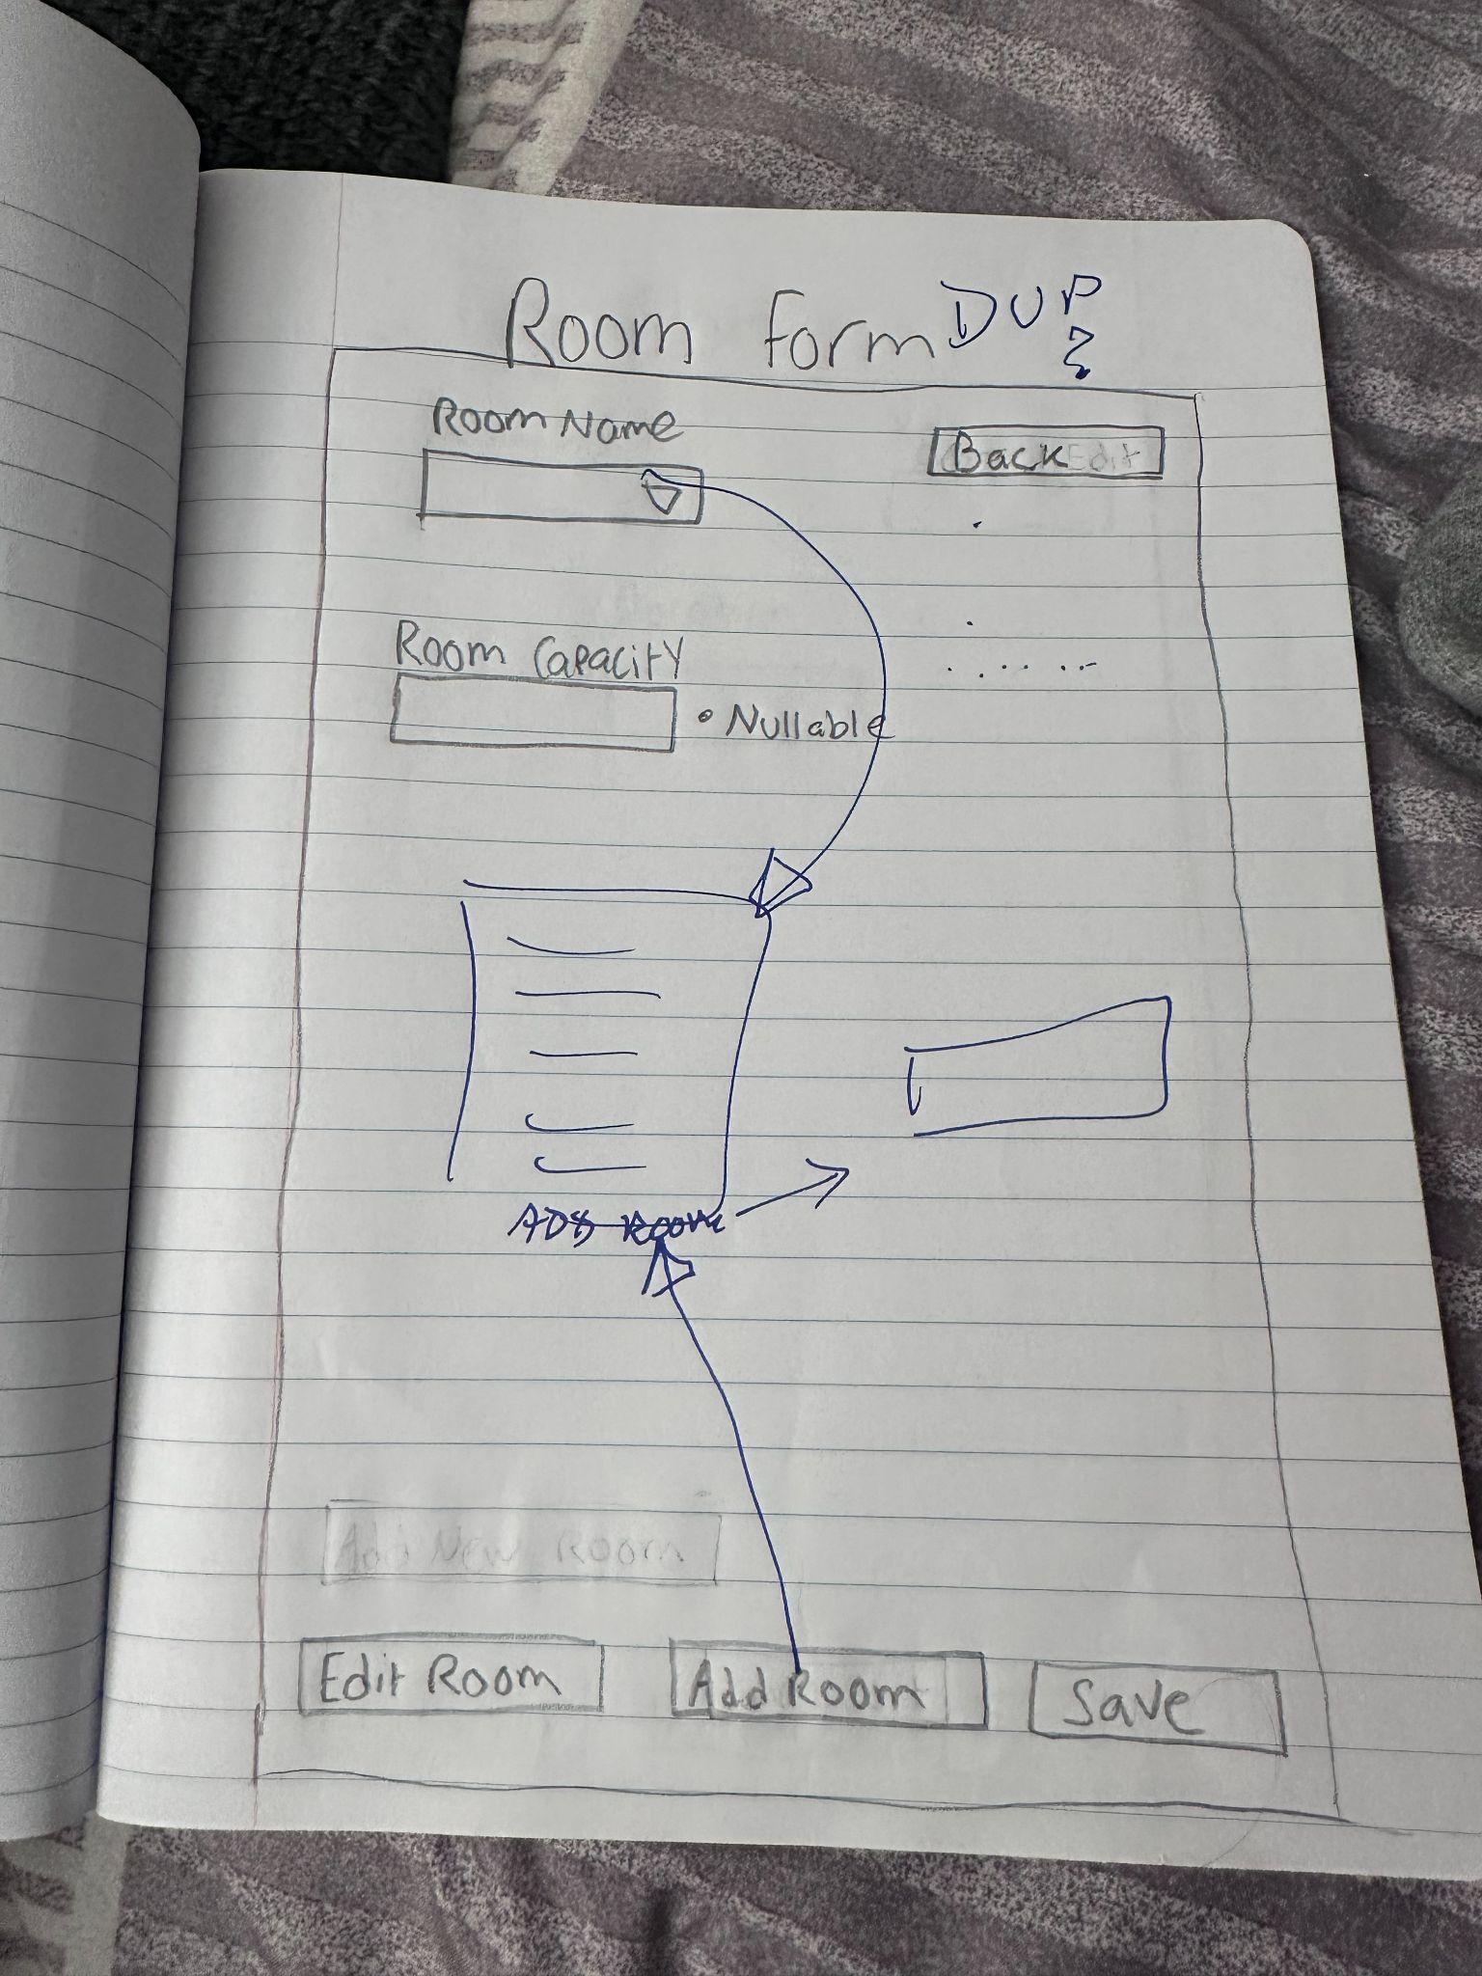

**Room name** (Text Field) this is user defined and is a label for the room

**Room capacity** (Numeric Field) this will input for room capacity, it should also validate for positive ints

**Add room**(Button) this will clear the form and allows for field input

**Edit room**(Button) this will enable the ability to edit select room details, inorder to do so it will require a room selection

**Save** (Button) this will validate the information entered and commit the information to the database

### **Backend**:

**Database Tables**: Room Form

1. RoomID (Primary Key)
2. RoomName(Text)
3. Capacity (Integar)

Logic:

1. Validation for capacity, this requires positive numbers

### **Frontend**

* Form layout with labeled fields and buttons.
* Input validation for Room Name and Capacity.
* Button handlers for Add, Edit, Save.
* Status indicator for invalid or missing capacity.
* Navigation logic for Back button.

# —--------------------------------------------------------

# Speaker Form

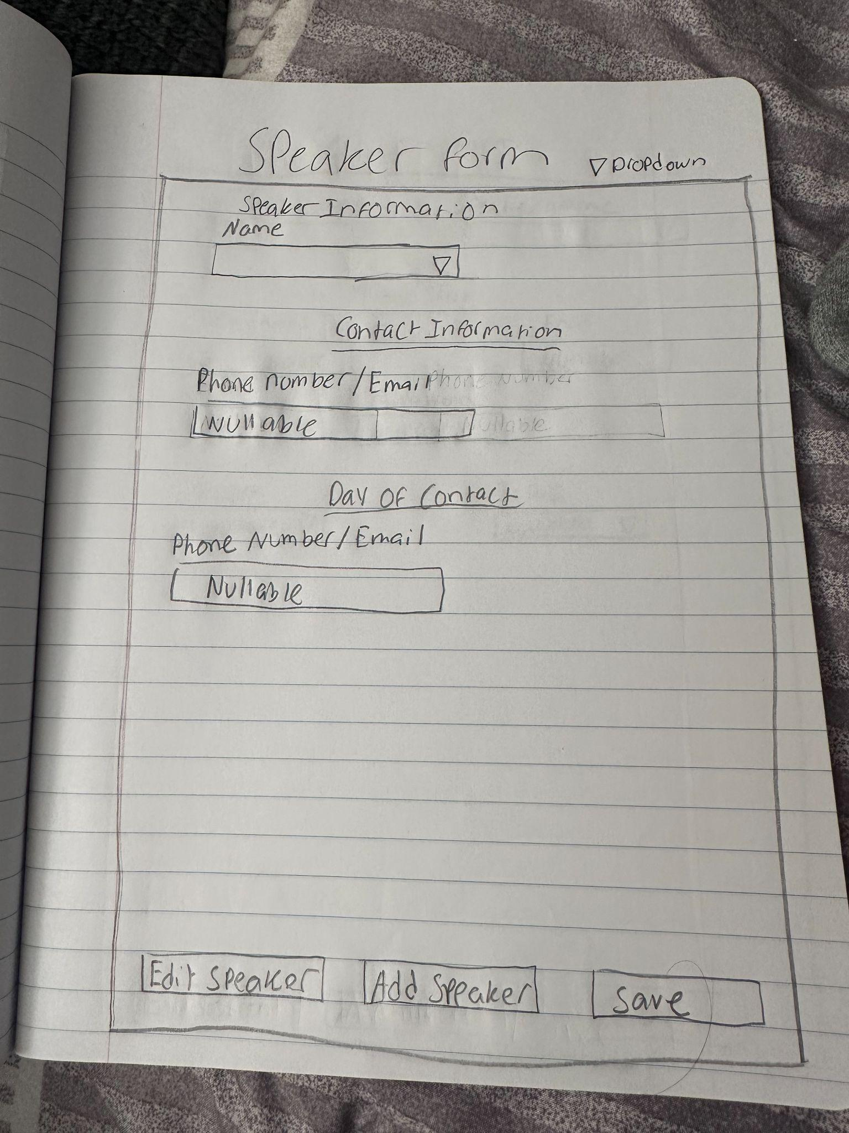

**Name**(Dropdown) doc told me to use drop down for this but this is the original area that they registar so im not sure how a drop down would work in this aspect

**Phone Number/ Email**(Dropdown/Text Field) this will allow to choose how they want to be contacted and also allow for entry

Day of contact

**Phone Number/Email** (Text Field) this isnt visible to public, this is used internally.

**Add Speaker**(Button) this clears the current form and prepares the form fields for input

**Edit Speaker**(Button) this allows modification of the selected details, this will require selection

**Save**(Button) this will validate information entered and commit it to database

### **Backend**

**Database Table:** Speaker Form

* SpeakerID (Primary Key)
* Name (Text)
* Production (Text or Foreign Key)
* PrimaryContact (Phone/Email)
* DayOfContact (Phone/Email, private)

### **Frontend**

* Form layout with labeled fields and buttons.
* Dropdown for contact method selection.
* Input validation for name and contact fields.
* Button handlers for Add, Edit, Save.
* Visibility toggle for private contact field.

—------------------------------------------------------------------------------------------------

# Time Slot Form:

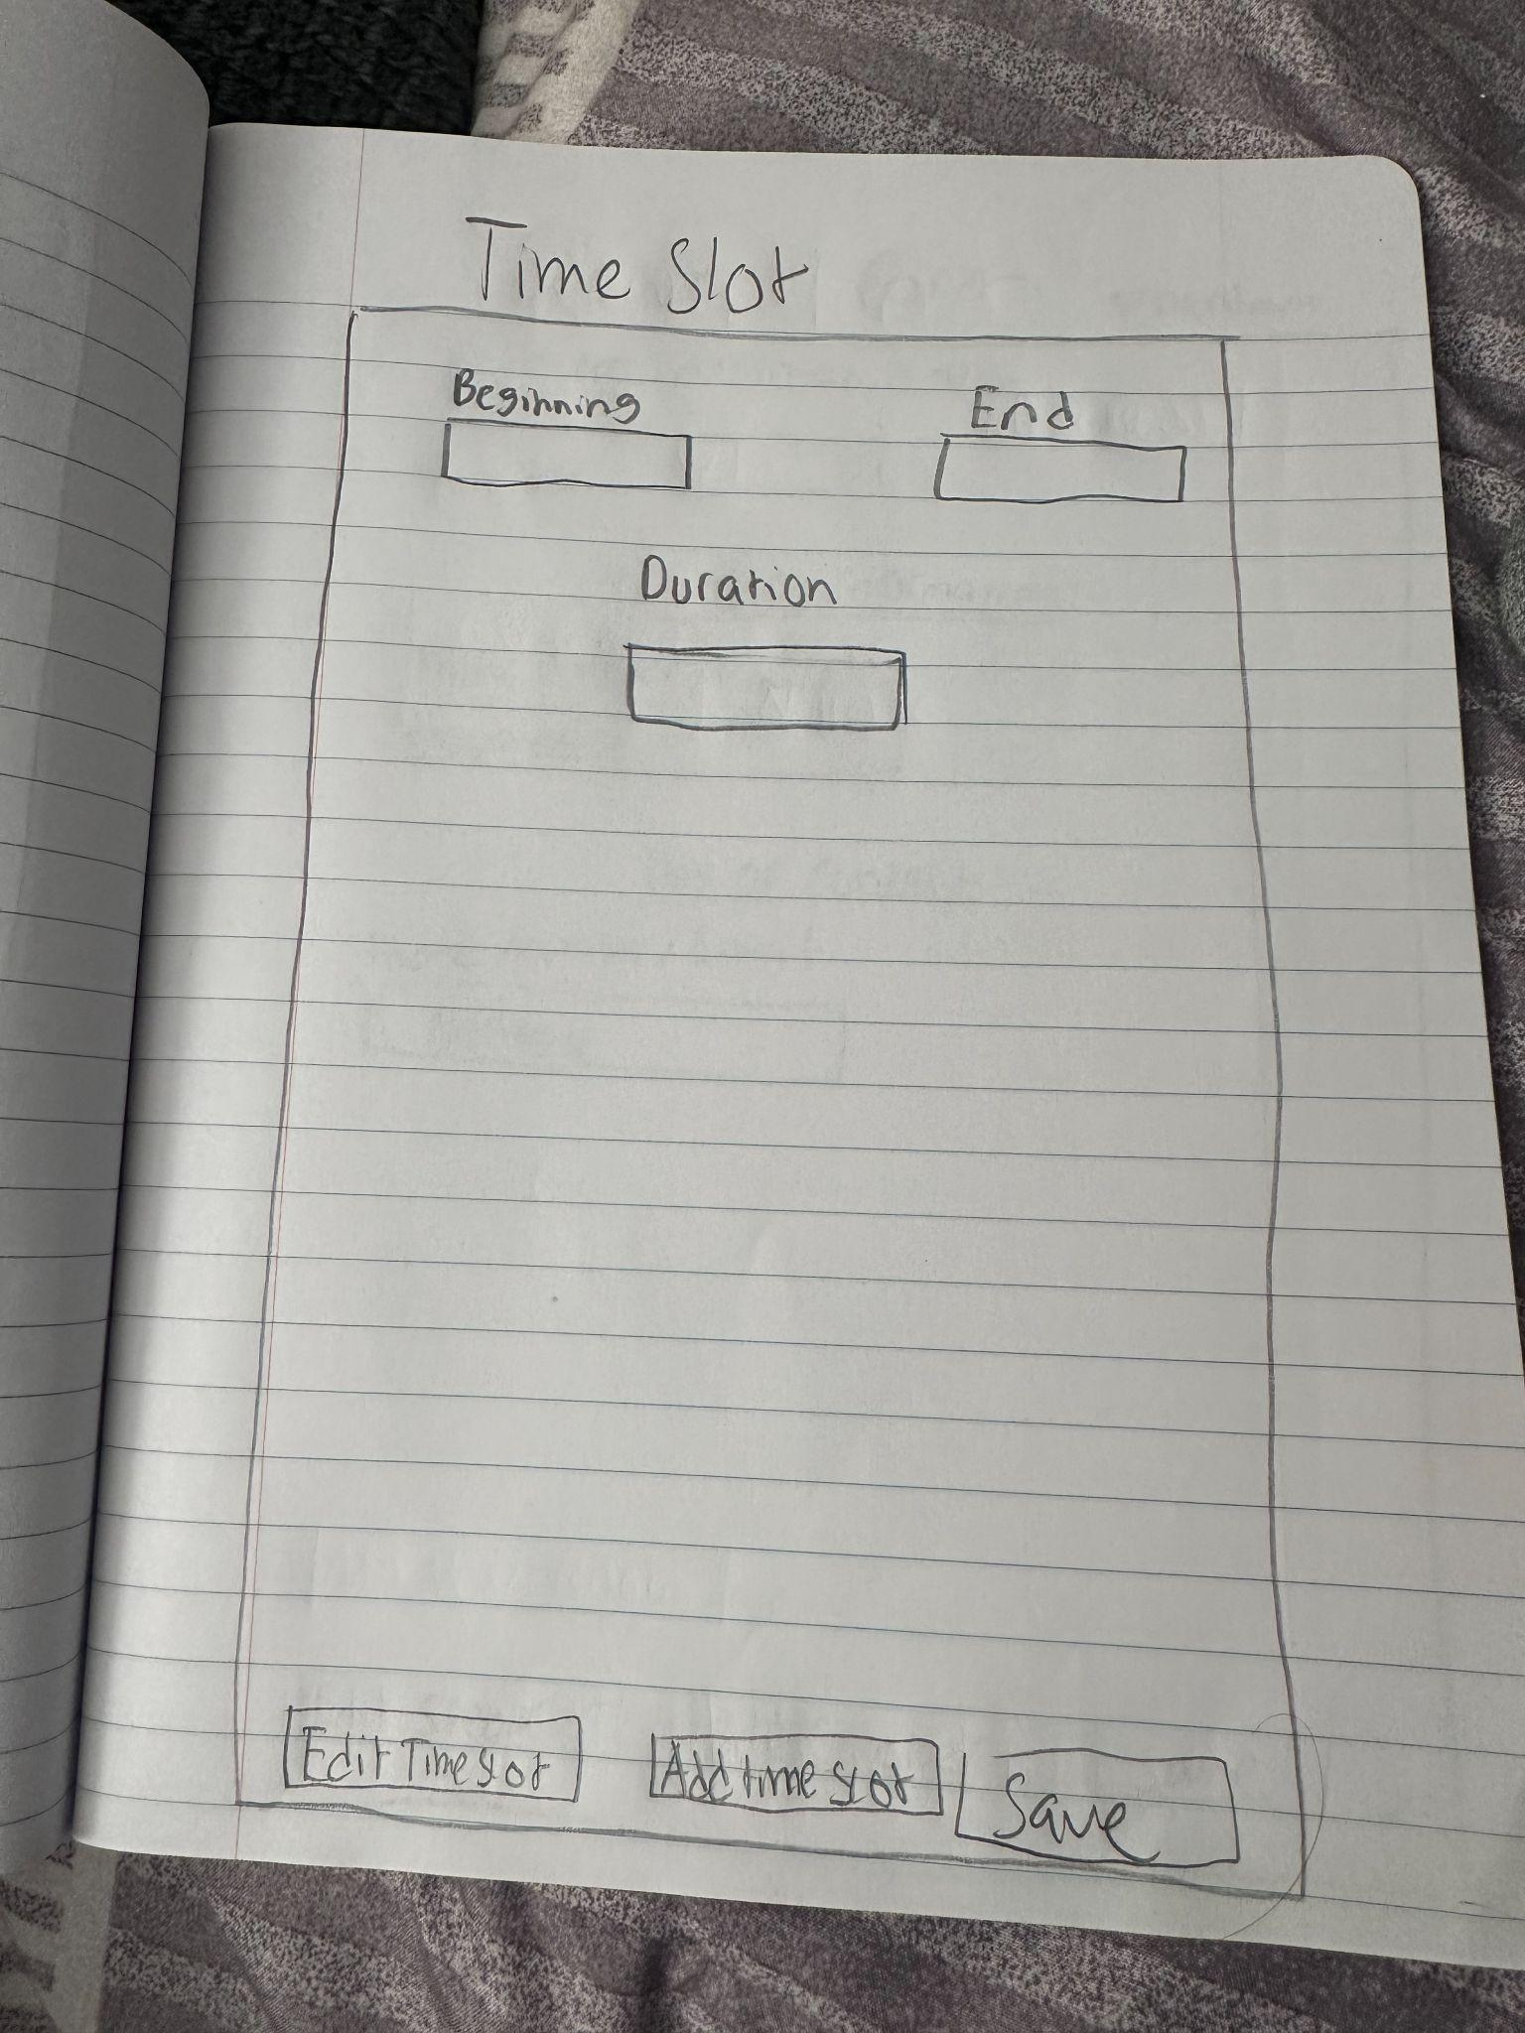

**Beginning**(Datetime Picker) starts the time of the current time slot

**End**(Datetime Picker) this will select the end time of current slot

**Duration** (Calculated Field) this will calculate the beginning time and end time and autopopulate the field

**Add TimeSlot**(Button) this clears the current form and prepares the form fields for input

**Edit TimeSlot**(Button) this allows modification of the selected details, this will require selection

**Save**(Button) this will validate information entered and commit it to database

### **Backend**

* **Database Tables:** TimeSlots
  + TimeSlotID (Primary Key)
  + StartTime (DateTime)
  + EndTime (DateTime)
  + Duration (Integer)

### **Frontend**

* Form layout with labeled fields and buttons.
* Date/time pickers for Beginning and End.
* Auto-calculation and display of Duration.
* Button handlers for Add, Edit, Save.
* Input validation and error messaging.