Session Form

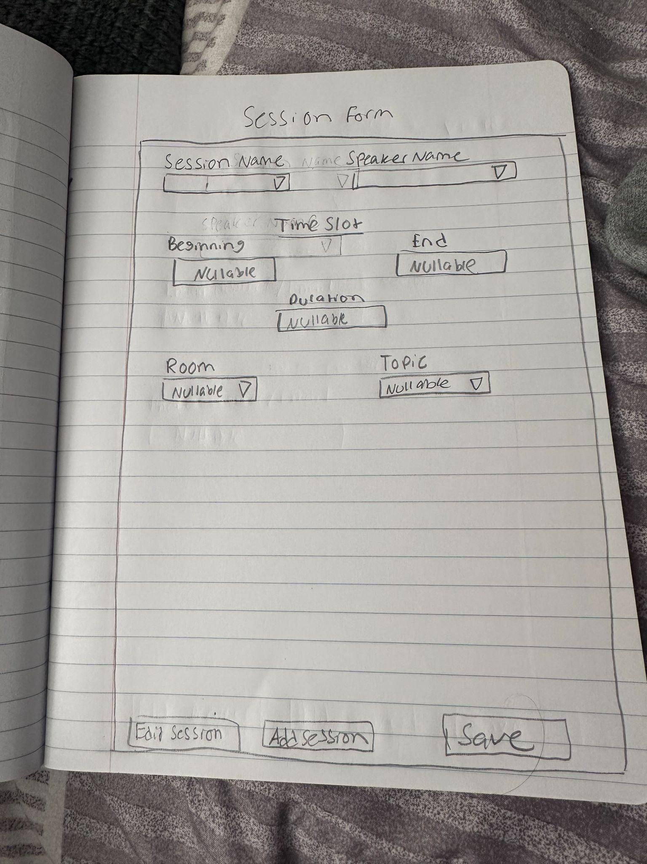
Session Name (Dropdown) this will be user defined name for the specific session
Speaker Name (Dropdown) selects from list of speakers that are registered

Timeslot(Dropdown) should auto populate if the field already exists

Beginning (Datetime Picker) choose start time
End (Datetime Picker) choose end time
Duration (Calculated Field) calculated using beginning and end time

Room (Dropdown) selects from available rooms
Topic (Dropdown) select from a list of predefined topics

Edit Session (Button) this will enable that ability to modify a session that is already existing, this will require a session selection
Add Session (Button) clears the form completely and will reset all the fields to empty values
Save (Button) this will validate information and commit the data to the database

Backend
- Database Tables: Session Form
  - Sessions: session name, speaker, time, duration, topic, room, etc.
  - Speakers: speaker ID, name, bio, etc.
  - Topics: topic ID, name, category.
  - Rooms: room ID, name, capacity.

Frontend
- Form layout with labeled fields and dropdowns.
- Date/time pickers for Beginning and End.
- Dynamic dropdowns populated from backend.
- Button handlers for Save, Edit, Add.
- Validation logic, this will help with making sure required fields are complete.
—----------------------------------------------------------------------------------------------------------------------

Room form
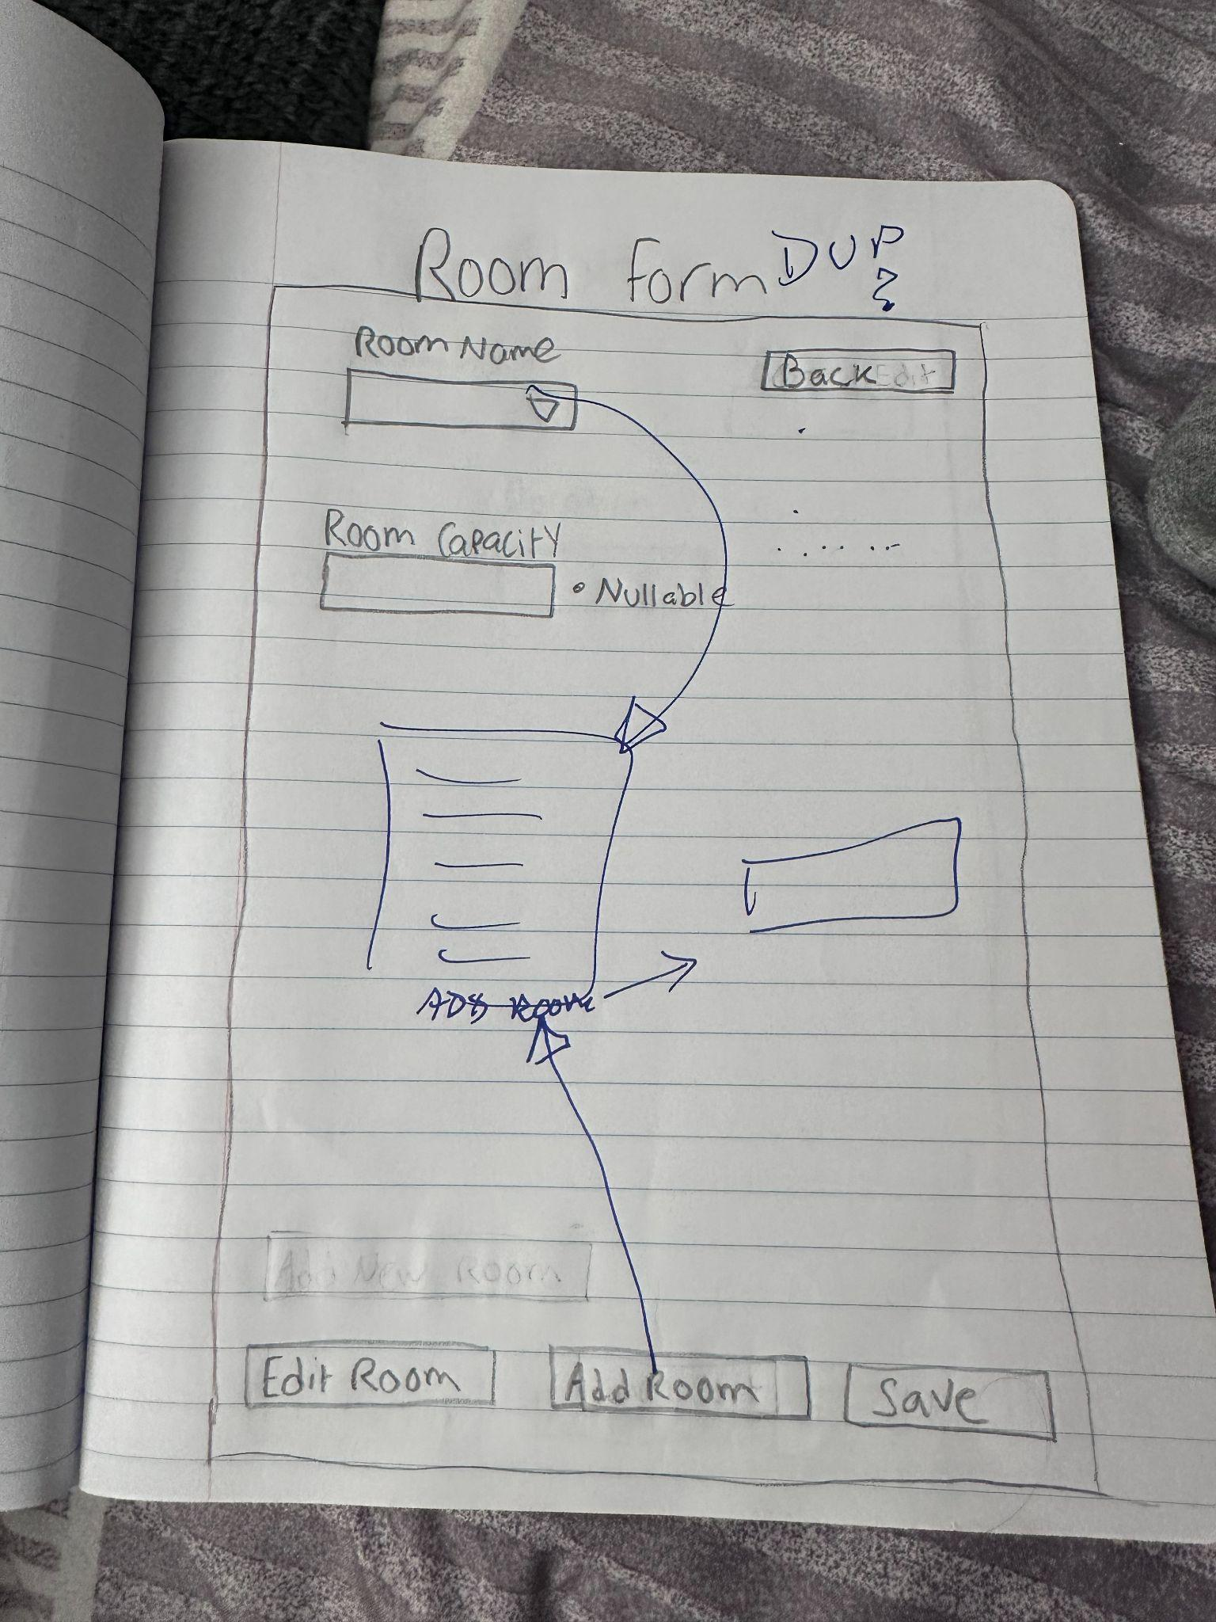
Room name (Text Field) this is user defined and is a label for the room
Room capacity (Numeric Field) this will input for room capacity, it should also validate for positive ints

Add room(Button) this will clear the form and allows for field input
Edit room(Button) this will enable the ability to edit select room details, inorder to do so it will require a room selection
Save (Button) this will validate the information entered and commit the information to the database

Backend:
Database Tables: Room Form
- RoomID (Primary Key)
- RoomName(Text)
- Capacity (Integar)
Logic:
- Validation for capacity, this requires positive numbers

Frontend
- Form layout with labeled fields and buttons.
- Input validation for Room Name and Capacity.
- Button handlers for Add, Edit, Save.
- Status indicator for invalid or missing capacity.
- Navigation logic for Back button.

—--------------------------------------------------------

Speaker Form
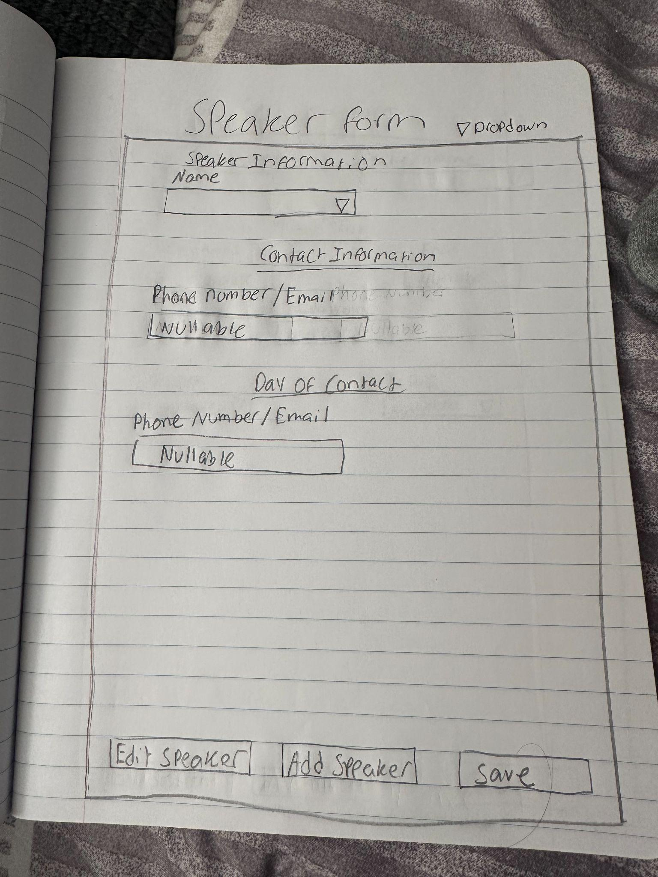
Name(Dropdown) doc told me to use drop down for this but this is the original area that they registar so im not sure how a drop down would work in this aspect
Phone Number/ Email(Dropdown/Text Field) this will allow to choose how they want to be contacted and also allow for entry
Day of contact
Phone Number/Email (Text Field) this isnt visible to public, this is used internally.
Add Speaker(Button) this clears the current form and prepares the form fields for input
Edit Speaker(Button) this allows modification of the selected details, this will require selection
Save(Button) this will validate information entered and commit it to database

Backend
Database Table: Speaker Form
- SpeakerID (Primary Key)
- Name (Text)
- Production (Text or Foreign Key)
- PrimaryContact (Phone/Email)
- DayOfContact (Phone/Email, private)

Frontend
- Form layout with labeled fields and buttons.
- Dropdown for contact method selection.
- Input validation for name and contact fields.
- Button handlers for Add, Edit, Save.
- Visibility toggle for private contact field.

—------------------------------------------------------------------------------------------------

Time Slot Form:
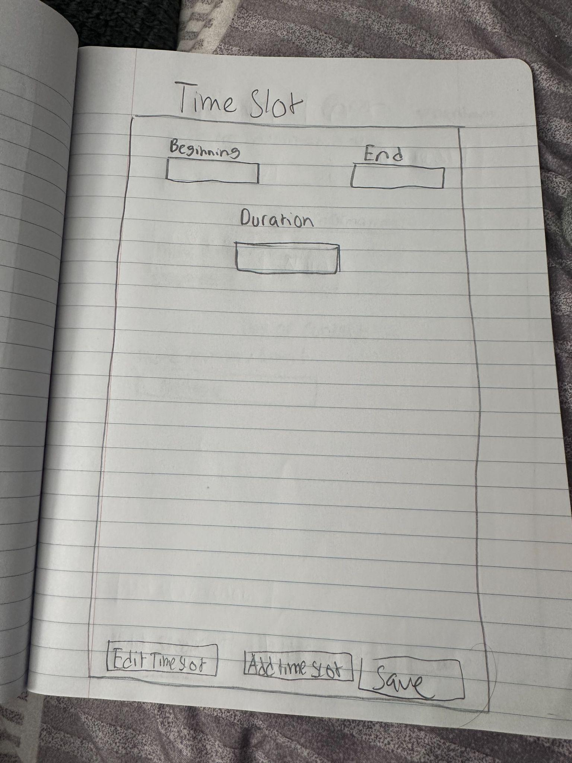

Beginning(Datetime Picker) starts the time of the current time slot
End(Datetime Picker) this will select the end time of current slot

Duration (Calculated Field) this will calculate the beginning time and end time and autopopulate the field
Add TimeSlot(Button) this clears the current form and prepares the form fields for input
Edit TimeSlot(Button) this allows modification of the selected details, this will require selection
Save(Button) this will validate information entered and commit it to database

Backend
- Database Tables: TimeSlots
  - TimeSlotID (Primary Key)
  - StartTime (DateTime)
  - EndTime (DateTime)
  - Duration (Integer)

Frontend
- Form layout with labeled fields and buttons.
- Date/time pickers for Beginning and End.
- Auto-calculation and display of Duration.
- Button handlers for Add, Edit, Save.
- Input validation and error messaging.

