Financial Data Visualization

# Tableau

There are many data visualization tools, and most of them require minimum coding skills. Tableau is one of those, it was made to create interactive dashboards to visualize data and is able to integrate a wide range of different data sources. It is suitable to work with financial data as well. As part of this project, the price of Google stocks over time will be visualized on different charts with Tableau.

# Charts

Candlestick charts, momentum and the Bollinger band will be displayed, which are commonly used on financial data.

## Candlestick chart

On the candlestick chart, the high-low and open-close differences over an interval (typically a day) are highlighted. The open-close difference is more thicker, that part is called the real body, and the parts above that are the shadows. When the close price is greater than the open price, and when the open price is higher than the close price is indicated with a different color. The first one represents bullish investor behaviour and latter represents bearish investor behaviour. It is a good summary chart, since it displays many parameters over time.

To create a candlestick chart in Tableau, we need 2 calculated fields, one for open-close difference, and one for high-low difference. Then we need to display the average close and open price over time, and we need to set these calculated values as the size of these marks. Then we can create a calculated field to check whether the close price is higher than the open price, and color that part of the chart accordingly. The result can be seen here:

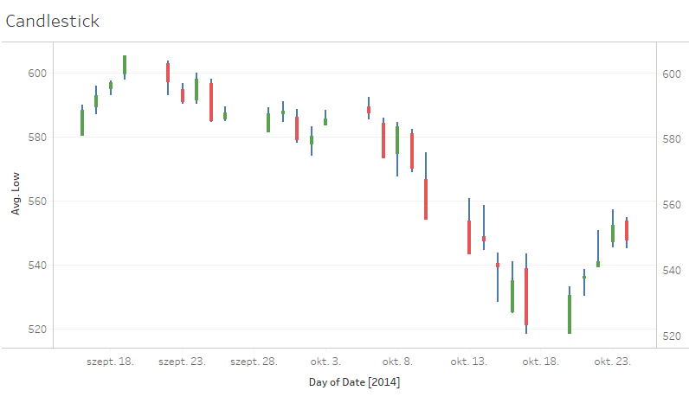

## Momentum

Momentum is a metric for rate of change, it essentially shows how fast a value of a variable is changing. The calculation formula for momentum is (Closingi - Closingi-N)/Closingi-N*100. Sharp increase in momentum can be a sign of instability.

To calculate momentum in Tableau, the Lookup function needs to be used. A value and offset has to be specified. The value can be the average of close values, and for the offset, we can define a parameter. The outcome on Google stock prices can be seen here:

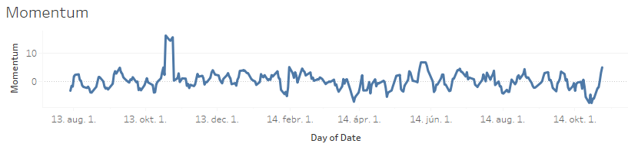

## Bollinger band

In Bollinger bands, not only the value of a security is displayed, but a moving average and upper limit and a lower limit with some number of standard deviations away from the moving average. Standard deviation is a good measure of volatility. This way, when the market is volatile, the band is wider. A typical way to use Bollinger bands is to buy when the price touches the lower band and sell when the price touches the moving average.

To calculate Bollinger bands in Tableau, we need to create a calculated field for moving average and standard deviation. This can conveniently be done with the WINDOW_AVG and WINDOW_STDEV functions. We need to create a parameter for window size. An additional parameter is also needed to specify the distance, meaning the number of standard deviations for the upper and lower bound. Then we can create two calculated fields for them. The results can be seen below.

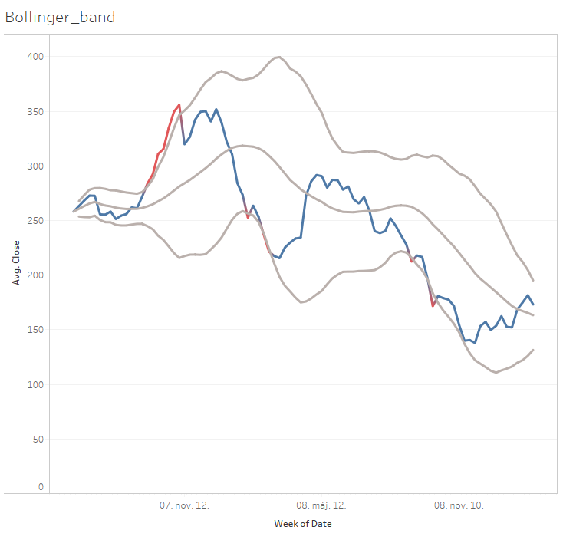

# Conclusions

Tableau is an easy to use tool, and by visualizing these charts, many useful insights can be derived to use in a financial trading system.