**Table of contents**

1. Optimization functions 3

2. Activation functions 3

3. Loss functions 3

4. Bibliography 3

[2. 5](#_File_contents_(dataset))

# Optimization functions

## SGD & ASGD

## Adam

## RMSprop

# Activation functions

# Loss functions

## ReLU & Leaky ReLU

$$Leaky ReLU= \left\{\begin{aligned}x, if x ≥0 \\ negSlope*x, otherwise\end{aligned}\right.$$

* negSlope - angle of the negative slope.

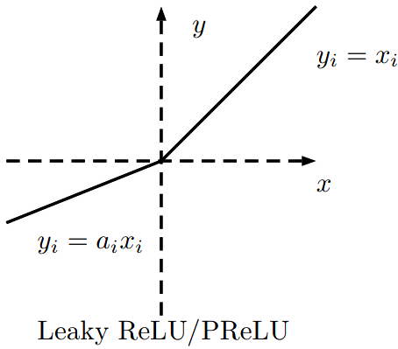

*Picture ***: Leaky ReLU activation function* ([*Bing Xu, Naiyan Wang, Tianqi Chen, Mu Li. Empirical Evaluation of Rectified Activations in Convolutional Network. 2017*](https://arxiv.org/abs/1505.00853)*)*

$$ReLU= \left\{\begin{aligned}x, if x ≥0 \\ 0, if x<0\end{aligned}\right.$$

* angle of the negative slope.

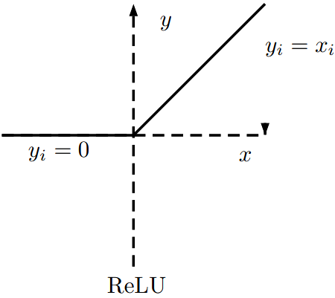

*Picture ***: Leaky ReLU activation function* ([*Bing Xu, Naiyan Wang, Tianqi Chen, Mu Li. Empirical Evaluation of Rectified Activations in Convolutional Network. 2017*](https://arxiv.org/abs/1505.00853)*)*

# Bibliography