Introduction

1. Setup

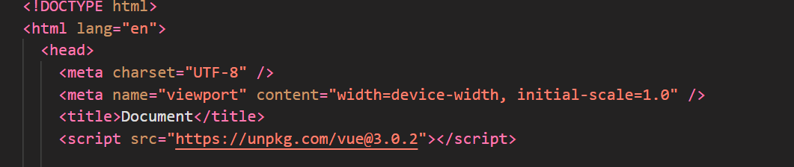Need to import “Vue’s” cdn in to html file.

1. Creating Vue app

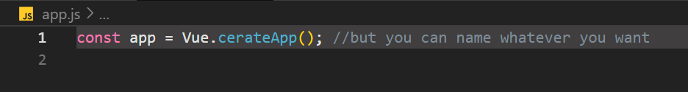There is a method called app, and we use this method to create Vue app

1. 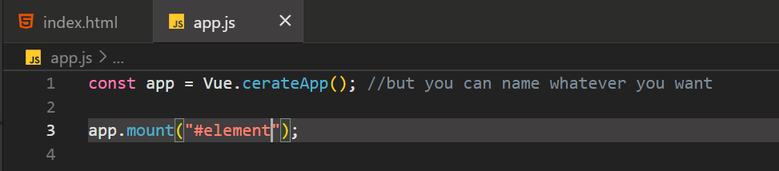After creating app function, we will have access to method named “mount”. Mount controls given specific content in the DOM

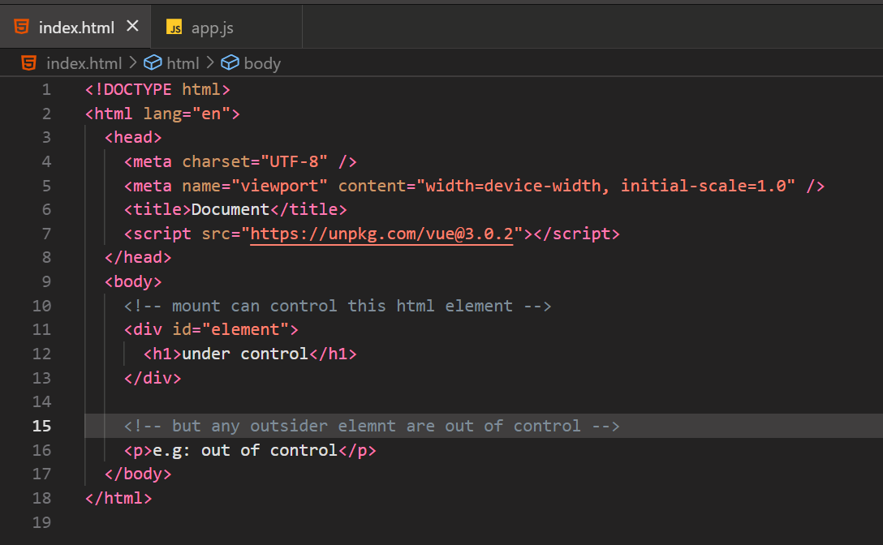But it applies which is id of “#element” content in the DOM