**Administrator**

**(Super)**

**Organization**

**Administrator**

**(Standard, Dispetcher)**

**Administrator**

**(Standard, Dispetcher)**

**Team**

**Team**

**Team**

**Team**

**Worker**

**Worker**

**Worker**

**Worker**

**Worker**

**Worker**

**Worker**

**Worker**

Task (H+D)

Task (H+D)

Task (H+D)

Task (H+D)

Task (H+D)

**Hub**

**Hub**

**Hub**

Destination

Destination

Destination

Destination

Destination

Destination

Destination

Our User account types:

|  |  |  |
| --- | --- | --- |
| **Account Type** | **Will be displayed as:** | **ID** |
| PRIMARY_ACCOUNT | Account Owner | 0 |
| ADMIN | Administrator | 1 |
| REGIONAL_MANAGER | Regional Manager | 2 |
| DISPATCHER | Dispatcher | 3 |
| PLANNER | Route Planner | 4 |
| DRIVER | Driver | 5 |
| ANALYST | Analyst | 6 |
| VENDOR | Vendor | 7 |
| CUSTOMER_SERVICE | Customer Service | 8 |

Correspondences:

|  |  |  |
| --- | --- | --- |
| **Onfleet** | **R4M** | **Comment** |
| Organization | Account Owner |  |
| Administrator | Administrator |  |
| Dispatcher | Dispatcher |  |
| Team | Regional Manager |  |
| Worker | Driver |  |
| Container | Optimization Problem and Routes |  |
| Task | Depot and Destination pairs from routes | Hub and Destination pairs |
| Hub | Depot |  |
| Destination | Address book locations |  |
| Recipients | Same as Address book locations? (some fields) |  |
| Webhooks | We can create webhook only by web UI |  |

========================== **Block schema from Onefleet website** ==============================================

Link: <https://support.onfleet.com/hc/en-us/articles/203797849-Structure-of-an-organization>

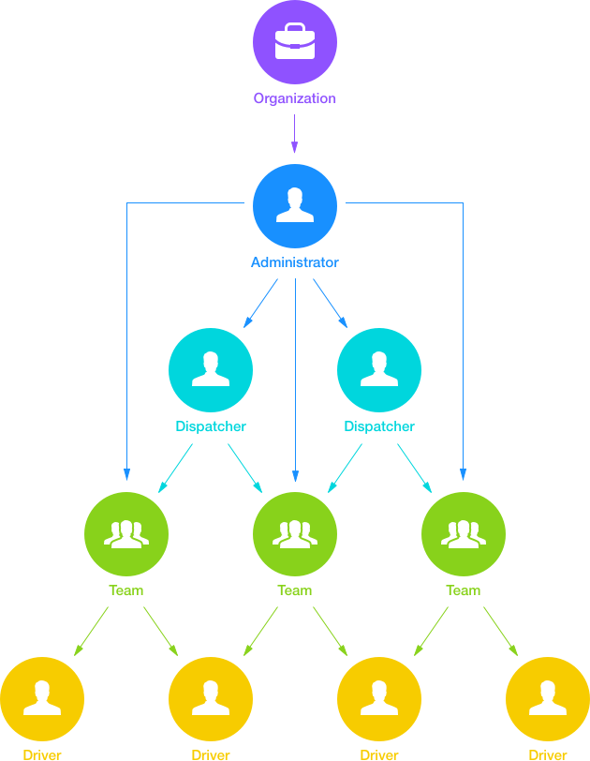

**Organization Structure:**

|  |  |  |
| --- | --- | --- |
| **Object** | **Description** | **Comment** |
| **Organizations** Link: <http://docs.onfleet.com/docs/organizations> | Organizations represent the top-most entity on Onfleet. Administrators, teams, workers and tasks all belong to an organization. Further, organizations may be linked to other organizations so that tasks can be assigned across organizational boundaries through the Connections feature. | Note: a delegatee is an organization to which an organization is able to assign tasks. |
| **Administrator** Link: <http://docs.onfleet.com/docs/administrators> | Administrators are users who perform actions via the dashboard. An organization has one administrator of type super and zero or more of type standard (also known as dispatchers in the dashboard). Administrators manage workers based on membership in the organization’s teams. |  |
| **Dispatchers** | Dispatchers are added by the administrator of an organization. Dispatchers create and edit tasks and assign them to drivers in their teams. Dispatchers manage one or more teams. |  |
| **Teams**  Link: <http://docs.onfleet.com/docs/teams> | Teams are named entities that bring together administrators and workers belonging to the same organization. Teams have hubs from where its workers may start and end their shifts. |  |
| **Drivers (workers)**  Link: <http://docs.onfleet.com/docs/workers> | Workers (also known as drivers in the dashboard) are the members of an organization who perform actions via the Onfleet mobile applications. They may belong to teams managed by any number of administrators in their own organization. Workers have a vehicle with which tasks are completed. | Drivers are added by the administrator of an organization. They use Onfleet through the driver app on Android or iOS to complete tasks |
|  |  |  |
| **Hubs**  Link: <http://docs.onfleet.com/docs/hubs> | A hub is a depot for a team: the location from where all deliveries start for the team's workers, for the purposes of route optimization only; teams can have zero or one hubs. |  |
| **Destination**  Link: <http://docs.onfleet.com/docs/destinations> | Destinations represent the location details for tasks, including exact coordinate and address information. | Like our Address book location |
| Recipients  Link: <http://docs.onfleet.com/docs/recipients> | A recipient is an organization’s customer and a target for a task, that is, whom the task is being delivered to. |  |
|  |  |  |
| **Containers**  Link: <http://docs.onfleet.com/docs/containers> | Containers are an abstraction which describes task assignment.  A container is an ordered list of tasks. Tasks always belong to exactly one container -- once created and when reassigned. When a task is started by a worker, it is no longer part of that container's tasks.  Organizations, teams and workers all correspond to containers as they can all be assigned tasks. | When inserting tasks into a container, newly included tasks will be removed from other containers. |
| **Tasks**  Link: <http://docs.onfleet.com/docs/tasks> | Tasks represent units of work, defined by one destination and one recipient, that administrators create and assign to workers for completion. | You may provide a container property when creating or updating a task to append the task to that container. |
|  |  |  |
| **Webhooks**  Link: <http://docs.onfleet.com/docs/webhooks> | Webhooks make it possible for your application to be notified of important system events, as soon as these take place within Onfleet. | While you are generally able to create as many webhook entries as you'd like, remember that a single webhook always targets a single trigger. |
|  |  |  |
|  |  |  |