**Lab 1 Documentation**

For the 1st lab, download and install Arduino IDE. Test with Jack’s demo code (Yellow LED blinking). Once the initial test is done. Proceed to working lab 1 tasks.

Open a new file. Write the Code based on C++ syntax and style.

For the 1st task, simply define the pin with different LEDs and use digitalWrite to turn them on and off respectively.

For the 2nd task, modify the 1st task code slightly to make all three LEDs turn on and off at the same time.

For the 3rd task, use delay() function to turn on first LED (Yellow) and use delay() function again to turn on other LED complimentarily (Red and Green). The delay time of .25s and .5s should be kept in mind to have correct blink sequence.

Resistor used: 100 ohm (since all LEDs are connected onto one resistor to make the circuit neat, larger resistance resistors wouldn’t be able to drive three leds blink together.)

LED: Yellow, Red, Green

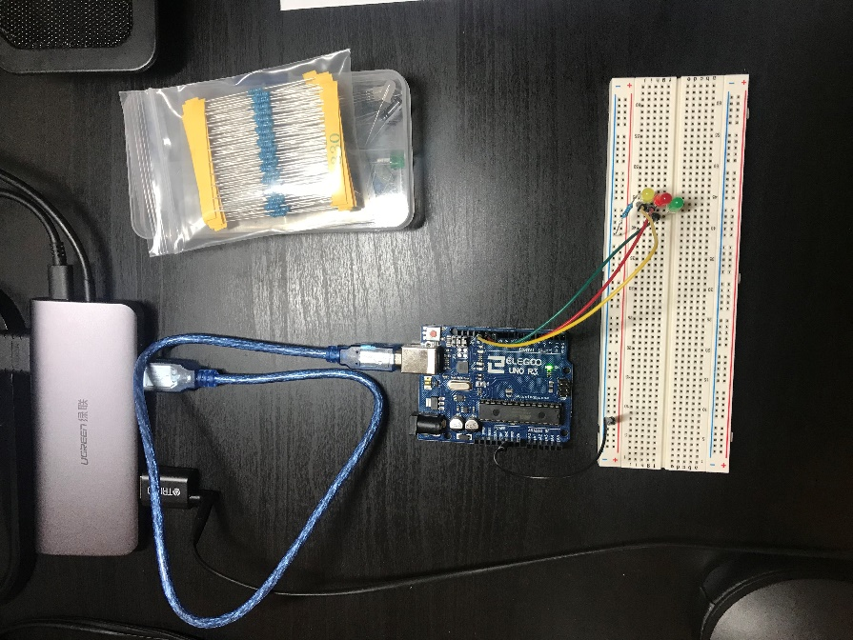

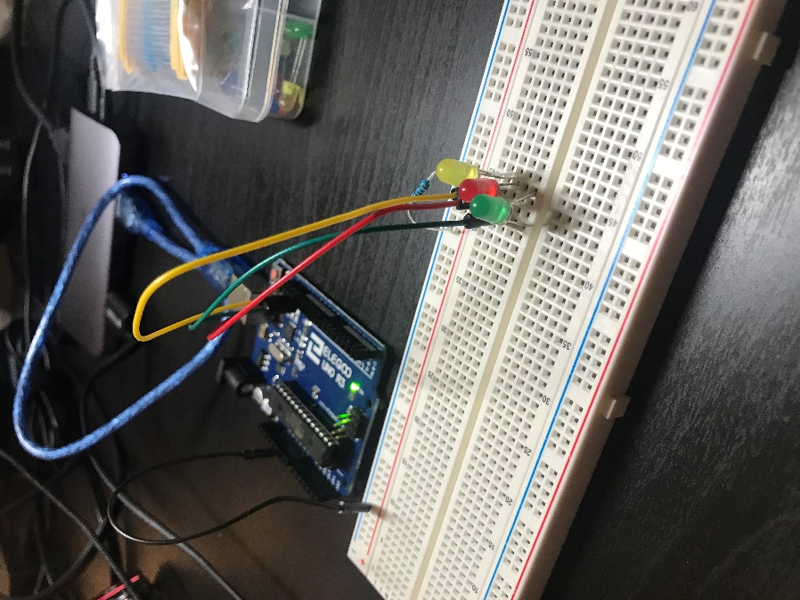

**Code**

