**Lab 2 Documentation**

The system design for realizing the paper towel dryer is via adapting humidity sensor onto the Arduino to detect the change of humidity, if the humidity is above threshold value then the LEDs blinks for number of times and fan motor turns on for certain time length as required. The client/user could modify the threshold value, LED blinking frequency, and time length for fan running by simply using the serial monitor (implementation in process).

Sensor used: humidity and temperature sensor DHT11

Motor used: fan blade and 3-6V motor

LEDs used: blue and green

Resistors used: 100 and 330 ohm

Potential improvement: use RC circuit could be one possible solution to realize the same function requirement, with even better sensing of wetness and dryness of the paper towel, without using any type of sensors. But more measurement work and passive electronic components are needed for this approach method.

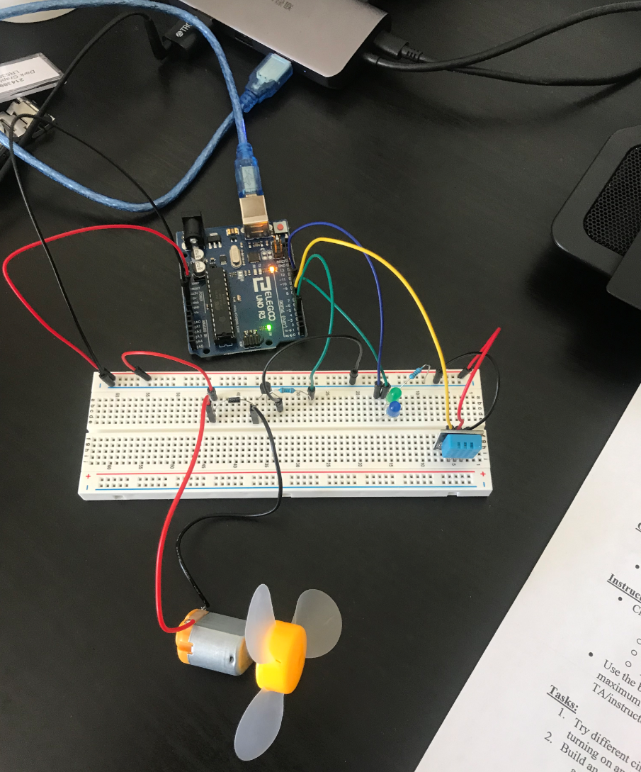**Circuit Wiring**

**Code**

/** lab2 Zhibo Wang

 *  Paper towel humidity sensor

 */

#include <dht.h>

dht DHT;

#define DHT11_PIN 4

const int motor_pin = 3;

const int greenled_pin = 7;

const int blueled_pin = 8;

const int blinkinterval = 500; // .5 second

const int blinkperiod = 3000;  // for 3 seconds

const int speed = 255;

int init_humidity; // record normal room temperature and humidity into the system

void setup()

{

    Serial.begin(9600);

    pinMode(motor_pin, OUTPUT);

    pinMode(greenled_pin, OUTPUT);

    pinMode(blueled_pin, OUTPUT);

    digitalWrite(greenled_pin, HIGH); // initial system check blink both LEDs for 1 second and then turn them off

    digitalWrite(blueled_pin, HIGH);

    delay(1000);

    digitalWrite(greenled_pin, LOW);

    digitalWrite(blueled_pin, LOW);

    delay(1000);

}

void loop()

{

    int chk = DHT.read11(DHT11_PIN);

    delay(2000); // time buffer

    int realt_humidity = DHT.humidity;

    int realt_temperature = DHT.temperature;

    // Serial.print("Temperature = ");

    // Serial.println(init_temperature);

    // Serial.print("Initial Humidity = ");

    // Serial.println(init_humidity);

    Serial.print("Humidity = ");

    Serial.println(realt_humidity);

    if (realt_humidity > 60) // rule-of-thumb wet value set for 60. more robust design needed for better algorithm

    {

        ledblinker();

        motorswitch();

    }

    // if (Serial.available())

    // {

    //     int speed = Serial.parseInt();

    //     if (speed >= 0 && speed <= 255)

    //     {

    //         analogWrite(motor_pin, speed);

    //         delay(5000);

    //     }

    // }

}

// int humiditychecker()

// {

//     int chk = DHT.read11(DHT11_PIN);

//     delay(2000);

//     int init_humidity = DHT.humidity; // record normal room temperature and humidity into the system

//     delay(2000);

//     init_humidity = DHT.humidity;

// }

void ledblinker()

{

    for (int i = 0; i < 3; i++)

    {

        digitalWrite(greenled_pin, HIGH);

        digitalWrite(blueled_pin, LOW);

        delay(blinkinterval);

        digitalWrite(greenled_pin, LOW);

        digitalWrite(blueled_pin, HIGH);

        delay(blinkinterval);

    }

    digitalWrite(greenled_pin, LOW);

    digitalWrite(blueled_pin, LOW);

}

void motorswitch()

{

    analogWrite(motor_pin, speed);

    delay(7000); // run fan for seven seconds and then turn it off as required

    analogWrite(motor_pin, 0);

}