The Influence of Learning in the Optimization of Royal Road Functions

 | Francisco Pereira  xico@alma.uc.pt |  | Ernesto Costa  ernesto@dei.uc.pt
Departamento de Engenharia Informática
Faculdade de Ciências e Tecnologia
Universidade de Coimbra - Pólo II
3030 Coimbra - Portugal
Tel: +351-39-7000000

Abstract
We will apply a hybrid Genetic Algorithm with learning to a class of functions widely studied in Evolutionary Computation, known as Royal Road functions. Individual learning, in this context, is usually implemented as a local search algorithm which is applied to some individuals of the population. Local search is the computational analogue to phenotypic plasticity in biological systems. Two different local search procedures will be used, RMHC and DHC. Experiments performed prove that they have a major impact in the results obtained. We will also consider two different learning strategies: Lamarckian learning and the Baldwin effect. We show that, for this problem and with a correct learning procedure, Lamarckian learning outperforms the Baldwin effect.

1.Introduction
The study of the influence of learning in artificial evolution is a growing subject in the area of Evolutionary Computation. The main goal of this research is to determine under what conditions can learning accelerate the evolution of artificial systems. Learning, in this context, can be seen as an operator that performs a local search on some individuals of the population. As stated in [Turney, 96], evolution performs a kind of global search, while individual learning performs a kind of local search. Local search procedures iteratively improve their estimates of the optimum by searching for better points in some local neighbourhood of the current solution [Hart & Belew, 96]. This will lead to a better understanding of the fitness of the individual. Fitness will be a measure, not only of the initial quality of the individual, but also of its ability to quickly evolve. If an individual, at birth, has a lower fitness than some other elements of the same generation, but has the capacity to evolve through its lifetime (move to better points in the fitness landscape), then it should have the chance to have a considerable number of descendants.

1.1.Genetic Algorithms with Local Search
Evolution and learning are two different ways in which organisms can change. Evolution induces changes at the population level, while learning produces changes at the individual level. We are interested in determine what is the influence that individual learning can have in the evolution at the population level. As stated in [Belew & Mitchell, 96], “in what ways does an individual’s learning behaviours during its lifetime interact with the evolution of its species?”
In the experiments we will perform, a hybrid genetic algorithm (GA) with local search will be applied. Evolution of the population will be performed by the standard GA. A local search procedure will perform individual learning. To understand how the local search procedure is applied, it is convenient to distinguish two representations of an individual. The genotype is the genetic constitution of an individual and is what is passed to its descendants. The phenotype is the set of observable characteristics of an organism, as determined by the genotype and the environment [Hart et al., 95], [Turney, 96]. Genetic operators are applied over the genotype, while local search procedures are applied over the phenotype representation (it is the individual that learns, not its genetic component). The relationship between the two representations can be formalized as follows (in this section we will follow the notation used in [Hart et al., 95]): let G be the space of the genotypes and let Ph be the space of phenotypes. There is a maturation function δ: G → Ph, which maps a genotype to the corresponding phenotype. In several situations the environment can affect the mapping. The fitness function of the GA can be represented: f: Ph → ℜ. A local search algorithm tries to find better points in some local neighbourhood of the current individual. Local search algorithms employ information about the fitness landscape when performing a search (e.g., the fitness of individuals) and can be seen as a mapping λ_{f}: Ph→Ph. If the local search operator L_{f} is applied iteratively then λ_{f}(ph) = L_{f}^{(k)} (ph), where k is the number of steps of the local search operator. After the application of L_{f} we hope that the fitness of the modified phenotype is higher than the fitness of the original one.

1.2.Royal Road Functions
The GA with learning will be applied to a class of functions known as Royal Road (RR) functions. These functions were designed to be the simplest class containing the features that are most relevant to the study of GA [Mitchell et al., 94]. We hope that they will also help us in the study of the influence of learning in the process of evolution. RR functions are codified as binary strings. The optimal fitness is obtained when we find a unique predetermined sequence of several blocks of bits, which in turn is constructed over a set of basic blocks. Following the “building block hypothesis”, it should be possible for a GA to build the basic blocks, then combine them and find the optimum. In this paper we will use a RR function proposed by J. Holland and presented in [Jones, 95]. Every string is composed of 16 non-overlapping contiguous regions of length 15 (the total length of the string will be of 240 bits). Each region is formed by one block of length 8 (bits 1 to 8 of the region) and one gap of length 7 (bits 9 to 15). A schema of the string is shown in figure 1.

String | 1 | ... | 8 | 9 | ... | 15 | 1 | ... | 8 | 9 | ... | 15 | ... | 1 | ... | 8 | 9 | ... | 15
 | block 1 |  |  | gap 1 |  |  | block 2 |  |  | gap 2 |  |  | ... | block 16 |  |  | gap 16
 | Region 1 |  |  |  |  |  | Region 2 |  |  |  |  |  | ... | Region 16
figure 1 - basic components of the string

In the fitness calculation only the bits of the blocks are considered. The optimal string has all blocks with all bits set to ‘1’. The fitness calculation of the string proceeds in two steps:
- Part calculation: each block receives a fitness score, based on the number of ‘1’ it has. Up to four, each ‘1’ adds to the fitness of the block. If the block has more than four ‘1’ and less than eight it receives a negative fitness. When a block is complete (all bits set to ‘1’) it receives fitness zero in the part calculation, but it is rewarded with a bonus (see table 1 taken from [Jones, 95]);

1’s in the block | 0 | 1 | 2 | 3 | 4 | 5 | 6 | 7 | 8
block fitness | 0.00 | 0.02 | 0.04 | 0.06 | 0.08 | -0.02 | -0.04 | -0.06 | 0.00
table 1 - Values for Part calculation

- Bonus calculation: this step rewards complete blocks separately and some combinations of several complete blocks. Bonification is given for attaining several levels. We considered 4 levels. The lowest, level 0, rewards single complete blocks. Level 1 rewards some pairs of complete blocks, level 2 groups of four complete blocks, level 3 groups of eight complete blocks, and, finally reward at level 4 is given when all blocks are completed. At all levels, the first set of complete blocks receives fitness 1.00 and the following 0.30 each. Total bonus contribution to the fitness is given by adding the fitness computed at each of the levels. The optimal string (all blocks completed) has a fitness of 12.80.

1.3.Learning Procedures
The two learning procedures applied are variants of hill-climbing methods. In each individual submitted to learning we will randomly flip some bits and see if its fitness increases. In addition to a current hill-climbing method, Random Mutation Hill-Climbing (RMHC) [Mitchell et al.,94], we developed another hill-climbing algorithm, named Double Hill-Climbing (DHC), which works as follows:

Double Hill-Climbing (DHC):
0. Choose a binary string at random for learning;
- Randomly choose a bit in the string between position 1 and length-1 (where length is the number of bits in the string). Assume position k is chosen;
- Flip the bits in position k and in position k+1;
- If the new string leads to an equal or higher fitness, it becomes the actual string;
- If the optimum has been found or the maximum number of evaluations equalled stop learning and return the string. Otherwise go to step 1.

The design of the RR function is such that the construction of the optimal solution by current hill-climbers (performed bit by bit) is not possible. The fitness landscape has deceptive regions for hill-climbing. When a block has four bits set to ‘1’ it is impossible for a current hill-climbing algorithm to continue the optimization, since it has been caught in a local optimum. Only when a block has 7 bits set to ‘1’ is possible for RMHC to complete it.
The learning procedure we designed tries to avoid some of these problems. DHC flips two contiguous bits in each string. This way it climbs more than one step - one bit - at a time. Although it does not avoid the local maxima of the fitness landscape, we hope it will be more helpful to the search performed by the GA than RMHC, since DHC is able to complete blocks with 6 bits set to ‘1’. It should be noticed that DHC was not developed to be applied to RR functions. As we said, DHC does not avoid local optima. Our goal is only to show that the learning procedure used may have a major impact in the results obtained.

1.4.Learning Strategies
We will consider two categories of learning, Lamarckian learning and Baldwinian learning, also known as the Baldwin effect. Learning changes the phenotype of an individual, increasing its ability to adapt to the environment. In the experiments we are considering there is no physical distinction between the genotype and the phenotype, so learning and evolution take place in the same representation (a string of bits). The local search algorithms we consider change some bits on the string, in order to find a new string, neighbour to the original one, that has an higher or equal fitness.
With Lamarckian learning, the changes in the phenotype are coded back to the genotype and passed to the descendants. There is a direct inheritance of characteristics acquired by individuals during their lifetime learning. So, in the experiments we will perform, modifications in the string produced by the learning process, will be passed to the descendants.
With the Baldwin effect, the only thing that changes is the fitness of the individual. The fitness landscape is modified, since the individuals with an higher ability to learn will have a bigger increase in their fitness, but the string is not modified as a result of learning. In this case, the effect of learning in evolution is indirect, since acquired characteristics are indirectly inherited. As stated by [Maynard Smith, 87], in a fixed environment when the best thing to learn remains constant, this can lead to genetic determination of a character. Given sufficient time, a behaviour that was once learned may become innate. Although the effect is similar to the one obtained by Lamarckian learning (what is learned becomes innate), there is no direct alteration of the genotype based on the learning performed by the phenotype.

2. Experiments
The experiments were performed with the Genesis 5.0 GA package developed in C by J. Grefenstette [Grefenstette, 90]. We added to the original software the learning procedure with the two hill-climbers, DHC and RMHC. The parameters of the GA are the following: population size: 100; maximum number of generations: 6000; two point crossover with crossover rate=0.8; single point mutation with mutation rate=0.01;
The learning operator adds two extra parameters to the GA:
- Learning Rate (LR): determines what is, in each generation, the percentage of individuals that learn. Individuals are randomly chosen from the population;
- Learning Length (LL): specifies the maximum number of steps that an hill-climber can make.
The GA uses proportional selection and elitist strategy.
Experiments were performed using evolution alone and evolution combined with each one of the learning strategies and local search algorithms described. We tried 4 combinations of LL/LR. All the other parameters remained constant over the experiments. The results presented are averaged over a set of 10 runs performed with the same initial conditions and with different random seeds. For comparison, we performed a previous optimization of the function without the learning procedures. The optimal solution, with evolution alone, was found in an average of 4500 generations.

3.Results and Discussion
3.1.Influence of the Learning Procedures
A summary of the results can be seen in tables 2 and 3. The tables present the average number of generations needed to find the optimum. Results suggest that the learning procedures may have a major impact in the results obtained. From the tables it is clear that, at least with Lamarckian learning, DHC is more effective than RMHC. The benefits of learning performed by RMHC are not visible. In the case of Lamarckian learning, the results are even worse than the ones obtained by evolution alone, since most of the times the GA fails to find the optimal solution. The difficulties of RMHC are not surprising. As we mentioned before, RR functions were designed to make optimization by hill-climbing very hard or even impossible. It is then very difficult for RMHC to help the GA in the search process. Only in particular situations - when there are blocks with less than four ‘1’ or when a block has all but one bit set to ‘1’ - RMHC will be an effective help in guiding evolution.

Results with RMHC
LL/LR | 50/0.25 | 50/0.5 | 100/0.25 | 100/0.5
Baldwin | 3967 | 3529 | 3315 | 3475
Lamarck^{a)} | 4/10 | 3/10 | 3/10 | 1/10
table 2 - Generations needed to find the optimum
a) number of times the GA found the optimum in the set of ten experiments.

Results with RMHC
LL/LR | 50/0.25 | 50/0.5 | 100/0.25 | 100/0.5
Baldwin | 3967 | 3529 | 3315 | 3475
Lamarck^{a)} | 4/10 | 3/10 | 3/10 | 1/10
table 3 - Generations needed to find the optimum

Even though DHC does not avoid local optima, it has a broader range of action. It changes two contiguous bits in each step, partially avoiding the difficulties of the fitness landscape. Considering Lamarckian learning, it helps the GA finding the optimum about three times faster than evolution alone.

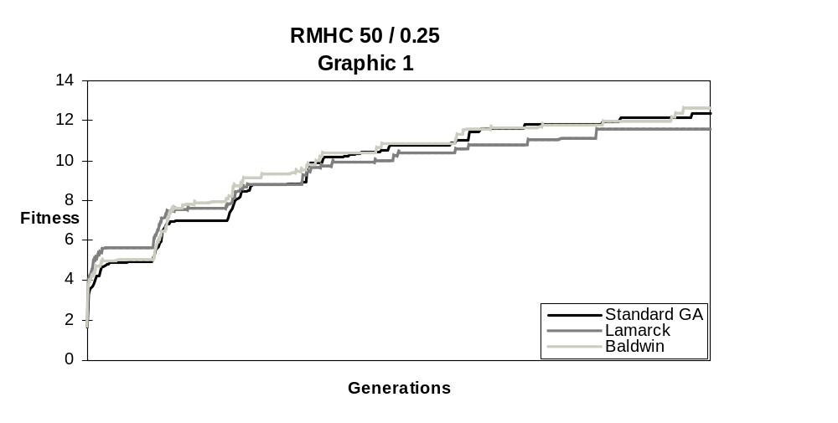
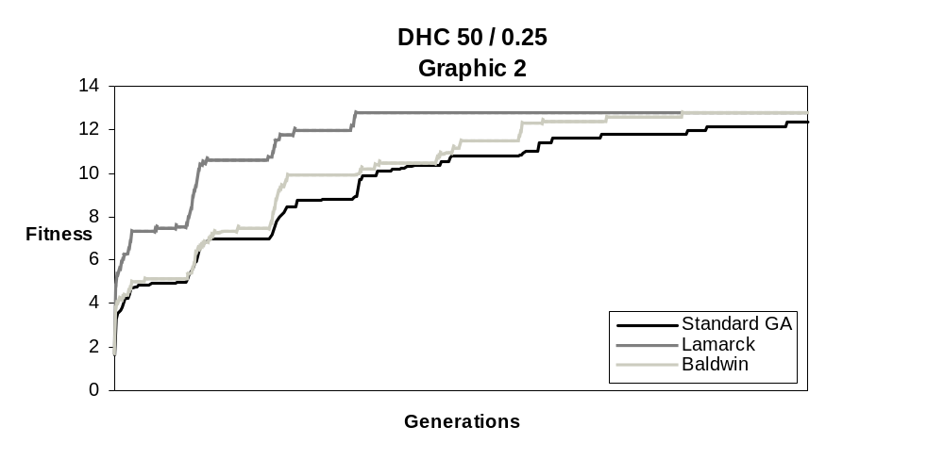
Learning procedures are time consuming (LL/LR parameters have a great impact in the consumption of CPU time). When applying them in optimization problems, such as this, we expect to accelerate the process of evolution in order to compensate the extra time spent in each generation. The results prove that if we can develop learning procedures that are not blind with respect to the structure of the problem being optimized we can obtain good performances. Obviously, in real situations, it is not possible to know in detail the structure of the problem being optimized. Anyway, the learning procedure proposed is general enough to be applied to other optimization problems. Its construction only used the knowledge that epistasis between neighbour genes is an usual feature in optimization of binary strings. From this we can conclude that even a partial understanding of the structure of the problem and its codification can be of great help in order to maximize performance. Graphics 1 and 2 plot the evolution of the best solution found by evolution alone and by Lamarckian learning and the Baldwin effect respectively with RMHC and DHC (LL=50; LR=0.25)

3.2.Influence of the Learning Strategies
The Baldwin effect produced little improvement in the optimization of the function. With both learning procedures the results achieved are not clearly better than the ones obtained by the GA alone. Also, the fact that the results achieved are similar with both learning procedures suggests that the Baldwin effect is not very sensitive to the modifications induced by any of them. Graphic 3 illustrates this situation. These results are not surprising. As noted by [Whitley et al., 94] and [Mitchell and Belew, 96] good performances obtained by the Baldwin effect have been related in complex domains, where the fitness landscape is hard to search by evolution alone. [Hinton and Nowlan, 87] argue that the main limitation of the Baldwin effect is that it is only effective in spaces that would be hard to search without an adaptive process to restructure the space. In this situation, where the optimization should be as fast as possible and evolution alone is able to search the space, there is not enough time to feel the influence of the Baldwin effect in the process of evolution.

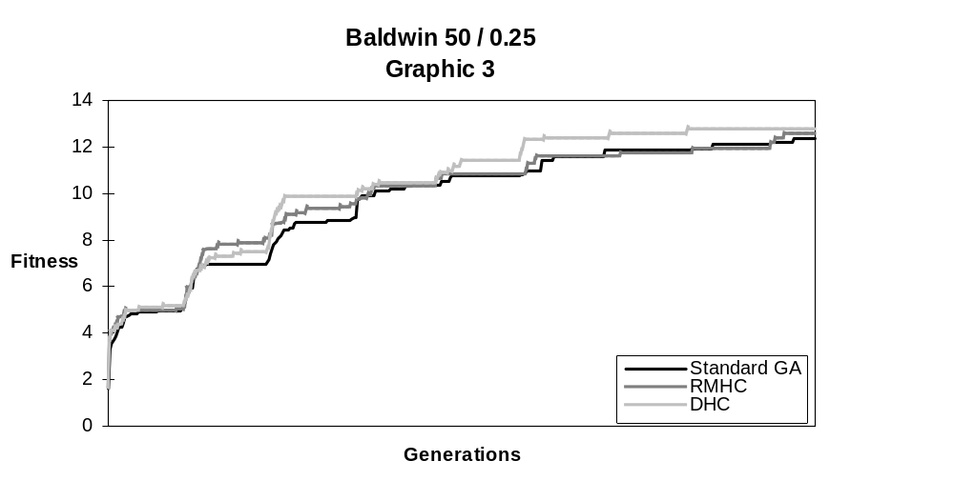

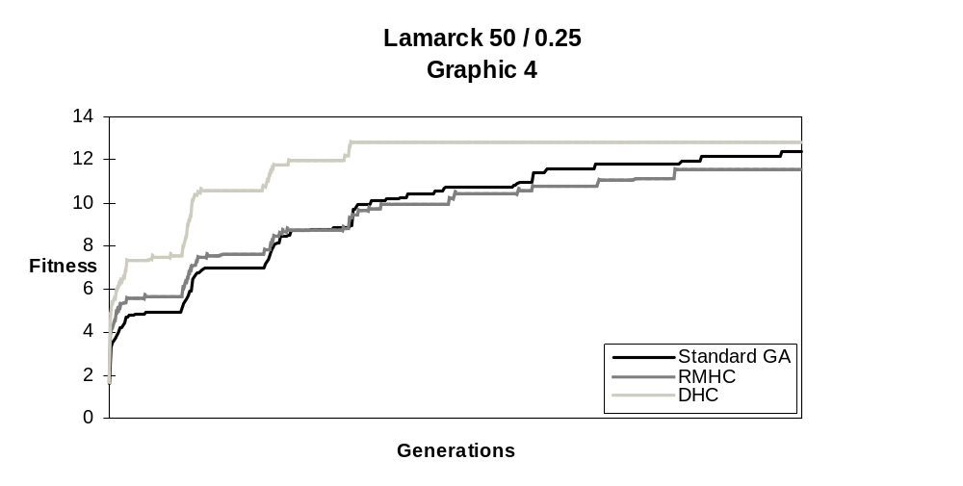

Lamarckian learning proved to be very sensitive to the learning procedure. It achieved good results with DHC and poor with RMHC. Graphic 4 illustrates this situation. When the local search algorithm is an effective guide, Lamarckian learning has a great impact in the process of evolution, leading it to converge in a short time. At the contrary, it seems that when the local search has difficulties in identifying promising individuals of the population, Lamarckian learning guides evolution to a local maxima. That’s what happened with RMHC. The explanation may be due to the fact that Lamarckian learning is a very powerful accelerator of evolution. If it is not used carefully or if it is misguided, then it may easily lead the GA to premature convergence.
In some situations Lamarckian learning might not be applicable, since the reverse mapping,δ⁻¹:Ph→G, might be impossible to achieve (e.g., if the maturation process depends on the environment) or computationable intractable. If with the Baldwin effect we could achieve higher rates of convergence, closer to the ones obtained with Lamarckian learning, then it would be possible to avoid this problem. Trying to increase the speed of convergence of experiments with the Baldwin effect might be the subject of future research.

3.3.Influence of the Variation of LL/LR Parameters
From the results presented it is not possible to determine what is the effective influence of the variation of the LL/LR parameters in the performance of the GA. Anyway, it seems clear that the increase of the learning process, either produced by the increase on the learning length or the frequency of learning, does not lead to an increase in the results. With Lamarckian learning, best results are obtained in the experiments with the smallest amount of learning ( LL=50; LR=0.25).
With the Baldwin effect, it is not clear what is the influence of the amount of learning in the optimization process. Anyway, increasing the values of LL/LR does not seem to accelerate the process of evolution. The mastery effect, described in [Hightower et al., 96] is not visible with the values used. Given a sufficient amount of learning, all individuals of a population will have the possibility to reach the optimal solution. When this happens, selective pressure disappears which will reduce the progress of evolution. It is shown that the reduction occurs linearly with the increasing of the amount of learning [Hightower et al., 96]. In our experiments, with the learning rates tried, the mastery effect is not clear.

4.Conclusions
In this work we applied a hybrid GA with learning to the optimization of a RR function. The results obtained prove that the evolution process may be accelerated if an appropriated learning procedure and learning strategy are chosen.
We observed that, in this experiment, the Baldwin effect is not an effective help to evolution. The reduction in the average number of generations needed to reach the optimal solution compared to the effort spent in the learning process is not significant. A possible explanation is that this problem is too easy to feel the influence of the Baldwin effect.
Lamarckian learning, if used carefully and with an effective local search algorithm, produces a dramatic reduction in the number of generations needed to reach a solution. With this experiment we proved that, under several conditions, Lamarckian learning might be an effective guide of evolution.
We are aware that the model we studied is of an extreme simplicity and does not reflect the complex relations between evolution and learning that exist in biological systems. Anyway, the results achieved can be seen as a starting point to the study of artificial systems with a higher degree of complexity.

References

Belew, R. K. And Mitchell, M. (1996). Introduction. In Belew, R. K. And Mitchell, M. (Eds.), Adaptive Individuals in Evolving Populations: Models and Algorithms, Proceedings Volume XXVI Santa Fe Institute, Studies in the Sciences of Complexity. 1-22, Addison-Wesley Publishing Company, Inc.

Grefenstette, J. (1990). A User’s Guide to GENESIS Version 5.0. Software and documentation available at ftp.aic.nrl.navy.mil:/pub/galist/src/ga/genesis.tar.Z.

Hart, W. E., Kammeyer, T. E. and Belew, R. K. (1995). The Role of Development in Genetic Algorithms. In Whitley, D. and Vose, M. D. (Eds.), Foundations of Genetic Algorithms 3, California: Morgan Kaufmann.

Hart, W. E. And Belew, R. K. (1996). Optimization with Genetic Algorithms Hybrids that Use Local Searches. In Belew, R. K. And Mitchell, M. (Eds.), Adaptive Individuals in Evolving Populations: Models and Algortihms, Proceedings Volume XXVI Santa Fe Institute, Studies in the Sciences of Complexity. 483-496, Addison-Wesley Publishing Company, Inc.

Hightower, R., Forrest, S. and Perelson, A. S.(1996).The Baldwin Effect in the Immune System: Learning by Somatic Hypermutation. In Belew, R. K. And Mitchell, M. (Eds.), Adaptive Individuals in Evolving Populations: Models and Algortihms, Proceedings Volume XXVI Santa Fe Institute, Studies in the Sciences of Complexity. 159-167, Addison-Wesley Publishing Company, Inc.

Hinton, G. E. And Nowlan, S. J. (1987). How Learning can Guide Evolution. Complex Systems. 1, 495-502.

Jones, T. (1995). A Description of Holland’s Royal Road Function. Evolutionary Computation 2(4): 409-415.

Maynard Smith, J. (1987). When Learning Guides Evolution. Nature, 329, 761-762.

Mitchell, M., Holland, J. and Forrest, S. (1994). When Will a Genetic Algorithm Outperform Hill Climbing? In Cowan, J. D., Tesauro, G. and Alspector, J. (Eds.), Advances in Neural Information Processing Systems 6, 51-58. San Francisco, CA: Morgan Kaufmann.

Mitchell, M. and Belew, R. K. (1996). Preface to Chapter 25. In Belew, R. K. And Mitchell, M. (Eds.), Adaptive Individuals in Evolving Populations: Models and Algortihms, Proceedings Volume XXVI Santa Fe Institute, Studies in the Sciences of Complexity. 443-446, Addison-Wesley Publishing Company, Inc.

Turney, P. (1996). Myths and Legends of the Baldwin Effect. Proceedings of the Workshop on Evolutionary Computing and Machine Learning at the 13th International Conference on Machine Learning (ICML-96), Bari, Italy, 135-142.

Whitley, D., Gordon, S. and Mathias, K.(1994). Lamarckian Evolution, the Baldwin Effect and Function Optimization. In Davidor, Y., Schwefel, H. P. and Manner, R. (Eds.), Parallel Problem Solving from Nature - PPSN III, 6-15. Berlin: Springer-Verlag.

- Correspondence should be addressed to the first author.

