1. How to use the template

AGILE 2015 instructions for the preparation of a 2-column-format camera ready paper using MS Word 2010

|  |  |  |  |
| --- | --- | --- | --- |
|  | John Doe  University/Institute  Address  City, Country  Email address | Ivan Petrov  University/Institute  Address  City, Country  Email address |  |

Abstract

These pages provide you with instructions on how to use this MS Word template to prepare your paper according to the required layout and style for AGILE 2015 papers. The abstract should be concise and no longer than 250 words.

*Keywords*: Please select a maximum of 6 keywords.

Using this template will enable you to prepare your paper in accordance with the instructions for authors for AGILE 2015 papers with a minimal amount of manual styling and formatting, by only copy, paste and overtyping. This style is based on the Article class with minor changes for the abstract and using Times Roman as default font.

Please read through the following sections for more information on preparing your paper. However, if you use the template you do not have to worry about setting margins, page size, and column size etc. as the template already has the correct dimensions.

1. Format

Text should be produced within the dimensions shown on these pages. Please, do not change the predefined margins. The maximum length of a paper is 6000 words, including figures, tables, equations and references.

There is a text box at the beginning of the document containing the title, the authors, the abstract and the keywords. If needed, feel free to extend this text box from its bottom side in order to make room for a bigger abstract or more authors. Authors are contained in a table. Rows and columns can be added in order to include more authors. Nonetheless, this table should not have more than three columns. Try to keep the size of this text box below half the size of the page, but please, do not change font sizes.

* 1. Spacing

You must use single line spacing. However, when typing complicated mathematical text it is important to increase the space between the text lines in order to prevent sub- and superscript fonts overlapping one another and making your printed matter unreadable.

Between the end of one section and the title of the next one, two full spaces must be added. The only exception is when the title of a section is at the beginning of a column.

* 1. Fonts

All text should be Times New Roman. Font sizes and styles are defined in the respective paragraph styles.

Section, subsection and subsection titles should use their own styles, “Section 1”, “Section 2” and “Section 3”, respectively. It should be pointed that text immediately after a section title should use “NormalPostSection” style, while the rest of the text should use “Normal” style. As you can see, there is some bleeding or indentation at the beginning of each paragraph in the normal text that is absent in the paragraphs that follow a section title.

* 1. Equations

Equations have to be numbered individually, using this number between parentheses to cross-reference them. They have to appear, if possibly, in one column.

In case an extremely long equation cannot be rendered in one column without affecting its readability, a text box can be used to span it across both columns. **Make sure you use one box per formula.**

Nevertheless, try to avoid this rendering as it might be confusing to readers. See the difference between (1) and (2).

Table 1: Example of table with title above.

(2)

|  |  |  |  |
| --- | --- | --- | --- |
| System | Chip 1 | Chip2 | |
| Detector thickness in µm | 300 | 300 | 700 |
| Edge angle in ° | 3.55 | 2.71 | 7.99 |
| Spatial resolution in µm | 4.26 | 10.17 | 10.56 |
| MTF at fmax | 0.53 | 0.37 | 0.39 |
| LSF-spatial resolution in µm | 129.7 | 52.75 | 50.78 |
| In % of pixel size | 76.3 | 95.9 | 92.3 |

Source: LyX's detailed Figure, Table, Floats, Notes, Boxes and External Material manual.

Figure 1: Example of figure, with title above the image.

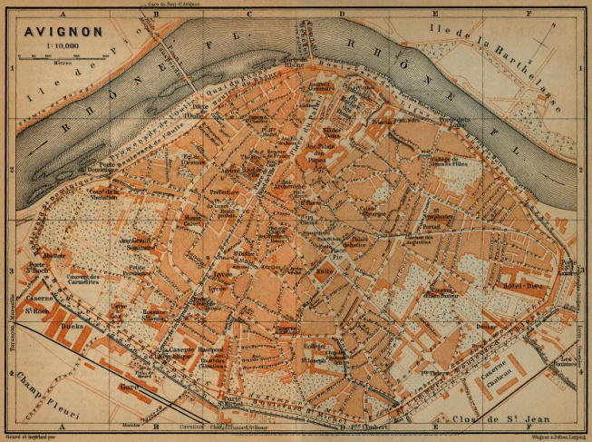

Source: Perry-Castañeda Library Map Collection, University of Texas.

* 1. Tables

Tables can appear in one column, as in Table 1, or spanned across both of them, as in Table 2, using a text box. **Remember to use one text box per table**.

Nevertheless, try to make tables that fit in one column as frequently as possible. See the difference between Tables 1 and 2.

Horizontal lines for separation between rows must be used, while no vertical lines for separation between columns are needed.

Titles or captions have to be placed above the tables, preceded by “Table”, the number that identifies the table and a colon. Titles or captions that use less than one line must be centered, while those that use more than one line must be justified.

Sources for the tables have to appear underneath them, justified and preceded by “Source:”.

* 1. Figures

Figures can appear in one column, as in Figure 1, or spanned across both columns, as in Figure 2, using a text box. **Remember to use one text box per table.**

It is important that you use high resolution images to keep the highest quality across the whole editing process. Images should have at least 300 DPI in the size they are going to be rendered in the camera ready version of the paper. No separate files for the figures are needed.

Titles or captions have to appear above the image, preceded by “Figure”, the number that identifies the figure and a colon. Titles are centered when they use less than one line and justified in other case. Sources for the images have to appear underneath them, justified and preceded by “Source:”.

1. References

References have to be cited numerically, between brackets and inline [2].

When more than one reference is cited at the same moment, they have to be sorted and separated by commas [1, 3, 4].

References have to appear in a separated, unnumbered section called “References”. The title “References” has to be typed using the “ReferencesTit” style. References have to be sorted alphabetically and their numerical labels assigned accordingly. References are typeset using the “References” style.

You can use the following as examples to format the main types of references (based on the “Plain” BibTeX style):

* Journals: Walter Crosby Eells. A mistaken conception of the center of population. *Journal of the American Statistical Association*, 25(169):33-40, 1930.
* Proceedings: Shan-Huo Chen and Chien-Chung Wang. Fuzzy distance using fuzzy absolute value. In *Proceedings of the Eighth International Conference on Machine Learning and Cybernetics*, Baoding, 2009.
* Book chapters: J. Darzentas. On fuzzy location model. In J. Kacprzyk and S. A. Orlovski, editors, *Optimization Models Using Fuzzy Sets and Possibility Theory*, pages 328--341. D. Reidel, Dordrecht, 1987.
* Books: Andy Ruina and Rudra Pratap. *Introduction to statics and dynamics*. Oxford University Press, Oxford, 2011.
* Edited and collective books: A. Ravi Ravindran, editor. *Operations research and management science handbook*. CRC Press, Boca Raton, 2008.

For aesthetic reasons, try to balance columns in the last page of the paper.

References

[1] S.-H. Chen and C.-C. Wang. Fuzzy distance using fuzzy absolute value. In *Proceedings of the Eighth International Conference on Machine Learning and Cybernetics*, Baoding, 2009.

[2] J. Darzentas. On fuzzy location model. In J. Kacprzyk and S. A. Orlovski, editors, *Optimization Models Using Fuzzy Sets and Possibility Theory*, pages 328-341. D. Reidel, Dordrecht, 1987.

[3] W. C. Eells. A mistaken conception of the center of population. *Journal of the American Statistical Association*, 25(169):33-40, 1930.

Figure 2: Example of figure, with title above the image.

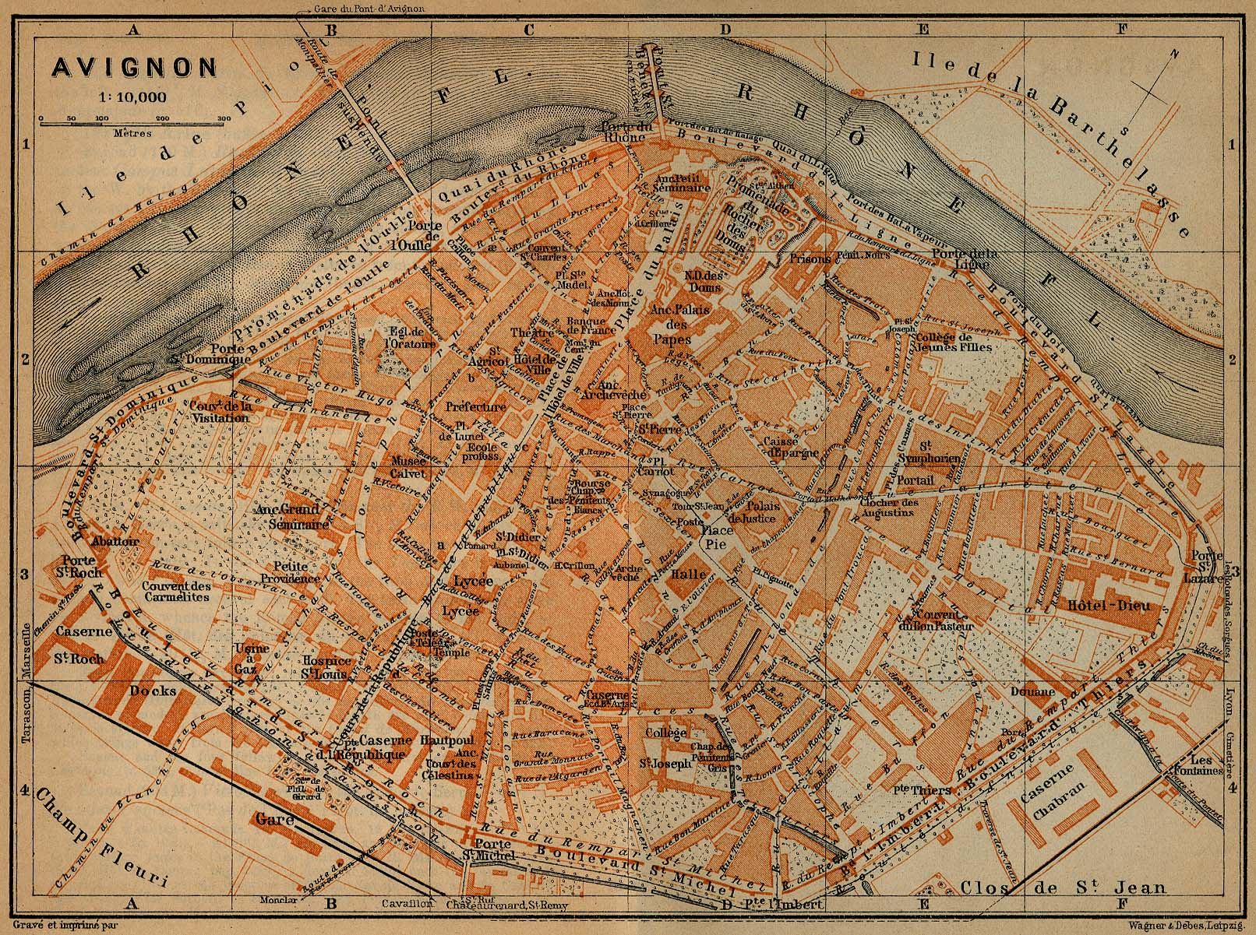

Source: Perry-Castañeda Library Map Collection, University of Texas.

Table 2: Example of table with title above

|  |  |  |  |
| --- | --- | --- | --- |
| System | Chip 1 | Chip2 | |
| Detector thickness in µm | 300 | 300 | 700 |
| Edge angle in ° | 3.55 | 2.71 | 7.99 |
| Spatial resolution in µm | 4.26 | 10.17 | 10.56 |
| MTF at fmax | 0.53 | 0.37 | 0.39 |
| LSF-spatial resolution in µm | 129.7 | 52.75 | 50.78 |
| In % of pixel size | 76.3 | 95.9 | 92.3 |

Source: LyX's detailed Figure, Table, Floats, Notes, Boxes and External Material manual.

[4] A. Ravi Ravindran, editor. *Operations research and management science handbook.* CRC Press, Boca Raton, 2008