String ->makeAbba

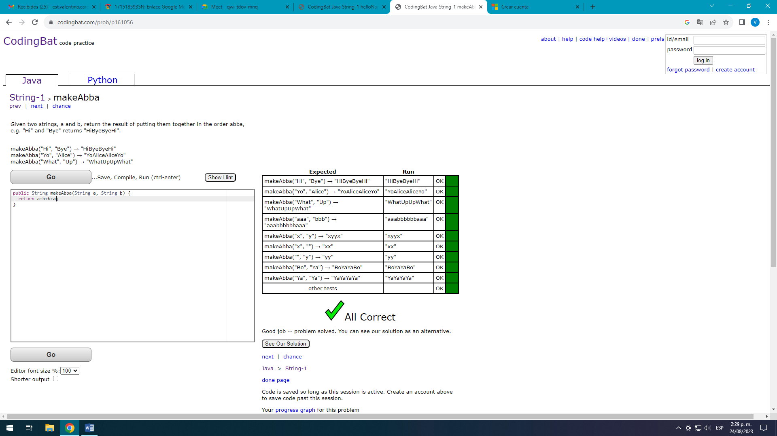

[String-1](https://codingbat.com/java/String-1) > makeTags

public String makeTags(String tag, String word) {

return "<"+tag+">"+word+"</"+tag+">";

}

[String-1](https://codingbat.com/java/String-1) > makeOutWord

public String makeOutWord(String out, String word) {

return out.substring(0,2)+word+out.substring(2,4);

}

[String-1](https://codingbat.com/java/String-1) > extraEnd

public String extraEnd(String str) {

return str.substring(str.length()-2)+str.substring(str.length()-2)+str.substring(str.length()-2);

}

[String-1](https://codingbat.com/java/String-1) > firstTwo

public String firstTwo(String str) {

if(str.length()>2){

return str.substring(0,2);

}else

return str;

}

[String-1](https://codingbat.com/java/String-1) > firstHalf

public String firstHalf(String str) {

return str.substring(0,str.length()/2);

}