Lawfirm

This is a basic web application which was created in Java. You may access and test this app via: https://valena.herokuapp.com/.
IMPORTANT: In case of error message - please try again - this app requires some time to load data from remote database :-)

Tools and frameworks used

Spring MVC, Hibernate, Spring Security, Spring boot, JavaScript, MySQL,Boostrap

Purpose
This application could be used by a law firm for the purposes of requesting for lawyer. Apps main functionality is booking of appointment time with the lawyer both admin and client can - app gives admin a convenient and intuitive insight into appointment time via timesheet. Admin may generate reports and charts based on the data inserted to the database by client.

Landing page

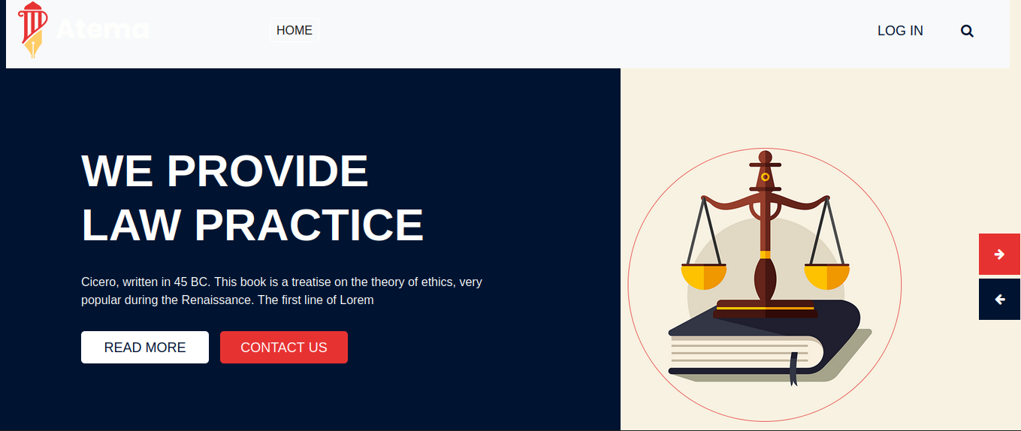
Landing page gives insight into what lawfirm software is and its usefulness as a tool. LOGIN
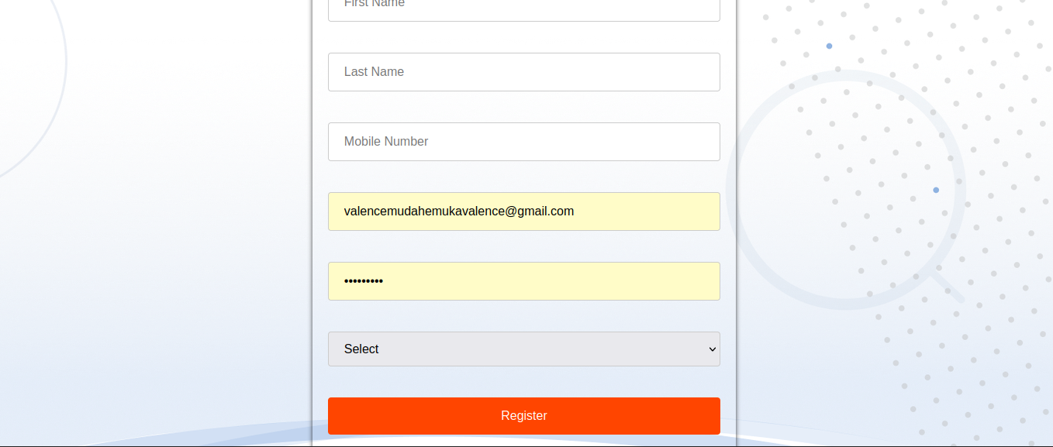
In order to enjoy app's entire functionality it is required of a user to create an account to login. After creating an account and login when you are creating an account you have to option you can create register as an admin of user both of the have different privileges
when you login as admin
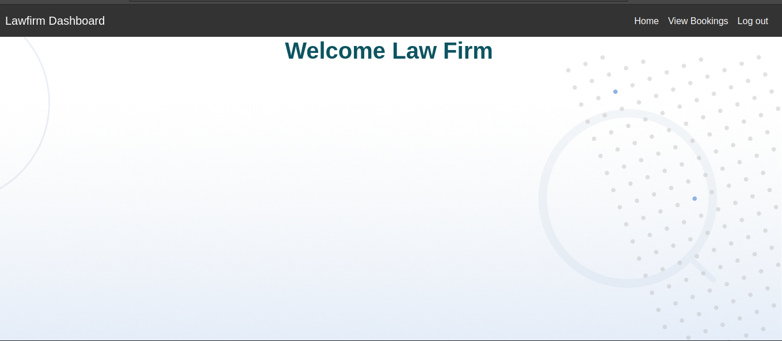
you can go on view bookings and you are able to make modification you are able to answer clients as shown blow

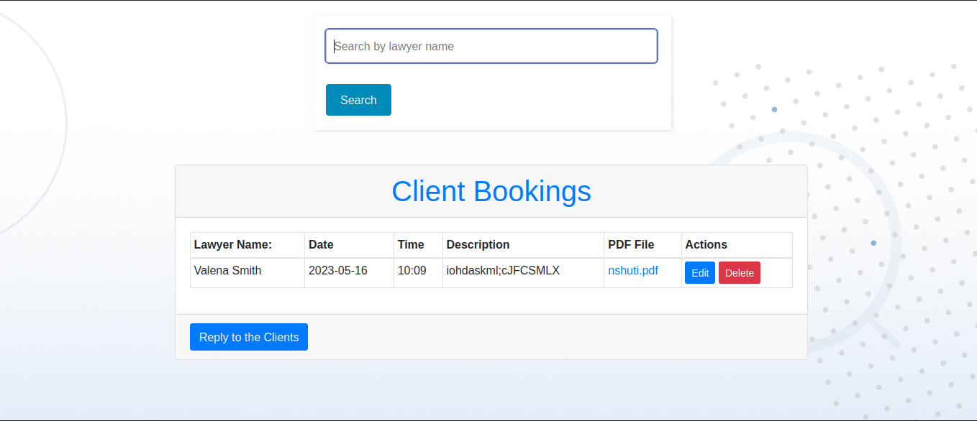
you can such a lawyer and be able to see all booking that belong to him or her
when you click on reply to the client you go to the next page with helps to reply to the client
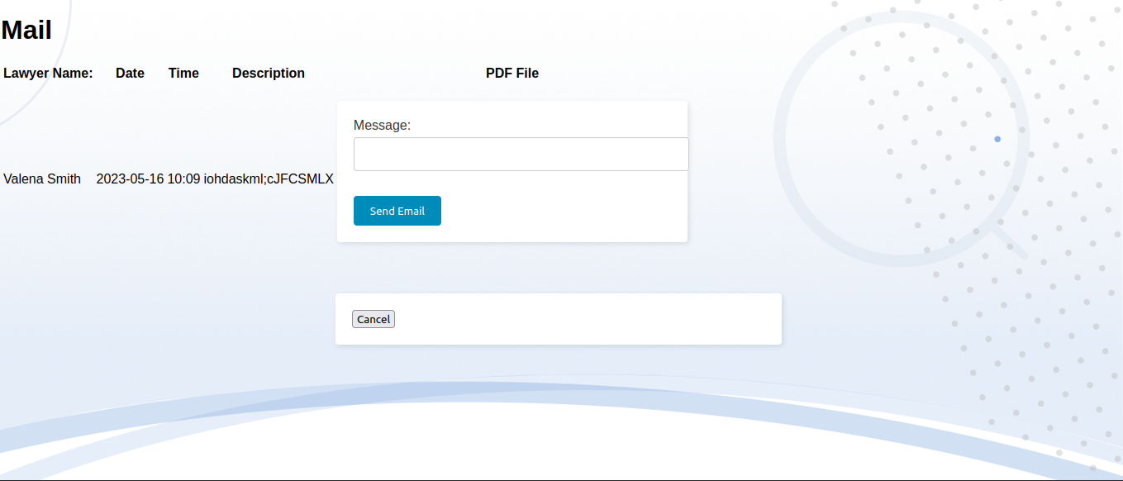
Login as user
first thing you see are available lawyers
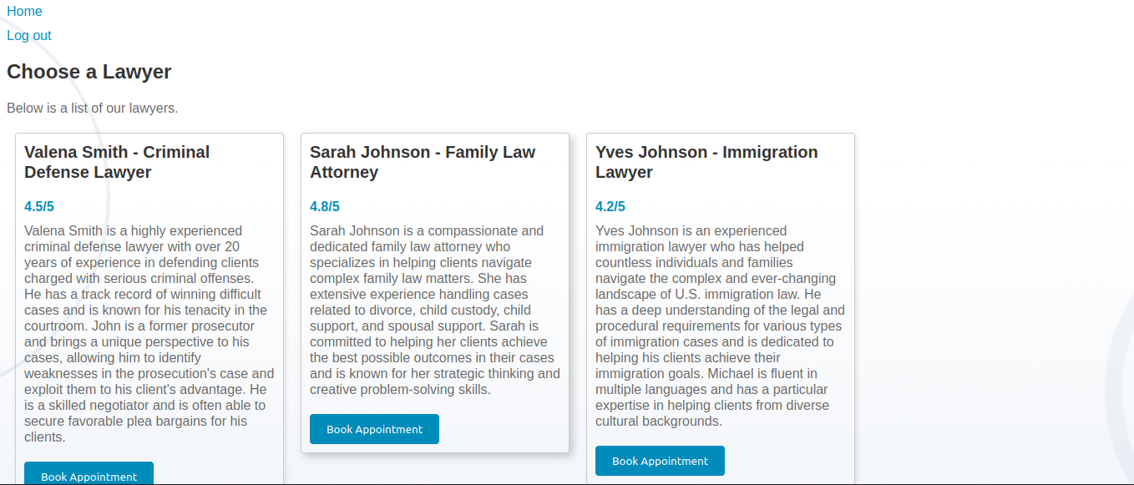
you can book an appointment when you click on book appointment

