## 7. Follow Up:

Activity to sustain

Weekly meeting with Sales support team – Items covered

* Stats on volume orders in validation
* Volumes of order week on week that are getting parked due to validation errors
* Volumes of orders with Non-conformances raised for validation errors
* Actions
* Update on cross skilling in Sales support
* Propose any updates to the validation checklist

Monthly meetings with Delivery teams review how the process is working / are there any gaps etc.

**Re baseline to happen End March**

**Benefits realised so far**

* Remove duplication from 6 teams to 1
* Customer expectations now being set up from re clean orders
* As of end Jan current Eir Delays at 39%
* As of end March Eir Delays at 35%

## Background:

When completing the end to end process review if became apparent that every team during the delivery process felt the need to complete a validation on information provided to them or work carried out prior to them before they could complete their task.

This is then causing delays and inefficiencies in our processes. Multiple teams validating the same information.

**VOC** - Our customers are calling out through Deep Insight feedback that our leadtimes are too long and don’t meet their requirements

**VOP** – Teams calling our unclean order as a blocker for them doing their job well / hitting targets

## 2. Current Condition:

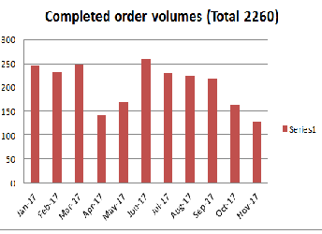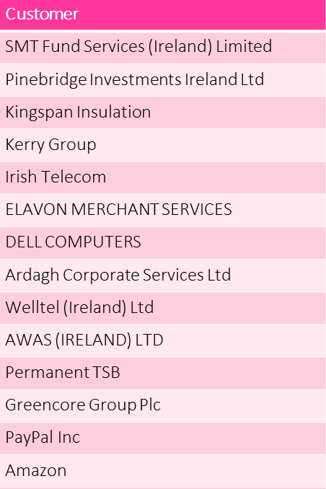 

* Currently there are 9 different team with delivery validation customer & Technical information

**Failure Rates**



## 3. Goal:

To reduce the failure rate as called out in the current condition

|  |  |
| --- | --- |
| Parked Volume | Reduce by 50% |
| Number of touch points for validation | Reduce 70% |
| Eir Delays | Reduce by 30% |
| Unclean OVQ | Reduce by 30% |

Timeline 12 months

## 4. Root Cause Analysis: What is causing the problem?

Process, People

1. In some cases we have teams validating is a field populated but not actually validating the data in the field, this is results in another team then needing to validation accuracy of the data.
2. Validation is not as robust as it needs to be so accuracy of data is an issue which has resulted in teams adding additional pieces of validation.
3. We have added additional validation points to the process over the years to catch inaccuracies instead of fixing the issues.
4. We have no set clear Roles of Responsibilities of who should validate what information to avoid duplication – no one team is accountable 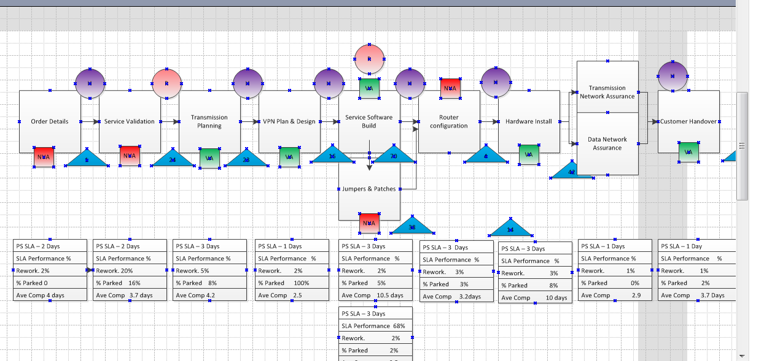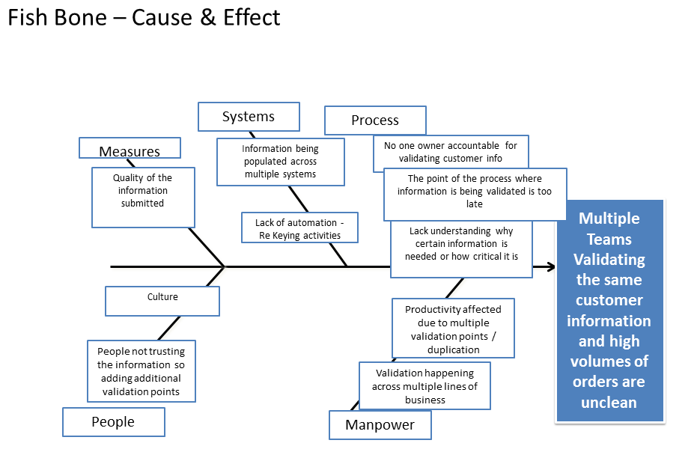

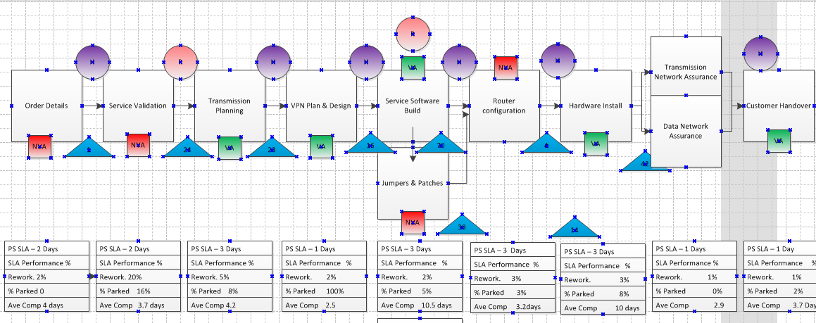

**Our customers are calling out through Deep Insight feedback that our lead-times are too long and don’t meet their requirements – 16 customers have called this out in the 2017 survey**

## Responsable: Michelle Finnegan, Frances Moran

When is this happening? **On all orders types Global & Domestic – volumes below**

## 5. Proposed Countermeasure:

What is the solution?

There is one team who is Responsible / accountable for validating a piece of information and these roles and responsibilities are known to everyone in the process

**Option 1.**

Collate all customer validation and move it to one team within Delivery, the team who raise the orders.

**Option 2**

Collate all customer validation and move it to the Pre Sales part of the process i.e all customer information is validated prior to being submitted to delivery.

Additional countermeasures

* Removal of rekeying tasks where ever possible in the process
* Fixing the root causes of the inaccuracies by capturing them via the NCR & Parked process and then putting corrective actions in place so they don’t reoccur. Review via VOC

*Benefit:*

* ***Remove duplication*** *of validating customer information in multiple teams by 80%*
* *Clean orders will help us achieve and* ***improve our lead-times***
* ***Earlier Billing*** *if we reduce customer delays on orders. Orders remain fluid*
* ***Quicker resolution*** *on orders that do go on delay as teams required to resolve sit in the one area.*
* *One team is responsible & accountable for clean order information resulting in a* ***clear simplified process***
* ***Clear expectations are set*** *with customer earlier on in the process example site readiness, customer contacts etc.*

## 6. Plan:

Steps to deliver the solution

|  |  |  |  |
| --- | --- | --- | --- |
| **Action** | **Owner** | **Timelines (reviewed in March 18)** | **Target Completion date** |
| Agreement & sign off of the proposed changes | Colm / Dermot | Week ending 30th March | 25th April 2018 |
| Further communication e.g.. HR, Voices, Teams impacted | Michelle / Frances / Dermot | Week ending 6th April | 31st July 2018 |
| Implementation Planning | Michelle / Frances / Dermot | Week ending 20th April | 2nd Aug 2018 |
| Agree Headcount moves | Niamh / Colm | Week ending 27th April | 1st Oct 2018 for 15th Oct start |
| Review & reset Signed to Create SLA’s | Michelle / Frances / Dermott | Week ending 27th April | To be reset by End of Q4 2019 |
| Create robust validations checklists based on current area’s of failure | Michelle / Frances / Dermott | Week ending 25th May | 28th Sept 2018 |
| Set up training and agree support period | Michelle / Frances / Dermott | Week ending 8th June | Training complete 28th Sept 2018, support on going. |
| Weekly Post implementation reviews set up | Michelle / Frances / Dermott | Week ending 29th June | Weekly support calls set up each week with Sales Support & Order Management |