**TUGAS 2  
ADMINISTRASI BASIS DATA**



Raihan Mufti Mubarok

3122522011

D3 PSDKU Sumenep

**PRODI D3 TEKNIK INFORMATIKA**

**DEPARTEMEN TEKNIK INFORMATIKA DAN KOMPUTER**

**PENS PSDKU SUMENEP**

Koneksi user ke database server

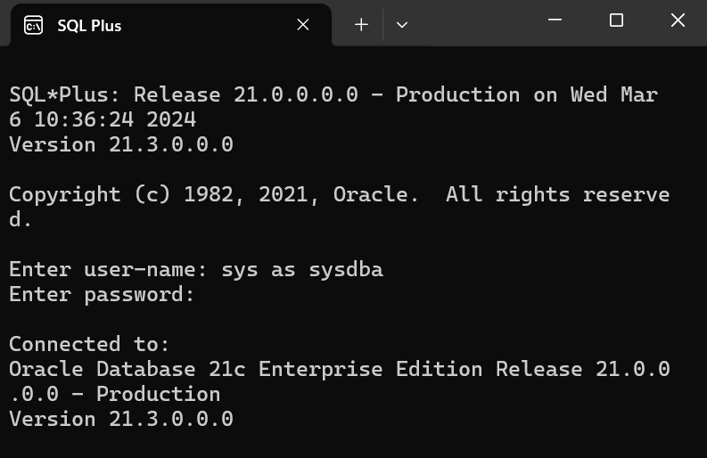

Startup

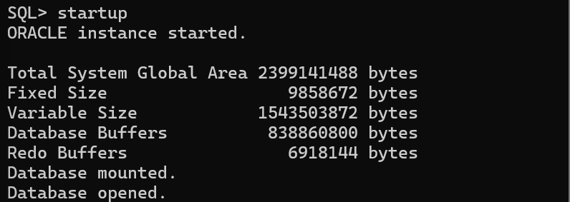

Startup Listener

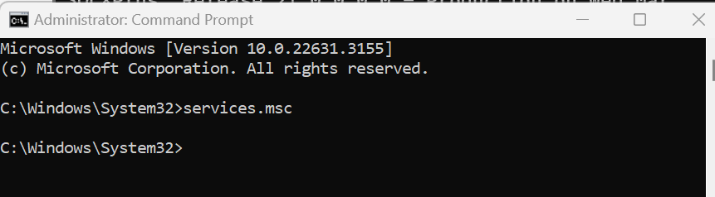

Secara em

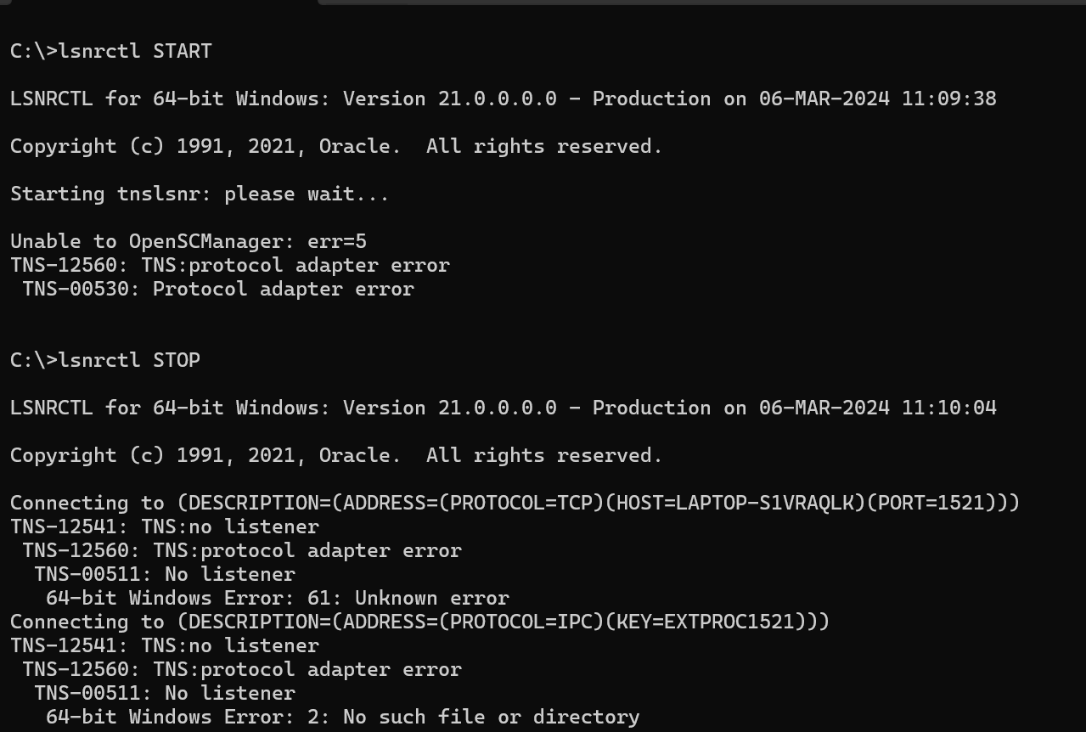



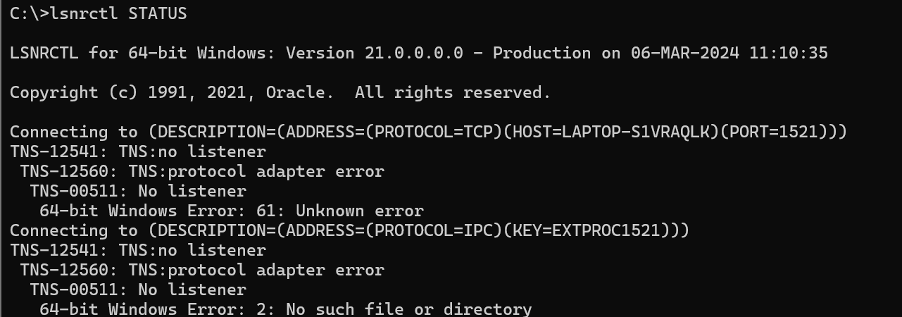

Listener service windows

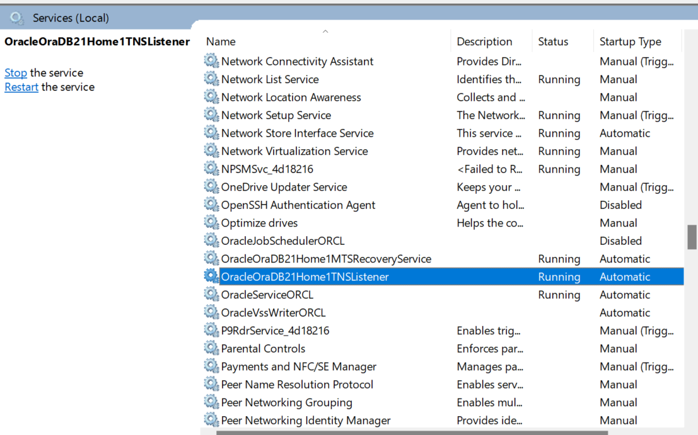

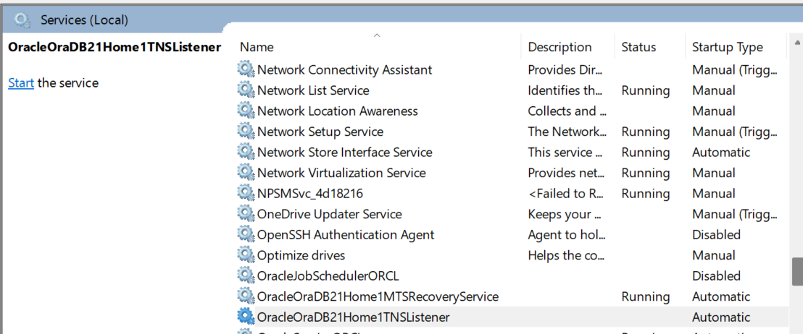

Shutdown Normal

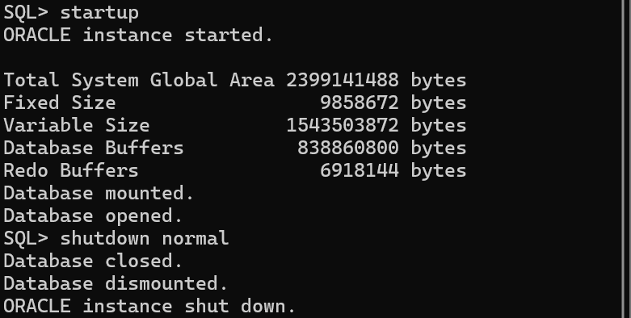

Shutdown Abort

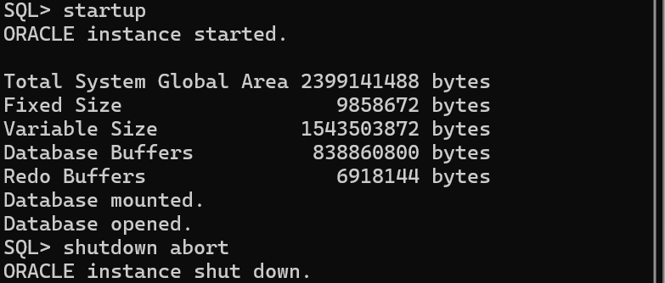

Shutdown Immediate

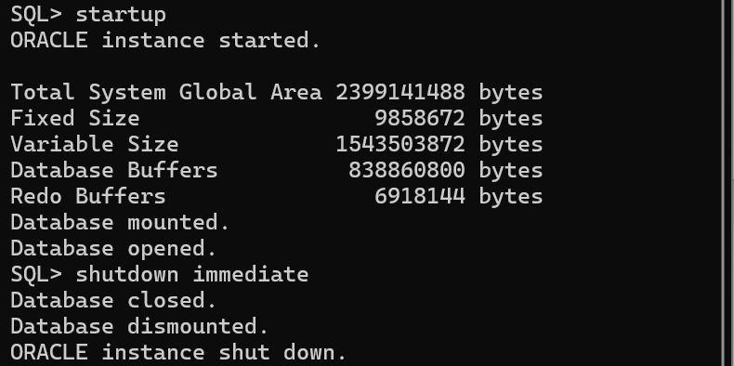

Shutdown Transactional

