As shown in the above diagram, the lambda function is called via the API Gateway by the first component, more exactly from the EC2 machine that is used to host the frontend of the application.

In the logs of the lambda function, we can also see the response time of the database calls to retrieve data. Using that data we created a charts to visualize the response time of the requests to the database.

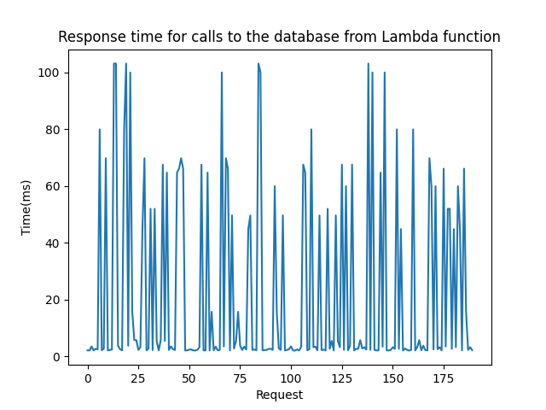

Response time for frontend component for 100 sequential requests

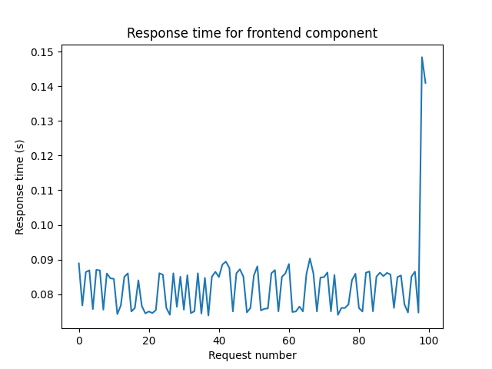

Response time for backend component for 100 sequential requests

