Changes to the digital menu
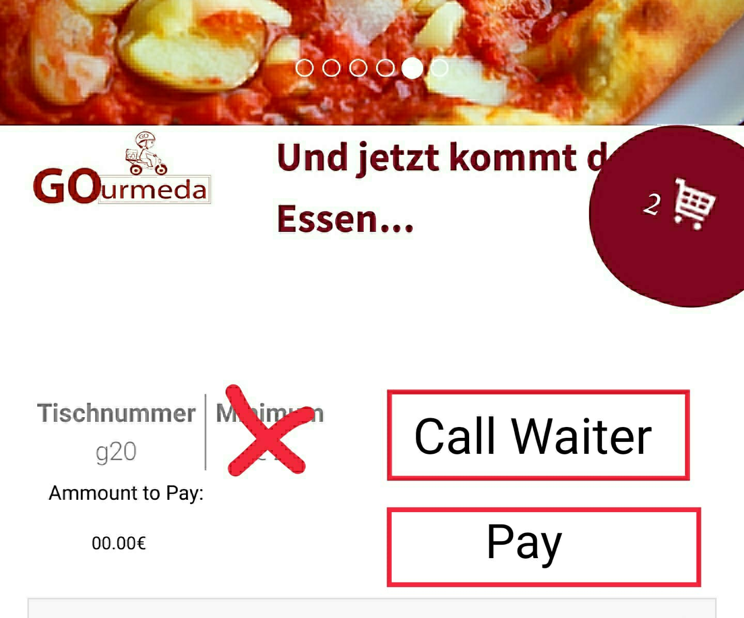
- Remove minimum order ammount (also from software – anny ammount should be orderable)
- Add “Ammount to Pay” field, showing current balance (below the table number)
- Add a “Call Waiter”-Button – send an alert to the waiter
- Add a “Pay”-button – call a waiter to the table to collect the payment (customers cannot pay online/without the waiter)
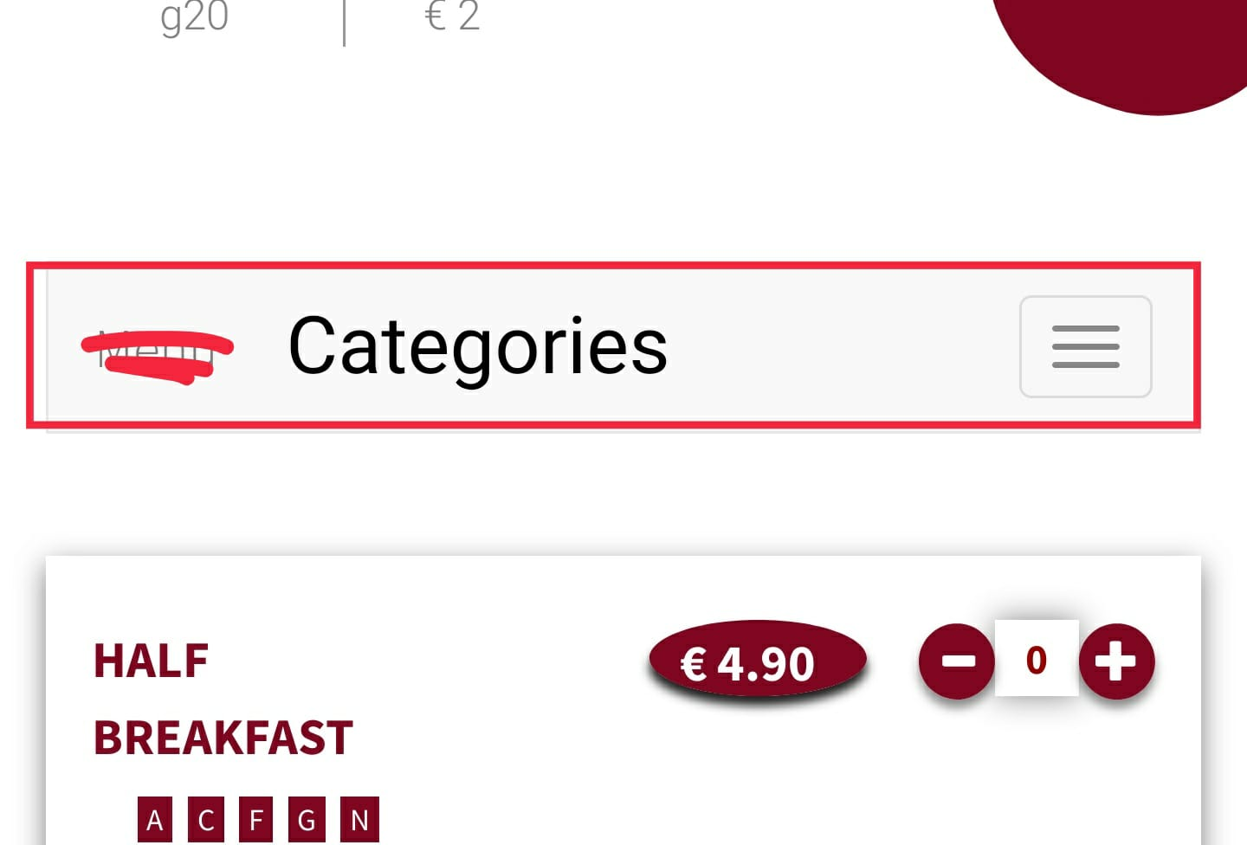
- Make the 1st line shown when opening the menu the actual header – color it red (like the categories currently are). When the user scrolls down, the categories should collapse and stay on the top of the screen. When the collapsed categories are clicked, automatically scroll back up and expand the list.

