Numerical modelling of excitation of exchange magnons in nickel films by picosecond acoustic pulses

V. Besse,1 A.V. Golov,2* V.S. Vlasov,2 L.N. Kotov,2 A. Alekhin,1 D.A. Kuzmin,3,4 I.V. Bychkov,3,4 and V.V. Temnov1

1*IMMM UMR CNRS 6283, Le Mans Université, 72085 Le Mans Cedex, France*

2*Syktyvkar State University named after Pitirim Sorokin, 167001, Syktyvkar, Russian Federation*

3*Chelyabinsk State University, Department of Radio-Physics and Electronics, 454001 Chelyabinsk, Russian Federation*

4*South Ural State University (National Research University),454080 Chelyabinsk, Russian Federation*

\**antongolov@mail.ru*

Here, we report a numerical study of exchange magnons in Ni thin films, excited by a series of picosecond acoustic pulses. Our numerical model is based on the Landau-Lifschitz-Gilbert (LLG) equation. We consider only the phonon-magnon interaction as the excitation mechanism. According to this mechanism, acoustic pulses propagate through a ferromagnetic film and alter the direction of the effective magnetic field thereby driving precessional motion of the magnetization.

We study how acoustic pulses drive and control the magnetization precession and what is the influence of the shape, amplitude and temporal delay between the acoustic pulses on the induced dynamics. In our work we consider different coupling conditions: phase matching, group matching and frequency matching, which can be realized applying the external magnetic field with certain magnitude and direction.

Changing the number of acoustic pulses and temporal delay between them, one can enhance certain harmonics and suppress the others, which is determined by the spectrum of the acoustic excitation.

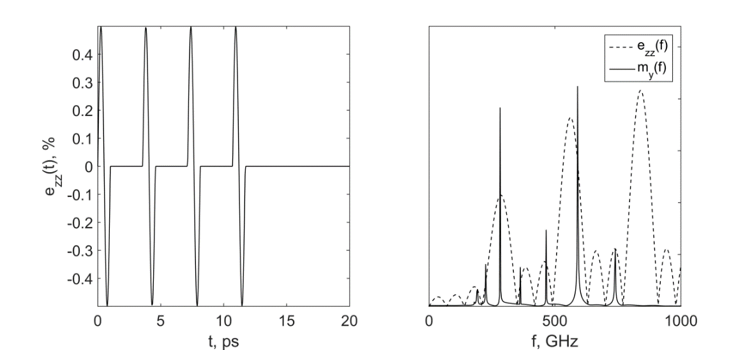

|  |
| --- |
| Fig. Time dependence of a series of four bipolar acoustic pulses propagating through a 30-nm nickel film (left). The spectra of the acoustic pulses and excited magnons obtained in the external magnetic field of 6.5T (right). |

We gratefully acknowledge the financial support from RFBR (grant # 17-02-01138), PRC CNRS-RFBR “Acousto-magneto-plasmonics” (grant # 17-57-150001), Stratégie Internationale NNNTelecom de la Region Pays de la Loire and Alexander von Humboldt Stiftung, the European Research Council (FP7/2007-2013) / ERC grant agreement no. 306277.