Theoretical description of phonon-magnon interactions at the nano-scale

V. Besse,1* A.V. Golov,2 V.S. Vlasov,2 L.N. Kotov,2 A. Alekhin,1 D.A. Kuzmin,3,4 I.V. Bychkov,3,4 and V.V. Temnov1

1*IMMM UMR CNRS 6283, Le Mans Université, 72085 Le Mans Cedex, France*

2*Syktyvkar State University named after Pitirim Sorokin, 167001, Syktyvkar, Russian Federation*

3*Chelyabinsk State University, Department of Radio-Physics and Electronics, 454001 Chelyabinsk, Russian Federation*

4*South Ural State University (National Research University),454080 Chelyabinsk, Russian Federation*

\**valentin.besse@univ-lemans.fr*

The discovery of ultrafast demagnetization by femtosecond laser pulses in 1996 [1] opened the new field of ultrafast manipulation of magnetization [2,3] being of a key for further development in spintronics. Magnetization dynamics induced by a pump laser pulse could be sort in different categories [4]: thermal, opto-magnetic and spin-transport effects. Nevertheless, the magnetically ordered substances are coupled with other systems such as the elastic system, which can also drive the magnetization dynamics. In the case of ferromagnetic transition metals (Ni,Co,Fe) important mechanisms originate from laser-induced heating, spin transport and phonon-magnon interactions.

This presentation will focus on understanding phonon-magnon interactions. We consider the generation and propagation of magnons excited by single and multiple picosecond acoustic pulses. We describe in detail the mechanisms that are at stack and model the spin motion by LLG equation with magneto-elastic and exchange terms. Analytical approximations as well as the role of phase and group matching conditions are discussed.

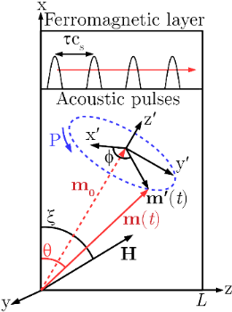 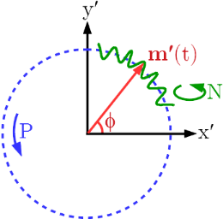

|  |  |
| --- | --- |
| Fig. 1. Scheme of the precession P movement of the magnetization vector **m** around an equilibrium position **m0** induced by periodic trains of picosecond acoustic pulses propagating at the sound velocity of cs with a delay τ between them. | Fig. 2. Scheme of the spin’s movement composed by the low-frequency (FMR) precession P and the hiogh-frequency (exchange magnon) nutation N. |

Funding through Nouvelle équipe, nouvelle thématique ”Ultrafast acoustics in hybrid magnetic nanostructures”, Stratégie internationale NNN-Telecom and the Acoustic HUB de la Region Pays de La Loire, Alexander von Humboldt Stiftung, ANR-DFG “PPMI-NANO”, PRC CNRS-RFBR ”Acousto-magneto-plasmonics” (grant number 1757 150001) is gratefully acknowledged.

[1] E. Beaurepaire, J.-C. Merle, A. Daunois, and J.-Y. Bigot, Phys. Rev Lett. **76**, 4250 (1996).

[2] B. Koopmans, M. van Kampen, J.T. Kohlhepp, *et al.*, Phys. Rev. Lett. **85**, 844 (2000).

[3] J.W. Kim, J.-Y. Bigot, Phys. Rev. B **95**, 144422 (2017).

[4] A. Kirilyuk, A.V. Kimel, T. Rasing, Rev. Mod. Phys*.* **82**, 2731 (2010).