Mechanisms related to exchange magnons induced by picosecond acoustic pulses

V. Besse,1* A.V. Golov,2 V.S. Vlasov,2 L.N. Kotov,2 A. Alekhin,1 D.A. Kuzmin,3 I.V. Bychkov,3 and V.V. Temnov1

1*IMMM UMR CNRS 6283, Le Mans Université, 72085 Le Mans Cedex, France*

2*Syktyvkar State University named after Pitirim Sorokin, 167001, Syktyvkar, Russian Federation*

3*Chelyabinsk State University, 454001 Chelyabinsk, Russian Federation*

\**valentin.besse@univ-lemans.fr*

The discovery of ultrafast demagnetization by femtosecond laser pulses in 1996 [1] opens the new and booming field of ultrafast laser manipulation of magnetization [2, 3]. This control of magnetization precession is a key for further development in spintronic. Magnetization dynamics induced by a pump laser pulse could be sort in different categories [4]: thermal effects, photomagnetic effects, and optomagnetic. Nevertheless, the magnetic system of ordered substances is coupled with other systems as the elastic system, which can drive the magnetization. In the case of a single ferromagnetic, we can limit our consideration just to two mechanisms: laser-induced heating and phonon-magnon interactions.

This presentation will focus only on phonon-magnon interactions. Our numerical model is based on the Landau-Lifschitz-Gilbert (LLG) equation. We consider the generation and propagation of magnons due to the propagation of picosecond acoustic pulses. We will present in detail the mechanisms that are at stack and we will describe the spin movement.

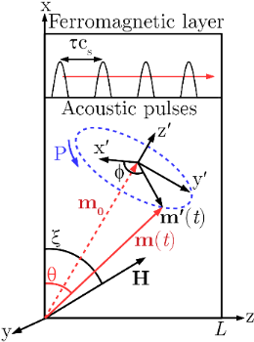 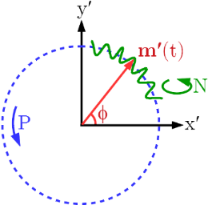

|  |  |
| --- | --- |
| Fig. 1. Scheme of the precession P movement of the magnetization vector **m** around an equilibrium position **m0** induced by the propagation of picosecond acoustic pulses at the sound velocity of cs.with a delay of τ between them. | Fig. 2. Scheme of the spin’s movement composed by the precession P and the nutation N. |

Funding through Nouvelle équipe, nouvelle thématique ”Ultrafast acoustics in hybrid magnetic nanostructures”, Stratégie internationale NNN-Telecom and the Acoustic HUB de la Region Pays de La Loire, Alexander von Humboldt Stiftung, ANR-DFG “PPMI-NANO”, PRC CNRS-RFBR ”Acousto-magneto-plasmonics” (grant number 1757 150001) is gratefully acknowledged.

[1] E. Beaurepaire, J.-C. Merle, A. Daunois, and J.-Y. Bigot, Phys. Rev Lett. **76**, 4250 (1996).

[2] B. Koopmans, M. van Kampen, J.T. Kohlhepp, *et al.*, Phys. Rev. Lett. **85**, 844 (2000).

[3] J.W. Kim, J.-Y. Bigot, Phys. Rev. B **95**, 144422 (2017).

[4] A. Kirilyuk, A.V. Kimel, T. Rasing, Rev. Mod. Phys*.* **82**, 2731 (2010).