Numerical modelling of excitation of exchange magnons in nickel films by picosecond acoustic pulses

V. Besse,1 A.V. Golov,2* V.S. Vlasov, 2 L.N. Kotov,2 A. Alekhin,1 D.A. Kuzmin,3,4 I.V. Bychkov,3,4 and V.V. Temnov1

1*IMMM UMR CNRS 6283, Le Mans Université, 72085 Le Mans Cedex, France*

2*Syktyvkar State University named after Pitirim Sorokin, 167001, Syktyvkar, Russian Federation*

3*Chelyabinsk State University, Department of Radio-Physics and Electronics, 454001 Chelyabinsk, Russian Federation*

4*South Ural State University (National Research University),454080 Chelyabinsk, Russian Federation*

\**antongolov@mail.ru*

Here, we report a numerical study of exchange magnons in nickel thin films, excited by a series of picosecond acoustic pulses. Our numerical model is based on the Landau-Lifschitz-Gilbert (LLG) equation. We consider only the phonon-magnon interaction as the excitation mechanism. Acoustic pulses propagate through a ferromagnetic film and alter the direction of the effective magnetic field thereby driving precessional motion of the magnetization.

We study the impact of the acoustic pulses on the magnetization precession, varying the amplitudes and time delays between the pulses. Also we investigate the effect of the shapes of the acoustic pulses, comparing unipolar and bipolar pulses. In our work we consider different coupling conditions: phase matching, group matching and frequency matching, which can be realized applying the external magnetic field with certain magnitude and direction.

The amplitude of the excited oscillations can be amplified by increasing the number of acoustic pulses. Changing the number of acoustic pulses and time between them, we can enhance certain harmonics and suppress the others. It is mostly determined by the spectrum of the acoustic excitation

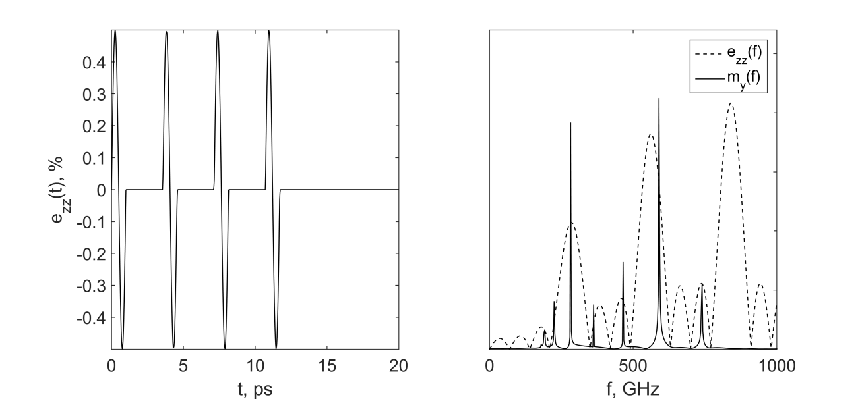

|  |
| --- |
| Fig. Time dependence of a series of four bipolar acoustic pulses propagating through a 30-nm nickel film (left). The spectra of the acoustic pulses and excited magnons in the external magnetic field of 6.5T (right). |

We gratefully acknowledge the financial support from RFBR (grants # 17-57-150001, # 17-02-01138), PRC CNRS-RFBR “Acousto-magneto-plasmonics” and Strategie Internationale NNNTelecom de la Region Pays de la Loire.