Theoretical description of phonon-magnon interactions at the nano-scale

V. Besse,1* A.V. Golov,2 V.S. Vlasov,2 L.N. Kotov,2 A. Alekhin,1 D.A. Kuzmin,3,4 I.V. Bychkov,3,4 and V.V. Temnov1

1*IMMM UMR CNRS 6283, Le Mans Université, 72085 Le Mans Cedex, France*

2*Syktyvkar State University named after Pitirim Sorokin, 167001, Syktyvkar, Russian Federation*

3*Chelyabinsk State University, 454001 Chelyabinsk, Russian Federation*

4*South Ural State University (National Research University),454080 Chelyabinsk, Russian Federation*

\**valentin.besse@univ-lemans.fr*

The discovery of ultrafast laser-induced demagnetization of Ni in 1996 [1] gave rise to a new field of ultrafast optical manipulation of magnetization [2,3]. Ultrashort laser pulses make it possible to manipulate the magnetization dynamics on short time scales comparable to the characteristic time constants of the underlying elementary processes. It is a key for further development in spintronics. There are different mechanisms which can be responsible for laser-induced magnetization precession: laser-induced heating, phase transition, spin transfer torque, etc [4]. In the case of single ferromagnetic transition metal films, we can limit our consideration just to two mechanisms: laser-induced heating and phonon-magnon interactions.

In the present numerical studies, we focus on understanding of the phonon-magnon interactions. We consider the generation and propagation of magnons excited by single and multiple picosecond acoustic pulses. We describe in detail the mechanisms that are at stack and model the spin motion using the Landau-Lifschitz-Gilbert equation with the magneto-elastic and exchange terms. Analytical approximations as well as the role of phase and group matching conditions are discussed.

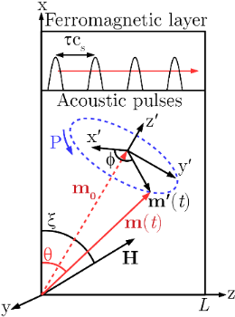 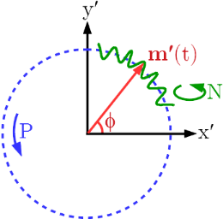

|  |  |
| --- | --- |
| Fig. 1. Scheme of the precession P movement of the magnetization vector **m** around the equilibrium direction **m0**, induced by a train of picosecond acoustic pulses propagating with the velocity of sound cs and the temporal delay τ between the pulses. | Fig. 2. Scheme of the spin movement composed by the homogeneous precession P and the high-frequency non-uniform (exchange magnon) modes N. |

Funding through Nouvelle équipe, nouvelle thématique “Ultrafast acoustics in hybrid magnetic nanostructures”, Stratégie internationale NNN-Telecom and the Acoustic HUB de la Region Pays de La Loire, Alexander von Humboldt Stiftung, ANR-DFG “PPMI-NANO”, PRC CNRS-RFBR “Acousto-magneto-plasmonics” (grant number 1757 150001) is gratefully acknowledged.

[1] E. Beaurepaire, J.-C. Merle, A. Daunois, and J.-Y. Bigot, Phys. Rev Lett. **76**, 4250 (1996).

[2] B. Koopmans, M. van Kampen, J.T. Kohlhepp, *et al.*, Phys. Rev. Lett. **85**, 844 (2000).

[3] J.W. Kim, J.-Y. Bigot, Phys. Rev. B **95**, 144422 (2017).

[4] A. Kirilyuk, A.V. Kimel, T. Rasing, Rev. Mod. Phys*.* **82**, 2731 (2010).