**Exchange Magnon in Ferromagnetic Thin Films Exited by a Series of Acoustic Pulses**

V. Besse*, A.V. Golov*b, V.S. Vlasov b, A. Alekhina, V.V. Temnova

a IMMM CNRS 6283, Le Mans Université, 72085 Le Mans cedex, France

bSyktyvkar State University named after Pitirim Sorokin, 167001, Syktyvkar, Russia

*\*e-mail: valentin.besse@univ-lemans.fr*

*Keywords: magnon-phonon interaction, ferromagnetic, magnetization dynamics, elastic excitation*

**Introduction**

Ultrafast demagnetization and precession of the magnetization induced by ultrashort laser pulses are very active topics1-17 even though their demonstration is quite recent18. The idea of data transmission by using the spins rather than electric currents had a large impact. Ultrafast manipulation of the magnetization is a key for further development of spintronics. Magnetization dynamics can be driven by different mechanisms19. Since we consider a single ferromagnetic, we can limit our consideration just to two mechanisms: laser-induced heating2,9,19 and phonon-magnon interaction14-20.

Here, we report a numerical study of the magnetization dynamics in cobalt thin films (30 nm) excited by a series of picosecond acoustic pulses. This situation can be realized in an optical pump-probe experiment using a train of laser pump pulses. **Figure 1** shows a possible experimental setup for this situation. Absorption of each pump pulse leads to the excitation of an acoustic pulse. Acoustic pulses propagate through a ferromagnetic film and alter the direction of the effective magnetic field thereby driving precessional motion of the magnetization. The direction of the effective magnetic field can also be modified by laser-induced thermal effects. We consider only the phonon-magnon interaction.

We study the impact of the acoustic pulses on the magnetization precession, varying the time delays between the pulses. Also we investigate the effect of the shapes of the acoustic pulses, either unipolar or bipolar pulses. We study different coupling conditions: phase matching, group matching and frequency matching. These different conditions can be realised by setting certain magnitude of the external magnetic field.

**Results and Discussion**

We consider the Landau-Lifschitz-Gilbert (LLG) equation

$\frac{d\vec{m}}{dt}=γ\vec{m}\left(t\right)×{\vec{H}}_{eff}\left(t\right)-\frac{α}{\left|\vec{m}\left(t\right)\right|}\vec{m}\left(t\right)×\frac{d\vec{m}}{dt}$’

where $\vec{m}$ is the magnetic moment, $γ$ is the gyromagnetic ration, ${\vec{H}}_{eff}$ is the effective magnetic field and $α$ is the dimensionless phenomenological Gilbert damping. The effective magnetic field consists of the demagnetization field, the external magnetic field, the exchange field and the magnetoelastic effect. The LLG equation can be written for each magnetization component. We calculate the analytical dispersion relation for the magnon. We adjust the value of the external magnetic field in order to have at least one crossing point (see **Figure 2(a)**), by example at 43.5 GHz for an external magnitude field with a magnitude H = 1.5 T. We set the delay between the acoustic pulses to be equal to the inverse of the frequency of this crossing point, *τ* = 23 ps.

We solve the LLG equations for each magnetization component and analyse spectrum of the excited spin waves (see **Figure 2(b)**). We compare it to the magnon dispersion curve. We analyse the induced magnetization dynamics referring to the magnon and phonon dispersion curves. We obtain equivalent result with a series of bipolar acoustic pulses.

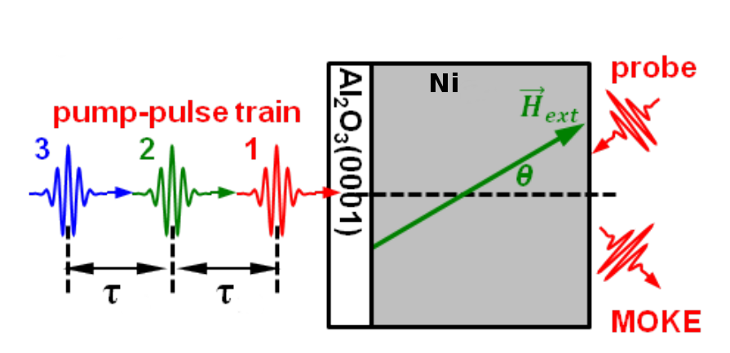

**Figure 1:** Sketch of the Back-pump-front-probe experiment with multiple pump pulses which corresponds to the numerical simulation. $τ$ corresponds to the delay between the laser.

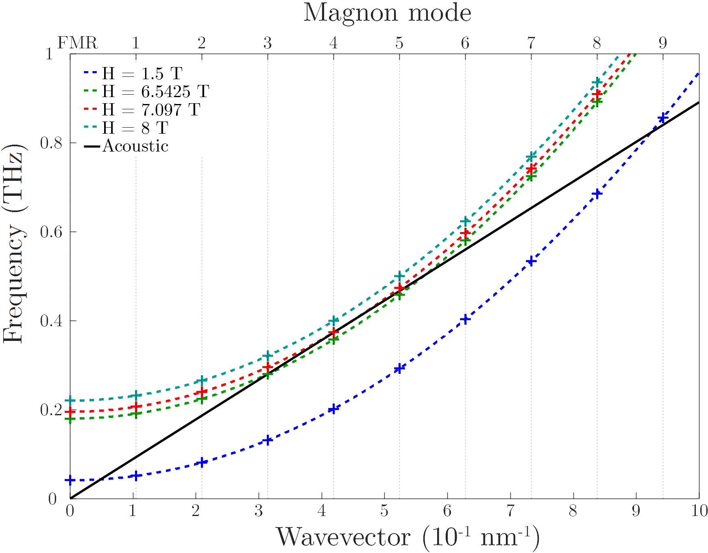

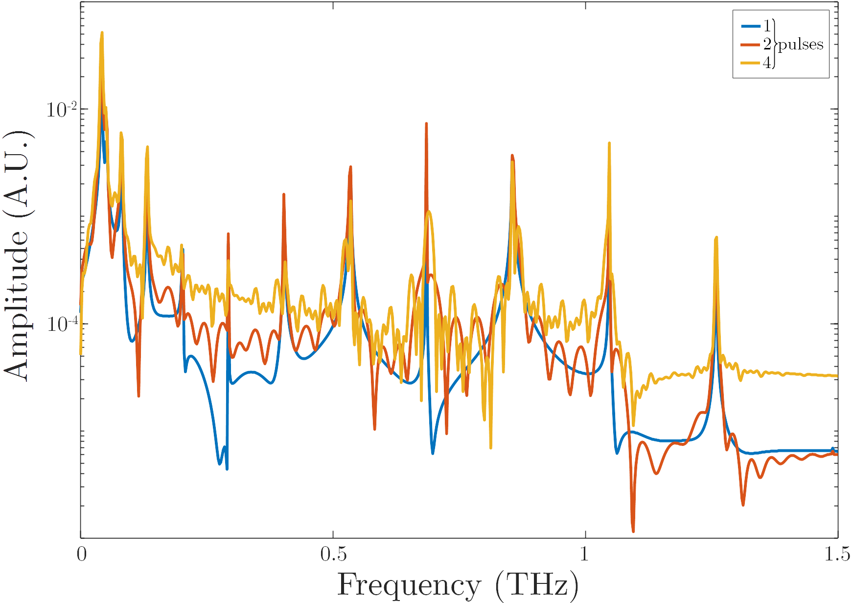

**( a )**

**( b )**

**Figure 2:** **(a)** Acoustic dispersion relation curve (black line) and magnon dispersion relation curve for H = 1.5 T (blue dashed curve), H = 6.5425 T (green dashed curve),H = 7.097 T (red dashed curve) and H = 8 T (light blue dashed curve). The corresponding magnon mode number are shown above the figure. **(b)** The figure is the spectrum of the resulting magnetization dynamics (only the y component) exited by a series of 1 (blue curve), 2 (red curve) and 4 (orange curve) acoustic pulses for H = 1.5 T. The frequencies of acoustic pulses is 43.5 GHz.

**Conclusions and/or Outlook**

We study the excitation of exchange magnons in cobalt thin film. By varying the magnitude of the magnetic field it is possible to tune the magnon dispersion curve and select which magnon mode we want to excite. However the spinwaves could be highly damped.

*Acknowledgement: the authors would like to acknowledge the Région Pays de la Loire for the financial support from Stratégie Internationale “NNN-Télécom” and NR-DFG ”PPMI-NANO” (ANR-15-CE24-0032 & DFG SE2443/2).*

References:

[1] Koopmans B., van Kampen M., Kohlhepp J. T., de Jonge W. J. M.; Ultrafast magneto-optics in nickel: Magnetism or optics?; Physical Review Letters 85:844–847; 2000

[2] Van Kampen M., Jozsa C., Kohlhepp J. T., LeClair P., Lagae L., De Jonge W. J. M., Koopmans B.; All-optical probe of coherent spin waves; Physical review letters, 88(22):227201; 2002

[3] Guidoni L., Beaurepaire E., Bigot, J.–Y; Magneto-optics in the ultrafast regime: Thermalization of spin populations in ferromagnetic films; Physical Review Letters; 89:17401; 2002

[4] Vomir M., Andrade L.H.F., Guidoni L., Beaurepaire E., Bigot J.–Y; Realspace trajectory of the ultrafast magnetization dynamics in ferromagnetic metals; Physical Review Letters; 94:237601; 2005

[5] Bigot J.–Y., Vomir M., Andrade L. H. F., Beaurepaire E.; Ultrafast magnetization dynamics in ferromagnetic cobalt: The role of the anisotropy; Chemical Physics; 318:137–146; 2005

[6] Kimel A.V., Kirilyuk A., Usachev P.A., Balbashov A.M., Rasing Th.; Ultrafast non-thermal control of magnetization by instantaneous photomagnetic pulses; Nature; 435:655–657; 2005

[7] Malinowski G., Dalla Longa F., Rietjens J. H. H., Paluskar P. V., Huijink R., Swagten H. J. M., Koopmans B.; Control of speed and efficiency of ultrafast demagnetization by direct transfer of spin angular momentum; Nature Physics; 4(11):855; 2008

[8] Bigot J.–Y., Vomir M., Beaurepaire E.; Coherent ultrafast magnetism induced by femtosecond laser pulses; Nature Phys. 5:515–520; 2009

[9] Radu I., Woltersdorf G., Kiessling M., Melnikov A., Bovensiepen U., Thiele J. U., Back C. H.; Laser-induced magnetization dynamics of lanthanide-doped permalloy thin films; Physical Review Letters; 102(11):117201; 2009

[10] Boeglin C., Beaurepaire E., Halté V., López-Flores V., Stamm C., Pontius N., Bigot J. Y.; Distinguishing the ultrafast dynamics of spin and orbital moments in solids; Nature; 465(7297):458; 2010

[11] Radu I., Vahaplar K., Stamm C., Kachel T., Pontius N., Dürr H. A., Tsukamoto A.; Transient ferromagnetic-like state mediating ultrafast reversal of antiferromagnetically coupled spins; Nature; 472(7342):205; 2011

[12] Rudolf D., Chan L. O., Battiato M., Adam R., Shaw J. M., Turgut E., ..., Silva T. J.; Ultrafast magnetization enhancement in metalic multilayers driven by superdiffusive spin current; Nature communications; 3201:1037; 2012

[13] Zhang Q., Nurmikko A. V., Anguelouch A., Xiao G., Gupta A.; Coherent magnetization rotation and phase control by ultrashort optical pulses in CrO 2 thin films; Physical Review Letters; 89:177402; 2002

[14] Kim J. W., Vomir M., Bigot, J. Y.; Ultrafast magnetoacoustics in nickel films; Physical review letters; 109(16):166601; 2012

[15] Bombeck M., Jäger J. V., Scherbakov A. V., Linnik T., Yakovlev D. R., Liu X., Bayer M.; Magnetization precession induced by quasitransverse picosecond strain pulses in (311) ferromagnetic (Ga, Mn) As; Physical Review B; 87(6):060302; 2013

[16] Kim J. W., Vomir M., Bigot J. Y.; Controlling the spins angular momentum in ferromagnets with sequences of picosecond acoustic pulses; Scientific reports; 5:8511; 2015

[17] Kim J. W., Bigot J. Y.; Magnetization precession induced by picosecond acoustic pulses in a freestanding film acting as an acoustic cavity; Physical Review B; 95(14):144422; 2017

[18] Beaurepaire E., Merle J.-C., Daunois A., Bigot J.-Y.; Ultrafast spin dynamics in ferromagnetic nickel; Physical Review Letters; 76:4250-4253; 1996

[19] Kirilyuk A., Kimel A. V., Rasing T; Ultrafast optical manipulation of magnetic order; Reviews of Modern Physics; 82(3): 2731; 2010

[20] Temnov V. V.; Ultrafast acousto-magneto-plasmonics; Nature Photonics; 6(11):728-736; 2012