Title of the abstract in 14pt bold
F. Author,¹ S. Author,^{2*} and Th. Author² 12pt
¹Institution, Postal code, City, Country, 11pt italic
²Institution, Postal code, City, Country, 11pt italic
*e-mail address of the presenting author, 11pt italic

This page is an example of presentation of your abstract (invited, contributed oral or poster). Since the abstracts will be directly reproduced in a volume to be distributed among the participants, please follow carefully the instructions below.
The abstracts should be submitted online via http://inno-mir.com/sw2018/. Abstracts submission deadline is March 1, 2018. Only DOC (DOCX) or RTF documents (Abstracts_SW2018_YourName.doc/rtf) are acceptable.
The maximum abstract size is limited to one page. The text should fill completely one page. Top margin is 2.5 cm, left margin is 2.5 cm. The text field dimensions are 16 cm wide and 24 cm high.
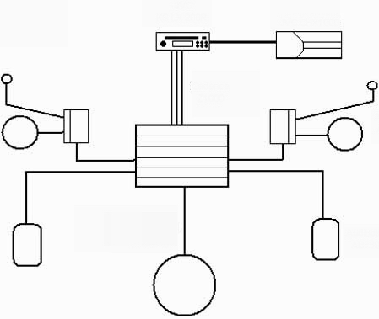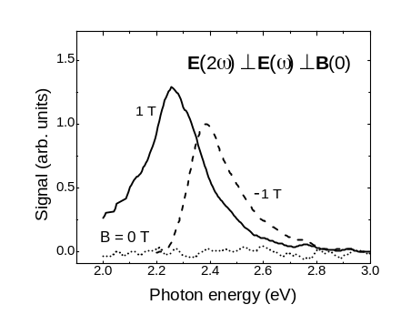
Fig. 1. Experimental setup, 11 pt. | Fig. 2. Results of our measurements, 11 pt.

The title is in Times New Roman 14 pt, bold, centred.
The author’s names are in Times New Roman 12 pt, centred. The name of the presenting author should be underlined. The author’s affiliations are in times New Roman 11 pt, italic, centred. On the next line you can provide the contact e-mail address of the corresponding or presenting author (11 pt, italic, centred). Please leave one line after the authors’ affiliations.
Body text is single-spaced, typed in Times New Roman 12 pt, justified. Please do not separate paragraphs by inserting blank lines. Please, indent paragraphs.
The figures, if necessary, should be inserted in the text. Please note, that the printed version of the Symposium Abstracts will be black and white. References typed in Times New Roman 11pt should appear at the end of the text following one blank line [1].
Please, note that abstracts that do not comply with these requirements are not eligible for publication in the Symposium Abstracts Booklet.

[1] S. M. Body and S. Else, Phys. Rev. Lett. 90, 1003 (1998).
[2] S. V. Vonsovskii, Magnetism (Nauka, Moscow, 1971).
[3] F. Author, S. Author, Th. Author, et al., Phys. Rev. B 152, 77 (1998).

