Software Project Management Plan

Project: Web-ShynewithYvette

February 28, 2021

Version 1.0

Derek Valentin

Revision History

**Document History**

**Version                               Date                                    Reason for Change**

0-0-1                                   02-28-2021                         Creating first version of SPMP

Preface

The following Software Project Management Plan (SPMP) describes the proposed plan to be taken by Me to complete the design and implementation of a working demo requirements specified by the client.

As such, the scope of this project includes all design and implementation by Derek V to get a functioning demo running by April 24th 2021.

The SPMP is intended to be used by the Yvette B to provide top services to her clients.

Table of Contents

Title Page………………………………………………………………………………………….1

Revision History…………………………………………………………………………………..2

Preface…………………………………………………………………………………………….3

Table of Contents..………………………………………………………………………………...4

List of Figures……………………………………………………………………………………..5

List of Tables……………………………………………………………………………………...6

1. Introduction……………………………………………………………………………………..

         1.1 Project Overview………………………………………………………………………

                     1.1.1 Executive Summary: Project Description and Summary……………………

         1.2 Project Deliverables…………………………………………………………………..

                     1.2.1 Items to be delivered, dates, and locations…………………………………

List of Figures

List of Tables

1.1 Project Overview

 Executive Summary:

         The purpose of this project is to create a website for a client that is into the esthetic industry to provide a service where people can explore her work and to book appointments(hair grooming )

1.2 Project Deliverables

1. Preliminary Project Plan                                                                                      02.05.2021

           2. Requirements Specification                                                                    03.31.2021

           3. Analysis [Object model, Dynamic model, and User interface]             04.10.2021

           4. Architecture Specification                                                                      04.15.2021

           7. Test Plan                                                                                                    04.25.2021 - 04.28.2021

           8. Final Product w/ Demo                                                               05.13.2021 - 05.13.2021

1.3 Evolution of the SPMP()

      This document will be updated as the project progresses. Updates should be expected in the following sections:

**i.** ***References*** - updated as necessary

**ii.** ***Definitions, acronyms, and abbreviations*** - updated as necessary

**iii.** ***Organizational Structure*** will be updated as the team leaders are assigned for each phase.

***iv.*** ***Technical Process -*** This section will be reviewed appropriately as design requirements and decisions become clearer.

**v.** ***Schedule –*** as the project progresses, the schedule will be updated accordingly

1.4 Reference Materials:

1.5 Definitions and Acronyms()

* **URD** - User Requirements Document
* **SPMP** Software Project Management Plan (this document)
* **APM**-Adaptive project management
* **TBD-**

**2. Project Organization**

2.1 Process Model: The project will be using a management model called APM

(Adaptive project management). it  is a **structured and systematic process that allows you to gradually improve your decisions and practices**, by learning from outcomes of the decisions that you took at previous stages in the project. Therefore, it is possible that we edit our requirements as we progress through the project.

2.2 Organizational Structure:

|  |  |  |  |
| --- | --- | --- | --- |
| days | Deliverable | Individual | Material due |
|  |  | Single- 1 person | analysis |
|  |  | single- 1 person | Requirement |
|  |  | single- 1 person | Architecture |
|  |  |  | Source code |
| MAY | TBD |  | Test plan |

2.3 **Organizational boundaries and interfaces:**

coordinating meetings, updates, communications with client

2.4 Project Responsibilities:

For the most vital responsibilities per phase of each team members, please refer to segment 2.2. Ultimately the whole complete development of project team is responsible for the successful delivery of the product. The team member tasks per deliverable according to expertise and the phases below:

1.     Project Plan – ind

2.     Requirements Specification – ind

3.     Analysis – ind

4.     Architecture Spec – ind

5.     Component/Object Specification – TBD

6.     Source Code – TBD

7.     Test Plan – TBD

8.     Final Deliverable – Entire Team

**3. Managerial Process**

3.1 Management Objectives and Priorities

3.2 Assumptions, Dependencies, and Constraints(Dagm Kebede)

* Quality:
* Cost:
  + Cost of getting a host and domain
  + Cost of getting the appropriate template
  + Cost of getting APIs  (still in talk with client)
* Time:
  + project’s schedule for completion, including the deadlines for each phase of the project, as well as the date for rollout of the final deliverable.

* Scope:

3.3 Risk Management

Insufficient fund

Run out of time.

Unable to reach out to client.

3.4 Staffing Plan

Coordinate with client accordingly. Meet with client throughout the week

3.5 Monitoring and Controlling Mechanisms

**4. Technical Process(Dv)**

HTML and CSS for page layout

 Json for interaction

4.2 Software Documentation

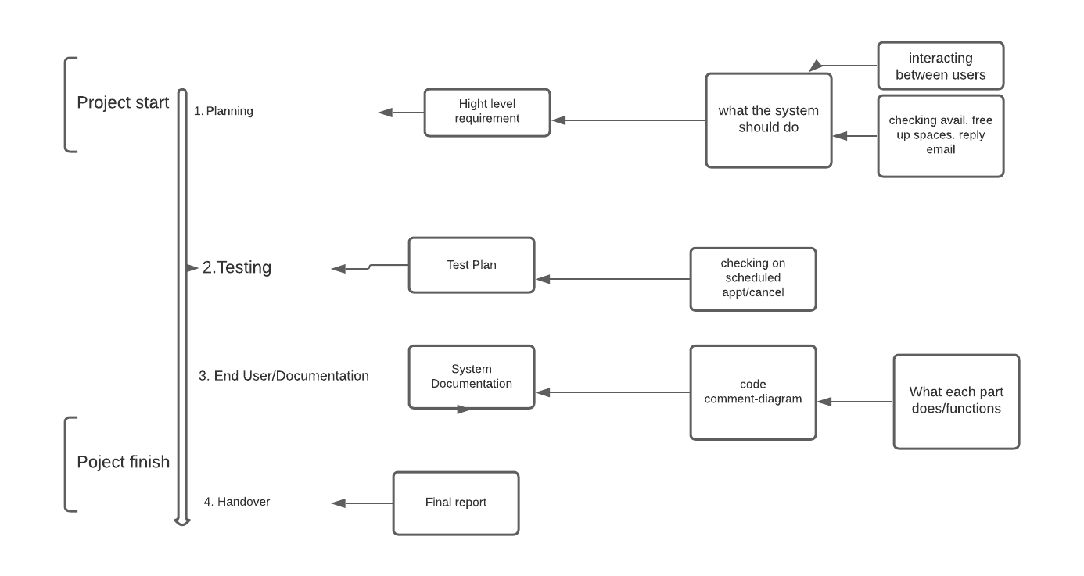

4.3 Project Support Functions

 Ensure the agreed project management methods, standards and processes are maintained throughout the project lifecycle.

* Assist the Project Manager and Team Managers in the production and maintenance of project plans.
* Develop and maintain the project library, filing, recording and reporting systems.
* Develop and implement appropriate configuration management procedures
* Co-ordinate the production of all reports and produce project summary reports.
* Set up and maintain systems for recording project costs.

1. Identify the goal of the website: create an environment where students, parents and coaches can coexist. A place where students can track their progress while working out and playing games.

1. Scope definition: the website requires a front page(sign up page/ log in) with a little of overview

students’ section

Parents section

Coaches section

Game section

Subscription section

C. Content creation: main focus of the page for Exercise Education Website for the U.S. Department of Education

D. Testing: testing as we go

E. Launch: final product TBD(04/26/21)

**5. Description of Work Packages (Sydney)**

5.1 Work Breakdown Structure

5.2 Dependencies Between Tasks