Electronic Annex to

Structure and properties of alkali aluminosilicate glasses and melts: insights from deep learning

Charles Le Losq1,2,3,*, Andrew Valentine2 ,4, Bjorn O. Mysen3, Daniel R. Neuville1

*1Université de Paris, Institut de physique du globe de Paris, CNRS-UMR 7154, Paris 75005, France*

*2 Research School of Earth Sciences, Australian National University, Canberra 2601, Australia*

*3 Earth Planets Laboratory, Carnegie Institution for Science, Washington D.C. 20001, U.S.A.*

*4Department of Earth Sciences, Durham University, South Road, Durham, DH1 3LE, UK.*

*\*Correspondence to: lelosq@ipgp.fr*

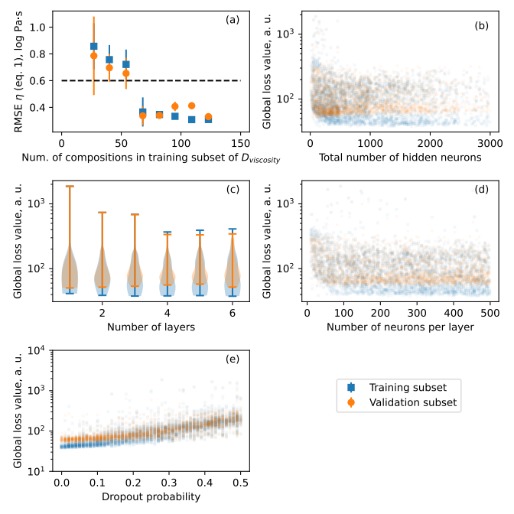

***Supplementary Figure 1.*** *Number of training samples, neural network architecture and dropout influence on predictive performance. Predictive performance was documented using the RMSE between viscosity predictions (from eq. 1) and measurements in training, validation and testing data subsets. 3,000 neural networks with randomly selected architectures were selected and trained to obtain those results. The effects of the numbers of* ***(a)*** *compositions in the training data subset,* ***(b)*** *hidden activation units,* ***(c)*** *hidden layers,* ***(d)*** *number of activation units per layer, and of the dropout probability* ***(e)*** *were explored. Subplot (c) is a violin plot with extreme values showed. Subplots (b), (d) and (e) are scatter plots in which each slightly transparent symbol corresponds to a given neural network; less transparence is directly indicative of a higher number of models for a given X-Y value.*

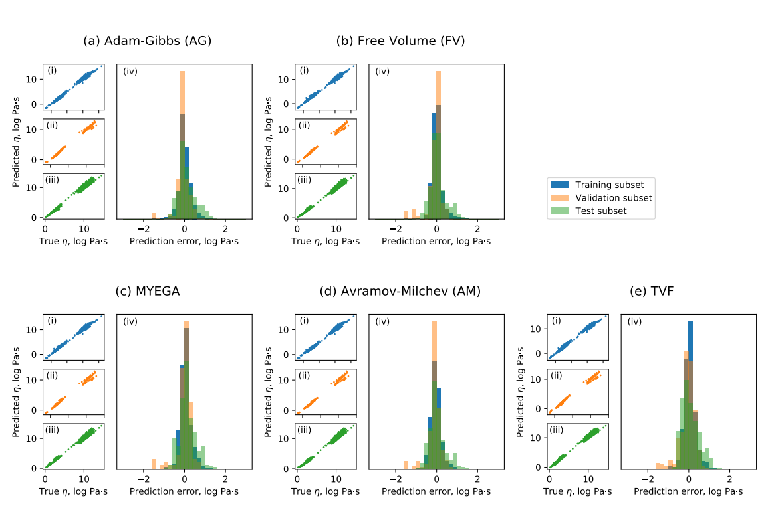

***Supplementary Figure 2:*** *Comparison between predicted and measured viscosity in the Na2O-K2O-Al2O3-SiO2 system. Predictions can be made using theories like Adam-Gibbs* ***(a****, eq. 1) and free volume* ***(b****, eq. 2), or empirical equations like MYEGA* ***(c****, eq. 5), Avramov-Milchev* ***(d****, eq. 4), and Tamman-Vogel-Fulcher* ***(e****, eq. 3). See table 3 for RMSE.*

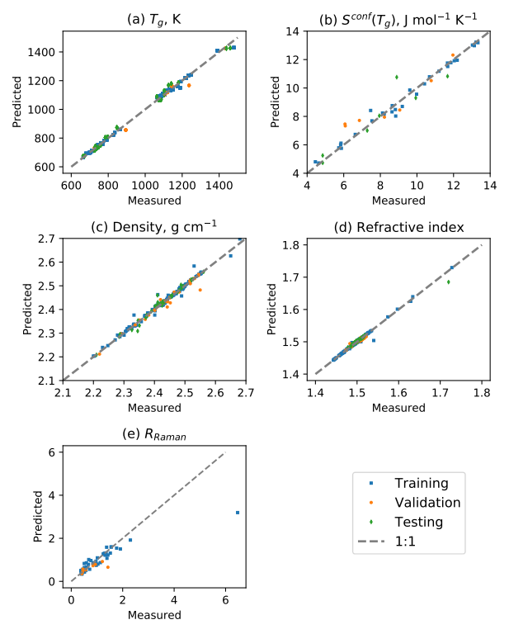

***Supplementary Figure 3:*** *Comparison between* ***(a)*** *predicted glass transition temperatures and those calculated from undercooled viscosity data, when available,* ***(b)*** *Sconf(Tg) values from* *(Richet, 1984; Neuville and Mysen, 1996; Neuville, 2006; Le Losq and Neuville, 2013, 2017; Le Losq et al., 2014, 2017),* ***(c)*** *density,****(d)*** *refractive index, and* ***(e)*** *RRaman. See Table 3 for RMSE.*

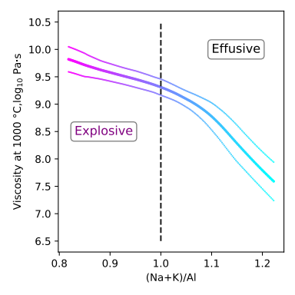

***Supplementary Figure 4:*** *Evolution of the viscosity at 1000 °C of a rhyolite melt, with a composition changing from a sodic peralkaline one to a potassic pearluminous one. The thick line is the mean prediction from 10 neural networks, and the thin lines are 95% confidence intervals.*