Çetiner, U., et al., 2025, How double-slab subduction shaped the Eastern Anatolian Plateau: Insights from geodynamic models: Geology, https://doi.org/10.1130/G53134.1

Supplemental Material

Supplemental files include model setup details, governing equations used in the numerical experiments, and sensitivity tests related to slab break-off timing.

SUPPLEMENTARY MATERIAL
Using ASPECT v2.3.0 we solve for momentum (1) and mass (2), respectively, are given for an incompressible medium with the Boussinesq approximation (Schubert et al., 2001),
$$\begin{aligned}-∇⋅ \left[2η\left(\dot{ε}\left(u\right)\right)\right]+ ∇ P= g,\#(1)\end{aligned}$$
$$\begin{aligned}∇⋅u =0,\#\left(2\right)\end{aligned}$$
where $η$ is the viscosity (Pa s), $u$ is the velocity (m s⁻¹), $\dot{ε}\left(u\right)$ is the strain rate, $P$ is the total pressure (Pa), g is the gravitational acceleration (m s⁻²) and $ρ$ is the density (kg m⁻³). Advection and diffusion of temperature is described through conservation of thermal energy,
$$\begin{aligned}ρC_{p}\left(\frac{∂T}{∂t}+u⋅∇T\right)-k∇^{2}T=ρH,\#(4)\end{aligned}$$
where $C_{p}$ is the heat capacity (J kg⁻¹ K⁻¹), T is the temperature (K), and k is thermal conductivity (W m⁻¹ K ⁻¹). There is no adiabatic or viscous heating. Density varies with temperature (equation of state);
$$\begin{aligned} \left(T\right)= {}_{ref}\left(1- α (T- T_{ref})\right),\#\left(5\right)\end{aligned}$$
where $α$is the thermal expansion coefficient (K⁻¹) and$ρ_{ref}$ is the reference density (kg m⁻³). The deformation for the upper crust is represented by the brittle rheology, and for the lower crust, it uses a viscous flow law. The dislocation (disl) creep, diffusion (diff) creep and effective viscosity for composite (comp) rheology are respectively defined as,
$$\begin{aligned}η_{disl}=\frac{1}{2}{A_{disl}}^{-\frac{1}{n}}{{\dot{ε}}_{ii}}^{{(1-n)}/n} exp⁡(\frac{E_{disl}+PV_{disl}}{nRT}),\#\left(6\right)\end{aligned}$$
$$\begin{aligned}η_{diff}=\frac{1}{2}A_{diff}^{-1}d^{m} exp⁡(\frac{E_{diff}+PV_{diff}}{RT}),\#\left(7\right)\end{aligned}$$
$$\begin{aligned}η_{comp}=\frac{η_{diff}η_{disl}}{η_{diff}+η_{disl}}\#\left(8\right)\end{aligned}$$
where $A$ is the prefactor (M Pa^{-n} s⁻¹), n is the stress component, E is activation energy (kJ mol⁻¹), V is the activation volume (m³ mol⁻¹), P is the pressure (Pa), R is the gas exponent (8.314 J K⁻¹mol⁻¹) and T is the temperature (K).
A Drucker-Prager yield criterion in 2D for plastic behavior (Davis & Selvadurai, 2002),
$$\begin{aligned} σ_{y}=C\cos{∅}+\sin{∅}P,\#\left(9\right)\end{aligned}$$
where C is cohesion, $∅$ is the internal angle of friction. When the viscous stress ($2ηε_{ii})$ surpasses the yield stress $σ_{y}$, the viscosity is adjusted to align with the yield criterion, such that
$$\begin{aligned} η_{y}=\frac{σ_{y}}{2{\dot{ε}}_{ii}}\#\left(10\right)\end{aligned}$$
Figure S1 shows the model setup for double-subduction which is based on the work of Keskin (2003) and van Hinsbergen et al., (2024), which incorporate a range of geological constraints derived from Tethyan orogenic reconstructions. The single-slab model has the same configuration, but only contains the southern slab, and there is no thickened accretionary prism material in front of the trench. Models utilize a composite rheological flow law and plastic yielding. The models only have one mantle material, and it uses a modified version of the wet olivine after Hirth & Kohlstedt (2003). The viscosity difference between the asthenosphere, oceanic mantle lithosphere and continental mantle lithosphere are due to the differences in the temperature gradient. The continental crust, Bitlis arc and accretionary prism are wet quartzite (Gleason & Tullis, 2005). Weak zones and oceanic crust are artificially weak materials with a constant viscosity of 5x10¹⁹ Pa s.
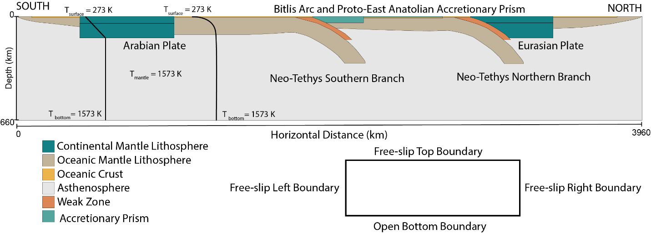
Figure S1: Double slab subduction setup and boundary conditions.
Top, left and right boundaries are free-slip, while the bottom boundary is an open boundary. To implement an open bottom boundary condition, we applied the "initial lithostatic pressure" approach available in ASPECT. This method computes a one-dimensional lithostatic pressure profile at a specific point at the start of the simulation and imposes it as a boundary traction. By prescribing lithostatic pressure as the boundary condition, this approach ensures the boundary remains dynamically consistent with the surrounding stresses. For additional details, please refer to the ASPECT manual (Bangerth et al., 2021).
Model topography is calculated from the isostatic compensation using the normal stresses acting on the surface, considering a mid-ocean ridge depth of -2.7 km and an average rock-air density contrast of 2900 kg/m³. The swath profile used for the comparison between the model topography and the observed topography was obtained using data from GeoMapApp (Ryan et al., 2009). It is created from 6 topography profiles taken at every 0.2 degrees between 42E and 43E and The profiles are N-S oriented and 800 km wide (see Figure 3).
Figure S2 provides a visual overview of the initial physical conditions used in both the double slab subduction and single slab reference models. The figure allows readers to verify the initial state and better understand the context of the simulations.
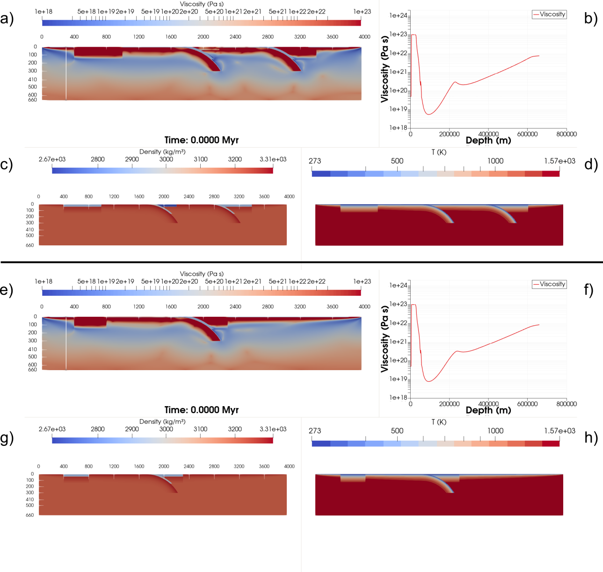
Figure S2: Initial physical properties of the geodynamic models at timestep t = 0. Panels a–d show the double slab subduction model, and panels e–h show the single slab reference model. For each model, the panels present (a, e) the 2D viscosity distribution, (b, f) the viscosity variation with depth at x = 300 km, (c, g) the density profile, and (d, h) the temperature profile. These profiles illustrate the initial rheological, thermal, and density structures that underpin the subsequent model evolution.
To assess the robustness of our geodynamic setup and better constrain the parameter space, we performed a suite of sensitivity tests focusing on the rheological and density structure of the models. Figure S3 illustrates how the choice of diffusion and dislocation creep prefactors influences slab break-off behavior in single slab models. The parameter space is divided into three main regions based on model behavior. Yellowish area corresponds to combinations that produce unrealistically low mantle viscosities, leading to unphysical model dynamics. In the brown area, deformation is governed almost entirely by dislocation creep, with little to no contribution from diffusion creep. The green-shaded zone represents the optimal range, where both diffusion and dislocation creep mechanisms operate concurrently, producing slab break-off in a geologically reasonable timeframe (typically within 10–20 million years after collision). This combined creep behavior is consistent with expected mantle rheology and forms the basis for selecting parameters in the double subduction models. Black dots mark the tested combinations of prefactor values.
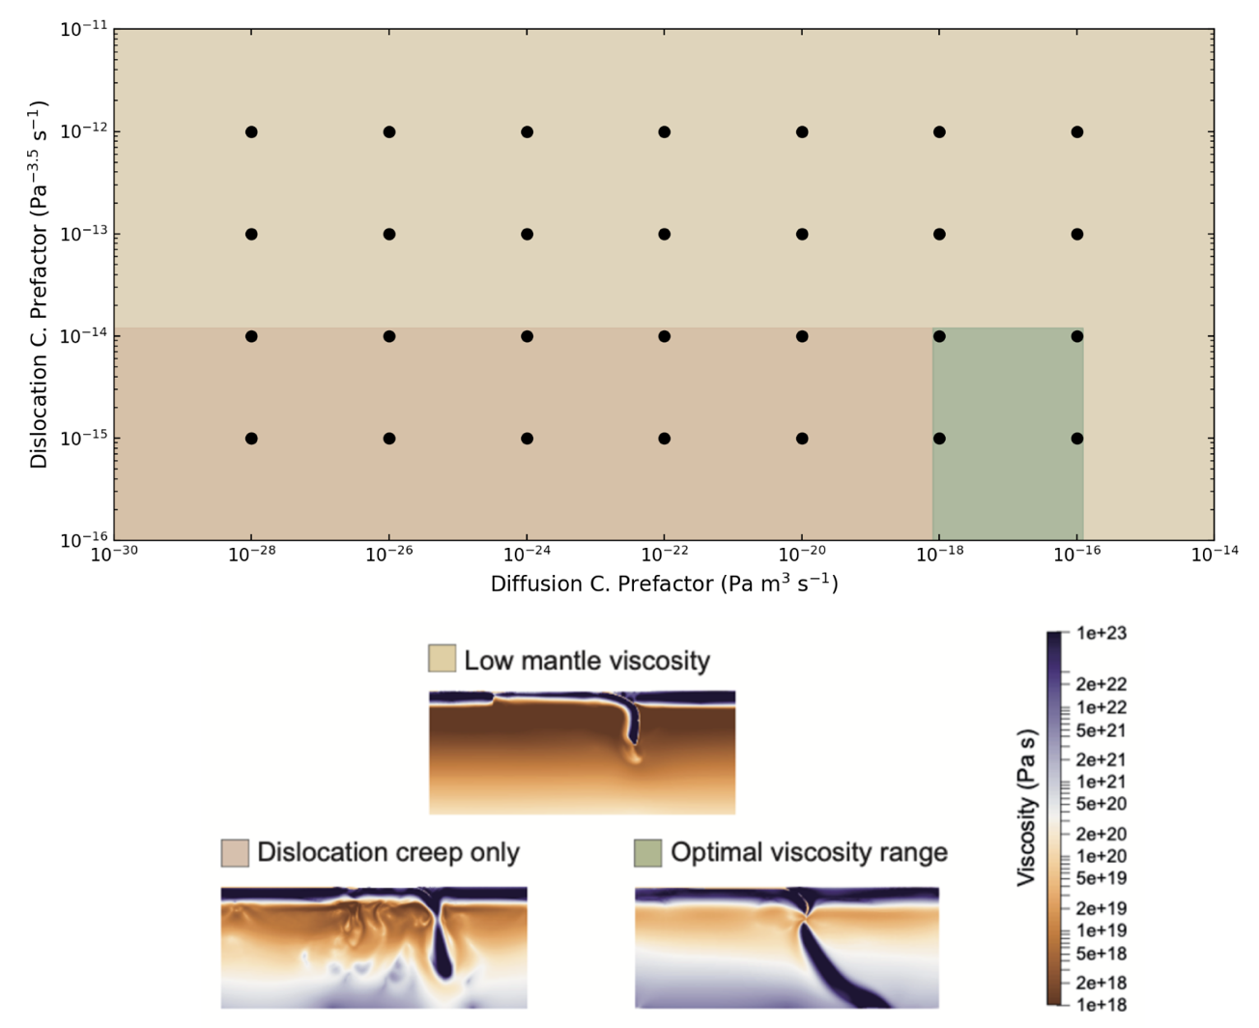
Figure S3: Parameter space exploration showing the combined effect of diffusion and dislocation creep prefactor values on slab break-off behavior in single slab models. The x-axis represents the prefactor for diffusion creep, and the y-axis represents the prefactor for dislocation creep. Black dots indicate the combinations of values that were tested. The green shaded region highlights the optimal range, defined as the parameter space in which slab break-off occurs consistently within a geologically reasonable timeframe following continental collision. The shaded areas are approximate and based on the outcomes of the tested combinations. This diagram summarizes the rheological sensitivity tests used to constrain the prefactor values employed in subsequent double subduction models.
In addition, we tested the effects of plateau thickness, continental crust thickness, and arc material thickness. We ran several models to assess whether variations in these parameters would significantly affect the results. As long as the values remained within geologically reasonable bounds, they did not lead to meaningful deviations in model behavior or outcomes. We also explored the influence of key strength-controlling parameters, such as the maximum yield stress, and found that changes in this parameter did not substantially alter the overall evolution of the system. Input files and results for these additional tests are available upon request.
REFERENCES
Bangerth, W., Dannberg, J., Fraters, M., Gassmoeller, R., Glerum, A., Heister, T., & Naliboff, J. (2021). ASPECT v2.3.0. Zenodo. https://doi.org/10.5281/zenodo.5131909
Davis, R. O., & Selvadurai, A. P. S. (2002). Plasticity and Geomechanics. https://doi.org/10.1017/CBO9780511614958
Keskin, M. (2003). Magma generation by slab steepening and breakoff beneath a subduction-accretion complex: An alternative model for collision-related volcanism in Eastern Anatolia, Turkey. Geophysical Research Letters, 30(24). https://doi.org/10.1029/2003GL018019
Ryan, W. B. F., Carbotte, S. M., Coplan, J. O., O’Hara, S., Melkonian, A., Arko, R., Weissel, R. A., Ferrini, V., Goodwillie, A., Nitsche, F., Bonczkowski, J., & Zemsky, R. (2009). Global Multi-Resolution Topography synthesis. Geochemistry, Geophysics, Geosystems, 10(3). https://doi.org/10.1029/2008GC002332
Schubert, G., Turcotte, D. L., & Olson, P. (2001). Mantle Convection in the Earth and Planets. Mantle Convection in the Earth and Planets. https://doi.org/10.1017/CBO9780511612879
van Hinsbergen, D. J. J., Gürer, D., Koç, A., & Lom, N. (2024). Shortening and extrusion in the East Anatolian Plateau: How was Neogene Arabia-Eurasia convergence tectonically accommodated? Earth and Planetary Science Letters, 641, 118827. https://doi.org/10.1016/J.EPSL.2024.118827

