ANNUAL SALES STATEMENT
Retail Sales Analysis
Customer Segmentation, Sales Trends & Basket Analysis · 2010-12-01 to 2011-12-09

Bottom Line
This UK online retailer generated £8.77M in revenue from 18,405 orders placed by 4,334 customers over thirteen months. Revenue is highly concentrated: the top 11% of customers ("Champions") generate roughly half of all revenue, while the bottom 29% ("Hibernating") contribute only 4%. Sales accelerate sharply from September through November ahead of the holiday season, and a clear set of product pairings shows where bundling and cross-sell promotions would have the most impact.
Recommendation: protect and grow the Champions segment with loyalty perks, run a win-back campaign targeted at the 897 "Needs Attention" customers before they fully lapse, and use the basket-analysis pairings below to drive cross-sell bundles and product placement.

The Data
The analysis is based on 396,470 cleaned transaction line items from a UK-based online retailer, covering 18,405 orders, 4,334 customers, and 3,660 distinct products between 2010-12-01 and 2011-12-09.
Cleaning steps applied to the raw export of 541,909 line items:
- Removed 135,080 line items with no Customer ID (can't be attributed to a customer for segmentation or basket analysis).
- Removed 8,905 cancelled-order line items (invoice numbers prefixed "C").
- Removed 1,421 non-product line items such as postage, bank charges, and manual fee adjustments.
- Removed 33 rows with zero or negative quantity/price left over after the above steps.
The result, 396,470 clean line items, is the single source of truth behind the Python script, SQL database, dashboard, and this summary.

Key Findings: Customer Segmentation
Customers were scored on Recency, Frequency, and Monetary value (RFM) and grouped into six segments. "Champions" (485 customers, 11.2% of the base) average £9.0k in lifetime spend and purchased as recently as 7 days ago on average, together accounting for 49.7% of total revenue.
Segment | Customers | Avg Recency | Avg Frequency | Avg Spend
Champions | 485 (11.2%) | 7 days | 15.5 orders | £9.0k
Loyal Customers | 1,031 (23.8%) | 22 days | 5.2 orders | £2.1k
At Risk | 453 (10.5%) | 105 days | 4.7 orders | £2.1k
Needs Attention | 897 (20.7%) | 92 days | 1.8 orders | £794
Hibernating | 1,249 (28.8%) | 194 days | 1.2 orders | £283
New Customers | 219 (5.1%) | 10 days | 1.6 orders | £1.3k
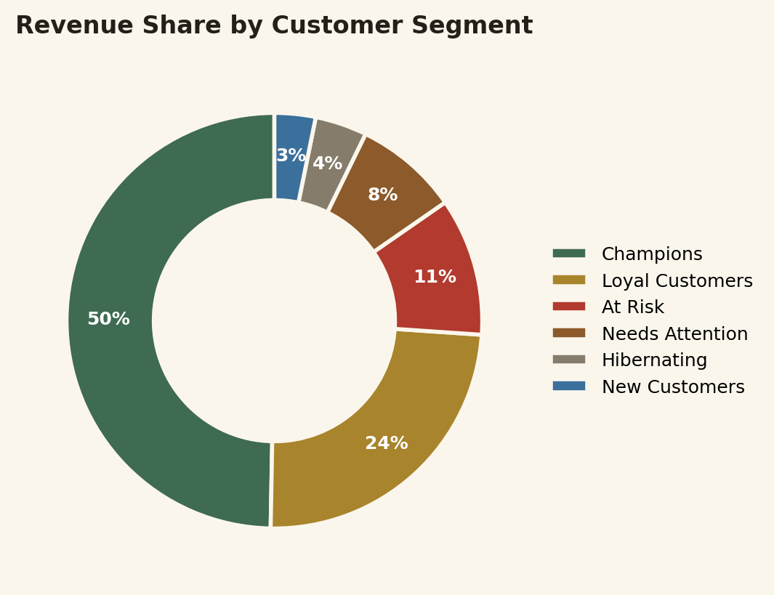

Additional Finding: Hibernating customers are a volume problem, not a value problem
"Hibernating" customers make up the largest single segment by headcount (1,249 customers, 28.8% of the base) but contribute only 4% of revenue, having gone an average of 194 days without a purchase. Re-engagement campaigns here should be low-cost per customer given the small average spend at stake.

Key Findings: Sales Trends
Monthly revenue climbed steadily through the year and peaked in 2011-11 at £1.14M across 2,642 orders, consistent with pre-Christmas ordering. Revenue more than doubled from the February low (£443.5k) to the November peak.
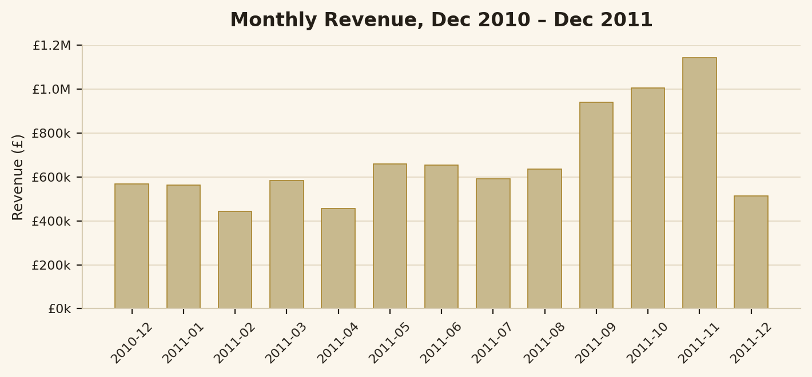
Order activity is concentrated on weekdays, peaking on Thursday, and almost entirely absent on Saturday (the retailer does not appear to process Saturday orders at all). Within the day, ordering peaks between 10am and 1pm. Geographically, the UK accounts for the large majority of revenue (£7.27M), with the Netherlands, Ireland (EIRE), Germany, and France as the next largest markets, each driven by a small number of high-volume wholesale-style accounts.

Key Findings: Basket Analysis
Across 18,405 orders, the average basket contains 21.0 distinct products, and only 7.2% of orders are single-item purchases — most customers are already buying multiple items per order, which is fertile ground for bundling.

Most frequently co-purchased products
The most common pairing, "JUMBO BAG PINK POLKADOT" with "JUMBO BAG RED RETROSPOT", appeared together in 546 separate orders.
Product Pair | Times Bought Together
JUMBO BAG PINK POLKADOT + JUMBO BAG RED RETROSPOT | 546
GREEN REGENCY TEACUP AND SAUCER + ROSES REGENCY TEACUP AND SAUCER | 541
ALARM CLOCK BAKELIKE GREEN + ALARM CLOCK BAKELIKE RED | 530
LUNCH BAG PINK POLKADOT + LUNCH BAG RED RETROSPOT | 523
LUNCH BAG BLACK SKULL. + LUNCH BAG RED RETROSPOT | 517
WOODEN FRAME ANTIQUE WHITE + WOODEN PICTURE FRAME WHITE FINISH | 468
LUNCH BAG RED RETROSPOT + LUNCH BAG SPACEBOY DESIGN | 467
LUNCH BAG BLACK SKULL. + LUNCH BAG PINK POLKADOT | 464

Strongest product affinities (by lift)
Lift measures how much more often two products are bought together than chance alone would predict. The strongest pairing, "PARTY PIZZA DISH BLUE POLKADOT" with "PARTY PIZZA DISH PINK POLKADOT", has a lift of 312.3x — meaning customers who buy one are over 312 times more likely than average to also buy the other. These high-lift, lower-volume pairs are strong candidates for "frequently bought together" prompts even though they don't appear in as many total orders as the pairs above.

Product Pair | Lift | Co-occurrences
PARTY PIZZA DISH BLUE POLKADOT + PARTY PIZZA DISH PINK POLKADOT | 312.3x | 32
ENAMEL PINK COFFEE CONTAINER + ENAMEL PINK TEA CONTAINER | 292.0x | 33
LANDMARK FRAME COVENT GARDEN + LANDMARK FRAME OXFORD STREET | 262.2x | 40
METAL SIGN CUPCAKE SINGLE HOOK + METAL SIGN,CUPCAKE SINGLE HOOK | 229.3x | 38
LANDMARK FRAME COVENT GARDEN + LANDMARK FRAME NOTTING HILL | 228.6x | 31
CHILDS GARDEN BRUSH BLUE + CHILDS GARDEN BRUSH PINK | 223.5x | 45
KIDS RAIN MAC BLUE + KIDS RAIN MAC PINK | 220.6x | 53
BLUE PUDDING SPOON + RED PUDDING SPOON | 218.2x | 33

Limitations & Caveats
- Recency, frequency, and monetary scoring uses quartile cutoffs; a customer just below a cutoff can land in a noticeably different segment than one just above it.
- 135,080 line items (about 25% of the raw export) lack a Customer ID and were excluded, meaning guest or unidentified purchases are not reflected in customer segmentation or basket analysis.
- The dataset ends on 2011-12-09, so December 2011 is a partial month and understates that month's true revenue.
- Basket analysis is based on product co-occurrence within an invoice; it does not account for promotions, stock-outs, or seasonal availability that may have influenced what was purchased together.
- All figures reflect this single retailer over a 13-month window in 2010–2011 and may not generalize to other retailers or time periods.

Recommendation
- Build a retention program for the Champions segment (loyalty perks, early access, dedicated support) since losing even a few of these customers has an outsized revenue impact.
- Launch a targeted win-back campaign for the "Needs Attention" segment before they drift into "Hibernating", where re-engagement becomes far harder.
- Use the high-co-occurrence and high-lift product pairs identified above to build "frequently bought together" bundles and adjust on-site/email product placement.
- Plan inventory and staffing for the September–November demand ramp, and consider a mid-week (Tuesday–Thursday), late-morning promotional push given when orders actually peak.

