An Atlas of Sound
Clustering 1,941 songs by audio DNA to power a content-based recommendation engine

Bottom Line
K-Means clustering on nine standardized Spotify audio features (danceability, energy, loudness, speechiness, acousticness, instrumentalness, liveness, valence, tempo) splits 1,941 songs into six sonically distinct, genre-associated regions. These regions work: used as a candidate filter ahead of a cosine-similarity ranking, they produce coherent, listenable recommendations — validated end-to-end across a Python notebook, a SQL query layer, and an interactive dashboard, all returning the same numbers.
For a test case (Dua Lipa, “Don’t Start Now”), the recommender's top match scored 0.961 cosine similarity, and all five recommendations landed in the same upbeat, danceable neighborhood — see the demo below.

The Data
Source: a 2,000-track Spotify sample spanning 1998–2020, covering danceability, energy, loudness, speechiness, acousticness, instrumentalness, liveness, valence, tempo, key, mode, genre, and popularity for each track.
- Cleaning: 59 exact duplicate rows removed; 22 tracks with an unlabeled genre field recoded to “Unknown.” Final dataset: 1,941 unique songs.
- Clustering features: the 9 continuous audio-DNA columns listed above, standardized to zero mean / unit variance. Key and mode were excluded — key isn’t meaningfully ordinal, and mode (major/minor) was tested but only split otherwise-identical clusters into near-duplicate pairs.
- Model: K-Means, k=6, chosen by comparing the elbow (inertia) curve and silhouette score across k=2–10. k=6 gave the best silhouette (0.157) of any non-trivial split while remaining musically interpretable.

Key Findings

Six sonic regions
Each region has a distinct audio signature — from upbeat, high-valence “Feel-Good Dance-Pop” (a third of the catalog) to a small, sharply distinct “Instrumental/Electronic” pocket (1.5%, defined by instrumentalness averaging 0.67 vs. ≤0.01 elsewhere):
Region | % of catalog | Avg. danceability | Avg. energy | Avg. valence | Avg. popularity | Top genre
Feel-Good Dance-Pop | 33.5% | 0.75 | 0.76 | 0.73 | 58.8 | pop (51%)
Moody High-Energy | 27.7% | 0.57 | 0.75 | 0.38 | 60.9 | pop (52%)
Hip-Hop & Rap Forward | 13.3% | 0.73 | 0.67 | 0.57 | 60.1 | hip hop (80%)
Live & Anthemic | 12.0% | 0.62 | 0.82 | 0.61 | 59.5 | pop (47%)
Acoustic & Mellow | 11.8% | 0.63 | 0.49 | 0.38 | 59.5 | pop (58%)
Instrumental/Electronic | 1.5% | 0.69 | 0.74 | 0.53 | 52.7 | pop (50%)
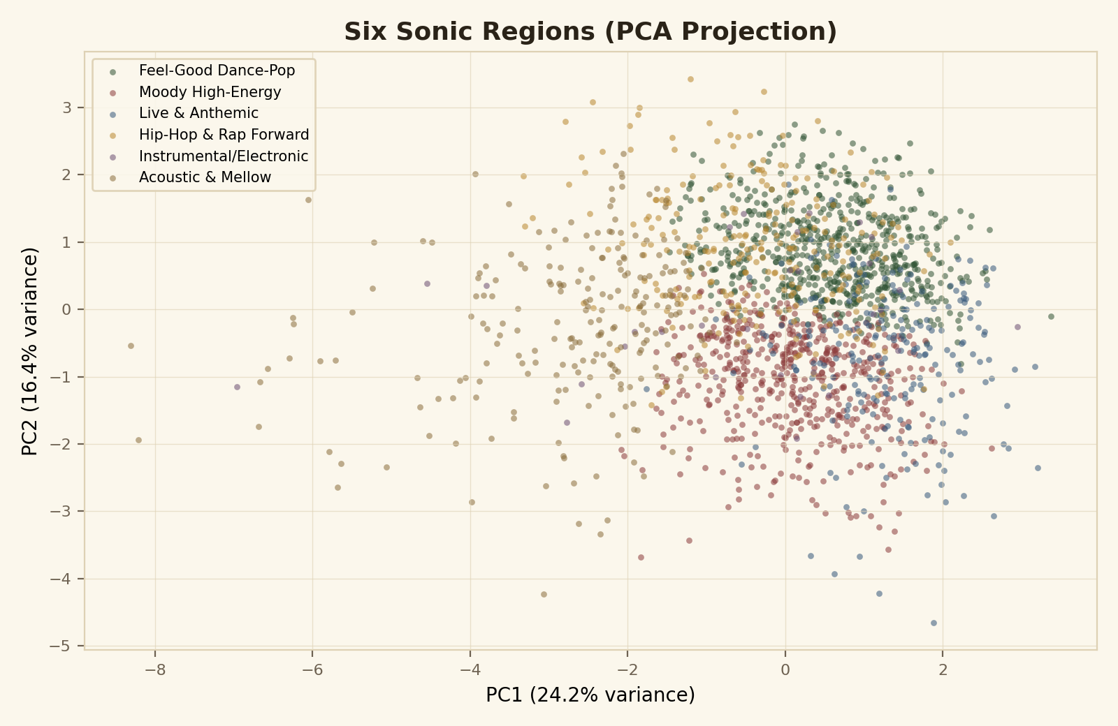
Songs projected from the 9 clustering features into two dimensions (PCA). Overlap between neighboring regions reflects a real property of music — genres and moods blend continuously rather than separating into hard clusters.

Regions track genre — without being genre
A chi-square test of independence between cluster assignment and primary genre returned p ≈ 4.8×10⁻⁵¹ — far below any conventional threshold, confirming the audio-only clusters are strongly associated with labeled genre. Hip-Hop & Rap Forward is the most “pure” region (79.5% hip hop, driven by high speechiness), while pop — a stylistically broad label — appears as the top genre in five of the six regions. Clusters are capturing sound, not just re-deriving genre tags.

Popularity doesn't favor one sound
A one-way ANOVA of popularity across the six regions returned p = 0.32 — not significant. Hit songs aren't concentrated in one sonic neighborhood, which matters for recommendation design: a recommender doesn't need to bias toward one region to surface popular tracks.

Additional Findings: The Recommender in Action
The recommendation engine uses clusters as a candidate filter (a production system would run this as a fast database lookup), then ranks candidates within the seed song's region by cosine similarity across the same 9 audio features. For the seed track Dua Lipa – “Don’t Start Now” (Feel-Good Dance-Pop region):
Rank | Track | Artist | Cosine similarity
1 | Loca People - Radio Edit | Sak Noel | 0.961
2 | Believer | Imagine Dragons | 0.948
3 | Dance Again | Jennifer Lopez | 0.935
4 | Lola's Theme - Radio Edit | The Shapeshifters | 0.934
5 | Shout Out to My Ex | Little Mix | 0.916
The SQL implementation (a min-max-normalized Euclidean-distance approximation, since exact cosine similarity requires the standardized feature space computed in Python) independently returns 3 of these same 5 tracks in its top 5 — cross-validating the recommendation logic across two different computational layers.

Limitations & Caveats
- Modest silhouette score (0.157): real music doesn't separate into hard clusters, so region boundaries are soft and some tracks sit ambiguously between regions — visible as overlap in the PCA scatter above.
- Content-based only: this recommender uses audio features exclusively. It has no signal from listening history, skips, likes, or co-listening patterns, all of which meaningfully improve real-world recommenders.
- Genre is self-reported and multi-label in the source data; “primary genre” here is simplified to the first listed tag, which can understate an artist's stylistic range.
- No live user evaluation: recommendation quality here is judged by audio-feature coherence, not by measured user satisfaction, click-through, or listening completion — the standard yardsticks for production recommenders.

Recommendation
Treat these 6 regions as the candidate-generation layer of a two-stage recommender: use cluster membership to cheaply narrow a large catalog (as demonstrated in the SQL query layer), then re-rank within-cluster candidates by audio similarity for the final list (as demonstrated in the notebook and dashboard). Before shipping to users, layer in collaborative-filtering signals — co-listening, skip rates, playlist co-occurrence — once interaction data is available; audio similarity alone is a strong cold-start solution but a weaker long-run signal than behavioral data.

