Comparing LLM and human peer reviews and ratings of social science research using data from Unjournal.org evaluations
David Reinstein
Valentin Klotzbücher
2025-08-30
Abstract
We will build and refine LLM tools to generate peer-reviews and ratings of impactful research, and compare these with human experts’ work (esp. from Unjournal.org): to benchmark performance, understand AI’s research taste, and develop tools to improve research evaluation and dissemination.
Table of contents

1. Project Overview
 Warning
Work in progress. Pages, metrics, and comparisons are under active development. Expect rough edges and frequent updates.
Motivation and questions
Is AI good at peer-reviewing? Does it offer useful feedback? Can it predict how human experts will rate research across a range of categories? Where does it do surprisingly well (e.g., catching math errors) or poorly (e.g., judging real-world relevance)? What does its “research taste” look like compared to humans?
If AI research evaluation works, it could free up substantial scientific resources (potentially on the order of billions of dollars annually) and enable more continual, structured feedback on research. It could also help characterize methodological strengths/weaknesses across papers, aiding training and research direction-setting. Understanding how AI evaluates research is also a window into its values, abilities, and limitations.
In this project, we are testing the capabilities of current large language models (LLMs), illustrating whether they can generate research paper evaluations comparable to expert human reviews. The Unjournal systematically prioritizes ‘impactful’ research and pays for high-quality human evaluations, structured quantified ratings, claim identification and assessment, and predictions. In this project, we use an AI (OpenAI’s GPT-5 model for now) to review social science research papers under the same criteria used by human reviewers for The Unjournal.
Each paper is assessed on specific dimensions – for example, the strength of its evidence, rigor of methods, clarity of communication, openness/reproducibility, relevance to global priorities, and overall quality. The LLM will provide quantitative scores (with uncertainty intervals) on these criteria and produce a written evaluation
Our initial dataset will include research papers that have existing human evaluations. For each paper, the AI will generate: (1) numeric ratings on the defined criteria, (2) identification of the paper’s key claims, and (3) a detailed review discussing the paper’s contributions and weaknesses. We will then compare the AI-generated evaluations to the published human evaluations.
Next, we will focus on papers currently under evaluation, ie where no human evaluation exists yet and we can rule out any contamination.

1.1 Related work
Luo et al. (2025) survey LLM roles from idea generation to peer review, including experiment planning and automated scientific writing. They highlight opportunities (productivity, coverage of long documents) alongside governance needs (provenance, detection of LLM-generated content, standardizing tooling) and call for reliable evaluation frameworks.
Eger et al. (2025) provide a broad review of LLMs in science and a focused discussion of AI‑assisted peer review. They emphasize: (i) peer‑review data is scarce and concentrated in CS/OpenReview venues; (ii) targeted assistance that preserves human autonomy is preferable to end‑to‑end reviewing; and (iii) ethics and governance (bias, provenance, detection of AI‑generated text) are first‑class constraints.
Zhang and Abernethy (2025) propose deploying LLMs as quality checkers to surface critical problems instead of generating full narrative reviews. Using papers from WITHDRARXIV and an automatic evaluation framework that leverages “LLM-as-judge,” they find the best performance from top reasoning models but still recommend human oversight.

2. Numerical ratings
We evaluate each paper along the following dimensions: claims & evidence, methods, logic & communication, open science, global relevance, and an overall assessment. Ratings are interpreted as percentiles relative to serious recent work in the same area. For each metric the model returns a midpoint and a 90% credible interval to communicate uncertainty.
We iterate over papers/*.pdf, collect raw results and write a long CSV to results/metrics_long.csv.

3. LLM vs. Human Ratings

3.1 Overview
This page compares the LLM‑generated ratings (gpt-5) from the(previous section with human evaluations across the Unjournal’s criteria. We (i) harmonize the two sources to a common set of metrics and paper IDs, (ii) compute paired scores per (paper, metric), and (iii) summarize agreement using distributional views and reliability statistics.

3.2 Data & Harmonization
- Sources. LLM ratings come from results/metrics_long.csv (rendered in the previous chapter). Human ratings are imported from your hand‑coded spreadsheet and mapped to LLM paper IDs via UJ_map.csv.
- Metric alignment. Human criteria are recoded to the LLM schema (e.g., claims → claims_evidence, adv_knowledge → advancing_knowledge, etc.). If humans provided both gp_relevance and real_world, we fold these into the single LLM metric global_relevance.
- Uncertainty fields. Where available, we carry lower/upper bounds for both LLM and humans; these are used in optional uncertainty checks but do not affect the mid‑point comparisons below.

3.3 Distribution of ratings
Unable to display output for mime type(s): text/html
(a) LLM vs Human with robust CI ellipses. Horizontal span covers the union of all human raters’ CIs and point ratings; vertical span from LLM CI. Centers at midpoints. Dropdown selects metric.

Unable to display output for mime type(s): text/html
(b)
Figure 3.1
For each paper (selected metric), the ellipse is centered at the pair of midpoints (Human, LLM). The horizontal radius covers the union of all human evidence for that paper — combining individual raters’ point scores and their CIs — while the vertical radius reflects the LLM CI. This makes the ellipse wide enough to contain every human point horizontally (unless a point lies outside its own stated CI, which is flagged in a diagnostic check).
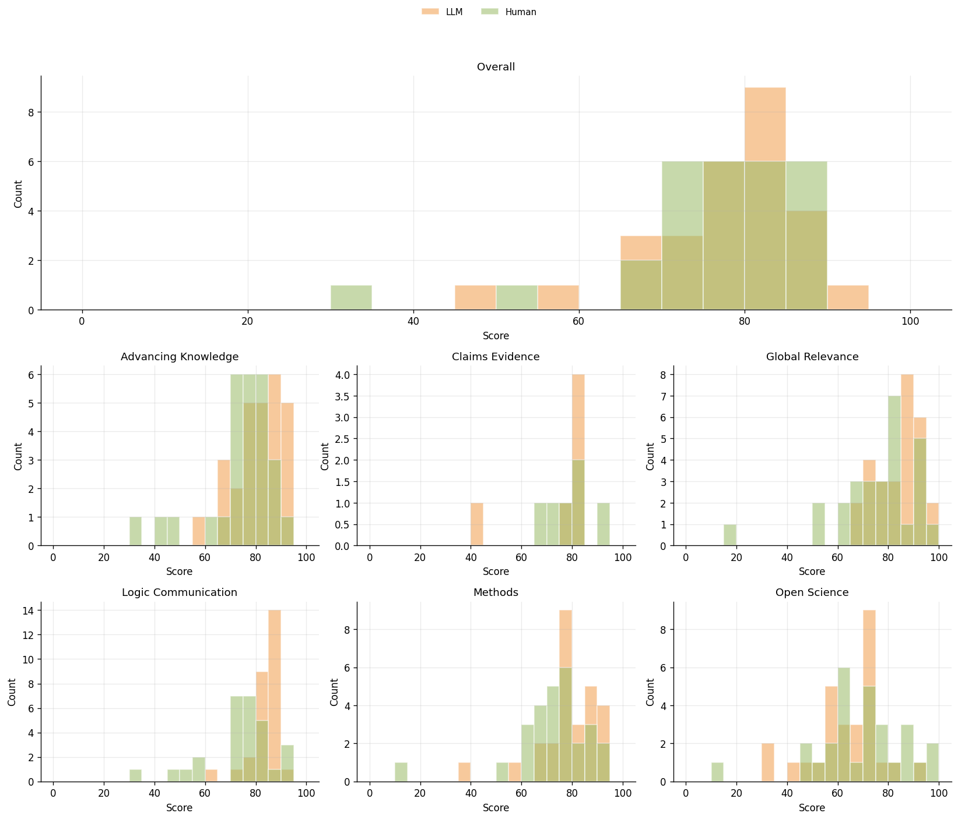
Figure 3.2: Distributions by metric. Top: Overall (full width). Bottom: remaining metrics in a 2×3 grid.

3.4 Differences by paper and metric
For each (paper, metric), we plot LLM − Human difference in Figure 3.3. Green means the LLM is lower than the human midpoint; orange means higher.
- Vertical stripes (by metric) suggest a metric‑specific bias (LLM systematically up/down on that metric).
- Horizontal stripes (by paper) flag paper‑specific disagreement (LLM consistently above/below for that paper across metrics).
- Isolated bright cells highlight individual outliers worth auditing qualitatively.
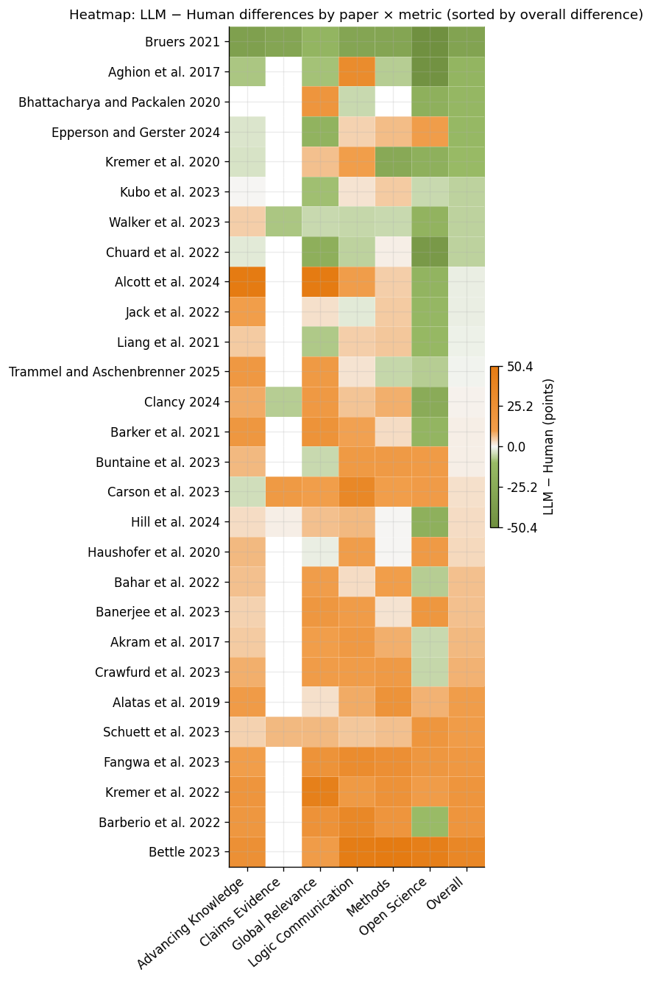
Figure 3.3: LLM − Human difference by paper × metric (robust, centered scale; rows sorted by signed overall difference).

3.5 Agreement metrics
Table 3.1 summarizes agreement: Pearson (r) captures linear alignment of levels; Spearman (ρ) captures rank agreement (monotonic relationship), robust to scale differences. We report the mean and median of (LLM − Human) to summarize both average shift and central tendency of the differences and Cohen’s κ (unweighted & quadratic). Because scores are continuous, we discretize both LLM and Human using shared quantile cutpoints (5 bins) and compute the Unweighted κ (exact category agreement beyond chance) and the Quadratic‑weighted κ that penalizes larger disagreements more than smaller ones.
As another indicator of agreement, we check whether each side’s credible interval contain the other’s point estimate, Table 3.3 shows the shares across rating categories.
Table 3.2 shows “calibration” results based on a simple linear regression; Figure 3.4 plots the width of human raters CI against the difference in ratings; and Table 3.4 lists the papers with the largest aabsolute difference between LLM and human raters.
Table 3.1: Agreement metrics by metric (Pearson, Spearman, mean/median bias, κ unweighted/weighted).
 | metric | n | pearson | spearman | mean_bias | median_bias | kappa_unwtd | kappa_quad
0 | advancing_knowledge | 27 | 0.198 | 0.259 | 7.12 | 6.0 | 0.052 | 0.257
1 | claims_evidence | 6 | 0.410 | 0.471 | -3.75 | -3.0 | -0.154 | 0.400
2 | global_relevance | 28 | 0.135 | 0.109 | 8.21 | 8.5 | -0.040 | 0.070
3 | logic_communication | 28 | 0.001 | 0.130 | 10.01 | 9.0 | -0.029 | 0.041
4 | methods | 27 | 0.309 | 0.403 | 6.60 | 5.5 | 0.148 | 0.288
5 | open_science | 28 | 0.138 | 0.103 | -6.01 | -7.0 | 0.009 | 0.137
6 | overall | 28 | 0.280 | 0.309 | 1.64 | 1.0 | 0.125 | 0.374

Table 3.2: Calibration of LLM to Human by metric (Human ≈ intercept + slope·LLM). Includes pre-/post- MAD.
 | metric | n | slope | intercept | r2 | MAD_pre | MAD_post | MAD_delta
0 | advancing_knowledge | 27 | 0.284 | 50.232 | 0.039 | 11.216 | 8.812 | 2.404
1 | claims_evidence | 6 | 0.220 | 61.234 | 0.168 | 11.250 | 5.859 | 5.391
2 | global_relevance | 28 | 0.255 | 53.573 | 0.018 | 14.589 | 12.000 | 2.589
3 | logic_communication | 28 | 0.002 | 72.823 | 0.000 | 13.464 | 9.802 | 3.663
4 | methods | 27 | 0.404 | 39.774 | 0.096 | 12.099 | 9.427 | 2.672
5 | open_science | 28 | 0.174 | 57.509 | 0.019 | 17.976 | 13.346 | 4.631
6 | overall | 28 | 0.357 | 47.941 | 0.078 | 9.149 | 7.837 | 1.312

Table 3.3: CI coverage: does one interval contain the other’s point estimate?
 | metric | N | human_in_llm | llm_in_human | both_cover
0 | advancing_knowledge | 24 | 0.67 | 0.62 | 0.54
1 | claims_evidence | 6 | 0.67 | 0.67 | 0.67
2 | global_relevance | 25 | 0.36 | 0.44 | 0.28
3 | logic_communication | 25 | 0.36 | 0.60 | 0.36
4 | methods | 24 | 0.62 | 0.54 | 0.50
5 | open_science | 25 | 0.48 | 0.40 | 0.28
6 | overall | 25 | 0.60 | 0.60 | 0.52

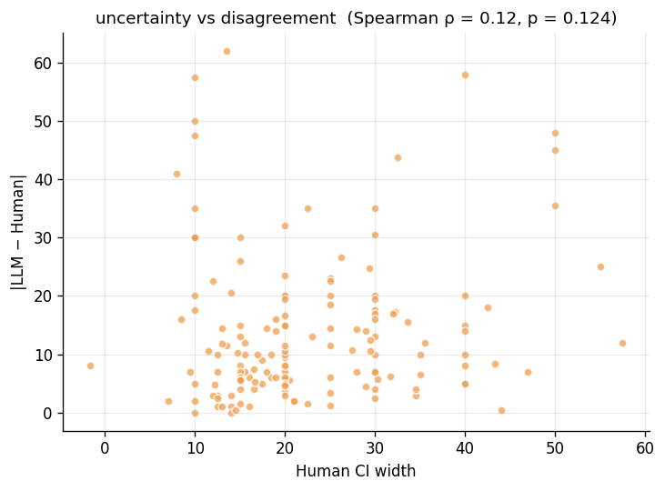
Figure 3.4: Human uncertainty (CI width) vs |LLM − Human|. Spearman correlation reported.
Table 3.4: Top absolute differences (LLM vs Human). Flags show whether each point lies within the other’s CI.
 | paper | metric | midpoint_llm | midpoint_human | abs_diff | human_in_llm | llm_in_human
23 | Alcott et al. 2024 | global_relevance | 78 | 16.00 | 62.00 | False | False
49 | Bettle 2023 | methods | 68 | 10.00 | 58.00 | False | False
20 | Alcott et al. 2024 | advancing_knowledge | 90 | 32.50 | 57.50 | False | False
63 | Bruers 2021 | open_science | 30 | 80.00 | 50.00 | False | False
51 | Bettle 2023 | logic_communication | 78 | 30.00 | 48.00 | False | False
4 | Aghion et al. 2017 | open_science | 40 | 87.50 | 47.50 | False | False
52 | Bettle 2023 | open_science | 55 | 10.00 | 45.00 | False | False
139 | Kremer et al. 2022 | global_relevance | 95 | 51.25 | 43.75 | False | False
82 | Chuard et al. 2022 | open_science | 55 | 96.00 | 41.00 | False | False
48 | Bettle 2023 | overall | 68 | 32.50 | 35.50 | False | False
75 | Carson et al. 2023 | logic_communication | 85 | 50.00 | 35.00 | False | False
39 | Barberio et al. 2022 | logic_communication | 80 | 45.00 | 35.00 | False | False
61 | Bruers 2021 | advancing_knowledge | 55 | 90.00 | 35.00 | False | False
58 | Bruers 2021 | overall | 48 | 80.00 | 32.00 | False | False
3 | Aghion et al. 2017 | logic_communication | 88 | 57.50 | 30.50 | False | False

References
Eger, Steffen, Yong Cao, Jennifer D’Souza, Andreas Geiger, Christian Greisinger, Stephanie Gross, Yufang Hou, Brigitte Krenn, Anne Lauscher, Yizhi Li, Chenghua Lin, Nafise Sadat Moosavi, Wei Zhao, and Tristan Miller, “Transforming science with large language models: A survey on AI-assisted scientific discovery, experimentation, content generation, and evaluation,” arXiv preprint arXiv:2505.05151, (2025).
Luo, Ziming, Zonglin Yang, Zexin Xu, Wei Yang, and Xinya Du, “LLM4SR: A survey on large language models for scientific research,” arXiv preprint arXiv:2501.04306, (2025).
Zhang, Tianmai M, and Neil F Abernethy, “Reviewing scientific papers for critical problems with reasoning LLMs: Baseline approaches and automatic evaluation,” arXiv preprint arXiv:2505.23824, (2025).

