

SCUOLA POLITECNICA E DELLE SCIENZE DI BASE

**EXAM PAPER OF**

**COMPLEMENTS OF CONTROLS**

Controlling a helicopter

|  |
| --- |
| Candidate |
| MARIO VALENTINO  P38000205 |

Academic Year 2022/2023

Summary

Introduction 3

Model 5

Assigning eigenvalues 6

Integral action 7

Observer 8

Results 8

Mixed Sensitivity Design 12

Choice of Wt 12

Choice of Ws and Wk 14

Results 15

LQ Control 19

Kalman filter 21

Appendix 24

# Introduction

The aim of the paper is the application of three different design techniques for the hovering control of a Yamaha R-MAX helicopter. The Yamaha R-MAX is a gasoline-powered UAV, controlled in line of sight by the user via a remote control. It was designed primarily to be used in agriculture.

The mathematical model of a helicopter is clearly non-linear and the equations to be used change according to the flight regime. In this paper we will focus on low-speed flight, whose model can be linearized and, with the appropriate simplifications, reduced to a system of order 13.

The control quantities are:

1. **Lateral Cyclic**: allows you to tilt the main rotor so as to move the thrust vector sideways allowing the helicopter to move in that direction.
2. **Longitudinal Cyclic**: like the lateral cyclic, it allows you to move longitudinally.
3. **Rudder**: allows you to control the direction in which the nose of the helicopter is pointing. The rudder works by changing the angle of incidence of the tail rotor, increasing or decreasing its thrust in the desired direction.
4. **Collective pitch**: allows you to vary the angle of incidence of the main rotor blades at the same time. By increasing the collective pitch, the vertical thrust is increased and the helicopter rises, while decreasing it reduces the thrust and the helicopter descends.

The control quantities vary between -1 and 1 (dimensionless). The validity regime of the model is such that if the control works well, the control quantities should always remain far from the limit values. In the Simulink simulation schemes, however, saturation blocks that simulate the physical limit of the actuators have been inserted.

The settling time should be about 5 seconds. Overelongation should be low (maximum 15-20%). In this context, a lower overelongation is preferable even if this leads to a slight increase in settling time.

The outputs of the model are the three translational speeds **u, v**  and w**, and the rotation speed about the vertical axis**  yaw rate measured by the gyroscopic yaw rate sensor.

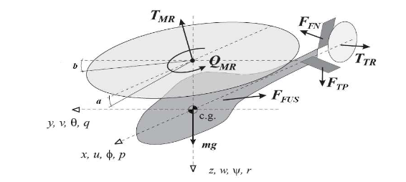

Figure 1: System Description

Matrix A:

|  |  |  |  |  |  |  |  |  |  |  |  |  |
| --- | --- | --- | --- | --- | --- | --- | --- | --- | --- | --- | --- | --- |
| -0.051 | 0 | 0 | 0 | 0 | -322 | -322 | 0 | 0 | 0 | 0 | 0 | -0.051 |
| 0 | -0.154 | 0 | 0 | 322 | 0 | 0 | 322 | 0 | 0 | 0 | 0 | 0 |
| -0.144 | 0.143 | 0 | 0 | 0 | 0 | 0 | 166 | 0 | 0 | 0 | 0 | -0.144 |
| -0.056 | -0.057 | 0 | 0 | 0 | 0 | 82.6 | 0 | 0 | 0 | 0 | 0 | -0.056 |
| 0 | 0 | 1 | 0 | 0 | 0 | 0 | 0 | 0 | 0 | 0 | 0 | 0 |
| 0 | 0 | 0 | 1 | 0 | 0 | 0 | 0 | 0 | 0 | 0 | 0 | 0 |
| 0 | 0 | 0 | -1 | 0 | 0 | -21.74 | -4.109 | 0 | 0 | 0 | 14 | 0 |
| 0 | 0 | -1 | 0 | 0 | 0 | 8 | -21.74 | 0 | 0 | 0 | 0 | 0 |
| 0 | 0 | 0 | 0 | 0 | 0 | -9.75 | -131 | -0.614 | 0.93 | 0 | 0 | 0 |
| 0 | 0 | 0.03 | -3.53 | 0 | 0 | 0 | 0 | 0 | 0.086 | -4.23 | -33.1 | 0 |
| 0 | 0 | 0 | 0 | 0 | 0 | 0 | 0 | 0 | 21.16 | -8.26 | 0 | 0 |
| 0 | 0 | 0 | -1 | 0 | 0 | 0 | 0 | 0 | 0 | 0 | -2.924 | 0 |
| 0 | 0 | 1 | 0 | 0 | 0 | 0 | 0 | 0 | 0 | 0 | 0 | 0 |

Matrix B:

|  |  |  |  |
| --- | --- | --- | --- |
| 0 | 0 | 0 | 0 |
| 0 | 0 | 0 | 0 |
| 0 | 0 | 0 | 0 |
| 0 | 0 | 0 | 0 |
| 0 | 0 | 0 | 0 |
| 0 | 0 | 0 | 0 |
| 0.68 | -2.174 | 0 | 0 |
| 3.043 | 0.3 | 0 | 0 |
| 0 | 0 | 0 | -45.8 |
| 0 | 0 | 33.1 | -3.33 |
| 0 | 0 | 0 | 0 |
| 0 | -0.757 | 0 | 0 |
| 0.798 | 0 | 0 | 0 |

Matrix C:

|  |  |  |  |  |  |  |  |  |  |  |  |  |
| --- | --- | --- | --- | --- | --- | --- | --- | --- | --- | --- | --- | --- |
| 1 | 0 | 0 | 0 | 0 | 0 | 0 | 0 | 0 | 0 | 0 | 0 | 0 |
| 0 | 1 | 0 | 0 | 0 | 0 | 0 | 0 | 0 | 0 | 0 | 0 | 0 |
| 0 | 0 | 0 | 0 | 0 | 0 | 0 | 0 | 1 | 0 | 0 | 0 | 0 |
| 0 | 0 | 0 | 0 | 0 | 0 | 0 | 0 | 0 | 0 | 1 | 0 | 0 |

The state variables are respectively: **u, v, roll rate, pitch rate, roll, pitch, flapping angle a, flapping angle b ,w ,yaw rate, gyroscope yaw rate, paddle angle c, paddle angle d**. All quantities are expressed in the units of measurement of the International System.

## Model

clear all

load('Elicottero.mat')

states = {'u','v','roll rate','pitch rate','roll','pitch','flapping a','flapping b','w','yaw rate','gyroscope yaw rate','paddle c', 'paddle d'};

inputs = {'Lateral cyclic [-1, 1]', 'Longitudinal cyclic [-1, 1]', 'Rudder [-1, 1]', 'Collective pitch [-1, 1]'};

outputs = {'u', 'v', 'w','gyroscope yaw rate'};

C = zeros(4,13);

C(1,strcmp(states, 'u')) = 1;

C(2,strcmp(states, 'v')) = 1;

C(3,strcmp(states, 'w')) = 1;

C(4,strcmp(states, 'gyroscope yaw rate')) = 1;

D = zeros(4,4);

sys = ss(A,B,C,D);

s = tf('s');

%matrice di trasferimento

G = tf(sys);

%bode(G), figure, step(G)

First you need to check the controllability and observability properties of the system. Since the elements of the controllability and observability matrix span a very large range (some elements are less than one, others are greater than )), the default tolerance used by Matlab leads to incorrect conclusions. By specifying an appropriate tolerance we see that the system is completely controllable and completely observable.

Ctr = ctrb(A,B); r_ctr = rank(Ctr,1e-6)

r_ctr = 13

Obs = obsv(A,C); r_obs = rank(Obs,1e-6)

r_obs = 13

# Assigning eigenvalues

The first design technique consists in assigning eigenvalues. Six poles of the system are chosen with the ITAE method: given a pulsation are the poles that minimize that guarantee few oscillations with a relatively small overelongation. The pulsation is chosen by trial and error on the basis of the desired settling time. The remaining poles must be chosen not too far to the left to avoid too much or too nervous control, not too close to the poles assigned with itae so as not to make them lose dominance. A good trade-off was found by taking them real and spacing them respectively by one to the left.

omega_n_itae = 1.7;

p_itae = itae(6,omega_n_itae);

for i=7:13

p_itae = [p_itae real(p_itae(i-1))-1];

end

Assigned poles:

disp(p_itae')

-0.5268 + 2.1477i

-0.5268 - 2.1477i

-0.9869 + 1.3308i

-0.9869 - 1.3308i

-1.2489 + 0.4883i

-1.2489 - 0.4883i

-2.2489 + 0.0000i

-3.2489 + 0.0000i

-4.2489 + 0.0000i

-5.2489 + 0.0000i

-6.2489 + 0.0000i

-7.2489 + 0.0000i

-8.2489 + 0.0000i

K_itae = place(A,B,p_itae);

CC_itae = ss(A-B*K_itae,B,C,D);

step(CC_itae), dcgain(CC_itae)



Figure 2: System Step Response with Status Feedback

ans = 4×4

103 ×

1.0043 1.7099 0.0187 -0.0026

2.2615 0.0263 -0.0043 0.0004

0.0681 0.0631 0.0027 -0.0207

-0.8790 -0.9459 0.1326 -0.0124

## Integral action

Obviously, the assignment of eigenvalues by state feedback does not allow by itself to obtain error at zero speed. To ensure this specification it is necessary to introduce 4 supplements that integrate the error of the output with respect to the reference. We therefore consider the increased system that must be completely controllable:

Aint = [A zeros(13,4);

-C zeros(4,4)];

Bint = [B; -D];

Cint = [C, zeros(4,4)];

Dint = D;

Ctr_int = ctrb(Aint,Bint); r_ctr_int = rank(Ctr_int,1e-6)

r_ctr_int = 17

The controllability matrix has full rank, so the answer is yes. At this point it is necessary to assign the 17 poles of the augmented system. The first 13 are those chosen previously, the following are chosen through the same considerations made before.

p_int = [p_itae';

p_itae(end)-0.5;

p_itae(end)-1;

p_itae(end)-1.5;

p_itae(end)-2];

K_int = place(Aint,Bint,p_int);

The K obtained with the place command consists of 17 elements. As the augmented implant matrices were constructed, the first 13 elements are related to the state feedback, the last 4 are the multiplicative constants of the supplements.

K_s = K_int(:,1:13);

K_i = K_int(:,14:17);

## Observer

For the principle of separation it is possible to design the observer directly. The poles of the observer must be chosen sufficiently to the left to allow rapid convergence of the estimation error, remembering, however, that an observer who is too fast increases the bandwidth of the system by amplifying the measurement noise.

p_obs = real(p_itae)-10;

L = place(A',C',p_obs)';

Aobs = (A-L*C);

Bobs = [B - L*D, L];

Cobs = eye(13);

Dobs = zeros(13,8);

## Results

To verify the functioning of the state feedback with integral action, the initial condition of the observer is equal to the initial condition of the system. In this way it is as if the observer were not there.

The graphs show the response to a reference of along x and, after three seconds, also a reference of along the vertical direction. Basically, the helicopter is being asked to move forward and simultaneously climb after three seconds, keeping the lateral and rotational speeds around the vertical axis null.

x0_obs = 0;

eig_out = sim('autovalori_sim.slx');

plotyu(eig_out,'ulim',[-0.05,0.05],'ylegend',outputs,'ulegend',inputs)



Figure 3: Control action corresponding to the simulation with eigenvalue assignment and integral action



Figure 4: Eigenvalue assignment simulation output and integral action

To verify the operation of the observer, the simulation can be repeated starting from an initial state different from that of the system. For the sole purpose of displaying the prediction error, an identity matrix has been added to the process's C matrix that displays its status.

x0_obs = rand(13,1)*0.005-0.0025;

eig_out_obs = sim('autovalori_sim.slx');

plotyu(eig_out_obs,'ulim',[-0.05,0.05],'ylegend',outputs,'ulegend',inputs,'un',1:4,'yn',1:4)

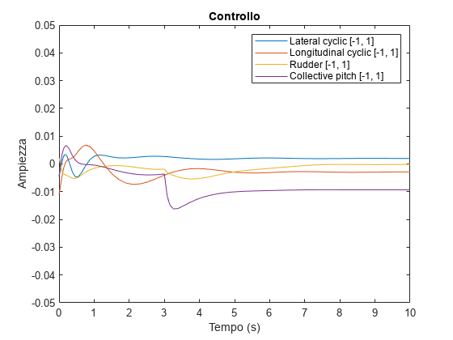

Figure 5: Control action with observer

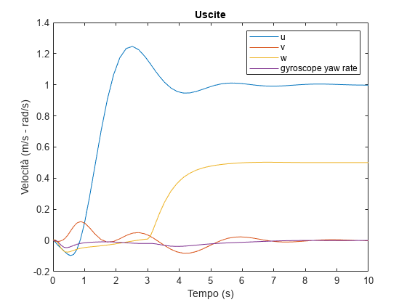

Figure 6: Simulation output with observer

plot(eig_out_obs.e.time,eig_out_obs.e.signals.values);

title('Errore di stima')

xlabel('Tempo (s)')

xlim([0 5])

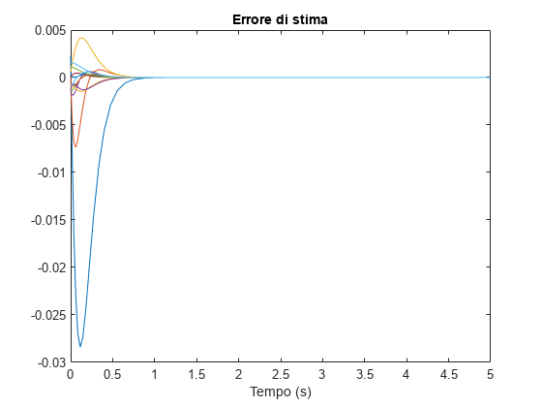

Figure 7: Error between observed state and actual state

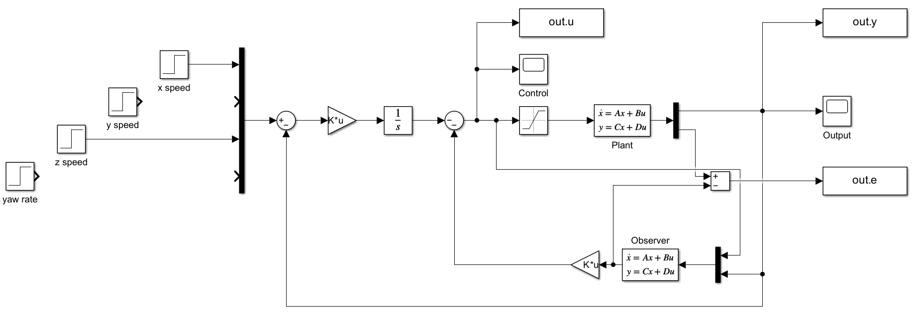

Figure 8: Final control scheme assigning eigenvalues

# Mixed Sensitivity Design

The Mixed Sensitivity Design technique also allows robustness specifications to be taken into account. The implant is assumed to be affected by multiplicative uncertainty:  where 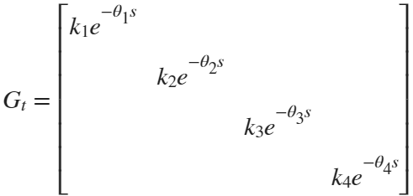: The actual plant has an output uncertainty on each channel which, in the worst case, is  on the gain and a time delay of .

The **mixsyn** command searches for the regulator  which minimizes the norm  of the matrix 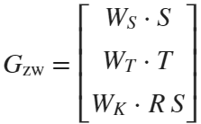 where  and  are the complementary and direct sensitivity functions, respectively. Matrices  are weight matrices that allow you to choose in which band to go to minimize the matrix that they multiply.

## Choice of Wt

Let  it is shown, applying the small gain theorem, that the system is robust if . The weight matrix  must be greater than  for all frequencies. Since this is generally a very restrictive sufficient condition, small frequency bands are tolerated in which the mark-up is not perfect.

delay = 0.01;

Gt = ss([],[],[],diag([1.1 1.1 1.1 1.1]));

Gt.OutputDelay=delay*ones(1,4);

Greal = Gt*sys;

bode(G(1,1),Greal(1,1))

legend("G(1,1)","Greal(1,1)")



Figure 9: Nominal and real process bode diagrams (first input-output channel only)

Delta=(eye(4)-Gt);

WT = (1 - 1.1*(1-s*delay/2)/(1+s*delay/2)).*eye(4);

sigma(WT,Delta)

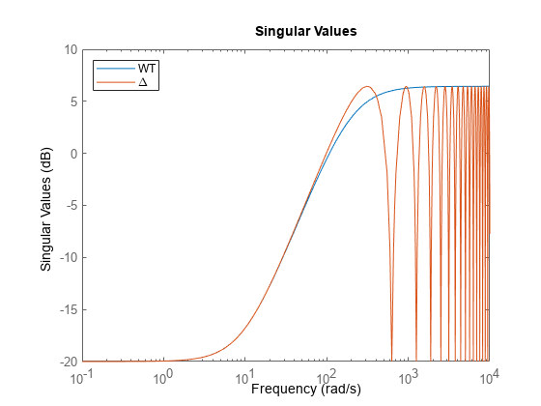

Figure 10: Uncertainties and weight matrix

## Choice of Ws and Wk

Matrices and are chosen by trial and error. The weight matrix of direct sensitivity is chosen large where we want  large, that is, in the desired bandwidth. To have tracking of the step reference, very low frequency poles are placed that force the presence of an integrator in the ring function.

WS = tf(zeros(4));

WS(1,1) = 1e4/(1+s/1e-4);

WS(2,2) = 1e4/(1+s/1e-3);

WS(3,3) = 1e4/(1+s/1e-5);

WS(4,4) = 1e4/(1+s/1e-5);

sigma(WT,WS)



Figure 11: Choosing WS Weight Matrices (in red)

The matrix  It is used to weigh the control action: it must be increased to reduce the control amplitude, being careful to comply with other specifications, including that on robustness. Constant 0.5 was taken on each channel. To further improve control in the initial moments, it was decided to filter the speed references through appropriate first order filters.

WK = tf(1e0.*diag([1 1 1 1]).*0.5);

[K_inf,CL,GAM,INFO] = mixsyn(sys,WS,WK,WT);

## Results

out_hinf = sim('H_inf_sim.slx');

plotyu(out_hinf,'ulim',

[-0.05,0.05],'ylegend',outputs,'ulegend',inputs,'un',1:4,'yn',1:4)

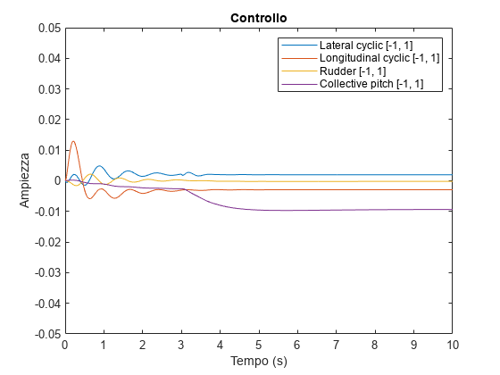

Figure 12: Control action with mixsyn

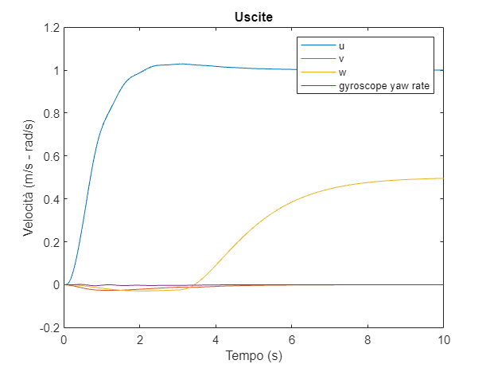

Figure 13: Controller simulation obtained with mixsyn

The specifications are largely respected with greater decoupling between channels than the design with assignment of eigenvalues.

L = G*K_inf;

S = feedback(eye(4),L);

T = feedback(L,eye(4));

sigma(T,S)

legend('T','S')



Figure 14: Diagram of singular values of direct and complementary sensitivity functions

In addition, the singular values of  are always below the axis , so the system is robust. This is confirmed in the simulation on the real system.

sigma(WT*T),grid



Figure 15: Robustness check

plotyu(out_hinf,'ulim',

[-0.05,0.05],'ylegend',outputs,'ulegend',inputs,'un',5:8,'yn',5:8)

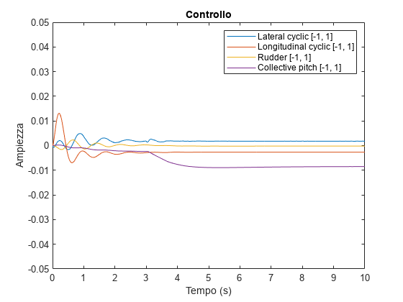

Figure 16: Control quantity action with the designed regulator, applied to the uncertain plant

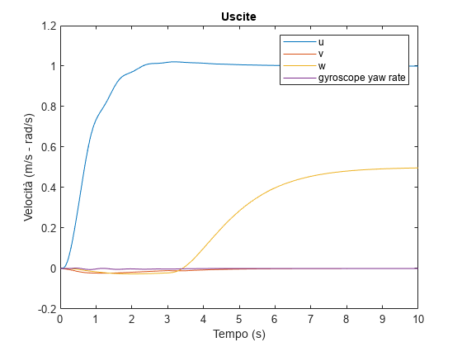

Figure 17: Simulation of the uncertain plant output

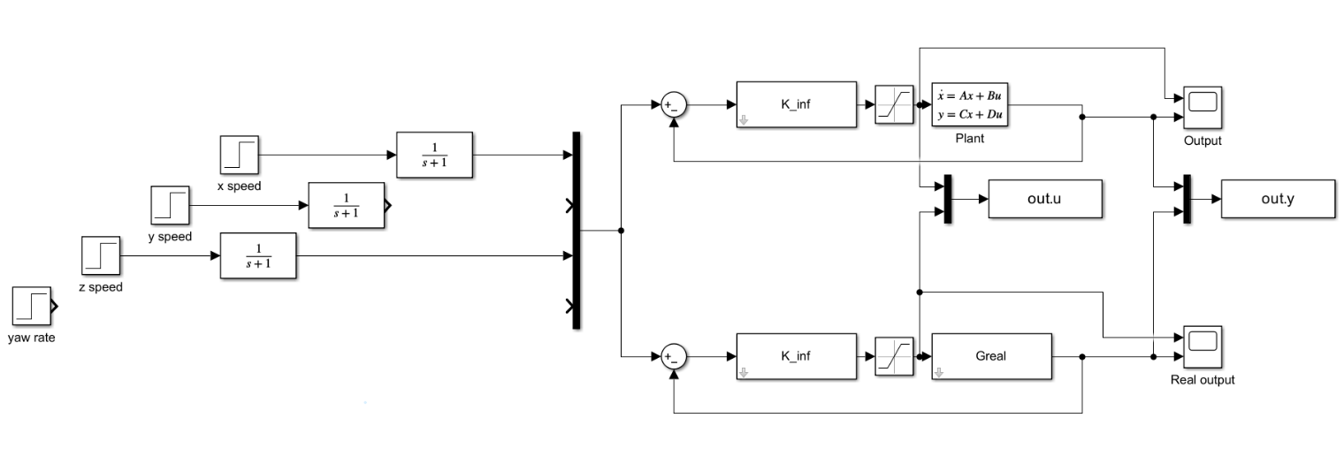

Figure 18: Complete simulink diagram with mixsyn

# LQ Control

The optimal LQ control consists of finding the  state feedback matrix that minimizes the objective function . The matrices  and  penalize respectively high values of the state and control inputs. The values are chosen by trial and error until the output with the desired characteristics is obtained. Since you want a null error on the speed, the **lqr command**  is executed on the matrices of the augmented system, with the presence of 4 integrators.

Q = diag([1; 1; 1; 1; 1; 1; 1; 1; 1; 1; 1; 1; 1; 0.3; 0.3; 0.3; 0.3]).*1;

R = diag([1; 4; 1; 1]).*5;

[K_lq, S, eig_LQ] = lqr(Aint, Bint,Q,R);

K_s_lq = K_lq(:,1:13);

K_i_lq = K_lq(:,14:17);

out_lq = sim('LQR_sim');

plotyu(out_lq,'ulim',[-0.05,0.05],'ylegend',outputs,'ulegend',inputs)



Figure 19: Control magnitude of the controller designed with the LQ control



Figure 20: Simulation with LQ Control

With this choice of weight matrices, it is possible to obtain a response that, with a slightly longer settling time, does not present overelongation. At the same time, the control quantities are very low and the channels are strongly decoupled. Given the context, such an output is very desirable despite the settling time slightly exceeding the specification.

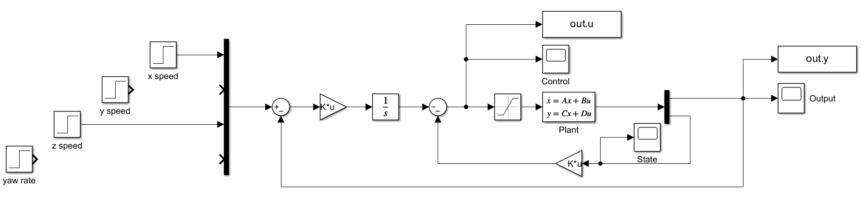

Figure 21: Complete diagram of state feedback with K obtained through the LQ control

# Kalman filter

To maintain the optimality of the solution by inserting an observer it is necessary to use a Kalman filter, which is also useful to minimize the variance of the estimation error in the event that there are process or output measurement noises. By the principle of separation, the observer's design can be carried out once the state feedback design is completed. In particular, it is sufficient to solve the LQ problem to the dual system by obtaining the observer matrix  . Again, the initial conditions of the observer and the system are different.

BandWidth=500;

NoisePower=1e-6/BandWidth;

Rt=eye(4)*NoisePower;

Qt=eye(13)*1e-10;

L_kalman = lqr(A',C',Qt,Rt)';

A_k = (A-L_kalman*C);

B_k = [B - L_kalman*D, L_kalman];

C_k = eye(13);

D_k = zeros(13,8);

x0_obs = rand(13,1)*0.005-0.0025;

out_lqg = sim('LQG_sim');

plotyu(out_lqg,'ulim',[-0.05,0.05],'ylegend',outputs,'ulegend',inputs)



Figure 22: Kalman filter system control magnitude in the presence of process and output noise



Figure 23: Kalman filter system output

The specifications are still met, the initial transient has a more oscillatory character due to the initial estimation error.

plot(out_lqg.e.time,out_lqg.e.signals.values);

title('Errore di stima')

xlabel('Tempo (s)')

xlim([0 5])



Figure 24: Estimation error between observed and actual state

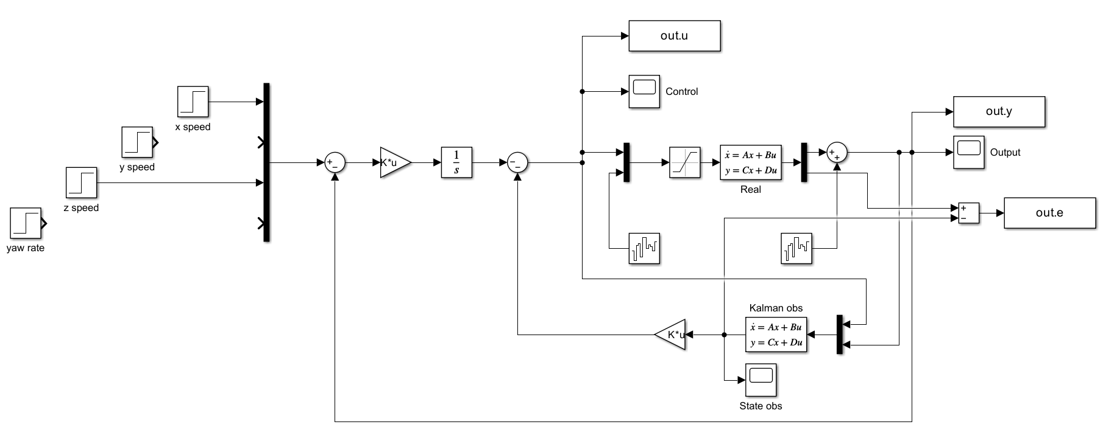

Figure 25: Complete diagram of the LQG control

# Appendix

A Matlab function called "plotyu" was created to avoid the repetition of the code needed to generate the control magnitude and output graphs. This feature is designed to print all charts in a standard format.

The "plotyu" function requests as an argument the object returned by the Matlab "sim" command and allows the use of optional parameters to specify the limits of the axes relative to the control quantity "u" and the output quantity "y" or a legend.

Using the "plotyu" function greatly reduces the amount of code required to generate control magnitude and output graphs, making it easier to display data consistently and consistently, and increasing code readability.

function plotyu(out,varargin)

p = inputParser;

addParameter(p, 'ulim', [-1 1]);

addParameter(p, 'ylim', 0);

addParameter(p,'ulegend',{});

addParameter(p,'ylegend',{});

addParameter(p,'un',0);

addParameter(p,'yn',0);

parse(p, varargin{:});

ulim = p.Results.ulim;

ylim = p.Results.ylim;

ulegend = p.Results.ulegend;

ylegend = p.Results.ylegend;

un = p.Results.un;

yn = p.Results.yn;

figure

if un~=0

plot(out.u.time, out.u.signals.values(:,un));

else

plot(out.u.time, out.u.signals.values);

end

title('Controllo');

xlabel('Tempo (s)');

ylabel('Ampiezza');

axis([out.u.time(1) out.u.time(end) ulim])

if isempty(ulegend) ~= 1

legend(ulegend);

end

figure

if un~=0

plot(out.y.time, out.y.signals.values(:,yn));

else

plot(out.y.time, out.y.signals.values);

end

title('Uscite');

xlabel('Tempo (s)');

ylabel('Velocità (m/s - rad/s)');

if isempty(ylegend) ~= 1

legend(ylegend);

end

if ylim ~= 0

axis([out.y.time(1) out.y.time(end) ylim])

end

end

For the model, reference was made to Model Helicopter Control, Tiago D. T. Rita - IDMEC/IST, Universidade Técnica de Lisboa (TU Lisbon) available at the link <https://fenix.tecnico.ulisboa.pt/downloadFile/395139413911/resumo.pdf>.