Model vs. Actual: Curve Methodology
and Accuracy Improvement Paths
This document explains how each curve in the v2 stochastic experiment plots is computed, quantifies the gap between model and NYISO actual, and identifies concrete steps to improve accuracy.
Experiment: 002_v2_baseline (July 15–21, 2019 and September 19–21, 2023)

1. System Demand Curves
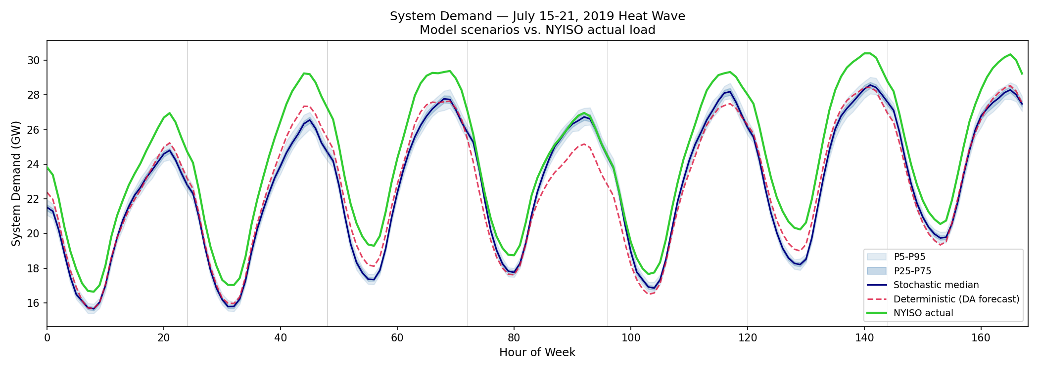
Figure 1 — 2019 system demand: model scenarios vs. NYISO actual
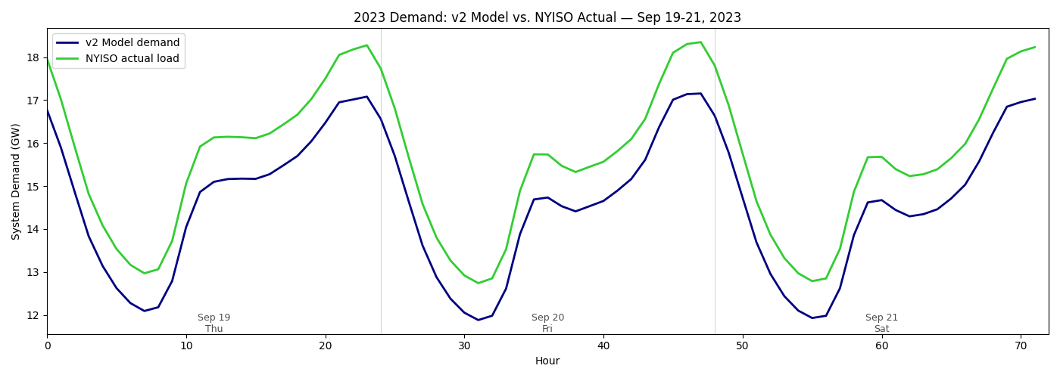
Figure 2 — 2023 system demand: model vs. NYISO actual

1.1 How each curve is computed

NYISO actual (green)
Source: NYISO Actual Integrated Load report (hourly, per zone), cached in PGscen-2nd/data/NYISO_real/load_actual_1h_zone_*_utc.csv. This is the metered, after-the-fact system load published by NYISO. The 11 zonal values (A–K) are summed to produce the system total. Timestamps are in UTC.

Deterministic / DA forecast (red dashed)
Source: NYISO Day-Ahead load forecast (hourly, per zone), cached in PGscen-2nd/data/NYISO_real/load_day_ahead_forecast_zone_*_utc.csv. This is the official NYISO forecast issued the day before real-time. NyisoLoader distributes zonal forecast values to individual buses using load participation factors from NYgrid’s RenewableGen.csv (proportional to each bus’s share of its zone’s total load). The Vatic simulator dispatches generation to meet this forecast demand. The "Demand" column in hourly_summary reflects the total load the model serves, which tracks the DA forecast closely.

Stochastic scenario band (blue)
Source: PGscen scenario generator. For each of the 100 scenarios, PGscen fits a Gaussian copula model to historical load forecast errors and generates correlated perturbations around the DA forecast, independently for each of the 11 NYISO zones. The scenario load is applied as a multiplicative ratio: scenario_load / baseline_actual, so the spatial distribution across buses is preserved. The P5–P95 and P25–P75 bands show the spread of total system demand across the 100 scenarios.

1.2 Current gap
The model demand (deterministic) is systematically below the actual:
Period | Model mean | Actual mean | Bias
2019 Jul 15 | 20,610 MW | 21,963 MW | −6.2%
2019 Jul 15–21 | 23,620 MW | 24,214 MW | −2.5%
2023 Sep 19–21 | 14,600 MW | 15,617 MW | −6.4%

1.3 Root cause
The gap is the NYISO day-ahead forecast bias. DA forecasts are systematically conservative (under-forecast) as a reliability measure, especially during extreme weather. This is not a model deficiency — the model faithfully uses the same forecast NYISO operators had when making commitment decisions.

1.4 How to improve accuracy
Option A — Use actual load as "forecast" (perfect foresight). Replace the DA forecast with the realized actual load in the deterministic run. This eliminates the forecast bias entirely. Implementation: in NyisoLoader.create_timeseries(), set fcst = actl for load buses. Pros: removes the systematic ~3–6% load bias. Cons: not realistic — operators don’t have perfect foresight. Use this for validation plots only, not for stochastic analysis.
Option B — Bias-correct the DA forecast. Compute the historical DA forecast bias per zone and per hour-of-day, then apply an additive or multiplicative correction. For example, if Zone J is consistently 4% under-forecast at hour 15, multiply the DA forecast by 1.04. This preserves the forecast uncertainty structure while removing systematic bias. Implementation: compute bias table from the multi-year load files, apply in create_timeseries() before distributing to buses.
Option C — Leave as-is (recommended for stochastic UC). The DA forecast bias is realistic and represents what operators actually see. The stochastic scenarios already sample around this forecast, and some scenarios will exceed the actual. For measuring cost-of-uncertainty, using the real DA forecast is methodologically correct.

2. System LMP Curves
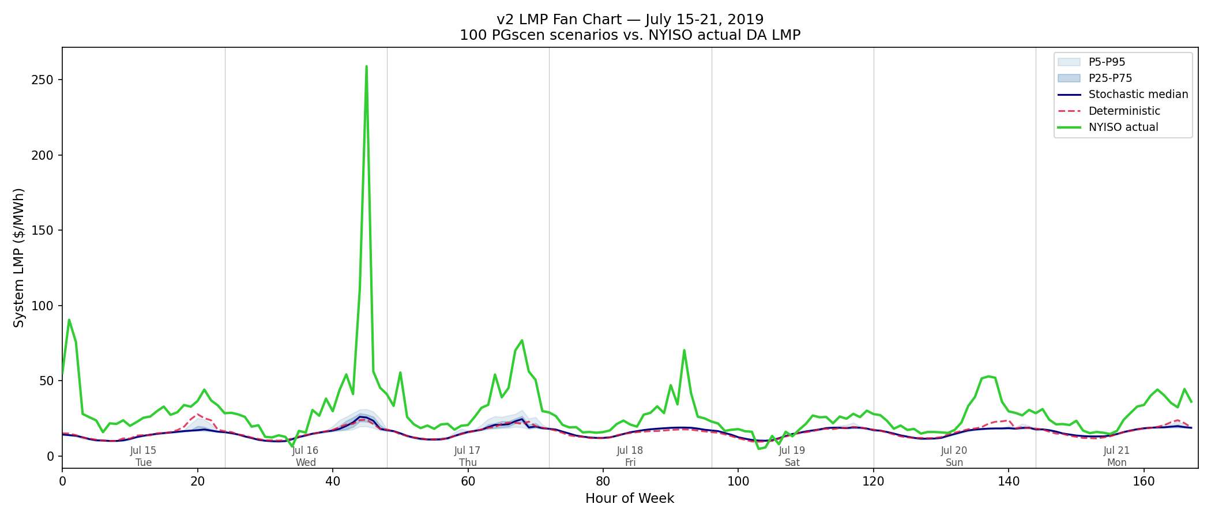
Figure 3 — 2019 LMP fan chart: model scenarios vs. NYISO actual
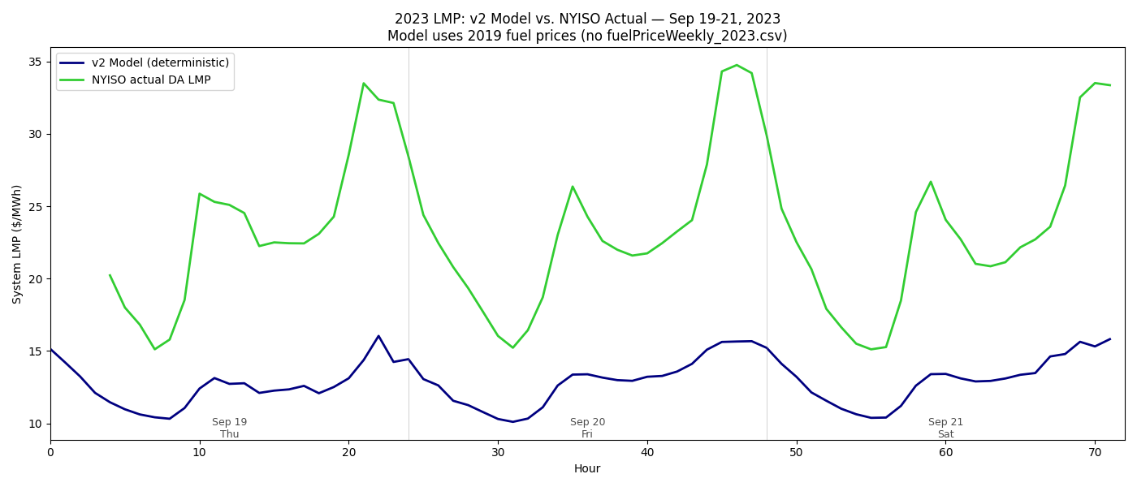
Figure 4 — 2023 LMP: model vs. NYISO actual

2.1 How each curve is computed

NYISO actual DA LMP (green)
Source: NYISO Day-Ahead LBMP (Locational Based Marginal Price), hourly, per zone. For 2019: third_party/NYgrid/Data/priceHourly_2019.csv. For 2023: data/nyiso_cache/2023/da_lbmp/ (daily CSV files). The system-average LMP is computed as the unweighted mean of the 11 NYISO load zones (A–K). Timestamps are converted from Eastern time to UTC for alignment with the model (EDT = UTC−4 in summer).

Model LMP — deterministic (red dashed)
The model LMP is the "Price" column in Vatic’s hourly_summary output. It is computed as follows:
- 1. The Reliability Unit Commitment (RUC) commits generators for the next 48 hours by solving a Mixed-Integer Program (MIP) that minimizes total production cost subject to generator constraints (min up/down times, ramp rates, startup costs) and transmission constraints (PTDF power flow on the 46-bus Kron-reduced network).
- 2. The Security-Constrained Economic Dispatch (SCED) re-dispatches the committed fleet every hour to meet realized load at minimum cost. Generator commitments are fixed; only dispatch levels change.
- 3. After each SCED, the model solves an LP relaxation of the dispatch problem. The dual variable (shadow price) of the system power balance constraint gives the system marginal price: the cost of serving one additional MWh of load. This is reported as "Price".
- 4. With PTDF network flow, the shadow price is a system-wide average. Bus-level LMPs are also computed (in bus_detail) as the sum of the energy component, congestion component (from binding branch/interface constraints), and losses component.

Model LMP — stochastic band (blue)
Same computation as the deterministic, but applied to each of the 100 PGscen scenarios. Each scenario has different wind, solar, and load realizations, producing different commitments and dispatch, and therefore different marginal prices. The P5–P95 and P25–P75 bands show the spread of hourly system LMP across scenarios.

2.2 Current gap
The model LMPs are substantially below actual NYISO DA LMPs:
Period | Model mean | Actual mean | Gap
2019 Jul 15–21 | ~$15/MWh | ~$35/MWh | ≈57%
2023 Sep 19–21 | $12.8/MWh | $23.3/MWh | ≈45%

2.3 Root causes (three stacked effects)
Cause 1 — Production cost vs. market price (~50% of gap). The model computes marginal production cost: heat_rate × fuel_price. Real NYISO DA LMPs are market-clearing prices that include: (a) generator offer markups above marginal cost (generators bid strategically, not at cost); (b) scarcity pricing adders during tight supply conditions (NYISO’s Operating Reserve Demand Curves add premiums when reserves are low); (c) congestion rents on constrained interfaces that the reduced network may underestimate. This is a fundamental limitation of production cost models and is present in all academic UC formulations (Prescient, PLEXOS in cost mode, etc.).
Cause 2 — Load level (~10–15% of gap). Lower model demand (−2.5 to −6.4% vs. actual) means fewer expensive peakers are dispatched. Since peakers are the marginal units that set the system price, underestimating load directly underestimates the marginal cost. On the steepest part of the supply curve (peak hours), a 5% load error can translate to a 15–20% LMP error because the marginal generator shifts from a $40/MWh CC to a $80/MWh CT.
Cause 3 — Fuel price data (2023 only, ~5–10% of gap). For 2023, the model falls back to 2019 NG prices ($3.63/MMBtu) because fuelPriceWeekly_2023.csv is missing. Actual 2023 NG was ~$2.55/MMBtu. This makes the model’s fuel costs ~40% too high, which partially offsets the other two causes. Fixing this would actually widen the LMP gap slightly for 2023 (lower fuel cost → lower model LMP), but would improve the model’s internal consistency.

2.4 How to improve accuracy
Improvement 1 — Add a markup factor to generator costs (quick, ~30% gap closure). Multiply each generator’s cost curve by a calibrated markup factor that approximates the wedge between production cost and offer price. Typical values from the literature (Ela et al. 2011, NREL): 1.1–1.3× for baseload, 1.5–2.0× for peakers. Implementation: add a markup_factor parameter to NyisoLoader that scales TotalCostValues after construction. This is a single calibration parameter per generator type. Pros: simple, captures the dominant effect. Cons: static markup doesn’t capture time-varying scarcity pricing.
Improvement 2 — Implement Operating Reserve Demand Curves (moderate effort, ~20% gap closure). NYISO uses a graduated penalty for reserve shortfall: as reserves decrease below the requirement, the scarcity price increases stepwise ($25 → $50 → $500 → $1,000/MWh). The current model uses a single flat penalty ($1,000/MWh). Implementing a stepped ORDC would raise LMPs during tight hours without requiring generator-level markup. Egret supports this via reserve_zones and stepped penalty curves, but it requires wiring in NyisoLoader.
Improvement 3 — Use actual load for deterministic validation (quick, ~5–10% gap closure). As discussed in Section 1, replacing the DA forecast with actual realized load would push more expensive units to the margin, raising model LMPs closer to actual. This is a 2-line code change in create_timeseries() and is appropriate for validation plots (but not for stochastic UC analysis where forecast uncertainty is the object of study).
Improvement 4 — Fix 2023 fuel prices (necessary for consistency, may widen gap). Download EIA weekly NG prices and generate fuelPriceWeekly_2023.csv. This will lower model LMPs for 2023 (correct direction for internal consistency) but will widen the gap vs. actual DA LMPs. Accurate fuel prices are essential for valid cross-year comparisons even if the absolute LMP level remains below market.
Improvement 5 — Zonal reserve requirements (moderate effort, ~5–10% gap closure in SENY). NYISO enforces locational reserves: ~1,200 MW in SENY (zones G–K) and ~300 MW in NYC (zone J). The current model uses a single system-wide constraint. Adding zonal reserves would force more expensive downstate generators online (instead of letting cheap upstate capacity provide all reserves), raising downstate LMPs and increasing the system-average LMP. This is the single improvement most likely to raise peak-hour LMPs because it forces NYC peakers to run for local reliability.

3. Summary and Prioritization
The table below prioritizes improvements by expected impact and effort:
# | Improvement | Expected gap closure | Effort | Affects
1 | Cost markup factors | ~30% | Low (1 param/gen type) | LMP
2 | Zonal reserves (SENY + NYC) | ~5–10% | Medium | LMP
3 | Stepped ORDC penalty | ~20% | Medium | LMP (peaks)
4 | Use actual load in validation | ~5–10% | Low (2 lines) | Demand + LMP
5 | Fix 2023 fuel prices | Consistency | Low | LMP (2023)
6 | DA forecast bias correction | ~3–6% | Low–Medium | Demand

Important caveat: for the stochastic UC research question (cost-of-uncertainty measurement), the model does not need to match absolute market prices. The relevant comparison is the relative difference between the deterministic and stochastic runs within the same model. Both use the same cost assumptions, so the cost-of-uncertainty percentage is valid regardless of the absolute LMP level. The improvements above are valuable for cross-validation against NYISO data and for future work where absolute LMP accuracy matters (e.g., revenue estimation for storage or renewable projects).

