# Working with GitHub

## What is GitHub

GitHub is a web-based platform and service that hosts software development projects using the Git version control system. It offers a range of features that facilitate collaboration, code management, and project organization for both open-source and private projects.

## Creating a profile on GitHub

* **Visit the GitHub Website**: Open your web browser and navigate to the GitHub website. The URL is <https://github.com>.
* **Sign Up**: On the GitHub homepage, you will find a "**Sign up**" button. Click on it to start the registration process.
* **Provide Account Details**: You will be directed to the registration page where you need to provide the following information:
* **Username**: Choose a unique username for your GitHub account. This will be used to identify you on GitHub.
* **Email Address**: Enter your email address. This will be used for account verification and communication from GitHub.
* **Password**: Create a strong password to secure your GitHub account

## Initialize Git Repository locally:

* Open your Spring project in IntelliJ IDEA.
* Go to the **VCS** menu.
* Select Enable **Version Control Integration**.
* Choose **Git** as the version control system.
* Click **OK** to initialize the Git repository.

## Create a new repository in GitHub:

* **Login** to your GitHub **Account**.
* On the main page select "**New**" to create a new empty repository.

* Give a name to your new repository.

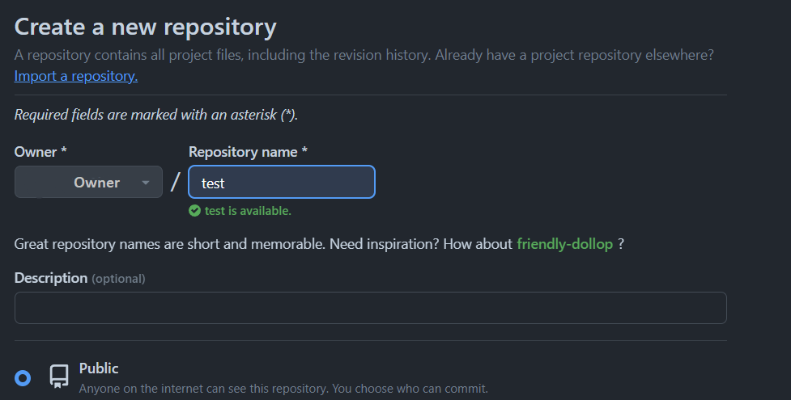

* And finally click on the "**Create repository**" button.

* Now copy the provided link – this is the link to your repository, keep it for later.

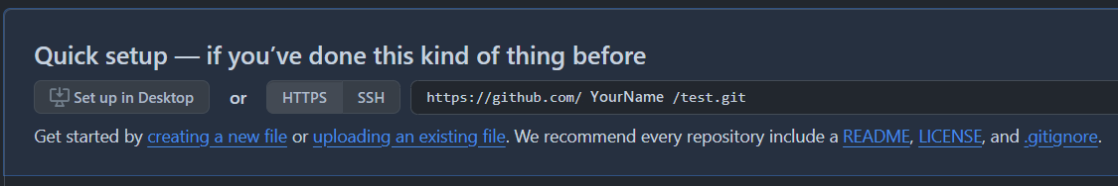

## Commit Changes:

* IntelliJ IDEA will show the changes in your project.
* Go to the Commit button (usually at the top left).

* You'll see the files that have changed. Select the files you want to commit.
* Right-click on the selected files and choose Git -> Add.
* Enter a commit message describing the changes.

* Click on the Commit button to commit your changes.

## Pushing commits to repository:

* Select "**master**" from the top left than "**Push**".

* Select "**Define remote**" from the top left then "**Push**".

* In the URL field paste the **link** you copied earlier from your new GitHub repository:

* If you succeed with pushing, you must see this window and then press "**Push**":

* You receive confirmation in bottom right corner of the screen:

**Now your repository is deployed**.

